Supplementary information
Appendix 1. CONSORT 2010 checklist. 2
Appendix 2. Figure S1. Kaplan‒Meier survival analysis of initial hypotension. 6
Appendix 3. Figure S2. Cumulative sufentanil consumption (A) and visual analogue pain score (VAPS) 24 h postoperatively (B). A, Cumulative sufentanil consumption. The plot describes the consumption from 0 to 24 h after anesthesia. The end lines are the 5th and 95th percentiles, and the points outside the ends represent outliers. B, The VAPS 24 h postoperatively (0 mm = no pain, 100 mm = the worst pain imaginable). 7
Appendix 4. The original trial protocol. 8

Appendix 1. CONSORT 2010 checklist.

Table 1. Information to Include When Reporting a Noninferiority or Equivalence Randomized Trial: Extension of CONSORT 2010 Checklist a
Section/Topic | Item No. | Standard CONSORT 2010 Checklist Item | Extension for Noninferiority Trials |  | Page
Title | 1a | Title and Abstract  Identification as a randomized trial in the title | Identification as a noninferiority randomized trial in the title |  |  | Title Page
Abstract | 1b | Structured summary of trial design, methods, results, and conclusions (for specific guidance see CONSORT for abstracts) | See Table 2 |  |  | Page  2-3
Background and objectives | 2a | Introduction  Scientific background and explanation of rationale | Rationale for using a noninferiority design |  |  | Page 5
Background and objectives | 2b | Specific objectives or hypotheses | Hypotheses concerning noninferiority, specifying the  noninferiority margin with the rationale for its choice |  |  | Page 2
Trial design | 3a | Methods  Description of trial design (such as parallel, factorial), including allocation ratio |  |  |  | Page 5
Trial design | 3b | Important changes to methods after trial commencement (such as eligibility criteria),with reasons |  |  |  | Page 8
Participants | 4a | Eligibility criteria for participants | Whether participants in the noninferiority trial are similar to those in any trial(s) that established efficacy of the reference treatment |  |  | Page 6
Participants | 4b | Settings and locations where the data were collected |  |  |  | Page 6
Interventions | 5 | The interventions for each group with sufficient details to allow replication, including how and when they were actually administered | Whether the reference treatment in the noninferiority trial is identical (or very similar) to that in any trial(s) that established efficacy |  |  | Page 6,15
Outcomes | 6a | Completely defined prespecified primary and secondary outcome measures, including how and when they were assessed | Specify the noninferiority outcome(s) and whether  hypotheses for main and secondary outcome(s) are noninferiority or superiority. Whether the outcomes in the noninferiority trial are identical (or very similar) to those in any trial(s) that established efficacy of the reference treatment |  |  | Page 7,12, 15
Outcomes | 6b | Any changes to trial outcomes after the trial commenced, with reasons Page 11 post-hoc analysis
Table 1. Information to Include When Reporting a Noninferiority or Equivalence Randomized Trial: Extension of CONSORT 2010 Checklist a
Section/Topic | Item No. | Standard CONSORT 2010 Checklist Item | Extension for Noninferiority Trials |  | Page
PPSample size | 7a | How sample size was determined | Whether the sample size was calculated using a noninferiority criterion and, if so, what the noninferiority margin was |  |  | Page 10
PPSample size | 7b | When applicable, explanation of any interim analyses and stopping guidelines | To which outcome(s) they apply and whether related to a noninferiority hypothesis |  |  | Page 10
Sequence generation | 8a | Randomization  Method used to generate the random allocation sequence |  |  |  | Page 6
Sequence generation | 8b | Type of randomization; details of any restriction (such as blocking and block size) |  |  |  | Page 6
Allocation concealment mechanism | 9 | Mechanism used to implement the random allocation  sequence (such as sequentially numbered containers), describing any steps taken to conceal the sequence until interventions were assigned |  |  |  | Page 6
Implementation | 10 | Who generated the random allocation sequence, who  enrolled participants, and who assigned participants to interventions |  |  |  | Page 6-8
Blinding | 11a | If done, who was blinded after assignment to interventions (for example, participants, care providers, those assessing outcomes) and how |  |  |  | Page 6
Blinding | 11b | If relevant, description of the similarity of interventions |  |  |  | Page 6
Statistical methods | 12a | Statistical methods used to compare groups for primary and secondary outcomes | Whether a 1- or 2-sided confidence interval approach was used |  |  | Page 9-10
Statistical methods | 12b | Methods for additional analyses, such as subgroup analyses and adjusted analyses |  |  |  | Page 10-11
Participant flow (a diagram is strongly recommended) | 13a | Results  For each group, the numbers of participants who were randomly assigned, received intended treatment, and were analyzed for the primary outcome |  |  |  | Page 12
Participant flow (a diagram is strongly recommended) | 13b | For each group, losses and exclusions after randomization, together with reasons |  |  |  | Figrue 1
Table 1. Information to Include When Reporting a Noninferiority or Equivalence Randomized Trial: Extension of CONSORT 2010 Checklist ª
Section/Topic | Item No. | Standard CONSORT 2010 Checklist Item | Extension for Noninferiority Trials | Page
Recruitment | 14a | Dates defining the periods of recruitment and follow-up |  |  |  | Page 6
Recruitment | 14b | Why the trial ended or was stopped |  |  |  | Page 6
Baseline data | 15 | A table showing baseline demographic and clinical characteristics for each group |  |  |  | Table 1
No. analyzed | 16 | For each group, number of participants (denominator)  included in each analysis and whether the analysis was by original assigned groups |  |  |  | Page 12
Outcomes and estimation | 17a | For each primary and secondary outcome, results for each group, the estimated effect size, and its precision (such as 95% confidence interval) | For the outcome(s) for which noninferiority was  hypothesized, a figure showing confidence intervals and the noninferiority margin may be useful |  |  | Table 2
Outcomes and estimation | 17b | For binary outcomes, presentation of both absolute and relative effect sizes is recommended |  |  |  | Table 3
Ancillary analyses | 18 | Results  Results of any other analyses performed, including subgroup analyses and adjusted analyses, distinguishing prespeci- fied from exploratory |  |  |  | Page 13
Harms | 19 | All important harms or unintended effects in each group (for specific guidance see CONSORT for harms26) |  |  |  | Page 12
Limitations | 20 | Discussion  Trial limitations, addressing sources of potential bias, imprecision, and, if relevant, multiplicity of analyses |  |  |  | Page 18
Generalizability | 21 | Generalizability (external validity, applicability) of the trial findings |  |  |  | Page 18
Interpretation | 22 | Interpretation consistent with results, balancing benefits and harms, and considering other relevant evidence | Interpret results in relation to the noninferiority hypothesis. If a superiority conclusion is drawn for outcome(s) for which noninferiority was hypothesized, provide justification for switching |  |  | Page 15-16
Registration | 23 | Other Information Registration number and name of trial registry |  |  |  | Page 1
Protocol | 24 | Where the full trial protocol can be accessed, if available |  |  |  | appendix 5
Funding | 25 | Sources of funding and other support (such as supply of drugs), role offunders |  |  |  | Page 1
ª This checklist relates to noninferiority trials, but the same issues apply to equivalence trials. The Consolidated Standards of Reporting Trials (CONSORT) Group “strongly recommends reading this checklist in conjunction with the CONSORT 2010 Explanation and Elaboration for important clarifications on all the items.”

Table 2. Information to Include in the Abstract of a Report of a Noninferiority or Equivalence Randomized Trial: Extension of CONSORT for Abstracts Checklist ^{a b}
Item | Standard Checklist Item | Extension for Noninferiority Trials | Page
Title | Identification of study as randomized | Identification of study as a noninferiority trial |  | Page 1
Trial design | Description of the trial design (eg, parallel, cluster, noninferiority) |  |  | Page 2
Participants | Methods  Eligibility criteria for participants and the settings in which the data were collected |  |  | Page 2
Interventions | Interventions intended for each group |  |  | Page 2
Objective | Specific objective or hypothesis | Specific hypothesis concerning noninferiority, including  noninferiority margin |  | Page 2
Outcome | Clearly defined primary outcome for this report | Clarify for all reported outcomes whether noninferiority or  superiority |  | Page 2
Randomization | How participants were allocated to interventions |  |  | Page 2
Blinding (masking) | Whether participants, caregivers, and those assessing the  outcomes were blinded to group assignment |  |  | Page 2
Numbers randomized | Results Number of participants  randomized to each group |  |  | Page 2
Recruitment | Trial status |  |  | Page 2
Numbers analyzed | Number of participants analyzed in each group |  |  | Page 2
Outcome | For the primary outcome, a  result for each group and  the estimated effect size and its precision | For the primary noninferiority  outcome, results in relation to noninferiority margin |  | Page 2
Harms | Important adverse events or side effects |  |  | Page 2
Conclusions | General interpretation of the results | Interpretation taking into account the noninferiority hypotheses and any superiority hypotheses |  | Page 3
Trial registration | Registration number and name of trial register |  |  | Page 3
Funding | Source of funding |  |  | Page 1
Abbreviation: CONSORT, Consolidated Standards of Reporting Trials.
ª This checklist relates to noninferiority trials, but the same issues apply to equivalence trials.
^{b} This checklist may be republished without restriction.

Appendix 2. Figure S1. Kaplan‒Meier survival analysis of initial hypotension.
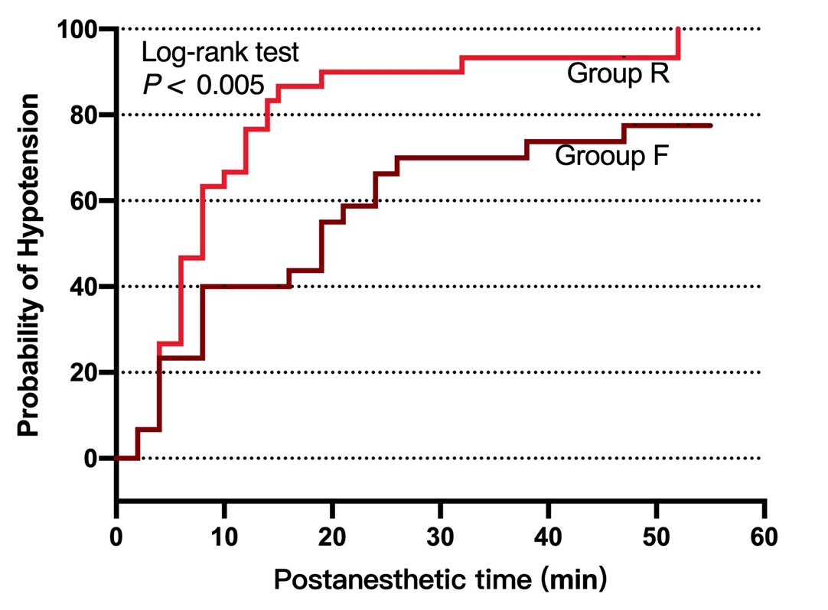

Appendix 3. Figure S2. Cumulative sufentanil consumption (A) and visual analogue pain score (VAPS) 24 h postoperatively (B). A, Cumulative sufentanil consumption. The plot describes the consumption from 0 to 24 h after anesthesia. The end lines are the 5th and 95th percentiles, and the points outside the ends represent outliers. B, The VAPS 24 h postoperatively (0 mm = no pain, 100 mm = the worst pain imaginable).

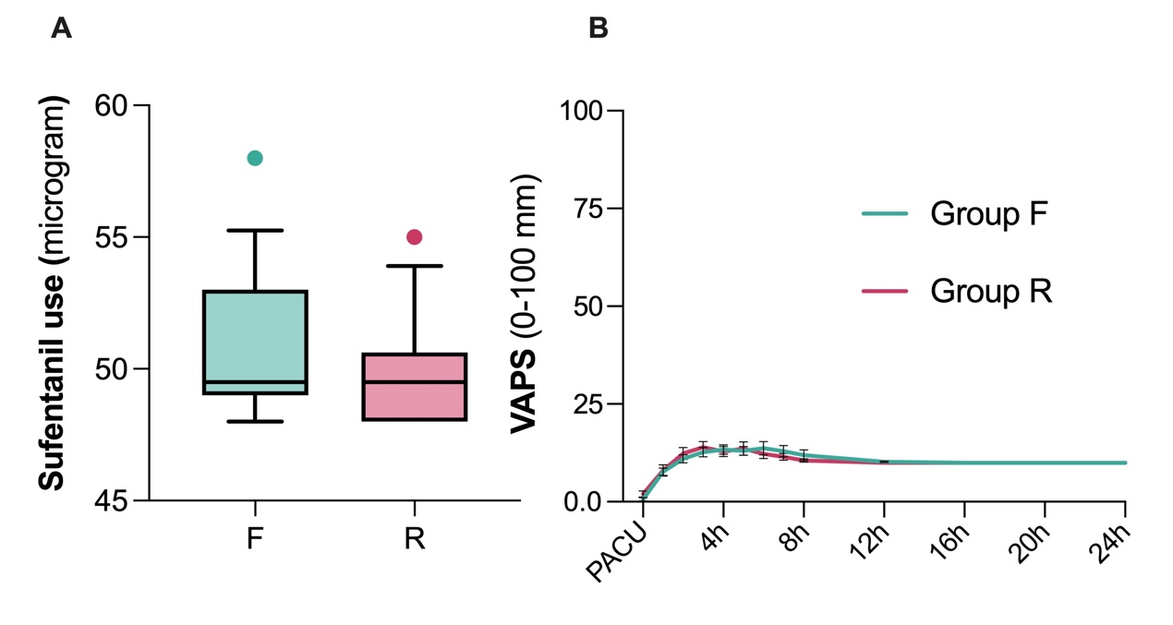

Appendix 4. The original trial protocol.
- Declaration of integrity:
I promise:(1) Ensure operation in strict accordance with test procedures and the authenticity of data records; (2) There is no conflict of interest.
- Research topic
Hemodynamic and analgesic effects of intrathecal injection of fentanyl combined with ropivacaine in patients undergoing cesarean section.
- Version number of research plan: 2.0.
- Source of funds: None
- Flow chart of the implementation of the study, with SPIRIT template.
 |  |  | STUDY PERIOD
 |  |  |  | Enrolment |  |  | Allocation |  | Past-allocation |  |  |  |  |  |  | Close-out
 | TIMEPOINT* |  | -t1 |  |  | 0 |  |  | t1 | t2 | t3 | t 4 |  | etc. |  | t_{χ}
ENROILMENT:
Eligibility screen
Informed consent (List other procedures) Allocation
 |  |  | X
 |  |  | X
 |  |  | X
 |  |  |  |  |  | X
NTERVENTIONS
(intervention A)
(intervention B) List other study groups)
 |  |  |  |  |  |  |  |  | X
 |  |  |  |  |  |  |  |  | X
ASSESSMENTS:
List baseline variables) List outcome variables) List other data variables)
 |  |  | X |  |  | X
 |  |  |  |  |  |  |  |  |  | X | X | X | etc. |  |  | X
 |  |  |  |  |  |  |  |  | X | X | X | X | etc. |  |  | X
List specific timepoints in this row

- Research background
Spinal anesthesia is the most commonly used method for cesarean section, and hypotension is its primary adverse reaction; it has been reported that intrathecal injection of fentanyl combined with local anesthetics can reduce the dosage of local anesthetics while minimizing the impact on the sympathetic nervous system. This trial aims to conduct a randomized controlled trial (RCT) on the use of intrathecal fentanyl combined with ropivacaine in patients undergoing cesarean section, to clarify the safety of reducing the dose of ropivacaine to improve the incidence of hypotension and the effectiveness, compared to higher doses of ropivacaine.
- Purpose of the study
A randomized controlled trial was conducted on the intrathecal injection of fentanyl combined with ropivacaine in patients who underwent cesarean section to clarify its safety in reducing the incidence of hypotension and its effectiveness, compared with higher doses of ropivacaine.
- Inclusion and exclusion criteria
Inclusion criteria: American Society of Anesthesiologists (ASA) grade I-II, age between 18 and 40 years old, singleton pregnancy, pregnancy age over 37 weeks, weight less than 100 kg, height greater than 150 cm, and normal fetal heart rate for elective or emergency laparotomy.
Exclusion criteria: patient allergy to any study drug, spinal deformity, emergency, preeclampsia or pregnancy-related hypertension.
- Sample size estimation (list four elements δ (Δ) or π1, π2, α, β or Power, and write down the calculation formula)
Primary outcome: Incidence of intraoperative hypotension (systolic blood pressure <100 mmHg or <80% baseline defined as hypotension). Pilot trial will be conducted with 12 cases per group, totaling 24 cases; base on the data from the pilot study, assuming an alpha of 0.05 and beta of 0.10 (i.e., 90% power), the sample size was calculated using statistical software.
Secondary outcome: success rate of anesthesia (anesthesia failure if the anesthetic plane did not reach T6 and epidural supplementation was required). According to research of P. Gautier: Comparing the primary variables, i.e., success rates across different groups, subsequent superiority and non-inferiority tests are employed. In the non-inferiority approach, clinical relevance is expressed at a 97.5% upper confidence limit (CL). A maximum allowable difference of 20% is considered the boundary for clinical relevance; values below 20% indicate non-inferiority. The exact power of the non-inferiority test between two binomial populations is 79.2%, with a maximum allowable difference of 20%, an I-class error (alpha) of 0.025, and probabilities of no response in the two study groups being 87% and 80%, respectively, then each group has 30 patients.
- Design scheme, design pattern diagram
Randomized controlled trial, parallel design
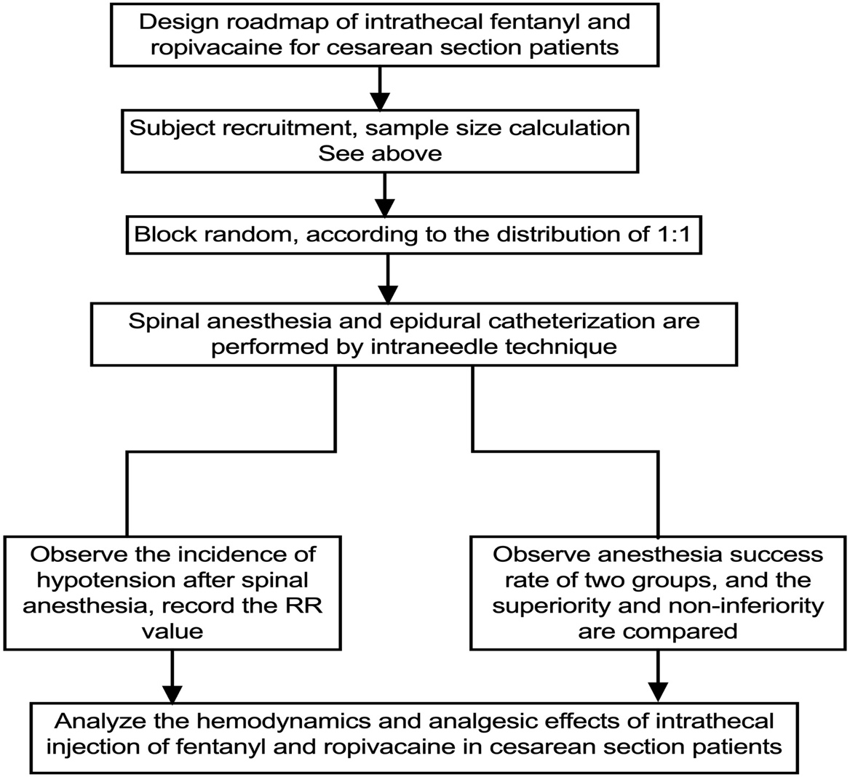
- Random and concealed grouping
Participants were randomly assigned to the experimental group and the control group by random grouping. The random sequence was generated and strictly preserved by a person who did not participate in the clinical trial, and was allocated by envelope method. The random number sequence was generated by computer software (SPSS).
- Blind method (please describe the method and process of implementing the blind method)
Researchers and subjects are blinded. Independent researchers prepared the drugs according to the random sequence. Both groups of drugs were colorless, tasteless, equal in quantity and appearance to ensure that all subjects and researchers were unaware of the group before data collection and analysis was completed.
- Measurement indicators (Measurement indicators are used to evaluate the results of the study, which are divided into primary indicators, secondary indicators and safety indicators, including adverse events and adverse reactions. Please describe the indicator name, measurement method and measurement time point.)
Primary indicator: The RR (Relative risk) value was derived from the incidence of intraoperative hypotension in two groups (hypotension defined as systolic blood pressure < 100 mmHg or < 80% baseline). Blood pressure was measured using a non-invasive cuff, every 2 minutes until delivery, and then every 5 minutes until the end of surgery.
Secondary indicator: success rate of anesthesia (anesthesia failure if the anesthetic level does not reach T6 and requires additional epidural injection). The primary variable is the spinal anesthesia success rate in different groups. The spinal anesthesia level is assessed by pinprick sensation at 2, 5, 10,15,20,25, and 30 minutes; every 30 minutes thereafter until fully recovery; if intolerable discomfort occurs (a VAS score of 5 or higher on a 10cm scale or patient requests analgesic rescue), an additional 5-7 ml of 2% lidocaine is administered epidurally. Pain is assessed using a linear visual analog scale (VAS) at incision, delivery, and abdominal closure with a 10 cm line.
Safety indicators: Intraoperative and postoperative day 1, ask patients whether they have dizziness, nausea and vomiting, itching, tremor; Follow-up on postoperative day 1, day 3 and 1 month to see whether patients have transient nerve root irritation syndrome.
- Definition of validity recognition for participants (including definitions of withdrawal, exclusion, loss to follow-up, confounding, discontinuation and suspension)
Withdrawal and exclusion criteria: Subjects who voluntarily withdraw from the trial, spinal anesthesia puncture failure or switch to general anesthesia or epidural anesthesia.
Standards for discontinuation, suspension and loss of follow-up: The subject is unwilling to continue the clinical trial and voluntarily withdraws; adverse reactions such as drug allergy, major bleeding, amniotic fluid embolism and other unexpected events occur.
- Definition, identification method and management system of adverse events and adverse reactions
Adverse events and adverse reactions are obtained through observation, follow-up and corresponding tests of subjects. If the information collector finds that the patient has adverse reactions, he/she should communicate with the team in time. If necessary, the envelope should be opened by patient number to unblind the patient for further treatment.
- Ethical considerations (including the selection of ethics committees, approval procedures, informed consent process, registration time and registration agency (after completion of registration, additional registration number))
The protocol, case report form, and informed consent form for this trial must all be approved in writing by the Ethics Committee of the First Peoples Hospital of Fuyang, Hangzhou, and the clinical trial must be registered successfully before proceeding. The investigator will be responsible for explaining the benefits and risks of participating in the trial to each patient, their legal representative, or a notary witness, and must obtain written informed consent from the patient before they enter the trial. All original copies of the informed consent forms should be kept by the investigator.
- Recruitment of participants (including selection of recruitment sites, methods of recruitment, screening process and researchers implementing the screening) Location: the First Peoples Hospital of Fuyang; After obtaining informed consent from patients, the researchers (Li Min, Lu Yefang and other members of the research team) began to recruit and screen subjects after an inquiry and review of relevant examinations and appropriate physical examination.
- Collection of general information about participants (including the researchers who conducted the collection and the content of the general information)
Researchers (Min Li, Yefang Lu et al. team members), general information (age, height, weight, gestational age, whether it is a single fetus, comorbidities, medical history)
- Baseline indicators and observation items (for treatment studies, observation items are not necessarily efficacy evaluation indicators, such as height and weight, may only be related to drug dosage, but not directly related to efficacy evaluation.)
Baseline indicators: preoperative baseline blood pressure; observed indicators: blood pressure, spinal anesthesia block level, pain score, and adverse reactions.
- Standard operating procedures (treatment operations, treatment methods, courses; diagnostic test standard procedures; etiological study standard procedures; Procedures for standardizing the study of prognosis; Procedures for standardizing the study of epidemiology)
Spinal anesthesia procedure: The patient is placed in a left lateral decubitus position and spinal anesthesia is administered using the traditional needle-in-needle method with epidural catheter placement at L3.4. A random group of drugs (2.2 ml) is injected, followed by a slow pumpback of cerebrospinal fluid to 3 ml, with the needle tip directed towards the cephalic side. The injection duration is approximately 10 seconds. Immediately after the injection, the patient lies supine, which time is defined as 0.
- Statistical analysis methods (select appropriate statistical analysis methods according to the data type of each measurement indicator; any other additional analysis methods, such as subgroup analysis and auxiliary analysis; when there is a reduction in personnel during the trial, indicate whether ITT analysis is used and compare it with PP analysis.)
A. Statistical analysis was performed using SAS and SPSS software.
B. Baseline data were expressed as appropriate median [range], mean (SD) or frequency. The characteristics of spinal anesthesia block were compared by Two-tailed Mann-Whitney u test. P value < 0.05 was considered statistically significant.
C. Primary outcomes: RR (Relative risk) value are derived from the incidence of intraoperative hypotension in two groups (systolic blood pressure < 100mmhg or < 80% baseline defined as hypotension). Secondary outcome: Anesthesia success rate (anesthesia failure if the intraoperative anesthesia level does not reach T6 or requires epidural supplementation). Comparing primary variables, i.e., success rates of different groups, using subsequent superiority tests and non-inferiority tests for comparison. When there is a reduction in personnel during the trial, an ITT analysis is used and compared with a PP analysis.
- Participant management system
Develop detailed informed consent forms to ensure that subjects fully understand the contents, risks and rights of the trial; provide necessary medical security for subjects to ensure their health and safety; strictly keep the personal information of subjects; establish a sound complaint and rights protection mechanism for subjects.
- The specimen management system has no specimens.
- Drug and equipment management system (including storage, distribution process and verification system, use and recovery)
Pharmaceuticals and equipment are managed by the anesthesiology department of Fuyang First People’s Hospital, stored in a special cabinet, checked under monitoring, used and managed according to the special residual pharmaceuticals management system.
- Data management system (including data collection, management of source data and its documents, personnel for collection and entry (recording), verification system)
Establish a sound data management system, use CRF to input data, ensure the authenticity, accuracy and traceability of the test data; implement special personnel management for document management and password setting; implement a double verification system for collection and input; carry out regular backup and archiving to ensure the security and reliability of the data.
- Data security and the composition and responsibilities of the Monitoring Committee
Data security and monitoring work is supervised and managed by the Ethics Committee of Fuyang First People’s Hospital.
- Research team (including names and contact information, positions)
Li Min, email: 15857134355@16 3.com, research leader.
Lu Yefang, a member of the research team at WeChat ID luye10131129.
Intellectual property (ownership of intellectual property; authorship policies and order; provision of means and time for public access to research programmers.)
The intellectual property rights belong to Zhejiang University School of Medicine. First author: Li Min; Corresponding author: Xiangming Fang.
- Publication Plan (expected time and way to publish the research report; number of publications (whether to publish the periodic summary report))
After the experiment, one paper will be published and no periodic summary report will be published.
- Original data sharing plan (the original data will be shared with the public no later than 6 months after the end of the trial; please indicate the public platform used for sharing.)
The original data will be submitted to the Ethics Committee of Fuyang First People’s Hospital and Clinical Trial Registration Center after the publication of the paper.
- Treatment and management of participants after the trial (after the trial, if there are still participants whose diseases have not been improved, such as What further medical care measures will be taken.)
After the end of the trial, if there are still adverse reactions in the participants that have not been improved, follow-up, treatment and etiology should be continued to help patients to the maximum extent.

