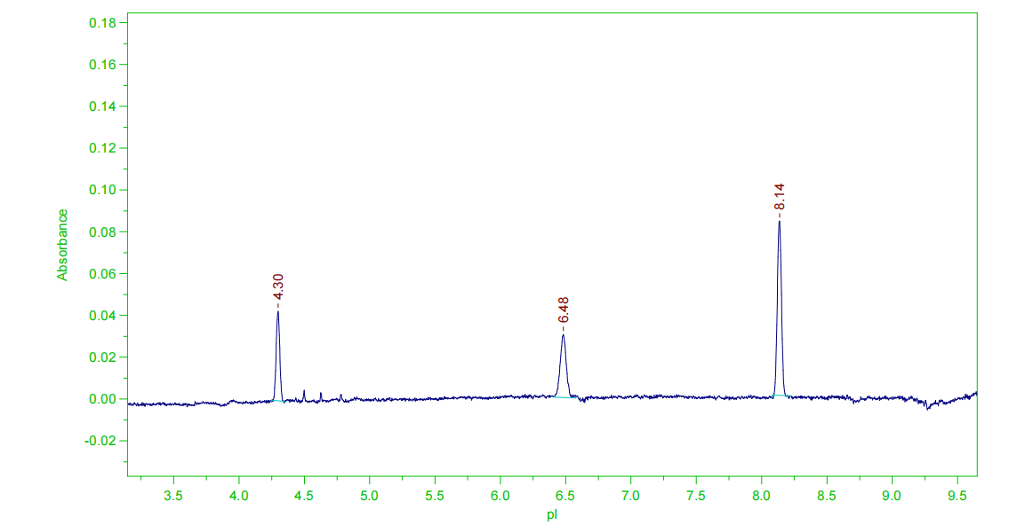
Figure S1 The pI diagram of Marker1, Marker2, and Marker3.

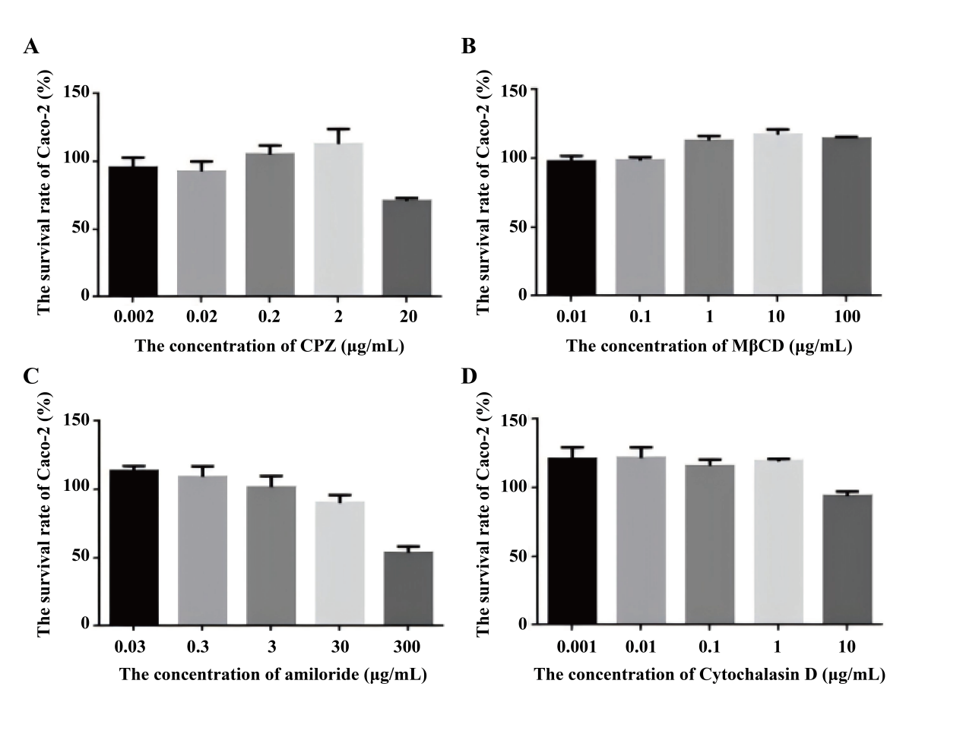
Figure S2 The cytotoxicity result of the CPZ (A), MβCD (B), amiloride (C), Cytochalasin D (D).

