Table S1 A comparative analysis of the detection rates among CMT, nasal tNGS, and BALF tNGS
 | CMT | Nasal tNGS | BALF tNGS
Detection, n | 91 | 144 | 147
Non-detection, n | 56 | 3 | 0
Detection rates (%) | 61.90% | 98.00% | 100%
χ² | - | 37.84* | 39.9*
P value | - | <0.001* | <0.001*
*Compared with CMT.
CMT, conventional microbiological tests; tNGS, targeted next-generation sequencing; BALF, bronchoalveolar lavage fluid.

Figure S1 Venn diagram of pathogen detection overlaps between CMT, nasal tNGS, and BALF tNGS.
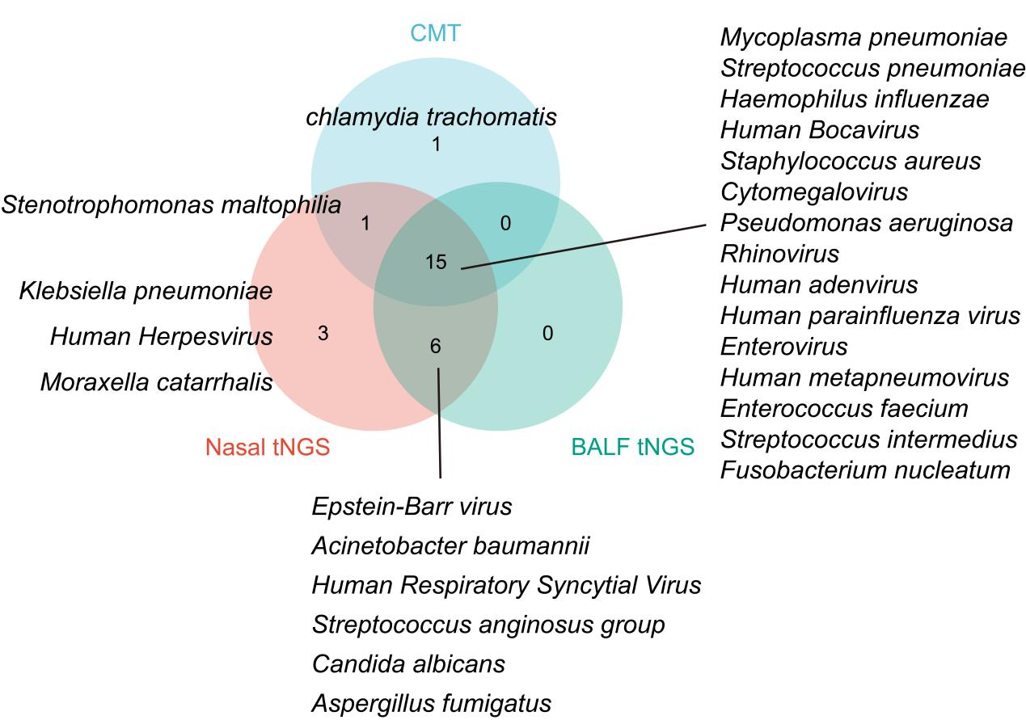
CMT, conventional microbiological tests; tNGS, targeted next-generation sequencing; BALF, bronchoalveolar lavage fluid.

