Supplementary Figure 1. Missing value analysis plot.
Supplementary Figure 2. Plot of fitted curves from multiple imputation.

Supplementary Figure 3. Static nomogram for hospital fall risk prediction.
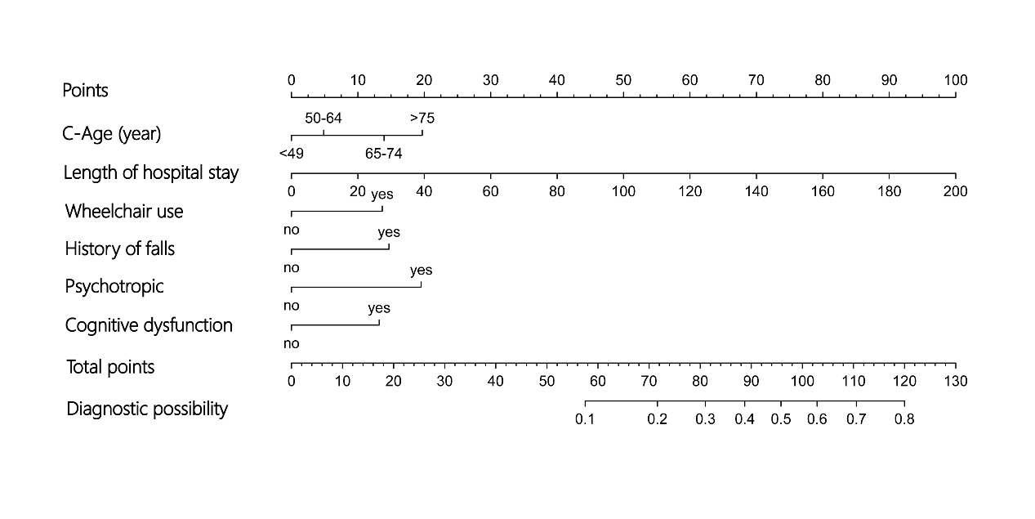

Supplementary Figure 4. Interface of the dynamic nomogram web application for hospital fall risk prediction.
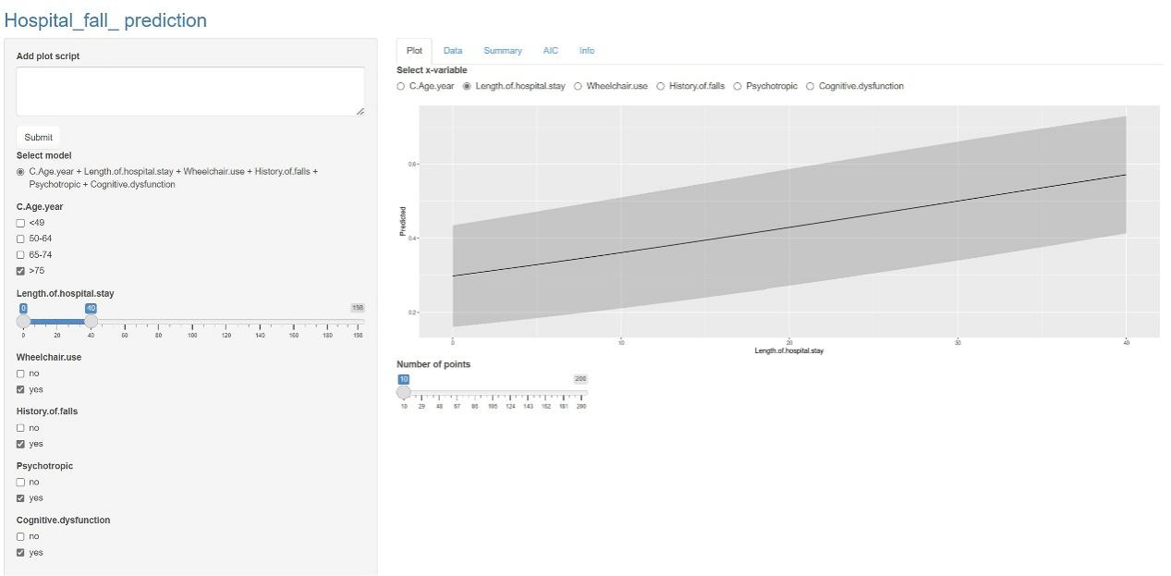
The figure shows the predicted probability of an in-hospital fall, as determined by the model, for a patient with the following characteristics: age over 75 years, length of stay of 40 days, wheelchair use, prior history of falls, history of psychotropic medication use, and cognitive impairment.

