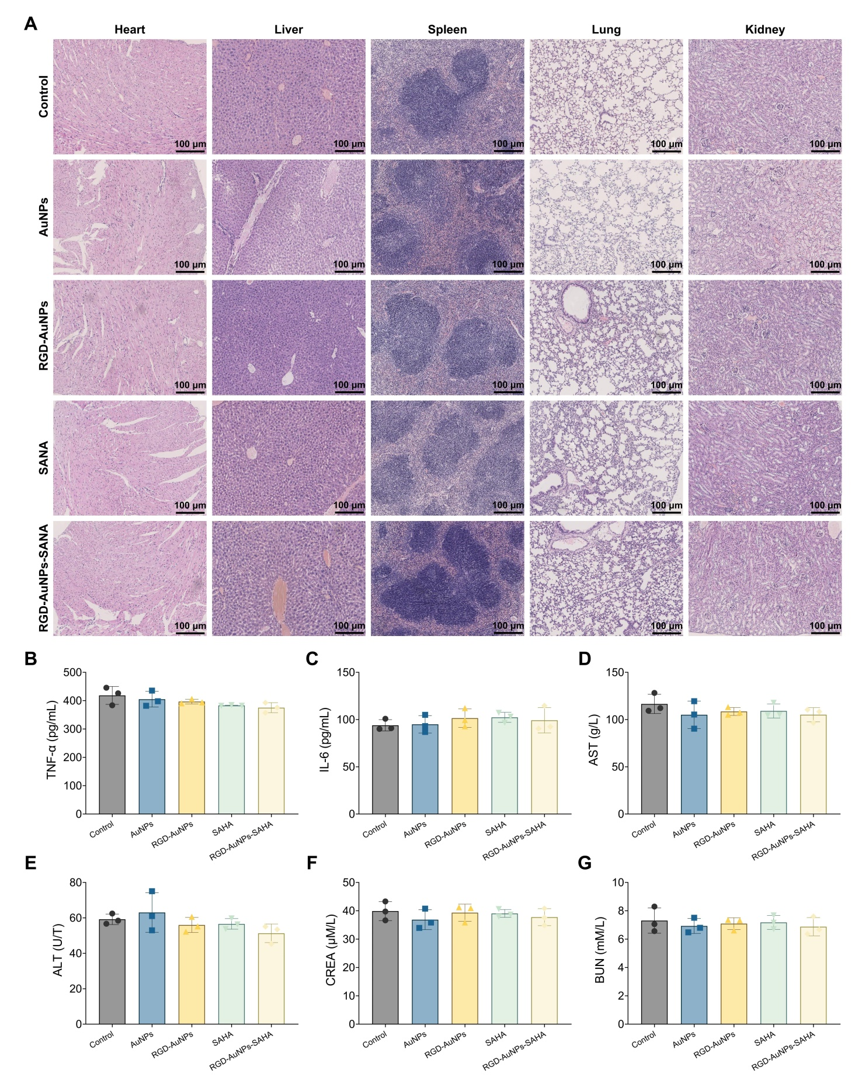
Figure S1. Toxicity and Inflammatory Response of Mice Treated with RGD-AuNPs-SAHA.
Note: (A) Histopathological examination of the heart, liver, spleen, kidney, and lung tissues in each group of mice; (B) ELISA measurement of blood tumor necrosis factor TNF-α levels; (C) ELISA measurement of blood interleukin IL-6 levels; (D) AST levels as an indicator of liver function; (E) ALT levels as a specific marker for liver function; (F) CREA levels for kidney function assessment; (G) BUN levels for evaluating both kidney and liver function. Each experiment was performed in triplicate (n=3). *p < 0.05; **p < 0.01.

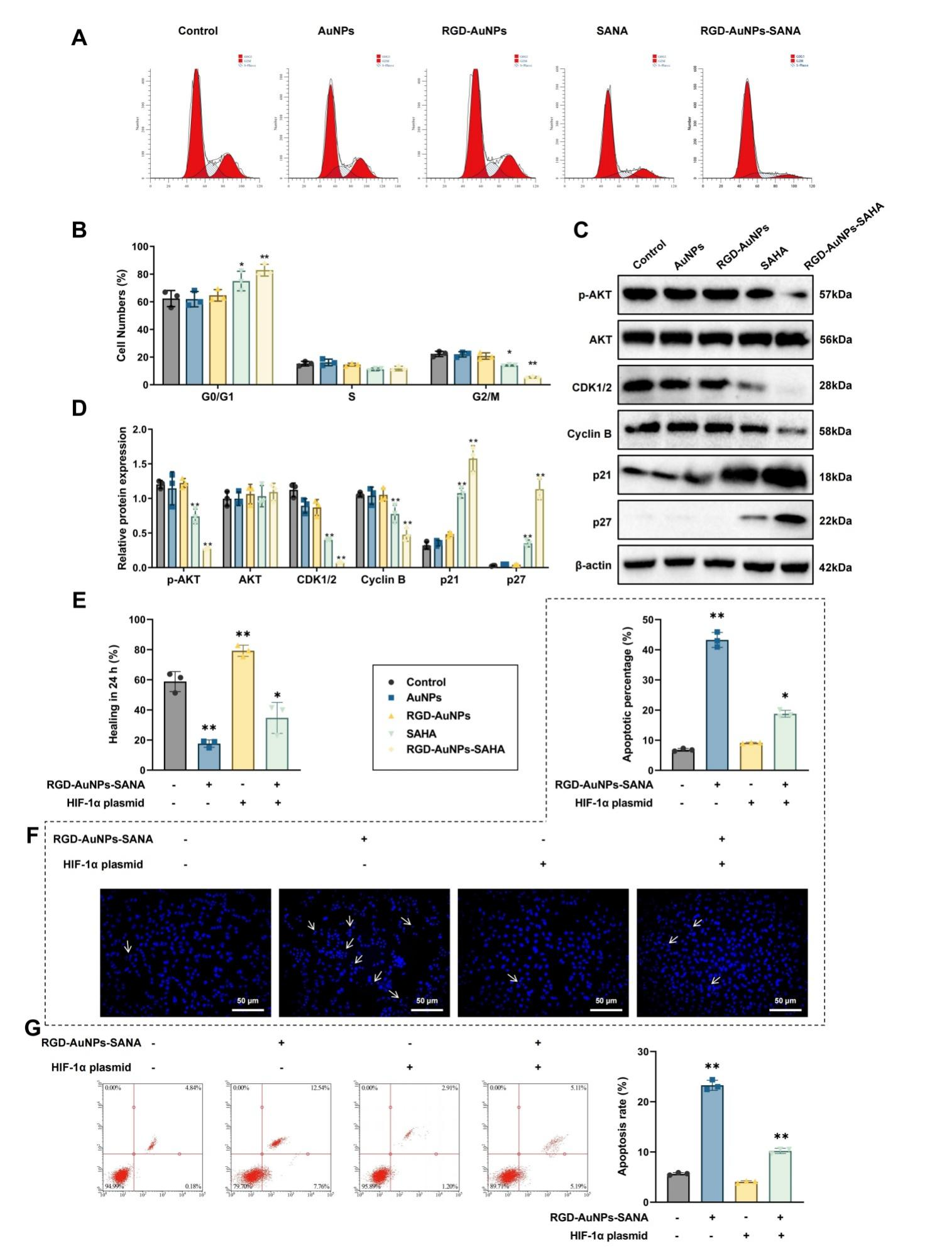
Figure S2. Peptide-Modified AuNPs with SAHA Regulate the Hypoxic Microenvironment and Inhibit Lung Cancer Cells.
Note: (A) Cell cycle distribution of each group analyzed by flow cytometry; (B) Quantitative analysis of the cell cycle distribution in each group; (C) Western blot analysis of P-AKT, AKT, CDK 1/2, Cyclin B, p21, and p27 expression; (D) Quantitative protein analysis of P-AKT, AKT, CDK 1/2, Cyclin B, p21, and p27; (E) Scratch assay evaluating the effects of HIF-1α overexpression and RGD-AuNPs-SAHA treatment on cell migration; (F) Hoechst-33258 staining showing nuclear morphology of A549 cells; (G) Flow cytometric detection of A549 cell apoptosis. Unless otherwise specified, experiments were performed in triplicate (n = 3). *p < 0.05; **p < 0.01.

Table S1. RT-PCR Primer Sequence.
Name | Primer Sequence
DAPDH | F GGAGCGAGATCCCTCCAAAAT
DAPDH | R GGCTGTTGTCATACTTCTCATGG
HIF-1α | F GAACGTCGAAAAGAAAAGTCTCG
HIF-1α | R CCTTATCAAGATGCGAACTCACA
VEGF | F AGGGCAGAATCATCACGAAGT
VEGF | R AGGGTCTCGATTGGATGGCA

