Supplementary material
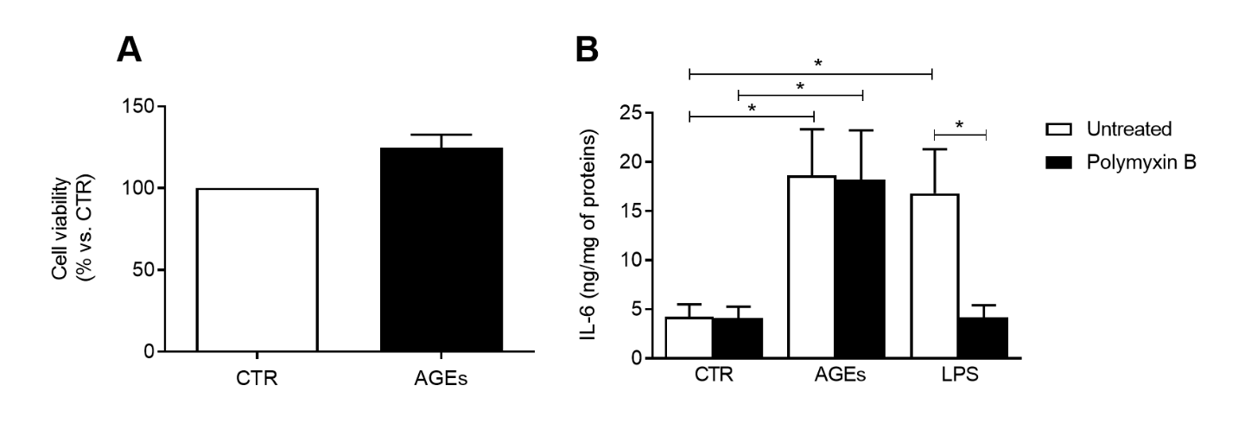
Supplementary Figure 1 (A) Comparison of cell viability of HLMs treated 16 hours with medium alone (CTR) or AGEs by the MTT assay. Cell survival data are presented in the form of a bar graph (B) Effect of polymyxin B on AGEs and LPS-induced release of IL-6 from HLMs. HLMs were incubated (16 hrs, 37 °C, 5% CO₂,) with medium alone (CTR), AGEs (100 µg/mL), or LPS (1 µg/mL) either in the absence or in the presence of polymyxin B (50 µg/mL). Data are the mean ± SD of 3 experiments obtained from different donors. IL-6 (B) proteins in supernatants were evaluated by ELISA. * p < 0.05 vs. all other groups.

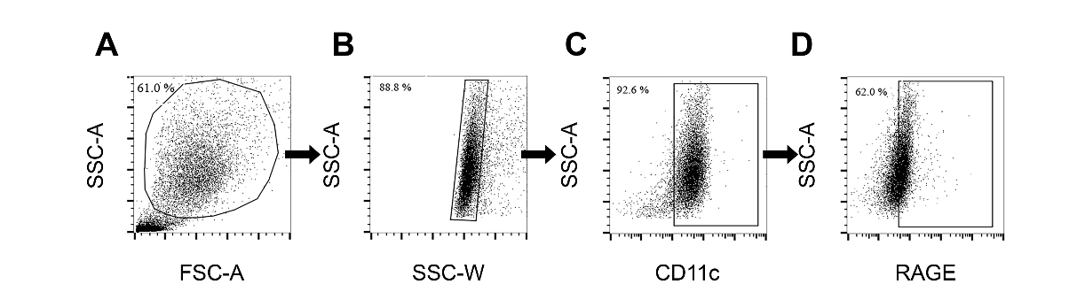
Supplementary Figure 2 Flow cytometry gating strategy used to define RAGE⁺ HLMs in the human lung. (A) Granulocytes were gated based on SSC-A versus FSC-A. (B) Singlets were selected from the SSC-A versus FSC-W dot plot. (C) Macrophages were identified by CD11c expression. (D) RAGE⁺ cells were then defined using RAGE antibody staining.

