Supplementary data

Supplementary Table 1: Topic Guide
Supplementary Table 1 shows an interview “Topic Guide” containing open-ended questions and probes.



People Living with IBD - Topic Guide

Exploring reasons for Intentional & Non-intentional Non-adherence to
prescribed Medication, as perceived by
people living with Inflammatory Bowel Disease & Healthcare Professionals: A Qualitative Study

22nd November 2022

Below is a list of topics to help guide the interviewer in the qualitative interviews with people living with inflammatory bowel disease (IBD) for the above study. Topics are listed into categories and then within those, there are prompts for the interviewer.
Topics | Categories | Prompts
Background: | Opening questions  Their Health  IBD Diagnosis | Can you please tell me some history about your health, with a specific focus upon your inflammatory bowel disease?  Could you please tell me about the type of IBD you have; ie: Crohn’s Disease or Ulcerative Colitis?  At what age were you diagnosed with IBD? Can you please share with me the circumstances around this?  Can you think about and remember how you felt?  What are the symptoms you currently experience with your IBD?  What is your understanding of your condition?  How do you feel about your IBD now?  Are you accepting of your diagnosis?  Are you open with others about it?
Medication history: | Medication first prescribed  Subsequent  Medications prescribed  Current  Medications prescribed | How do you feel about the treatment involved with your IBD?  What medications were you first prescribed for your IBD?  How did you feel about taking long-term medication?  What advice were you given re: taking your medications?  Are you monitored for taking your medication by healthcare professionals? Could you tell me a little more about this?  What medication are your currently prescribed for your IBD?  What route is your medication administered for your IBD?  What dosage of medication are you prescribed for your IBD?  Do you have a medication regime for your IBD?  What, if any, side effects have you experienced from your IBD medication/s? How have these made you feel?  What if any, contraindications have you experienced? (contraindications definition (if required)– reason for not taking a certain treatment, due to harm it may cause an individual).
Your adherence | Your current adherence / non-adherence  Adherence history  Any barriers/supports inhibiting/improving adherence? | What is your understanding of the term “adherence”?  (adherence definition (if required)– the extent to which a patient’s actions matches the agreed recommendations).  Would you say that you are you currently adherent to your prescribed IBD medications?  Can you elaborate upon this? If yes, what / who has helped you achieve this? If no, are you able to reflect upon and discuss this further?  How has your adherence been since first being prescribed IBD medications?  Has your adherence changed since being prescribed medication for your IBD?  Can you tell me more about your experience of taking the medication for your IBD?  Are you able to tell me a little more information please so I understand you in more detail?
Reasons behind adherence /non-adherence | Personal reasons  General reasons  Justification? | What are the factors that may affect your adherence?  What are the factors that may affect your non-adherence?  What are the reasons for you not being adherent? (only ask this question if patient indicates non-adherence)  What are the types of medications which are associated with your non-adherence?  What are the types of medications which are associated with your adherence?  Can you tell me if there are specific medication routes which impact upon your adherence? Can you provide me with some examples? Can you explain why you think these routes have impact your adherence?  Would you say there are any medication regimes which lead to your non-adherence?  Would you say there are any medication regimes which lead to your adherence?  What medication patients most frequently adhere to and why?  What medication patients most frequently non-adhere to and why?  What do you think about the taste of oral medication?  What do you think about the taste and size of oral medication?  How does this affect your adherence to … (state specific oral medication which the participant has made reference to).  How do you feel about IBD medication which you are advised to inject?  How do you feel about IBD medication which you are advised to insert rectally?  Have you experienced any side effects from taking your medication? Have these impacted upon adherence?  Have you experienced any contraindications from taking your medication? Have these impacted upon adherence?
Beliefs about why adherence / non-adherence takes place | Adherence challenges | What do you think are the challenges with regards to adherence?  Why do you think certain people with IBD are adherent to their IBD medications and others are not?  Would you say non-adherence is a short-term challenge? Can you explain why?  Would you say non-adherence is a long-term challenge? Can you elaborate why?
Adherence Support | Healthcare professionals  Family members  Friends | Did you experience any adherence support on first being diagnosed with IBD? Please can you elaborate on any support that you may have had?  Who do you/did you discuss this with and why?  Do you have discussions with your healthcare professionals (Gastroenterologist / IBD Nurse / other healthcare professional) about your adherence to your IBD medication? If you do have these discussions, what are your thoughts on them?  How frequently do you have discussions with your healthcare professionals (Gastroenterologist / IBD Nurse / other healthcare professional) about your adherence to your IBD medication?  Has your healthcare professional discussed with you, strategies to support your adherence? You please tell me a little more about this?  Do you feel supported by your healthcare professionals in terms of your IBD medication adherence?  Do you discuss your IBD and medication taking with your friends / family?  What are the opinions of your friends /family about your taking long-term medication?  Would you say that your friends /family have influenced your perspectives on taking your IBD medication? Could you explain a little more about this?  Would you say that your friends /family have influenced your behaviours around taking your IBD medication? Could you explain a little more about this?  Have your friends /family had an involvement in your IBD and medication adherence in any other way?  Do others (who) have a role to play in your IBD medication adherence (eg: reminding you to take your medications)?  Do others (who) support you in your IBD medication adherence? Can you explain how?  Would you like additional support with your IBD medication adherence? Can you tell me who you think would be the best to deliver this for you?
Support strategies | Strategies used  Potential Strategies  Barriers to adherence | What if any, approaches have you used that are successful in supporting your adherence? Can you explain these a little more?  What if any, approaches have you used that are unsuccessful in supporting adherence? Can you explain these a little more?  How do you think healthcare professionals can help support you with your IBD adherence?  How do you think researchers can help support you with your IBD adherence?  How do you think healthcare professionals can help support other IBD patients with their adherence? If so, what type of strategies would work best?  How do you think researchers can help support other IBD patients with their IBD adherence?  Who do you think should be involved in supporting people with IBD and their adherence?  Do you think training in adherence support would be helpful for healthcare professionals?  Do you think training in adherence support would be beneficial for researchers?  Do you think training in adherence support would be beneficial for people with IBD?  Do you think training in adherence support would be beneficial for people with IBD’s family / friends?  Can you think of any tools that could be useful to help support people with IBD with their adherence? For example physical tools (eg: dosette boxes, alarm reminders) or electronic / online systems (eg: text messages or websites)?
Anything else? |  | Would you like to add anything else?

Thank you very much for your time.

Supplementary Information Text
Strategies to Promote Adherence
Participants identified various strategies to support adherence, which could be implemented by HCPs and/or themselves. These strategies were categorised according to who would deliver the approach, followed by the strategy or tip, with a supporting quotation (Table3).

HCPs
Clinical care
More than half of participants emphasised the importance of HCPs being trustworthy, genuine and empathic, demonstrating a commitment to their well-being with best interests (Supplementary Table2, quote1a). Personalised, holistic care was considered critical for promoting adherence and providing reassurance (Table3, quotations 1b; 1c). Informative communication that reinforced the importance of sustained adherence (Table3, quote1d), delivered by a supportive, multidisciplinary healthcare team, was valued by most participants, enhancing their overall care experience. Additionally, encouragement from HCPs served as a motivator for medication adherence while also helping to identify patients who were struggling (Table3, quote 1e).
Treatment
Adherence would be best promoted by a simple personalised regimen tailored to an individual’s lifestyle (Table3, quote2a). Labelling medication packaging with specific days and times (am/pm), either by pharmaceutical companies or by the patient, was a widely popular strategy (Table3, quote2b). Additionally, being prepared for potential side-effects and understanding how to manage them further supported adherence (Table3, quote2c).

HCPs and Patients
Communication with HCPs
Multiple participants highlighted the importance of clear communication with HCPs, emphasising active listening, openness, and transparency (Table3, quotations 3a; 3b). Many advised self-advocacy, encouraging patients to proactively request for support (Table 3, quote 3c) and ask questions to enhance their treatment understanding and engagement (Table3, quotations3di; 3dii).

Patients
Practicalities
Several interviewees shared strategies they used to adhere to their medication regimen, primarily focused on reducing forgetfulness. Developing a routine from the beginning of the treatment programme, tailored to an individual's lifestyle, was often cited as the most effective approach, as it helped the medication become a habit (Table3, quote4a). Making associations or cues with treatment was also seen as beneficial, as well as ensuring medication was easily visible and accessible (Table3, quote4b).
Three participants highlighted the importance of organisation, advanced planning for receiving and storing medication, and having spare supplies to aid adherence (Table3, quote4c). This included using tools like diaries, organisers, alarms, phones, sticky notes and dosette boxes to help remember and maintain the prescribed routine (Table3, quotations4d; 4e).
Emotions
A quarter of respondents emphasised the importance of self-care, which involved maintaining a positive mentality whilst making life easier (Table3, quote5a). Reminding themselves of the reasons for treatment and its importance helped sustain adherence (Table3, quote5b). Additionally, disclosing their IBD diagnosis to others was another critical coping strategy for many (Table3, quotations5ci; 5cii).
Learning & Educational Resources
Participants encouraged making use of all available IBD resources, particularly those provided by HCPs and IBD charities (Table3; quotations6a; 6bi; 6bii). The value of peer support throughout the IBD journey was recommended as an educational tool by several participants (Table3; quote6c), although there were risks from using internet forums (Table3; quote6d).

Supplementary Table 2: Patient Suggested Interventions, Resources, Strategies & Tips to Promote Medication Adherence in IBD
Resource | Strategies & Tips | Example quotes
Healthcare Professionals | 1) Clinical Practice  a) Genuine supportive care, informative & communication with consistency.  ----------------------------  b) Personalised, holistic care.  ----------------------------  c) Reassurance by HCPs they are caring for your well-being & have your best interests at heart.  ----------------------------  d) Reinforcement by the HCPs of medication benefits and importance of remaining adherent.  ----------------------------  e) For HCPs to encourage adherence and recognise and acknowledge if and when patients are struggling.  ---------------------------- | a)“Above and beyond all of that it’s just having that person, someone who is interested and has a bit of knowledge. If I trusted that they did have the knowledge I think any of those people I’d be fine with. It’s just having a human being…That would be the dream just having that one person who knew you.” (P4, F, 50years, UC).  ----------------------------  b) “Like your healthcare provider actually like cares…the need for the holistic care rather than just dealing with the symptoms...what needs to be on a case-by-case basis.” (P1, F, 34years, CD).  ----------------------------  c) “It's all about, it's all about you. Like ultimately they [HCPs] want to make you better and you want to feel better.” (P19, M, 36years, UC).  ----------------------------  d) “The way the team were talking about the medication was that it could make me feel better and even at that point they were stressing that when I started to feel well in the future I’d need to keep taking it though and that I shouldn’t associate the medicine with illness. The medicine was just with me regardless of how I was feeling.” (P13, F, 25years, UC).  ----------------------------  e)“Just to acknowledge that even when it appears that someone is doing well with their adherence they might still be having a lot of emotional energy taken up by it. So even when it appears to be going well it might still be a bit of a struggle.” (P13, F, 25years, UC).  ----------------------------
 | 2) Treatment  a) A non-complicated regime, personalised around an individual’s lifestyle.  ----------------------------  b) Treatment packaging can enhance adherence, particularly if days and/or times are printed on packets or labelled by the individual.  ----------------------------  c) Being made aware of potential side-effects to prepare for them or knowing how to manage these.  ---------------------------- | 2a) “If I’m working shift patterns a standardised eat breakfast, lunch, dinner this time doesn’t work for me.…. So have that discussion and ensure that it works into your life.” (P14, F, 32years, UC).  ----------------------------  2b)“I did like the blister packs that I got with one of my medications where it was showing a.m. and p.m. because…it would be a few hours after I usually take my medication being like, wait did I?...To know did I or did I not take medication. So I found those colour coded blister packs were helpful in that regard.” (P8, F, 33years, UC).  ----------------------------  2c) “I think they need an appointment first with someone with an IBD nurse or with the pharmacist specific to take them through the tablets, why they need to take them and if they have a flare-up what they need to do and why they need to be on steroids and the side-effects that they might have. I think a session would be useful.” (P16, F, 32years, CD).  ----------------------------
Healthcare Professionals & Patient | 3) Communication with HCPs  a) Really listening to your HCPs.  ----------------------------  b) Being open and transparent with your HCP team.  ----------------------------  c) Request for support when needed.  ----------------------------  d) Self advocating for yourself through proactively asking HCPs questions.  ---------------------------- | 3a) “…I didn’t realise was how much the time of day I was taking my medication was affecting me. It’s really listening to your doctors. I just thought look as long as I get my two, three tablets in a day I was fine. Whereas actually, learning taking medication in the morning as opposed to the evening was benefiting my sleep.” (P14, F, 32years, UC).  ----------------------------  3b) “I’d encourage you to be open and transparent with your healthcare team and persist with them...” (P19, M, 36years, UC)  ----------------------------  3c) “I would say if you need help, ask. That’s all I can say. But if you don’t speak up nobody is going to know you are struggling so its really difficult if you don’t vocalise or communicate how can somebody guess.” (P20, F, 37 years, UC).  ----------------------------  3d i) “Question it, ask them why? Make them tell you exactly why and why they think this is the right thing for you and get as much information on the drug as possible. Talk to them about how long you’re gonna have to be on it, the possible side-effects.” (P7, F, 26years, UC).  3d ii) “I would tell them go and speak to your nurses, is there another way you could take it. Is there a different formulation, can it be crushed?…But the point is speak to somebody. If your medication is wrong why should you suffer. Go and speak to somebody because there may be something else they can do.” (P18, M, 59years, UC).  ----------------------------
Patient | 4)Practicalities  - Importance of a routine, established  from the start of being prescribed treatment, personally suited for individual’s lifestyle that could easily develop into a habit.  Making associations or use cues as medication reminders.  ----------------------------  b) Keeping treatment visible and accessible, such as near their bedside or in the kitchen were recommended strategies.  ----------------------------  c) Being organised, planning in advance when receiving and storing treatment, as well as having spares.  Minimise non-adherence through logging aspects of IBD (e.g. in a notebook, diary or phone including medication taking), or having emergency packs.  ----------------------------  d) Using prompts to remember treatment, e.g. alarms, calendar or phone reminders.  ----------------------------  e) Dosette boxes useful when prescribed multiple medications, particularly helpful for promoting adherence if boxes were visually attractive and in-sight. Dosette boxes also helped to ensure treatment was accessible and ordered when needed.  -------------------------- | 4a) “Associate it with something that you already do. So for example going down making breakfast I will always pour myself a fruit juice. So having it near the fridge or near where you get your glass from so that there’s a cue that you have like a visual cue.…and that it fits within your existing routine. I think that’s the most helpful for me.” (P3, M, 31years, UC).  ----------------------------  4b) “Put the knife and fork out on the tray ready for your tea, put your tablets on the tray as well. If you see them, you are more likely to take them than if they are out of sight.” (P6, F, 56years, CD).  ----------------------------  4c)“I’m not the best organised person generally, so I like to write everything down. So I’ve got a calendar and a notebook that is literally everything to do with my diagnosis and symptoms and when I’ve done what. So I’ve always got it written down about when I’m due my next injection.” (P10, M, 37years, CD).  ----------------------------  4d)“…For the date I have to take the Ustekinumab, I write it on my phone.” (P8, F, 33years, UC).  ----------------------------  4e) “I’ve got them in one of the little tins with days on them so I can keep check on the day….Because I just couldn’t remember whether I’d taken them the day before or not. So it was the only way I could track when I’d actually taken them because obviously days merge into one so trying to remember what I’d done the day before well I just couldn’t.” (P2, F, 44years, CD).  ----------------------------
Patient | 5) Emotions  a) Importance of taking care of oneself, including having a positive mentality, making life easier.  ----------------------------  b) Self-advice around taking treatment and one’s IBD.  ----------------------------  c) Disclosure is a critical coping strategy for many.  ---------------------------- | 5a)“Just be kind, really, really kind to yourself because I beat myself up for so long, I blamed myself for a condition that was nothing to do with me.” (P14, F, 32years, UC).  ----------------------------  5b) “I used to hate the idea of it, but now because I do it less frequently, I’m thinking you know what you’ve got to do… It’s not the end of the world. You’ve got to nip it in the bud if you are bleeding. It’s going to save your life. So I see things and think about things different.” (P21, F, 34years, IBDU).  ----------------------------  5c i) “The most important thing is talk. My God talk to everybody. There’s that discussion you talk to your loved ones about the impact this has on you. Talk to your friends, talk to your employer.” (P14, F, 32years, UC).  5c ii) “The main lesson in it is to talk and to be open about this because bowel disease is not an attractive illness but just because it’s not an attractive illness and it’s one people don’t always like talking about doesn’t mean it’s not being talked about and that it’s not going on behind closed doors.” (P14, F, 32years, UC).  ----------------------------
Patient | 6) Learning & Educational Resources  a) Reading the resources you are provided with to learn and promote one’s IBD understanding  ----------------------------  b) Seek support from Crohn’s and Colitis UK, and IBD charity sites and become a member  ----------------------------  c) Share IBD advice and education through peers living with IBD  ----------------------------  d) Be wary of internet forums  ------------------------- | 6a)“Read the leaflet because basically it will have a list of things of side-effects, these are common ones…but it’s the general ones you’ve got to be aware of.” (P18, M, 59years, UC).  ----------------------------  6b i)“When I joined Crohn’s & Colitis UK they send you a huge, huge file of documents and all the different books. So I read through all of it… But I’ve enjoyed doing that. But yes it’s knowing what’s going on.” (P18, M, 59years, UC).  6b ii) “I got it [adherence support and information] from the Crohn’s & Colitis UK page…I think the extent to which there is concrete evidence or data on it I would trust the patient charities and that type of thing over, well not over but I just would go there as the first point of contact….Yes I would go there. Yes I would.” (P3, M, 33years, UC).  ----------------------------  6c)“When you are speaking to somebody who has had the same experience that you have there’s almost a degree of respect that comes with that from patients that have then been diagnosed later. They treat the information from each other differently and in some ways I think more believably than just reading something on a website or an information leaflet. So I think that’s the key point in the pathway.” (P10, M, 37years, CD).  ----------------------------  6d) “When I first got diagnosed going on Reddit forums about ulcerative colitis and stuff made me feel very negative because a lot of the stuff on there was people offloading how they were feeling. That’s fine but that wasn’t positive for me to be seeing when I was new and not really understanding what was going on. It made me feel very frightened. (P13, F, 25years, UC).  ----------------------------
Key: CD: Crohn’s Disease; GP: General Practitioner/Family Doctor; HCPs: Healthcare Professionals; IBD: Inflammatory Bowel Disease; IBDU: Inflammatory Bowel Disease Unclassified; F: Female; M: Male; P: Participant; UC: Ulcerative colitis.

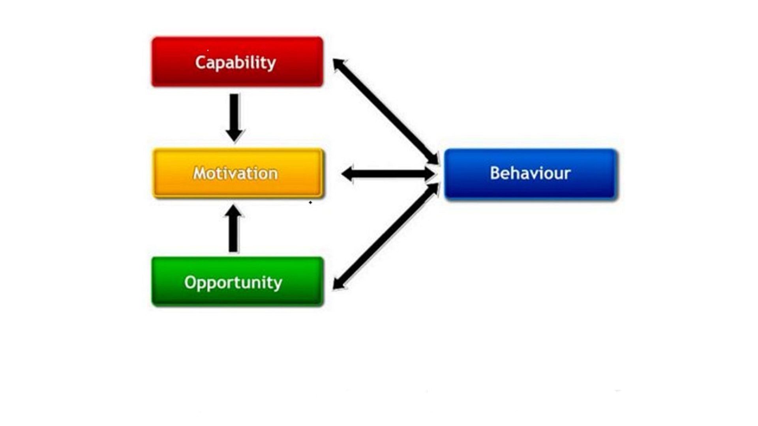
Supplementary Figure 1: COM-B Model
Supplementary Figure 1 shows the theoretical basis known as "COM-B."²
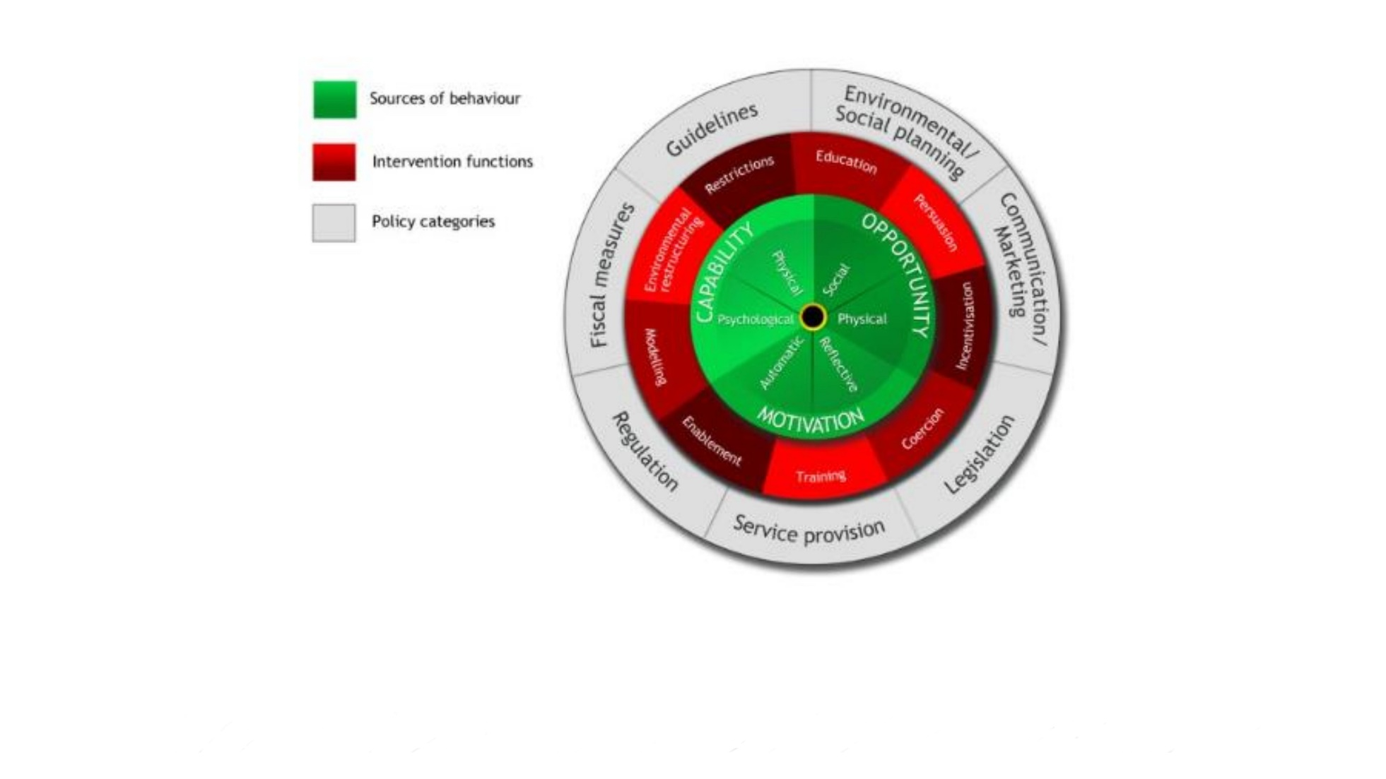

Supplementary Figure 2: Behaviour Change Wheel
Supplementary Figure 2 present the Behaviour Change Wheel.²⁵

