Supplementary Material 1
Exploring Migraine Experiences in Patients with Patent Foramen Ovale (PFO): A Qualitative Interview Guide
Version: 1.0 (March 2025)
Developed by: Meng Li
Institution: Nursing Department,The Third People’s Hospital of Henan Province, China
Interview Protocol based on the Symptom Management Theory
Section | Details
Purpose | To explore the lived experiences of migraine symptoms, management strategies, and outcomes in patients with PFO, guided by the Symptom Management Theory (SMT).
Ethical Considerations | Reiterate confidentiality and voluntary participation. Obtain verbal consent for audio recording.
Duration | 45–60 minutes
Setting | Private room in the cardiology ward.
Interview Protocol | -
A. Opening Script | "Thank you for participating. Today, we’ll discuss your experiences with migraines and PFO. There are no right or wrong answers—we’re interested in your personal perspective. You may skip any questions or stop at any time."
B. Core Questions | -
I. Symptom Perception | Pain Description: "Can you describe a typical migraine episode? Think about the pain location, intensity, and duration." Probe: "How would you rate your worst episode on this scale?" (Show 10-cm VAS: 0 = no pain, 10 = worst imaginable)  Triggers & Variability: "What factors seem to trigger or worsen your migraines?" Prompts: Weather, stress, sleep, diet, physical activity.
II. Symptom Management | Coping Methods: "What treatments or self-care practices have you tried? What worked or didn’t?" Probe: "How did PFO closure surgery affect your migraines?"  Healthcare Interactions: "What support have you received from doctors/nurses? What was helpful or lacking?"
III. Symptom Outcomes | Psychosocial Impact: "How do migraines affect your daily life, work, or relationships?" Probe: "Can you share an example of when migraines disrupted your plans?"  Unmet Needs: "What additional support do you wish healthcare providers offered?"
C. Closing | "Is there anything else about your PFO or migraine experience you’d like to share?" "Thank you for your time. Your insights are invaluable to improving care for patients like you."
Supplementary Tools | Visual Analog Scale (VAS): Printed 10-cm line with anchors (0–10). Administered before discussing pain experiences.  Field Notes Template: Non-verbal cues (e.g., gestures, pauses). Contextual observations (e.g., emotional tone).
Ethical Compliance | This study was reviewed and approved by the Ethics Committee of the Third People's Hospital of Henan Province (Ethics Number: 2025SZSYLCYJ0301). Aligns with COREQ (Qualitative Research Reporting Guidelines).

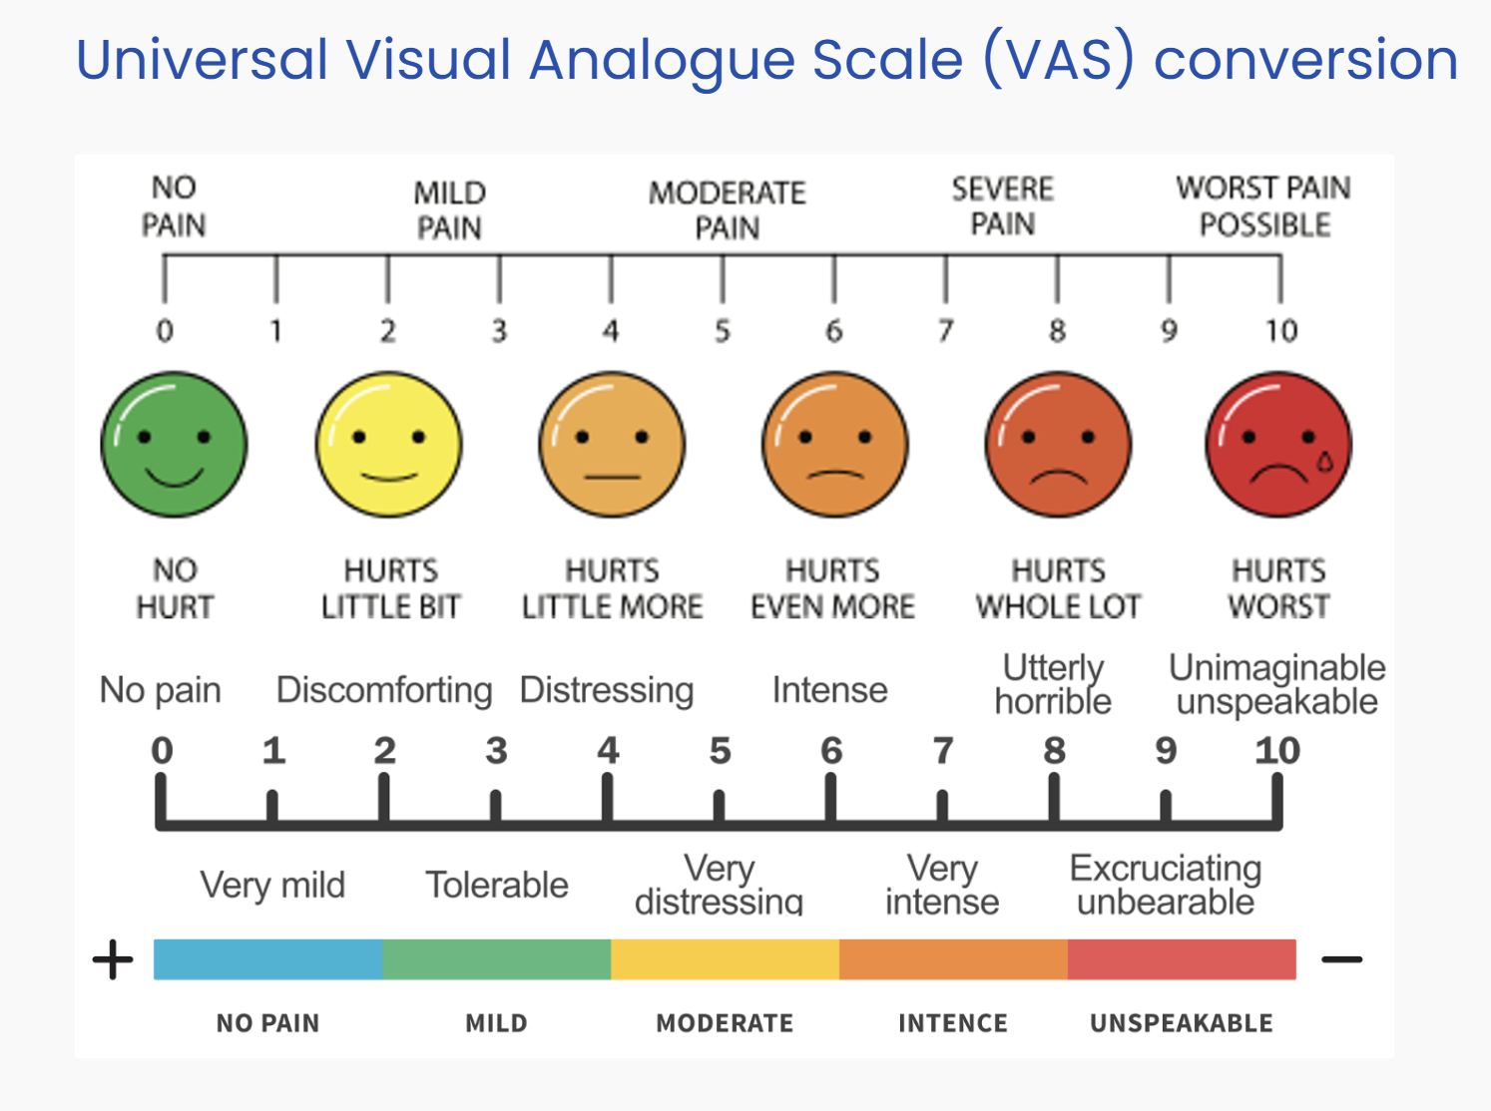
Figure 1.VAS scoring
Note：The visual analog scale (VAS) is a pain rating scale first used by Hayes and Patterson in 1921. Scores are based on self-reported measures of symptoms that are recorded with a single handwritten mark placed at one point along the length of a 10-cm line that represents a continuum between the two ends of the scale—“no pain” on the left end (0 cm) of the scale and the “worst pain” on the right end of the scale (10 cm). Measurements from the starting point (left end) of the scale to the patients' marks are recorded in centimeters and are interpreted as their pain. The values can be used to track pain progression for a patient or to compare pain between patients with similar conditions.

