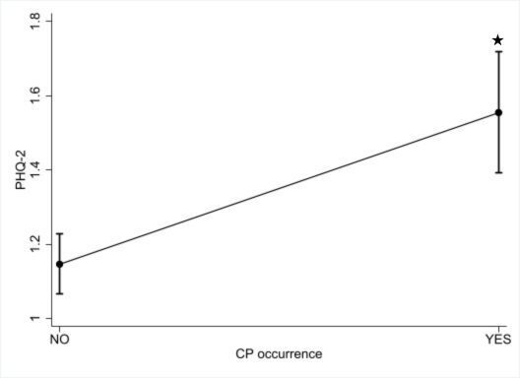
Supplementary Figure S1. Predictive margins of regression models of depression symptomatology on chronic pain occurrence.
Note:
CP, chronic pain; PHQ-2, 2-item patient health questionnaire
* Significant difference compared to base category (i.e., no chronic pain).

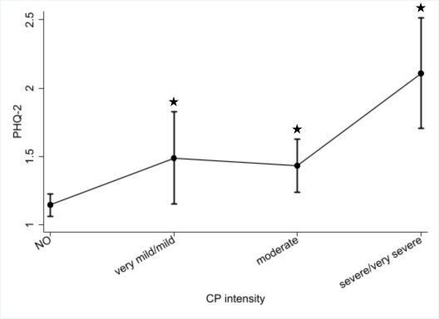

Supplementary Figure S2. Predictive margins of regression models of depression symptomatology on chronic pain intensity.
Note:
CP, chronic pain; PHQ-2, 2-item patient health questionnaire
* Significant difference compared to base category (i.e., no chronic pain).

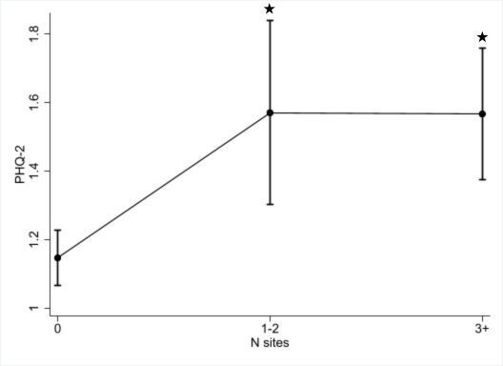

Supplementary Figure S3. Predictive margins of regression models of depression symptomatology on chronic pain body sites.
Note:
CP, chronic pain; PHQ-2, 2-item patient health questionnaire
* Significant difference compared to base category (i.e., no chronic pain).

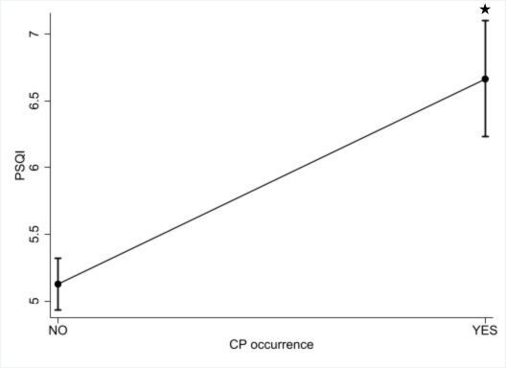

Supplementary Figure S4. Predictive margins of regression models of sleep quality on chronic pain occurrence.
Note:
CP, chronic pain; PSQI, Pittsburgh sleep quality index
* Significant difference compared to base category (i.e., no chronic pain).

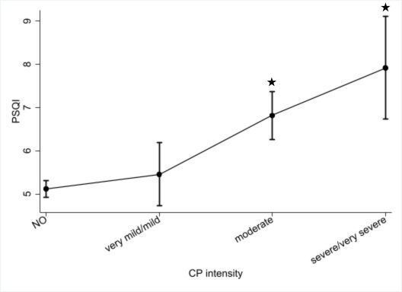

Supplementary Figure S5. Predictive margins of regression models of sleep quality on chronic pain intensity.
Note:
CP, chronic pain; PSQI, Pittsburgh sleep quality index
* Significant difference compared to base category (i.e., no chronic pain).

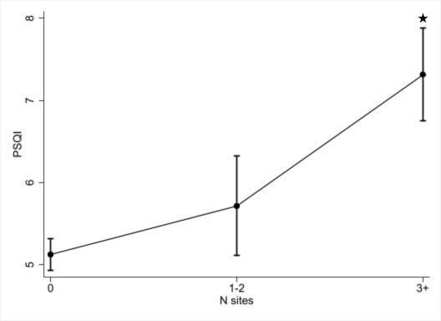

Supplementary Figure S6. Predictive margins of regression models of sleep quality on chronic pain body sites.
Note:
CP, chronic pain; PSQI, Pittsburgh sleep quality index
* Significant difference compared to base category (i.e., no chronic pain).

