Supplementary Information
Table S1. Depression items
Long label | Short label | Construct | Item dimensions
I was bothered by things that usually don’t bother me. | D1 | Depression | Depressed affect
I wasn’t able to feel happy, even when my family or friends tried to help me feel better. | D3 | Depression | Depressed affect
I felt down and unhappy. | D6 | Depression | Depressed affect
I felt like things I did before didn't work out right. | D9 | Depression | Depressed affect
I felt scared. | D10 | Depression | Depressed affect
I felt lonely, like I didn't have any friends. | D14 | Depression | Depressed affect
I had crying spells. | D17 | Depression | Depressed affect
I felt sad. | D18 | Depression | Depressed affect
I felt like I was just as good as other kids. | D4* | Depression | Positive affect
I felt like something good was going to happen. | D8* | Depression | Positive affect
I was happy. | D12* | Depression | Positive affect
I had a good time. | D16* | Depression | Positive affect
I did not feel like eating; I wasn’t very hungry. | D2 | Depression | Somatic
I felt like I couldn't pay attention to what I was doing. | D5 | Depression | Somatic
I felt like I was too tired to do things. | D7 | Depression | Somatic
I didn't sleep as well as I usually sleep. | D11 | Depression | Somatic
I was more quiet than usual. | D13 | Depression | Somatic
It was hard to get started doing things. | D20 | Depression | Somatic
I felt like kids I knew were not friendly or that they didn't want to be with me. | D15 | Depression | Interpersonal
I felt people didn't like me. | D19 | Depression | Interpersonal
Note. Depression items belong to CES−DC. *The scoring of the Positive affect content of depression items was reversed.

Table S2. Demographic information and descriptive statistics for DSHI−9 and CES−DC items in Total Sample, Girls, and Boys
 | Total (N = 1122) |  | Girls (n = 584) |  | Boys (n = 538) |  | t−tests |  | 95% CI
 | M | SD | M | SD | M | SD | t | Cohen’s d | LL | UL
Demographics
age | 13.51 | 1.10 | 13.45 | 1.13 | 13.58 | 1.05
T1SES | 4.20 | 1.55 | 4.23 | 1.51 | 4.20 | 1.61
T2SES | 4.51 | 1.36 | 4.59 | 1.37 | 4.46 | 1.40
W1 NSSI
W1T1 | 1.16 | 0.53 | 1.14 | 0.47 | 1.18 | 0.59 | 1.14 | −0.07 | −0.03 | 0.10
W1T2 | 1.19 | 0.63 | 1.18 | 0.60 | 1.21 | 0.67 | 0.70 | −0.04 | −0.05 | 0.10
W1T3 | 1.19 | 0.61 | 1.21 | 0.61 | 1.16 | 0.61 | −1.15 | 0.07 | −0.11 | 0.03
W1T4 | 1.22 | 0.61 | 1.23 | 0.63 | 1.20 | 0.59 | −0.69 | 0.04 | −0.10 | 0.05
W1T5 | 1.07 | 0.40 | 1.07 | 0.39 | 1.08 | 0.42 | 0.33 | −0.02 | −0.04 | 0.05
W1T6 | 1.10 | 0.43 | 1.09 | 0.38 | 1.11 | 0.49 | 0.80 | −0.05 | −0.03 | 0.07
W1T7 | 1.13 | 0.49 | 1.12 | 0.45 | 1.14 | 0.53 | 0.66 | −0.04 | −0.04 | 0.08
W1T8 | 1.04 | 0.30 | 1.02 | 0.15 | 1.07 | 0.40 | 3.11** | −0.19 | 0.02 | 0.09
W1T9 | 1.13 | 0.52 | 1.14 | 0.53 | 1.12 | 0.52 | −0.86 | 0.05 | −0.09 | 0.03
W1 Depression
W1D1 | 1.85 | 0.77 | 1.91 | 0.76 | 1.79 | 0.77 | −2.67** | 0.16 | −0.21 | −0.03
W1D2 | 1.98 | 0.92 | 2.06 | 0.94 | 1.88 | 0.89 | −3.30** | 0.20 | −0.29 | −0.07
W1D3 | 1.73 | 0.90 | 1.76 | 0.91 | 1.69 | 0.89 | −1.41 | 0.08 | −0.18 | 0.03
W1D4 | 2.65 | 1.10 | 2.68 | 1.09 | 2.61 | 1.10 | −1.10 | 0.07 | −0.20 | 0.06
W1D5 | 1.96 | 0.91 | 2.01 | 0.93 | 1.90 | 0.88 | −2.17* | 0.13 | −0.22 | −0.01
W1D6 | 2.02 | 0.95 | 2.18 | 0.99 | 1.86 | 0.89 | −5.74*** | 0.34 | −0.43 | −0.21
W1D7 | 1.72 | 0.87 | 1.74 | 0.90 | 1.70 | 0.84 | −0.88 | 0.05 | −0.15 | 0.06
W1D8 | 2.95 | 0.98 | 2.97 | 1.00 | 2.93 | 0.97 | −0.61 | 0.04 | −0.15 | 0.08
W1D9 | 1.75 | 0.89 | 1.78 | 0.92 | 1.72 | 0.86 | −1.05 | 0.06 | −0.16 | 0.05
W1D10 | 1.68 | 0.93 | 1.70 | 0.93 | 1.65 | 0.93 | −0.86 | 0.05 | −0.16 | 0.06
W1D11 | 2.06 | 1.05 | 2.14 | 1.05 | 1.98 | 1.05 | −2.68** | 0.16 | −0.29 | −0.04
W1D12 | 2.28 | 1.06 | 2.34 | 1.06 | 2.21 | 1.06 | −2.07* | 0.12 | −0.25 | −0.01
W1D13 | 2.38 | 1.04 | 2.29 | 1.02 | 2.47 | 1.05 | 2.87** | −0.17 | 0.06 | 0.30
W1D14 | 1.65 | 0.95 | 1.68 | 0.99 | 1.62 | 0.91 | −1.04 | 0.06 | −0.17 | 0.05
W1D15 | 1.53 | 0.84 | 1.52 | 0.84 | 1.54 | 0.84 | 0.47 | −0.03 | −0.07 | 0.12
W1D16 | 2.35 | 1.03 | 2.31 | 1.03 | 2.40 | 1.03 | 1.42 | −0.09 | −0.03 | 0.21
W1D17 | 1.80 | 0.98 | 1.98 | 1.05 | 1.62 | 0.88 | −6.25*** | 0.37 | −0.47 | −0.25
W1D18 | 1.83 | 0.98 | 1.92 | 1.02 | 1.72 | 0.92 | −3.50*** | 0.21 | −0.32 | −0.09
W1D19 | 1.70 | 0.93 | 1.82 | 0.97 | 1.57 | 0.87 | −4.52*** | 0.27 | −0.36 | −0.14
W1D20 | 2.04 | 0.93 | 2.04 | 0.91 | 2.04 | 0.96 | −0.17 | 0.01 | −0.12 | 0.10
W2 NSSI
W2T1 | 1.17 | 0.59 | 1.16 | 0.59 | 1.18 | 0.60 | 0.34 | −0.03 | −0.06 | 0.08
W2T2 | 1.26 | 0.76 | 1.24 | 0.73 | 1.28 | 0.80 | 0.82 | −0.05 | −0.05 | 0.13
W2T3 | 1.27 | 0.75 | 1.31 | 0.80 | 1.23 | 0.68 | −1.67 | 0.11 | −0.16 | 0.01
W2T4 | 1.37 | 0.85 | 1.45 | 0.97 | 1.28 | 0.70 | −3.34** | 0.20 | −0.27 | −0.07
W2T5 | 1.12 | 0.51 | 1.13 | 0.56 | 1.11 | 0.46 | −0.79 | 0.04 | −0.08 | 0.04
W2T6 | 1.14 | 0.56 | 1.16 | 0.58 | 1.12 | 0.55 | −1.03 | 0.07 | −0.10 | 0.03
W2T7 | 1.22 | 0.65 | 1.23 | 0.67 | 1.21 | 0.63 | −0.59 | 0.03 | −0.10 | 0.05
W2T8 | 1.06 | 0.37 | 1.02 | 0.21 | 1.10 | 0.49 | 3.65*** | −0.22 | 0.04 | 0.13
W2T9 | 1.14 | 0.59 | 1.15 | 0.58 | 1.14 | 0.61 | −0.07 | 0.01 | −0.07 | 0.07
W2 Depression
W2D1 | 1.99 | 0.84 | 2.05 | 0.84 | 1.92 | 0.83 | −2.52* | 0.15 | −0.22 | −0.03
W2D2 | 2.06 | 0.97 | 2.19 | 1.01 | 1.92 | 0.89 | −4.78*** | 0.29 | −0.38 | −0.16
W2D3 | 1.77 | 0.92 | 1.85 | 0.96 | 1.68 | 0.86 | −3.18** | 0.19 | −0.28 | −0.07
W2D4 | 2.58 | 1.00 | 2.69 | 0.99 | 2.46 | 1.01 | −3.75*** | 0.22 | −0.34 | −0.11
W2D5 | 2.09 | 0.95 | 2.12 | 0.96 | 2.06 | 0.93 | −1.16 | 0.07 | −0.18 | 0.05
W2D6 | 2.00 | 0.96 | 2.08 | 1.00 | 1.91 | 0.91 | −2.89** | 0.17 | −0.28 | −0.05
W2D7 | 1.81 | 0.93 | 1.85 | 0.96 | 1.77 | 0.89 | −1.41 | 0.08 | −0.19 | 0.03
W2D8 | 2.92 | 0.97 | 3.02 | 0.98 | 2.82 | 0.95 | −3.47** | 0.21 | −0.31 | −0.09
W2D9 | 1.79 | 0.89 | 1.81 | 0.92 | 1.77 | 0.86 | −0.79 | 0.05 | −0.15 | 0.06
W2D10 | 1.68 | 0.93 | 1.76 | 0.99 | 1.59 | 0.84 | −3.09** | 0.18 | −0.28 | −0.06
W2D11 | 2.08 | 1.06 | 2.21 | 1.11 | 1.94 | 0.98 | −4.25*** | 0.25 | −0.39 | −0.14
W2D12 | 2.33 | 1.04 | 2.40 | 1.06 | 2.24 | 1.01 | −2.65** | 0.16 | −0.29 | −0.04
W2D13 | 2.41 | 1.06 | 2.38 | 1.09 | 2.45 | 1.02 | 1.19 | −0.07 | −0.05 | 0.20
W2D14 | 1.68 | 0.97 | 1.74 | 1.01 | 1.61 | 0.91 | −2.36* | 0.14 | −0.25 | −0.02
W2D15 | 1.52 | 0.82 | 1.54 | 0.86 | 1.50 | 0.78 | −0.81 | 0.05 | −0.14 | 0.06
W2D16 | 2.58 | 0.99 | 2.65 | 1.00 | 2.49 | 0.96 | −2.75** | 0.16 | −0.28 | −0.05
W2D17 | 1.82 | 1.01 | 2.00 | 1.08 | 1.62 | 0.89 | −6.59*** | 0.39 | −0.50 | −0.27
W2D18 | 1.82 | 1.00 | 1.95 | 1.06 | 1.69 | 0.92 | −4.42*** | 0.26 | −0.38 | −0.15
W2D19 | 1.63 | 0.89 | 1.69 | 0.94 | 1.57 | 0.83 | −2.36* | 0.14 | −0.23 | −0.02
W2D20 | 2.11 | 0.96 | 2.13 | 0.99 | 2.08 | 0.92 | −0.78 | 0.05 | −0.16 | 0.07
Note. Depression items belong to CES−DC; NSSI items belong to DSHI−9. SES = Subjective socioeconomic status. M = mean; SD = standard deviation. CI = confidence interval; LL = lower limit; UL = upper limit. The 95% CIs for parameter estimates in boldface do not contain zero. ∗p < 0.05; ∗∗p < 0.01; ∗∗∗p < 0.001.

Table S3. Weighted adjacency matrix of the total sample.
 | T1 | T2 | T3 | T4 | T5 | T6 | T7 | T8 | T9 | D1 | D2 | D3 | D4 | D5 | D6 | D7 | D8 | D9 | D10 | D11 | D12 | D13 | D14 | D15 | D16 | D17 | D18 | D19 | D20
T1 | 0 | 0.19 | 0.11 | 0.01 | 0 | 0.08 | 0 | 0.09 | 0.15 | 0 | 0.05 | 0.02 | 0 | 0 | 0.02 | 0.01 | 0 | 0.01 | 0 | 0 | 0 | 0 | 0.03 | 0.04 | 0.02 | 0.01 | 0 | 0 | 0
T2 | 0.20 | 0 | 0.10 | 0.06 | 0.10 | 0.13 | 0.06 | 0 | 0.07 | 0 | 0 | 0 | 0 | 0 | 0 | 0.01 | 0 | 0.02 | 0.01 | 0.03 | 0 | 0 | 0 | 0.05 | 0 | 0 | 0 | 0.04 | 0
T3 | 0.11 | 0.14 | 0 | 0.19 | 0.26 | 0.21 | 0.19 | 0 | 0 | 0 | 0 | 0.04 | 0 | 0 | 0.01 | 0.01 | 0 | 0 | 0.01 | 0 | 0.01 | 0 | 0 | 0 | 0 | 0.02 | 0.02 | 0 | 0
T4 | 0.02 | 0.02 | 0.07 | 0 | 0 | 0.01 | 0.03 | 0 | 0.02 | 0 | 0 | 0 | 0 | 0 | 0 | 0.03 | 0 | 0 | 0 | 0 | 0.03 | 0 | 0 | 0 | 0.01 | 0.01 | 0 | 0 | 0
T5 | 0.04 | 0.06 | 0.32 | 0.08 | 0 | 0.13 | 0.04 | 0.21 | 0.01 | 0 | 0 | 0 | 0 | 0 | 0 | 0 | 0 | 0.01 | 0 | 0 | 0 | 0 | 0 | 0 | 0 | 0 | 0 | 0 | 0
T6 | 0.19 | 0.12 | 0.07 | 0.02 | 0.11 | 0 | 0.12 | 0.05 | 0.21 | 0 | 0 | 0 | 0 | 0 | 0 | 0 | 0 | 0 | 0.02 | 0 | 0 | 0 | 0 | 0 | 0 | 0 | 0 | 0 | 0
T7 | 0 | 0.08 | 0.26 | 0.20 | 0.05 | 0.17 | 0 | 0.18 | 0.10 | 0 | 0 | 0 | 0 | 0 | 0 | 0.03 | 0 | 0 | 0 | 0 | 0 | −0.01 | 0 | 0 | 0 | 0.04 | 0 | 0 | 0
T8 | 0 | 0.08 | 0 | 0.07 | 0.09 | 0.04 | 0.03 | 0 | 0.15 | 0 | 0 | 0 | 0 | 0 | 0 | 0 | 0 | 0 | 0 | 0 | 0 | 0 | 0 | 0 | 0 | 0 | 0 | 0 | 0
T9 | 0 | 0.03 | 0.01 | 0 | 0.02 | 0.25 | 0.17 | 0.25 | 0 | 0 | 0 | 0 | 0 | 0 | 0.01 | 0 | 0 | 0 | 0 | 0 | 0 | 0 | 0.05 | 0 | 0.01 | 0 | 0 | 0 | 0
D1 | 0.02 | 0 | 0 | 0 | 0 | 0 | 0 | 0 | 0 | 0 | 0.05 | 0.04 | 0 | 0.08 | 0.06 | 0.10 | 0 | 0.01 | 0.03 | 0.07 | 0 | 0 | 0.01 | 0.01 | 0 | 0.01 | 0.05 | 0.02 | 0.03
D2 | 0 | 0 | 0 | 0 | 0.03 | 0 | 0.02 | 0 | 0 | 0.08 | 0 | 0.11 | 0 | 0.03 | 0.09 | 0.04 | 0 | 0.09 | 0 | 0.02 | 0 | 0 | 0 | 0 | 0 | 0.03 | 0 | 0 | 0
D3 | 0.06 | 0 | 0.01 | 0 | 0 | 0 | 0 | 0 | 0.01 | 0.06 | 0.18 | 0 | 0.02 | 0.02 | 0.10 | 0.06 | −0.01 | 0.07 | 0.02 | 0.09 | 0.04 | 0 | 0.08 | 0.02 | 0.03 | 0 | 0.06 | 0.04 | 0.09
D4 | 0 | 0 | 0.02 | 0.02 | 0 | 0 | 0 | 0 | 0 | 0 | 0 | 0 | 0 | 0 | 0 | 0 | 0.10 | 0 | 0 | 0 | 0.17 | −0.02 | 0 | 0 | 0.23 | 0 | 0.01 | 0.04 | 0
D5 | 0 | 0 | 0 | 0 | 0 | 0 | 0 | 0 | 0 | 0.14 | 0 | 0.04 | 0 | 0 | 0.17 | 0.12 | 0 | 0.09 | 0.02 | 0.08 | 0 | 0 | 0 | 0 | 0 | 0 | 0.02 | 0 | 0.08
D6 | 0 | 0 | 0.01 | 0 | 0 | 0 | 0 | 0 | 0 | 0.01 | 0.06 | 0.10 | 0.02 | 0.19 | 0 | 0.15 | 0 | 0 | 0.07 | 0.03 | 0.09 | 0 | 0.11 | 0 | 0 | 0.10 | 0.08 | 0.04 | 0.01
D7 | 0.03 | 0.01 | 0.02 | 0 | 0 | 0 | 0 | 0 | 0 | 0.02 | 0.04 | 0.13 | 0.02 | 0.10 | 0.15 | 0 | −0.04 | 0.15 | 0.07 | 0.09 | 0 | 0 | 0 | 0.04 | 0.01 | 0.02 | 0 | 0.01 | 0.01
D8 | 0 | 0 | 0 | 0 | 0 | 0 | 0 | −0.01 | 0 | 0 | −0.05 | 0 | 0.14 | 0 | 0 | 0 | 0 | 0 | −0.03 | 0 | 0.11 | −0.06 | 0 | 0 | 0.05 | 0 | 0 | 0 | −0.06
D9 | 0 | 0.01 | 0 | 0 | 0 | 0.02 | 0 | 0 | 0 | 0.05 | 0.03 | 0.04 | 0 | 0.10 | 0.01 | 0.17 | −0.05 | 0 | 0.13 | 0.06 | 0 | 0 | 0.06 | 0.03 | 0 | 0.02 | 0 | 0.03 | 0.01
D10 | 0.03 | 0.08 | 0.01 | 0 | 0 | 0.04 | 0.01 | 0 | 0.03 | 0 | 0 | 0 | 0.01 | 0 | 0.12 | 0.08 | 0 | 0.08 | 0 | 0.14 | 0 | 0 | 0.06 | 0.06 | 0.01 | 0.07 | 0.08 | 0 | 0.07
D11 | 0 | 0 | 0 | 0.08 | 0 | 0 | 0 | 0 | 0 | 0.07 | 0.09 | 0.01 | 0 | 0.09 | 0.04 | 0.11 | 0 | 0.08 | 0.10 | 0 | 0 | 0.02 | 0 | 0.03 | 0.04 | 0.06 | 0.01 | 0.03 | 0
D12 | 0 | 0 | 0 | 0 | 0 | 0 | 0 | 0 | 0 | 0 | 0 | 0.06 | 0.17 | 0 | 0.08 | 0 | 0.14 | 0 | 0.01 | 0 | 0 | −0.15 | 0 | 0 | 0.32 | 0.03 | 0.03 | 0 | 0
D13 | 0 | 0 | 0 | 0 | 0 | 0 | 0 | 0 | 0 | 0 | 0.03 | 0 | −0.01 | 0 | 0 | 0 | 0 | 0 | 0 | 0.01 | −0.14 | 0 | 0.03 | 0.02 | −0.03 | 0 | 0.06 | 0 | 0
D14 | 0 | 0 | 0 | 0 | 0 | 0 | 0 | 0.01 | 0.02 | 0.01 | 0 | 0.03 | 0 | 0 | 0.10 | 0 | 0 | 0.01 | 0.11 | 0.06 | 0.09 | 0.17 | 0 | 0.21 | 0.02 | 0.06 | 0.08 | 0.14 | 0
D15 | 0 | 0 | 0 | 0.03 | 0 | 0 | 0 | 0 | 0 | 0 | 0 | 0.04 | 0 | 0 | 0 | 0.08 | −0.01 | 0.04 | 0.08 | 0 | 0.03 | 0.02 | 0.20 | 0 | 0.03 | 0 | 0.04 | 0.20 | 0.09
D16 | 0 | 0 | 0 | 0 | 0 | 0 | 0 | 0 | 0 | 0 | 0 | 0 | 0.24 | 0 | 0.02 | 0 | 0.15 | 0 | 0 | 0 | 0.31 | 0 | 0.04 | 0 | 0 | 0 | 0.03 | 0.02 | 0
D17 | 0 | 0 | 0.03 | 0 | 0 | 0 | 0 | 0 | 0 | 0 | 0.06 | 0.05 | 0 | 0 | 0.07 | 0.04 | 0 | 0 | 0.09 | 0.07 | 0.01 | 0 | 0 | 0.01 | 0.03 | 0 | 0.48 | 0.10 | 0.02
D18 | 0 | 0 | 0 | 0.03 | 0 | 0.01 | 0 | 0 | 0 | 0.06 | 0.04 | 0.03 | 0 | 0 | 0.13 | 0.04 | 0 | 0 | 0.06 | 0 | 0 | 0.01 | 0.10 | 0 | 0 | 0.52 | 0 | 0.18 | 0
D19 | 0 | 0 | 0 | 0 | 0 | 0 | 0 | 0 | 0.04 | 0.02 | 0 | 0.05 | 0.03 | 0 | 0 | 0 | 0 | 0.07 | 0.05 | 0 | 0.02 | 0 | 0.18 | 0.24 | 0.03 | 0.06 | 0.15 | 0 | 0.14
D20 | 0 | 0 | 0 | 0 | 0 | 0 | 0 | 0 | 0 | 0.04 | 0.01 | 0 | 0 | 0.06 | 0 | 0.06 | −0.03 | 0.06 | 0.04 | 0.02 | 0 | 0 | 0 | 0.01 | 0 | 0.03 | 0.04 | 0.11 | 0
Note. The weighted adjacency matrix at W1 are presented above the diagonal and at W2 below the diagonal.
Table S4. Weighted adjacency matrix of the girl sample.
 | T1 | T2 | T3 | T4 | T5 | T6 | T7 | T8 | T9 | D1 | D2 | D3 | D4 | D5 | D6 | D7 | D8 | D9 | D10 | D11 | D12 | D13 | D14 | D15 | D16 | D17 | D18 | D19 | D20
T1 | 0 | 0.25 | 0.10 | 0.03 | 0.01 | 0.09 | 0 | 0.04 | 0.21 | 0 | 0.03 | 0.05 | 0 | 0 | 0.03 | 0 | −0.01 | 0 | 0 | 0 | 0 | 0 | 0.01 | 0.03 | 0 | 0.03 | 0 | 0 | 0
T2 | 0.23 | 0 | 0.08 | 0.02 | 0.02 | 0.16 | 0.10 | 0 | 0.01 | 0 | 0 | 0 | 0 | 0 | 0 | 0.04 | 0 | 0.02 | 0 | 0 | 0 | −0.02 | 0 | 0.02 | 0 | 0 | 0 | 0.01 | 0
T3 | 0.10 | 0.13 | 0 | 0.21 | 0.28 | 0.25 | 0.18 | 0 | 0 | 0 | 0 | 0.01 | 0 | 0 | 0 | 0 | 0 | 0 | 0 | 0 | 0 | 0 | 0 | 0 | 0 | 0.01 | 0.06 | 0 | 0
T4 | 0.04 | 0.07 | 0.05 | 0 | 0 | 0 | 0.02 | 0 | 0 | 0 | 0 | 0 | 0 | 0 | 0 | 0.06 | 0 | 0.01 | 0 | 0 | 0 | 0 | 0 | 0 | 0 | 0.01 | 0 | 0 | 0
T5 | 0.01 | 0.04 | 0.28 | 0.05 | 0 | 0.06 | 0 | 0.05 | 0 | 0 | 0 | 0 | 0 | 0 | 0 | 0 | 0 | 0 | 0 | 0 | 0.03 | 0 | 0 | 0 | 0 | 0 | 0 | 0 | 0
T6 | 0.20 | 0.11 | 0.07 | 0 | 0.14 | 0 | 0.04 | 0 | 0.22 | 0 | 0 | 0 | 0 | 0 | 0 | 0 | 0 | 0 | 0.01 | 0 | 0 | 0 | 0 | 0 | 0 | 0 | 0 | 0 | 0
T7 | 0 | 0.01 | 0.28 | 0.18 | 0.11 | 0.27 | 0 | 0.04 | 0.02 | 0 | 0 | 0 | 0 | 0 | 0 | 0 | 0 | 0 | 0 | 0.04 | 0 | 0 | 0 | 0 | 0 | 0.06 | 0 | 0 | 0
T8 | 0 | 0.06 | 0.01 | 0.05 | 0 | 0.08 | 0.01 | 0 | 0 | 0 | 0 | 0 | 0 | 0 | 0 | 0 | 0 | 0 | 0 | 0 | 0 | 0 | 0 | 0 | 0 | 0 | 0 | 0 | 0
T9 | 0 | 0.04 | 0 | 0 | 0 | 0.34 | 0.08 | 0.10 | 0 | 0 | 0 | 0 | 0 | 0 | 0.03 | 0 | −0.01 | 0 | 0 | 0 | 0 | 0 | 0 | 0.01 | 0.02 | 0 | 0 | 0.03 | 0
D1 | 0.03 | 0 | 0 | 0 | 0 | 0 | 0 | −0.01 | 0 | 0 | 0 | 0.01 | 0 | 0.11 | 0.07 | 0.07 | 0 | 0 | 0 | 0.09 | 0 | 0 | 0 | 0 | 0 | 0.03 | 0.04 | 0.06 | 0.02
D2 | 0 | 0 | 0 | 0 | 0.02 | 0 | 0.02 | 0 | 0 | 0.05 | 0 | 0.09 | 0 | 0 | 0.08 | 0.03 | −0.01 | 0.11 | 0 | 0.01 | 0 | 0 | 0.01 | 0 | 0 | 0.01 | 0 | 0 | 0
D3 | 0.07 | 0.03 | 0 | 0 | 0 | 0 | 0 | 0.01 | 0 | 0.08 | 0.20 | 0 | 0.05 | 0.02 | 0.10 | 0.06 | 0 | 0.08 | 0 | 0.06 | 0.03 | 0 | 0.09 | 0.01 | 0.04 | 0 | 0.09 | 0.04 | 0.04
D4 | 0 | 0.01 | 0.03 | 0.01 | 0 | 0.02 | 0.01 | 0 | 0 | 0 | 0 | 0 | 0 | 0 | 0 | 0 | 0.04 | 0 | 0 | 0 | 0.23 | 0 | 0 | 0 | 0.25 | 0 | 0.03 | 0 | 0
D5 | 0 | 0 | 0 | 0 | 0 | −0.01 | 0 | 0 | 0 | 0.16 | 0 | 0.07 | 0 | 0 | 0.18 | 0.09 | 0 | 0.08 | 0.05 | 0.06 | 0 | 0 | 0 | 0.03 | 0 | 0.02 | 0 | 0 | 0.07
D6 | 0 | 0 | 0 | 0 | 0 | 0 | 0 | 0 | 0 | 0.03 | 0.04 | 0.10 | 0 | 0.18 | 0 | 0.15 | 0 | 0 | 0.06 | 0.01 | 0.08 | 0 | 0.12 | 0 | 0 | 0.09 | 0.11 | 0.03 | 0
D7 | 0.01 | 0.03 | 0.05 | 0 | 0 | 0 | 0 | 0 | 0.02 | 0 | 0.02 | 0.13 | 0.06 | 0.11 | 0.16 | 0 | −0.06 | 0.15 | 0.09 | 0.10 | 0 | 0 | 0 | 0 | 0 | 0.01 | 0.05 | 0.02 | 0
D8 | 0 | 0 | −0.02 | 0 | 0 | 0 | 0 | −0.02 | 0 | 0 | −0.05 | −0.01 | 0.17 | −0.02 | 0 | 0 | 0 | −0.02 | 0 | 0 | 0.10 | −0.05 | 0 | 0 | 0.06 | 0 | 0 | 0 | −0.03
D9 | 0 | 0.02 | 0.01 | 0 | 0 | 0.01 | 0 | 0.02 | 0.02 | 0 | 0.04 | 0.06 | 0 | 0.07 | 0 | 0.13 | −0.10 | 0 | 0.17 | 0.05 | 0 | 0 | 0.06 | 0 | 0 | 0 | 0 | 0.01 | 0.06
D10 | 0.02 | 0.09 | 0 | 0 | 0 | 0.04 | 0.03 | 0 | 0.02 | 0.03 | 0 | 0 | 0 | 0 | 0.11 | 0.11 | 0 | 0.12 | 0 | 0.16 | 0 | 0 | 0.05 | 0.01 | 0 | 0.08 | 0.08 | 0.04 | 0.05
D11 | 0 | 0 | 0 | 0.07 | 0 | 0 | 0 | 0 | 0 | 0.09 | 0.10 | 0 | 0 | 0.07 | 0.07 | 0.17 | 0 | 0.07 | 0.14 | 0 | 0 | 0 | 0 | 0.05 | 0.01 | 0.03 | 0 | 0.04 | 0.03
D12 | 0 | 0 | 0 | 0 | 0 | 0 | 0 | 0 | 0 | 0 | 0 | 0.06 | 0.14 | 0 | 0.05 | 0.02 | 0.18 | 0 | 0 | 0 | 0 | −0.12 | 0 | 0 | 0.27 | 0.06 | 0.02 | 0 | 0
D13 | 0 | 0 | 0 | 0 | 0 | 0 | 0 | 0 | 0 | 0 | 0.07 | 0.02 | 0 | 0 | 0 | 0 | 0 | 0 | 0 | 0 | −0.12 | 0 | 0.01 | 0 | 0 | 0 | 0.06 | 0 | 0
D14 | 0 | 0 | 0 | 0 | 0 | 0 | 0 | 0.01 | 0 | 0 | 0 | 0.01 | 0 | 0 | 0.07 | 0.03 | 0 | 0 | 0.07 | 0.06 | 0.12 | 0.22 | 0 | 0.16 | 0.01 | 0.10 | 0.03 | 0.15 | 0
D15 | 0.01 | 0 | 0 | 0.03 | 0 | 0 | 0 | 0 | 0.02 | 0 | 0 | 0.01 | 0 | 0 | 0 | 0.05 | 0 | 0.03 | 0.08 | 0 | 0.02 | 0.05 | 0.25 | 0 | 0.04 | 0 | 0.05 | 0.25 | 0.03
D16 | 0 | 0 | 0 | 0 | 0 | 0 | 0 | 0 | 0 | 0 | 0 | 0 | 0.22 | 0 | 0.08 | 0 | 0.13 | 0 | 0 | 0 | 0.35 | 0 | 0.06 | 0 | 0 | 0.02 | 0.03 | 0.05 | 0
D17 | 0.01 | 0.01 | 0.03 | 0.02 | 0 | 0 | 0 | 0 | 0 | 0 | 0.04 | 0.06 | 0 | 0 | 0.04 | 0.06 | 0 | 0 | 0.08 | 0.05 | 0 | 0 | 0.01 | 0 | 0 | 0 | 0.49 | 0.12 | 0
D18 | 0 | 0 | 0 | 0.01 | 0.01 | 0 | 0 | 0 | 0 | 0.01 | 0.04 | 0.05 | 0.01 | 0 | 0.15 | 0 | 0 | 0.02 | 0.05 | 0 | 0 | 0 | 0.09 | 0 | 0.01 | 0.54 | 0 | 0.15 | 0
D19 | 0 | 0 | 0 | 0 | 0 | 0 | 0 | 0 | 0.02 | 0.05 | 0 | 0 | 0.01 | 0 | 0.03 | 0 | 0 | 0.08 | 0.04 | 0 | 0.03 | 0 | 0.19 | 0.24 | 0.02 | 0.08 | 0.15 | 0 | 0.15
D20 | 0 | 0.02 | 0 | 0 | 0 | 0 | 0 | 0 | 0 | 0.05 | 0 | 0 | 0 | 0.10 | 0 | 0.11 | −0.03 | 0.01 | 0.03 | 0.03 | 0 | 0 | 0 | 0.03 | −0.01 | 0.03 | 0 | 0.15 | 0
Note. The weighted adjacency matrix at W1 are presented above the diagonal and at W2 below the diagonal.
Table S5. Weighted adjacency matrix of the boy sample.
 | T1 | T2 | T3 | T4 | T5 | T6 | T7 | T8 | T9 | D1 | D2 | D3 | D4 | D5 | D6 | D7 | D8 | D9 | D10 | D11 | D12 | D13 | D14 | D15 | D16 | D17 | D18
T1 | 0 | 0.11 | 0.10 | 0 | 0 | 0.04 | 0.06 | 0.10 | 0.04 | 0 | 0.05 | 0 | 0 | 0 | 0.01 | 0.01 | 0 | 0.03 | 0 | 0 | 0 | 0 | 0.04 | 0.01 | 0.04 | 0.01 | 0
T2 | 0.15 | 0 | 0.14 | 0.06 | 0.17 | 0.07 | 0 | 0 | 0.08 | 0 | 0 | 0 | 0 | 0 | 0.02 | 0 | 0 | 0 | 0.04 | 0.04 | 0 | 0 | 0.01 | 0.03 | 0 | 0.01 | 0
T3 | 0.11 | 0.15 | 0 | 0.13 | 0.21 | 0.14 | 0.20 | 0.10 | 0 | 0 | 0 | 0.05 | 0 | 0 | 0.01 | 0.01 | 0 | 0 | 0.01 | 0 | 0.04 | 0 | 0 | 0 | 0 | 0.03 | 0
T4 | 0 | 0 | 0.08 | 0 | 0 | 0.06 | 0 | 0 | 0.09 | 0 | 0 | 0 | 0 | 0 | 0.03 | 0 | 0 | 0 | 0 | 0 | 0.03 | 0 | 0 | 0 | 0.01 | 0 | 0
T5 | 0.07 | 0.09 | 0.32 | 0.08 | 0 | 0.18 | 0.07 | 0.19 | 0.11 | 0 | 0 | 0 | 0 | 0 | 0 | 0 | 0 | 0 | 0 | 0 | 0 | 0 | 0 | 0 | 0 | 0 | 0
T6 | 0.17 | 0.16 | 0.05 | 0.05 | 0.03 | 0 | 0.20 | 0.09 | 0.09 | 0.01 | 0 | 0 | 0 | 0 | 0 | 0 | 0 | 0 | 0 | 0 | 0 | 0 | 0 | 0.01 | 0 | 0 | 0
T7 | 0 | 0.14 | 0.21 | 0.18 | 0 | 0.06 | 0 | 0.13 | 0.17 | 0 | 0 | 0 | 0 | 0 | 0 | 0.03 | 0 | 0 | 0 | 0 | 0 | 0 | 0 | 0.03 | 0 | 0 | 0
T8 | 0 | 0.05 | 0 | 0.07 | 0.11 | 0.12 | 0.05 | 0 | 0.29 | 0 | 0 | 0 | 0 | 0 | 0 | 0 | 0 | 0 | 0 | 0 | 0 | 0 | 0.03 | 0 | 0 | 0 | 0
T9 | 0 | 0 | 0.02 | 0.11 | 0.15 | 0.12 | 0.20 | 0.30 | 0 | 0.02 | 0 | 0 | 0 | 0 | 0 | 0 | 0 | 0 | 0 | 0 | 0 | 0 | 0.05 | 0 | 0 | 0 | 0
D1 | 0 | 0 | 0 | 0 | 0 | 0 | 0 | 0 | 0 | 0 | 0.08 | 0.06 | 0 | 0.03 | 0.02 | 0.12 | 0 | 0.02 | 0.05 | 0.03 | 0 | 0 | 0.02 | 0.05 | 0 | 0 | 0.03
D2 | 0 | 0.03 | 0 | 0 | 0 | 0 | 0 | 0 | 0 | 0.09 | 0 | 0.11 | 0 | 0.05 | 0.09 | 0.05 | 0 | 0.03 | 0 | 0 | 0 | 0 | 0 | 0 | 0 | 0.01 | 0.01
D3 | 0.03 | 0 | 0 | 0 | 0 | 0 | 0 | 0 | 0 | 0.04 | 0.13 | 0 | 0 | 0.02 | 0.11 | 0.05 | 0 | 0.06 | 0.05 | 0.12 | 0.05 | 0 | 0.06 | 0.02 | 0.01 | 0 | 0.02
D4 | 0 | 0 | 0 | 0 | 0 | 0 | 0 | 0 | 0 | 0 | 0 | 0 | 0 | 0 | 0 | 0 | 0.13 | 0 | 0 | 0 | 0.09 | −0.02 | 0 | 0 | 0.19 | 0 | 0
D5 | 0 | 0 | 0 | 0 | 0 | 0 | 0 | 0 | 0 | 0.09 | 0 | 0.01 | 0 | 0 | 0.14 | 0.14 | 0 | 0.08 | 0 | 0.08 | 0 | 0 | 0 | 0 | 0 | 0 | 0.03
D6 | 0 | 0 | 0.02 | 0.02 | 0 | 0 | 0 | 0 | 0 | 0 | 0.07 | 0.09 | 0.01 | 0.19 | 0 | 0.16 | 0 | 0.01 | 0.10 | 0.04 | 0.06 | 0 | 0.10 | 0.01 | 0.03 | 0.06 | 0.06
D7 | 0.02 | 0 | 0 | 0 | 0 | 0 | 0 | 0 | 0 | 0.04 | 0.06 | 0.12 | 0 | 0.08 | 0.11 | 0 | 0 | 0.12 | 0.04 | 0.07 | 0 | 0 | 0 | 0.07 | 0.01 | 0.01 | 0
D8 | 0 | 0 | 0 | 0 | 0 | 0 | 0 | 0 | 0 | 0 | 0 | 0 | 0.08 | 0 | 0 | 0 | 0 | 0 | −0.01 | 0 | 0.10 | −0.03 | 0 | −0.04 | 0.02 | 0 | 0
D9 | 0 | 0 | 0 | 0 | 0 | 0 | 0 | 0 | 0 | 0.10 | 0 | 0.02 | 0 | 0.12 | 0.05 | 0.19 | 0 | 0 | 0.06 | 0.07 | 0 | 0 | 0.04 | 0.07 | 0 | 0.11 | 0
D10 | 0.05 | 0.04 | 0 | 0 | 0 | 0.02 | 0 | 0.01 | 0.02 | 0 | 0 | 0 | 0.04 | 0 | 0.10 | 0.05 | 0 | 0.03 | 0 | 0.10 | 0 | 0 | 0.05 | 0.10 | 0.02 | 0.06 | 0.05
D11 | 0 | 0 | 0 | 0.05 | 0 | 0 | 0 | 0 | 0 | 0.02 | 0.06 | 0.02 | 0 | 0.10 | 0 | 0.04 | 0 | 0.10 | 0.04 | 0 | 0 | 0.07 | 0 | 0.01 | 0.08 | 0.06 | 0.06
D12 | 0 | 0 | 0 | 0 | 0 | 0 | 0 | 0 | 0 | 0 | 0 | 0.06 | 0.18 | 0 | 0.09 | 0 | 0.07 | 0 | 0.01 | 0 | 0 | −0.12 | 0 | 0 | 0.36 | 0 | 0.02
D13 | 0 | 0 | 0 | 0 | 0 | 0 | 0 | 0 | 0 | 0 | 0 | 0 | 0 | 0 | 0 | 0 | 0 | 0 | 0 | 0 | −0.12 | 0 | 0 | 0.01 | −0.06 | 0 | 0.03
D14 | 0 | 0 | 0.03 | 0 | 0 | 0 | 0 | 0 | 0.05 | 0 | 0.01 | 0.05 | 0.03 | 0 | 0.10 | 0 | 0 | 0.03 | 0.15 | 0.05 | 0.02 | 0.02 | 0 | 0.23 | 0.01 | 0.02 | 0.14
D15 | 0 | 0.01 | 0 | 0 | 0 | 0 | 0 | 0 | 0 | 0 | 0.02 | 0.06 | 0 | 0 | 0.01 | 0.08 | 0 | 0.04 | 0.08 | 0 | 0.01 | 0 | 0.13 | 0 | 0 | 0.01 | 0.04
D16 | 0 | 0 | 0 | 0 | 0 | 0 | 0 | 0 | 0 | 0 | 0 | 0 | 0.24 | 0 | 0 | 0 | 0.14 | 0 | 0 | 0 | 0.24 | 0 | 0 | 0 | 0 | 0 | 0.02
D17 | 0 | 0 | 0 | 0 | 0 | 0 | 0 | 0 | 0 | 0 | 0.05 | 0.02 | 0 | 0 | 0.09 | 0.03 | 0 | 0 | 0.09 | 0.04 | 0.04 | 0 | 0 | 0.06 | 0.02 | 0 | 0.43
D18 | 0 | 0.02 | 0 | 0 | 0 | 0.03 | 0 | 0 | 0.01 | 0.09 | 0.04 | 0 | 0 | 0 | 0.09 | 0.11 | 0 | 0 | 0.07 | 0.06 | 0 | 0.01 | 0.12 | 0 | 0 | 0.45 | 0
D19 | 0 | 0 | 0 | 0 | 0 | 0 | 0 | 0.05 | 0.01 | 0 | 0 | 0.09 | 0 | 0 | 0 | 0.01 | 0 | 0.05 | 0.05 | 0 | 0.03 | 0 | 0.17 | 0.21 | 0.02 | 0.05 | 0.15
D20 | 0 | 0 | 0 | 0 | 0 | 0 | 0 | 0 | 0 | 0 | 0.05 | 0 | 0 | 0 | 0 | 0 | 0 | 0.11 | 0.03 | 0 | 0 | 0 | 0 | 0 | 0 | 0.02 | 0.09
Note. The weighted adjacency matrix at W1 are presented above the diagonal and at W2 below the diagonal.
Table S6. Adjacency Matrix of the W1 to W2 Cross−lagged Panel Network for total sample.
 | T1 | T2 | T3 | T4 | T5 | T6 | T7 | T8 | T9 | D1 | D2 | D3 | D4 | D5 | D6 | D7 | D8 | D9 | D10 | D11 | D12 | D13 | D14 | D15 | D16 | D17 | D18 | D19 | D20
T1 | 0.11 | 0.02 | 0.02 | 0.05 | 0.04 | 0.11 | 0.06 | 0 | 0 | 0 | 0 | 0 | 0 | 0 | 0 | 0 | 0 | 0.03 | 0.04 | 0.03 | 0 | 0 | 0.02 | 0.01 | 0.01 | 0 | 0 | 0 | 0
T2 | 0.01 | 0.23 | 0.03 | 0.02 | 0.09 | 0.03 | 0.04 | 0 | 0.08 | 0.02 | 0.02 | 0 | 0 | 0.03 | 0.05 | 0.11 | 0 | 0.01 | 0.09 | 0.02 | 0 | 0 | 0.02 | 0.07 | 0 | 0 | 0.02 | 0.02 | 0.03
T3 | 0.06 | 0.01 | 0.23 | 0.11 | 0.15 | 0.03 | 0.16 | 0 | 0.03 | 0 | 0 | 0 | 0.05 | 0 | 0 | 0 | 0 | 0.05 | 0 | 0.04 | 0 | 0 | 0 | 0 | 0.04 | 0 | 0 | 0 | 0
T4 | 0 | 0 | 0.03 | 0.29 | 0.03 | 0 | 0.03 | 0 | 0 | −0.01 | 0 | 0 | 0 | 0.03 | 0.07 | 0 | 0 | 0 | 0.04 | 0.10 | 0 | 0.03 | −0.05 | 0 | 0 | 0 | 0.03 | 0 | 0
T5 | 0.02 | 0.08 | 0.08 | 0 | 0.06 | 0.01 | 0.06 | 0 | 0 | 0 | 0 | 0 | 0.02 | 0 | −0.05 | 0 | 0 | 0 | 0 | 0 | 0 | −0.04 | 0.01 | 0.07 | 0 | 0 | 0 | 0 | 0
T6 | 0.06 | 0 | 0 | 0 | 0 | 0.16 | 0 | 0 | 0 | 0.01 | 0 | 0 | 0 | 0.01 | 0 | 0 | 0 | 0 | 0 | 0 | 0 | 0 | 0 | 0 | 0 | 0 | 0.01 | 0 | 0
T7 | 0.05 | 0.07 | 0.05 | 0.03 | 0.03 | 0.04 | 0.15 | 0 | 0.03 | 0 | 0 | 0 | 0 | 0 | 0.03 | 0 | 0 | 0.02 | 0.02 | 0.03 | 0 | 0 | 0.04 | −0.03 | 0 | 0 | 0.02 | 0 | 0
T8 | 0 | 0.04 | 0 | 0.06 | 0.09 | 0 | 0 | 0.37 | 0.07 | 0 | 0 | 0 | 0 | 0 | −0.03 | −0.07 | −0.13 | 0 | 0 | −0.10 | −0.07 | −0.03 | 0.03 | −0.02 | −0.08 | 0 | 0 | 0 | 0
T9 | 0.03 | 0.06 | 0.11 | 0.04 | 0 | 0.12 | 0.09 | 0.04 | 0.29 | 0 | 0.03 | 0 | 0 | 0 | 0.06 | 0.05 | −0.02 | 0.03 | 0.04 | 0 | 0.02 | 0 | 0.01 | 0 | 0 | 0 | 0.01 | 0 | 0
D1 | 0 | 0 | −0.02 | 0 | −0.03 | 0 | 0 | 0 | 0 | 0.07 | 0.01 | 0.01 | 0 | 0.02 | 0.04 | 0.02 | 0 | 0 | 0 | 0.02 | 0 | 0 | 0.01 | 0 | 0 | 0 | 0 | 0 | 0.01
D2 | 0 | 0 | 0 | −0.01 | −0.01 | 0 | 0 | 0 | 0 | 0.02 | 0.23 | 0.01 | 0 | 0 | 0.06 | 0.06 | 0 | 0.02 | 0 | 0.06 | 0 | 0 | 0 | 0.03 | 0 | 0 | 0.05 | 0 | 0
D3 | 0 | 0 | 0.01 | 0.01 | 0 | 0 | 0 | 0.01 | 0 | 0 | 0.06 | 0.18 | 0.08 | 0.01 | 0.06 | 0.10 | 0 | 0.02 | 0.02 | 0 | 0.06 | 0 | 0 | 0 | 0.04 | 0.06 | 0.06 | 0.03 | 0
D4 | 0 | 0 | 0 | 0 | 0.01 | 0 | 0 | 0 | 0 | 0 | 0 | 0 | 0.16 | 0 | 0.01 | 0 | 0 | 0 | 0.02 | 0 | 0.04 | 0 | 0.05 | 0.03 | 0.08 | 0 | 0 | 0 | 0
D5 | 0 | 0 | 0.01 | 0.03 | 0 | 0 | 0 | 0.01 | 0 | 0.01 | 0 | 0.01 | 0 | 0.17 | 0.04 | 0.03 | 0 | 0.08 | 0 | 0.04 | 0 | −0.02 | 0 | 0.02 | 0.01 | 0 | 0.01 | 0.02 | 0
D6 | 0 | 0 | 0 | 0 | 0 | 0 | 0 | 0 | 0 | 0.09 | 0 | 0.03 | 0 | 0.06 | 0.12 | 0.02 | 0 | 0.01 | 0 | 0.01 | 0 | 0.03 | 0 | 0 | 0.04 | 0.01 | 0.03 | 0.01 | 0
D7 | 0 | 0 | 0.01 | 0.01 | 0 | 0 | 0.01 | 0 | 0 | 0 | 0.03 | 0.02 | 0 | 0.02 | 0.02 | 0.13 | 0 | 0.10 | 0.03 | 0.03 | 0.01 | 0 | 0 | 0 | 0 | 0 | 0 | 0 | 0.04
D8 | 0 | 0 | 0 | −0.01 | 0 | 0 | 0 | 0 | 0 | 0 | 0 | 0 | 0.02 | 0 | 0.02 | 0 | 0.20 | 0 | 0 | 0 | 0.05 | 0 | 0 | 0.03 | 0.01 | 0 | 0 | 0 | 0
D9 | 0 | 0 | 0 | 0 | −0.02 | 0 | 0 | 0 | 0 | 0.03 | 0 | 0 | 0 | 0.04 | 0 | 0.03 | 0 | 0.06 | 0.03 | 0 | 0 | 0 | 0 | 0.05 | 0 | 0 | 0 | 0 | 0
D10 | 0.01 | 0.01 | 0.03 | 0 | 0.02 | 0.02 | 0.02 | 0 | 0.03 | 0.01 | 0 | 0.01 | 0.03 | 0 | 0.02 | 0 | 0.02 | 0.01 | 0.15 | 0 | 0.02 | −0.04 | 0.02 | 0.03 | 0 | 0 | 0 | 0 | 0
D11 | 0 | 0 | 0.03 | 0 | 0 | 0 | 0 | 0 | 0 | 0.06 | 0.05 | 0 | 0 | 0.03 | 0 | 0.02 | −0.07 | 0 | 0 | 0.16 | 0 | 0 | −0.01 | −0.03 | 0 | 0 | 0 | 0 | 0
D12 | 0 | 0 | 0 | 0.04 | 0.01 | 0 | 0.03 | 0 | 0.01 | 0 | 0 | 0.02 | 0.17 | 0.03 | 0.04 | 0.03 | 0.08 | 0 | 0 | 0.05 | 0.17 | −0.01 | 0.02 | 0 | 0.09 | 0 | 0.01 | 0 | 0
D13 | 0 | 0 | 0 | 0 | 0 | 0 | 0 | 0 | 0 | 0 | 0 | 0 | −0.01 | 0 | −0.03 | 0 | −0.05 | 0 | −0.02 | 0 | 0 | 0.18 | 0.03 | 0.03 | 0 | 0 | 0 | 0 | 0
D14 | 0 | 0.01 | 0 | 0 | 0 | 0 | 0 | 0 | 0 | 0 | 0.05 | 0.02 | 0 | 0.02 | 0.11 | 0.06 | −0.03 | 0.04 | 0.03 | 0.06 | 0.03 | 0.12 | 0.20 | 0.08 | 0 | 0.07 | 0.12 | 0.08 | 0.01
D15 | 0.01 | 0 | 0.02 | 0 | 0 | 0 | 0.01 | 0.02 | 0.01 | 0 | 0 | 0 | 0 | 0 | 0 | 0 | 0 | 0.04 | 0 | 0 | 0 | 0 | 0.03 | 0.08 | 0 | 0 | 0 | 0.03 | 0
D16 | 0 | 0 | 0 | 0 | 0 | 0 | 0 | 0 | 0 | 0 | 0 | 0.07 | 0.01 | 0.03 | 0.04 | 0.06 | 0 | 0.01 | 0.02 | 0.02 | 0.05 | −0.01 | 0.03 | 0.06 | 0.12 | 0.01 | 0.03 | 0.09 | 0
D17 | 0.03 | 0.02 | 0 | 0.03 | 0.03 | 0 | 0 | 0 | 0 | 0.06 | 0.05 | 0.09 | 0 | 0 | 0.06 | 0.08 | 0.05 | 0.02 | 0.10 | 0.07 | 0.06 | 0.01 | 0.09 | 0 | 0.09 | 0.29 | 0.18 | 0.05 | 0.08
D18 | 0.02 | 0.01 | 0.04 | 0 | 0.02 | 0.04 | 0 | 0 | 0.03 | 0 | 0.01 | 0.02 | 0 | 0 | 0.01 | 0.01 | 0 | 0.02 | 0.08 | 0 | 0.01 | 0 | 0.04 | 0.01 | 0 | 0.07 | 0.10 | 0.04 | 0
D19 | 0 | 0.01 | 0 | 0.02 | 0.01 | 0 | 0 | 0 | 0.01 | 0 | 0 | 0 | 0.07 | 0 | 0 | 0 | 0.06 | 0 | 0.04 | 0 | 0.04 | 0 | 0.07 | 0.12 | 0.04 | 0.03 | 0.04 | 0.19 | 0
D20 | 0 | 0 | 0 | 0 | 0 | 0 | 0 | 0 | 0 | 0.03 | 0 | 0 | 0 | 0.02 | 0 | 0 | 0 | 0.01 | 0.02 | 0.01 | 0.03 | −0.01 | 0.04 | 0.04 | 0 | 0 | 0 | 0.01 | 0.19
Note. Independent variables are in rows, and dependent variables are in columns. Autoregressive edges are presented along the diagonal.
Table S7. Adjacency Matrix of the W1 to W2 Cross−lagged Panel Network for girl sample.
 | T1 | T2 | T3 | T4 | T5 | T6 | T7 | T8 | T9 | D1 | D2 | D3 | D4 | D5 | D6 | D7 | D8 | D9 | D10 | D11 | D12 | D13 | D14 | D15 | D16 | D17 | D18 | D19 | D20
T1 | 0.13 | 0.01 | 0.11 | 0.14 | 0.09 | 0.19 | 0.21 | 0.00 | 0.02 | 0 | 0 | 0 | 0 | 0 | 0 | 0 | 0 | 0.04 | 0.01 | 0 | 0 | 0 | 0 | 0 | 0 | 0.02 | 0 | 0 | 0
T2 | 0.03 | 0.22 | 0.02 | 0 | 0.04 | 0 | 0.01 | 0 | 0.08 | 0.05 | 0 | 0 | 0 | 0.08 | 0.07 | 0.19 | 0 | 0.06 | 0.11 | 0.09 | 0 | 0 | 0.02 | 0 | 0 | 0.03 | 0.07 | 0.08 | 0.10
T3 | 0.13 | 0 | 0.31 | 0.05 | 0.17 | 0.09 | 0.21 | 0 | 0 | 0.06 | 0 | 0 | 0.03 | 0 | 0 | 0 | 0 | 0.03 | 0 | 0.03 | 0.01 | 0 | −0.04 | 0 | 0.04 | 0 | 0 | 0 | 0
T4 | 0 | 0 | 0 | 0.34 | 0.02 | 0 | 0 | 0 | 0 | 0 | 0 | 0 | 0 | 0 | 0.09 | 0.02 | 0 | 0 | 0.06 | 0.10 | 0 | 0 | 0 | 0 | 0 | 0.03 | 0 | 0 | 0
T5 | 0.05 | 0.11 | 0.02 | 0 | 0.05 | 0.06 | 0.03 | 0 | 0 | 0 | 0 | 0 | 0.07 | 0 | −0.05 | 0.02 | 0 | 0 | 0.01 | 0 | 0.05 | 0 | 0.13 | 0.17 | 0.02 | 0 | 0 | 0 | 0
T6 | 0 | 0 | 0 | 0.04 | 0.03 | 0.05 | 0.04 | 0 | 0 | 0 | 0.10 | 0 | 0 | 0.09 | 0.07 | 0.03 | 0 | 0 | 0.06 | 0.02 | 0 | 0 | 0 | 0 | 0 | 0 | 0.02 | 0.02 | 0
T7 | 0 | 0 | 0.03 | 0.08 | 0.06 | 0 | 0.13 | 0 | 0 | 0 | 0.08 | 0 | 0.02 | 0 | 0.05 | 0 | 0 | 0.06 | 0 | 0.08 | 0 | 0 | 0.06 | 0 | 0 | 0 | 0 | 0 | 0
T8 | 0 | 0 | 0 | 0.04 | 0 | 0 | 0 | 0 | 0 | 0 | 0 | 0 | 0 | 0 | −0.03 | 0 | −0.32 | 0.04 | 0 | 0 | −0.19 | 0 | 0 | 0 | −0.12 | 0 | 0.01 | 0 | 0
T9 | 0.05 | 0.08 | 0.11 | 0 | 0 | 0.18 | 0.07 | 0 | 0.35 | 0 | 0 | 0 | 0 | 0 | 0 | 0.05 | −0.02 | 0.06 | 0.09 | 0 | 0.02 | 0 | 0.07 | 0 | 0.01 | 0 | 0 | 0 | 0
D1 | 0 | 0.02 | 0 | 0 | 0 | 0 | 0 | 0 | 0 | 0.10 | 0.03 | 0 | 0 | 0 | 0.02 | 0.05 | 0 | 0 | 0 | 0.02 | 0 | 0 | 0.03 | 0.01 | 0 | 0.01 | 0.01 | 0 | 0
D2 | 0 | 0 | 0 | −0.01 | 0 | 0 | 0 | 0 | 0 | 0.01 | 0.30 | 0 | 0 | 0 | 0.05 | 0.04 | 0 | 0 | 0 | 0.10 | 0 | 0 | 0 | 0 | 0 | 0 | 0.05 | 0 | 0
D3 | 0 | 0 | 0.02 | 0 | 0 | 0 | 0 | 0 | 0 | 0.03 | 0.04 | 0.19 | 0.09 | 0.07 | 0.06 | 0.12 | 0.03 | 0.06 | 0.04 | 0.06 | 0.05 | 0 | 0 | 0 | 0.01 | 0.03 | 0.02 | 0.01 | 0
D4 | 0 | 0 | 0 | 0 | 0.01 | 0 | 0 | 0 | 0 | 0 | 0 | 0 | 0.18 | 0 | 0 | 0 | 0.05 | 0 | 0 | 0 | 0.05 | 0 | 0.04 | 0 | 0.10 | 0 | 0 | 0 | 0
D5 | 0 | 0 | 0.01 | 0 | 0 | 0 | 0 | 0 | 0 | 0 | 0 | 0.03 | 0.01 | 0.17 | 0.01 | 0.05 | 0 | 0.07 | 0 | 0.04 | 0 | 0 | 0 | 0 | 0.03 | 0.03 | 0.01 | 0 | 0
D6 | 0 | 0 | 0 | 0 | 0 | 0 | 0 | 0 | 0 | 0.02 | 0 | 0.02 | 0 | 0.03 | 0.11 | 0 | 0 | 0 | 0 | 0 | 0 | 0 | 0 | 0 | 0.12 | 0 | 0 | 0 | 0
D7 | 0 | 0 | 0.03 | 0.02 | 0 | 0 | 0.02 | 0 | 0 | 0 | 0 | 0.01 | 0 | 0.05 | 0.01 | 0.09 | 0.03 | 0.05 | 0.05 | 0 | 0 | 0 | 0 | 0 | 0 | 0 | 0 | 0 | 0
D8 | 0 | 0 | 0 | −0.02 | 0 | 0 | 0 | 0 | 0 | 0 | 0 | 0 | 0 | 0 | 0.02 | 0 | 0.22 | −0.01 | 0 | 0 | 0 | 0 | 0.03 | 0 | 0 | 0 | 0 | 0 | 0
D9 | 0 | 0 | 0 | 0 | 0 | 0 | 0 | 0 | 0 | 0 | 0 | 0 | 0 | 0.06 | 0.05 | 0.05 | 0 | 0.10 | 0.05 | 0 | 0 | 0 | 0 | 0.04 | 0 | 0 | 0 | 0.01 | 0
D10 | 0 | 0 | 0 | 0 | 0 | 0.02 | 0 | 0 | 0.03 | 0.07 | −0.06 | 0 | 0 | 0.01 | 0 | 0.03 | 0 | 0 | 0.11 | 0 | 0.02 | 0 | 0.02 | 0.08 | 0 | 0 | 0 | 0.02 | 0
D11 | 0 | 0 | 0.04 | 0 | 0 | 0 | 0 | 0 | 0 | 0.04 | 0.07 | 0.03 | 0 | 0 | 0.02 | 0 | −0.11 | 0 | 0 | 0.12 | 0 | 0 | 0 | 0 | 0 | 0.01 | 0 | 0.04 | 0
D12 | 0 | 0 | 0 | 0.04 | 0 | 0.02 | 0.04 | 0 | 0 | 0 | 0 | 0 | 0.13 | 0.01 | 0.02 | 0.06 | 0.02 | 0.04 | 0.03 | 0.01 | 0.10 | 0 | 0.03 | 0 | 0.06 | 0 | 0.02 | 0 | 0
D13 | 0 | 0 | 0 | 0 | 0 | 0 | 0 | 0 | 0 | 0 | 0 | 0 | 0 | 0 | 0 | 0 | −0.04 | 0 | −0.02 | −0.01 | 0 | 0.19 | 0.03 | 0 | 0 | 0 | 0 | 0 | 0
D14 | 0 | 0 | 0 | 0 | 0 | 0 | 0 | 0 | 0 | 0 | 0.03 | 0.04 | 0 | 0.03 | 0.10 | 0.01 | 0 | 0.01 | 0.03 | 0.03 | 0.09 | 0.15 | 0.28 | 0.14 | 0 | 0.06 | 0.12 | 0.10 | 0
D15 | 0 | 0 | 0 | 0 | 0 | 0 | 0 | 0 | 0 | 0 | 0 | 0 | 0 | 0 | 0.03 | 0 | 0 | 0.07 | 0.04 | 0 | 0 | 0 | 0.03 | 0.13 | 0 | 0 | 0 | 0.09 | 0
D16 | 0 | 0 | 0 | 0.01 | 0 | 0 | 0 | 0 | 0 | 0 | 0 | 0.06 | 0.03 | 0 | 0.07 | 0.04 | 0 | 0 | 0 | 0 | 0.08 | 0 | 0.01 | 0.06 | 0.13 | 0 | 0.04 | 0.06 | 0
D17 | 0.03 | 0.07 | 0.03 | 0 | 0.01 | 0 | 0 | 0 | 0 | 0.04 | 0.04 | 0.09 | 0 | 0 | 0.07 | 0.09 | 0.03 | 0 | 0.07 | 0.08 | 0.02 | 0 | 0.08 | 0 | 0.07 | 0.32 | 0.21 | 0.04 | 0.04
D18 | 0 | 0 | 0 | 0 | 0.02 | 0.02 | 0 | 0 | 0.02 | 0 | 0.04 | 0 | 0 | 0 | 0.03 | 0 | 0 | 0 | 0.07 | 0 | 0.03 | 0 | 0.04 | 0 | 0.03 | 0.07 | 0.10 | 0.03 | 0
D19 | 0 | 0 | 0 | 0.02 | 0 | 0 | 0 | 0 | 0.01 | 0 | 0 | 0 | 0.06 | 0 | 0 | 0 | 0.05 | 0.03 | 0 | 0.02 | 0 | 0 | 0 | 0.05 | 0 | 0 | 0.02 | 0.14 | 0.04
D20 | 0 | 0 | 0 | 0 | 0 | 0 | 0 | 0 | 0 | 0 | 0 | 0 | 0 | 0 | 0 | 0 | 0 | 0 | 0.05 | 0.03 | 0.03 | 0 | 0.08 | 0.01 | 0.02 | 0 | 0 | 0.04 | 0.19
Note. Independent variables are in rows, and dependent variables are in columns. Autoregressive edges are presented along the diagonal.
Table S8. Adjacency Matrix of the W1 to W2 Cross−lagged Panel Network for boy sample.
 | T1 | T2 | T3 | T4 | T5 | T6 | T7 | T8 | T9 | D1 | D2 | D3 | D4 | D5 | D6 | D7 | D8 | D9 | D10 | D11 | D12 | D13 | D14 | D15 | D16 | D17 | D18 | D19 | D20
T1 | 0.05 | 0 | 0 | 0 | 0 | 0 | 0 | 0 | 0 | 0 | 0 | 0 | 0.03 | 0 | 0 | 0 | 0 | 0 | 0 | 0 | 0 | 0 | 0.04 | 0 | 0 | 0 | 0 | 0 | 0
T2 | 0 | 0.21 | 0.01 | 0.01 | 0.11 | 0.07 | 0.04 | 0 | 0.07 | 0 | 0.01 | 0 | 0.01 | 0 | 0 | 0 | 0 | 0 | 0.04 | 0 | 0.06 | 0 | 0 | 0.06 | 0.07 | 0 | 0 | 0 | 0
T3 | 0 | 0.03 | 0.07 | 0.14 | 0.05 | 0 | 0.02 | 0 | 0.03 | 0 | 0 | 0 | 0.01 | 0 | 0 | 0 | 0 | 0.04 | 0 | 0 | 0 | 0 | 0 | 0 | 0 | 0 | 0 | 0 | 0
T4 | 0 | 0 | 0.05 | 0.21 | 0 | 0 | 0.04 | 0 | 0 | −0.04 | 0 | 0 | 0 | 0 | 0 | 0 | 0 | 0 | 0 | 0.06 | 0 | 0 | −0.04 | 0 | 0 | 0 | 0.01 | 0 | 0
T5 | 0 | 0 | 0.16 | 0 | 0.01 | 0 | 0.07 | 0 | 0 | 0 | 0 | 0 | 0 | 0 | 0 | 0 | 0 | 0 | 0 | 0 | −0.02 | −0.11 | 0 | 0 | 0 | 0 | 0 | 0 | 0
T6 | 0.07 | 0 | 0 | 0 | 0 | 0.22 | 0 | 0 | 0 | 0 | 0 | 0 | 0 | 0 | 0 | 0 | 0 | 0 | 0 | 0 | 0 | 0 | 0 | 0 | 0 | 0 | 0 | 0 | 0
T7 | 0.11 | 0.15 | 0.10 | 0 | 0 | 0.12 | 0.21 | 0 | 0.10 | 0 | 0 | 0 | 0 | 0 | 0 | 0 | 0 | 0 | 0.06 | 0 | 0 | 0 | 0 | 0 | 0 | 0 | 0.08 | 0.01 | 0
T8 | 0.05 | 0.05 | 0 | 0.08 | 0.22 | 0 | 0.08 | 0.41 | 0.29 | 0 | 0 | 0 | 0 | 0 | 0 | 0 | 0 | 0 | 0.04 | 0 | 0 | 0 | 0.09 | 0 | 0 | 0 | 0 | 0 | 0
T9 | 0 | 0 | 0.03 | 0.07 | 0 | 0 | 0 | 0.01 | 0.04 | 0.01 | 0.05 | 0 | 0 | 0 | 0.10 | 0 | 0 | 0 | 0 | 0 | 0 | 0 | 0 | 0 | −0.03 | 0 | 0.01 | 0 | 0
D1 | 0 | 0 | −0.04 | 0 | 0 | 0 | 0 | 0 | 0 | 0.03 | 0 | 0 | 0 | 0.02 | 0.04 | 0 | 0 | 0 | 0 | 0 | 0 | 0 | 0 | 0 | 0 | 0 | 0 | 0 | 0
D2 | 0 | 0 | 0 | 0 | 0 | 0 | 0 | 0 | −0.02 | 0.01 | 0.13 | 0 | 0.04 | 0.04 | 0.05 | 0.06 | 0 | 0.05 | 0 | 0 | 0 | 0 | 0.01 | 0 | 0.02 | 0 | 0 | 0.03 | 0
D3 | 0 | 0 | 0 | 0 | 0 | 0 | 0.02 | 0 | 0 | 0 | 0.07 | 0.13 | 0.04 | 0 | 0.03 | 0.06 | 0 | 0 | 0 | 0 | 0.04 | 0 | 0 | 0 | 0.04 | 0.07 | 0.08 | 0.01 | 0
D4 | 0 | 0 | 0.01 | 0 | 0 | 0 | 0 | 0 | 0 | 0 | 0 | 0 | 0.11 | 0 | 0.02 | 0 | 0 | 0 | 0.01 | 0 | 0.02 | 0 | 0.03 | 0 | 0.03 | 0.04 | 0 | 0 | 0
D5 | 0 | 0 | 0 | 0.06 | 0 | 0 | 0 | 0 | 0 | 0.03 | 0 | 0 | 0 | 0.14 | 0.05 | 0 | 0 | 0.06 | 0 | 0.01 | 0 | −0.02 | 0 | 0.02 | 0 | 0 | 0 | 0.01 | 0
D6 | 0 | 0 | −0.02 | 0.03 | 0 | 0 | 0 | 0 | 0.03 | 0.14 | 0 | 0.01 | 0 | 0.06 | 0.13 | 0.05 | 0 | 0.02 | 0 | 0.01 | −0.04 | 0.05 | 0.01 | 0.03 | 0 | 0.03 | 0.05 | 0.04 | 0
D7 | 0 | 0 | 0 | 0 | 0 | 0 | 0 | 0 | 0 | 0 | 0.12 | 0.03 | 0 | 0 | 0 | 0.15 | −0.02 | 0.13 | 0 | 0.11 | 0.07 | 0 | 0 | 0.02 | 0 | 0 | 0 | 0 | 0.05
D8 | 0 | 0 | 0 | 0 | 0 | 0 | 0 | 0 | 0 | −0.03 | 0 | 0 | 0.06 | 0 | 0 | 0.04 | 0.13 | 0 | 0 | 0 | 0.10 | 0 | 0 | 0 | 0.06 | 0 | 0 | 0 | 0
D9 | 0 | 0 | 0 | −0.02 | 0 | 0 | 0 | 0 | 0 | 0.05 | 0 | 0 | 0 | 0 | 0 | 0 | 0 | 0 | 0 | 0 | 0 | 0 | 0 | 0 | 0 | 0 | 0 | 0 | 0
D10 | 0.04 | 0.01 | 0.05 | 0.01 | 0.03 | 0 | 0.03 | 0 | 0.01 | 0 | 0 | 0.02 | 0.06 | 0 | 0.03 | 0 | 0.01 | 0.06 | 0.16 | 0.01 | 0.01 | −0.04 | 0 | 0 | 0 | 0 | 0 | 0 | 0
D11 | 0 | 0 | 0.01 | 0 | 0 | 0 | 0 | 0 | 0 | 0.04 | 0 | 0 | 0 | 0.04 | 0 | 0.02 | 0 | 0 | 0 | 0.17 | 0 | 0 | 0 | 0 | 0 | 0 | 0 | 0 | 0.01
D12 | 0 | 0 | 0 | 0.02 | 0 | 0 | 0 | 0 | 0 | 0 | 0 | 0.04 | 0.17 | 0.01 | 0.04 | 0 | 0.09 | 0 | 0 | 0.05 | 0.20 | 0 | 0 | 0 | 0.08 | 0 | 0 | 0 | 0
D13 | 0 | 0 | 0.01 | 0 | 0 | 0 | 0 | 0 | 0 | 0 | 0 | 0 | −0.06 | 0 | −0.05 | 0 | −0.01 | 0 | 0 | 0 | 0 | 0.11 | 0 | 0 | −0.01 | 0 | 0 | 0 | 0
D14 | 0.04 | 0.03 | 0.04 | 0 | 0 | 0.02 | 0 | 0 | 0 | 0 | 0.08 | 0 | 0 | 0 | 0.11 | 0.10 | −0.05 | 0.05 | 0.03 | 0.05 | 0 | 0.01 | 0.10 | 0 | 0 | 0.09 | 0.10 | 0.05 | 0.01
D15 | 0.01 | 0 | 0.06 | 0 | 0 | 0 | 0.02 | 0 | 0 | 0 | 0 | 0 | 0 | 0 | −0.03 | 0 | 0 | 0 | 0 | 0 | 0 | 0 | 0.04 | 0.02 | 0 | 0 | 0 | 0 | 0
D16 | 0 | 0 | 0 | 0 | 0 | 0 | 0 | 0 | 0.02 | 0 | 0 | 0.06 | 0 | 0.04 | 0 | 0.05 | 0 | 0 | 0.03 | 0.04 | 0.02 | 0 | 0.03 | 0.01 | 0.11 | 0.04 | 0 | 0.10 | 0
D17 | 0.04 | 0 | 0 | 0.02 | 0 | 0 | 0 | 0 | 0 | 0.02 | 0 | 0 | 0 | 0 | 0.01 | 0.03 | 0 | 0.03 | 0.10 | 0 | 0.07 | 0 | 0.06 | 0.02 | 0.03 | 0.20 | 0.11 | 0.04 | 0.08
D18 | 0.01 | 0 | 0.03 | 0 | 0 | 0.02 | 0 | 0.02 | 0.03 | 0 | 0 | 0.10 | 0 | 0 | 0 | 0.01 | 0 | 0.04 | 0.07 | 0.02 | 0 | 0 | 0.05 | 0.01 | 0 | 0.06 | 0.11 | 0.05 | 0.02
D19 | 0 | 0 | 0 | 0 | 0 | 0 | 0 | 0 | 0 | 0.02 | 0 | 0 | 0.04 | 0 | 0 | 0 | 0 | 0 | 0.07 | 0 | 0.06 | 0 | 0.12 | 0.17 | 0.04 | 0.02 | 0.03 | 0.21 | 0
D20 | 0 | 0 | 0 | 0.03 | 0 | 0 | 0 | 0 | 0.02 | 0.05 | 0 | 0.02 | 0 | 0.03 | 0 | 0.02 | 0 | 0 | 0 | 0 | 0.01 | 0 | 0 | 0.01 | 0 | 0 | 0.01 | 0 | 0.14
Note. Independent variables are in rows, and dependent variables are in columns. Autoregressive edges are presented along the diagonal.

Fig S1. Simulation results using the estimated refitted network as true network structure. The top panel shows the sensitivity (true positive rate), specificity (true negative rate) and correlation between true and estimated networks, and the bottom panel shows the correlation between true and estimated centrality indices.

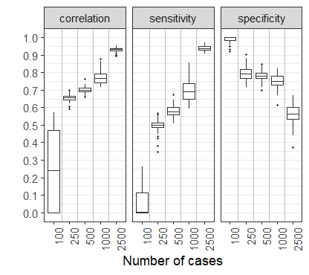
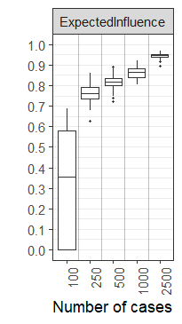

Fig S2. Stability estimations of EI and BEI centrality indices using the case−drop bootstrapping method for total, girl, and boy samples, respectively. The left is the result of the stability test at W1, and the right is at W2.
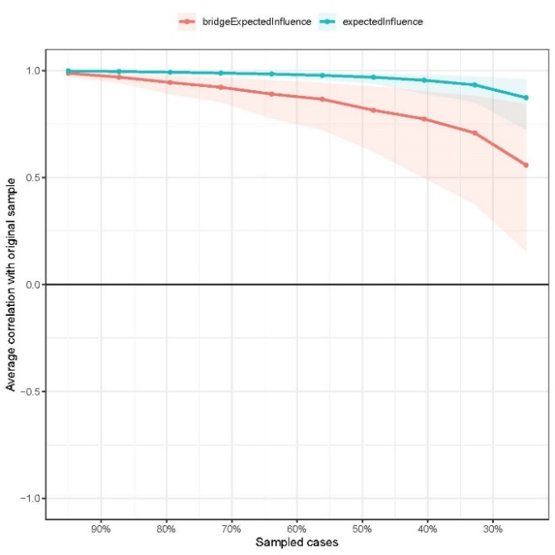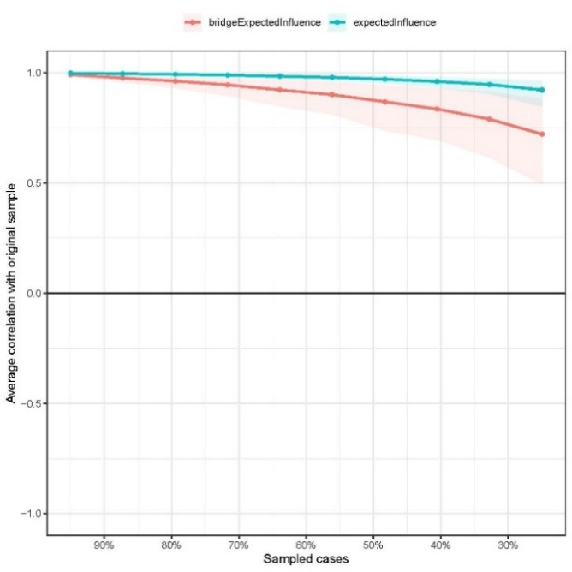
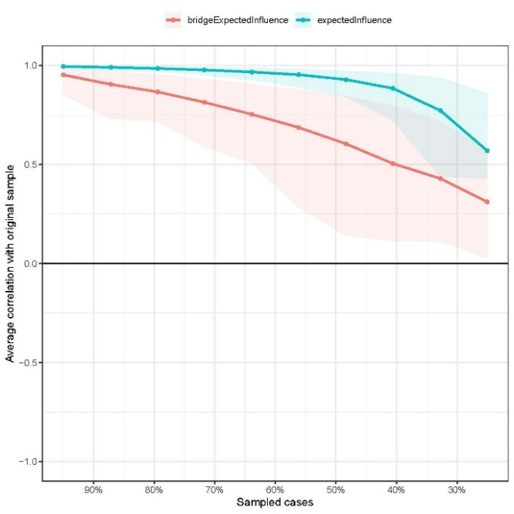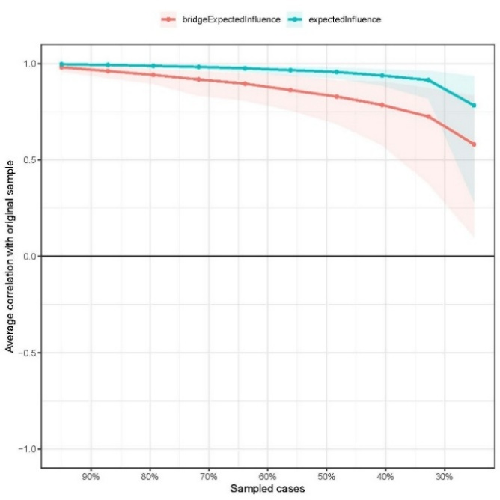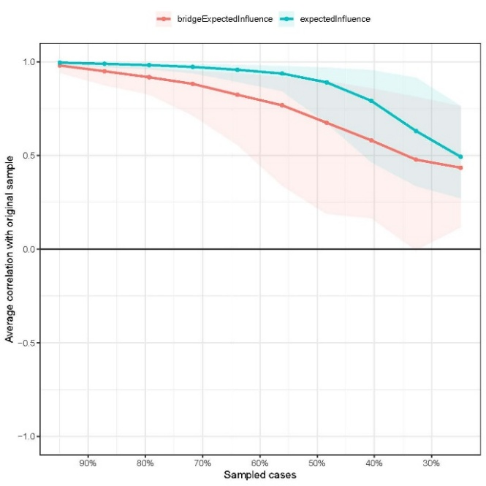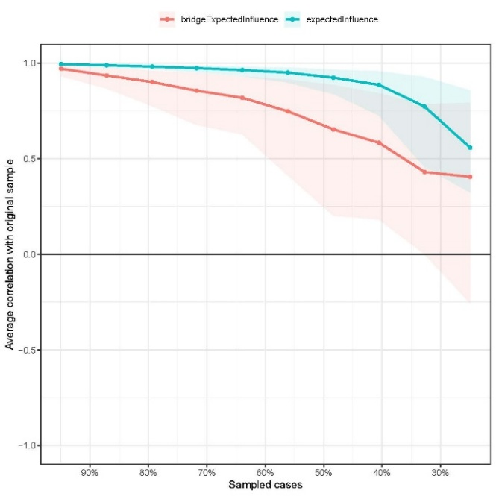

Fig S3. Nonparametric bootstrapped confidence intervals of estimated edges for total, girl and boy samples, respectively. The red line represents the estimated edge, while the shaded area indicates the 95% bootstrap confidence interval. The left is the result of the accuracy test at W1, and the right is at W2.
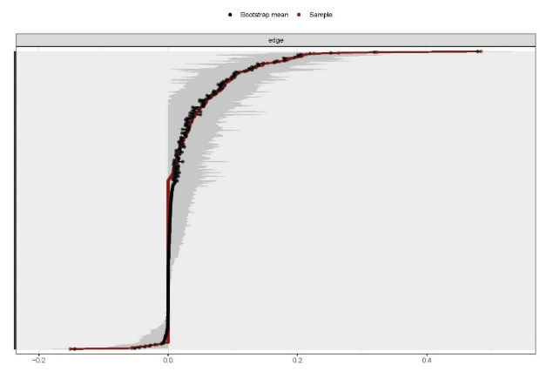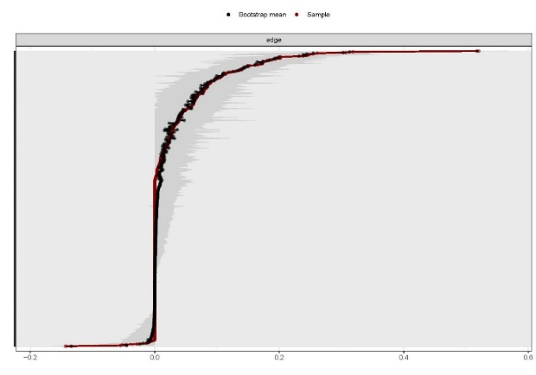
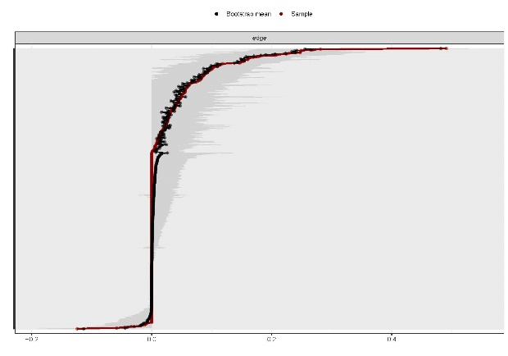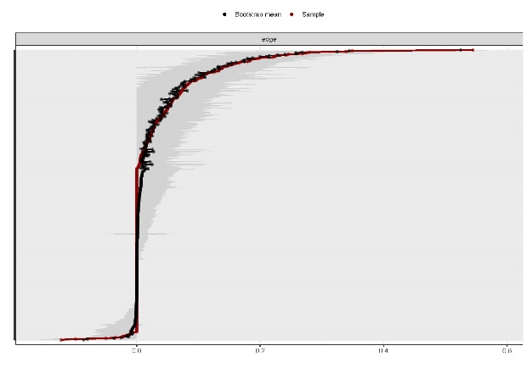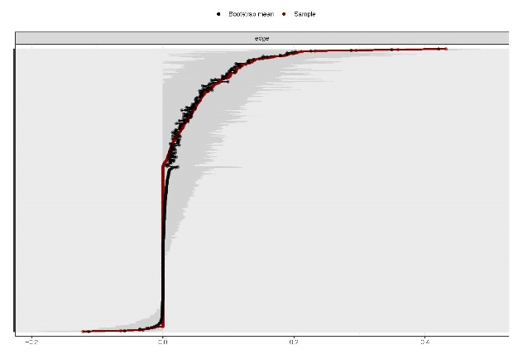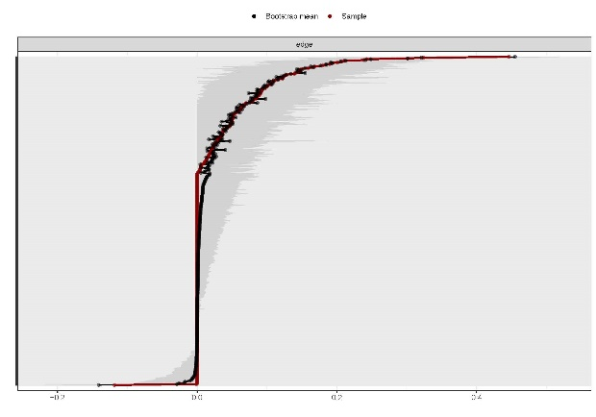
Fig S4. Nonparametric bootstrapped difference test for edges of total, girl and boy samples, respectively. Grey boxes indicate no significant difference, whereas black boxes indicate a statistically significant difference (p < 0.05). Diagonal color and saturation represent the magnitude and direction of each estimated edge. The left is the result of the accuracy test at W1, and the right is at W2.
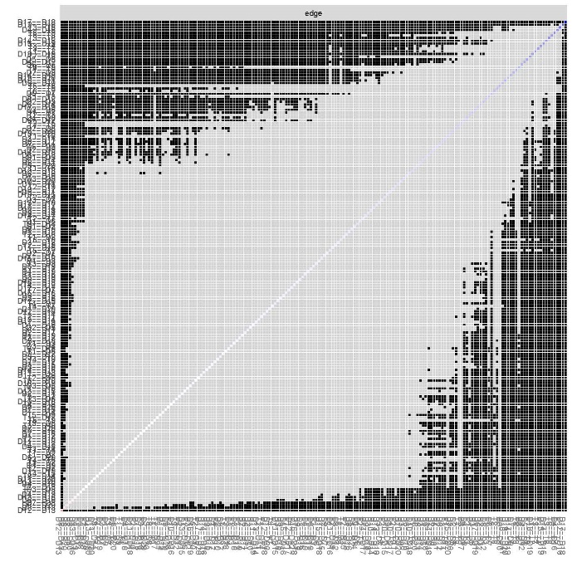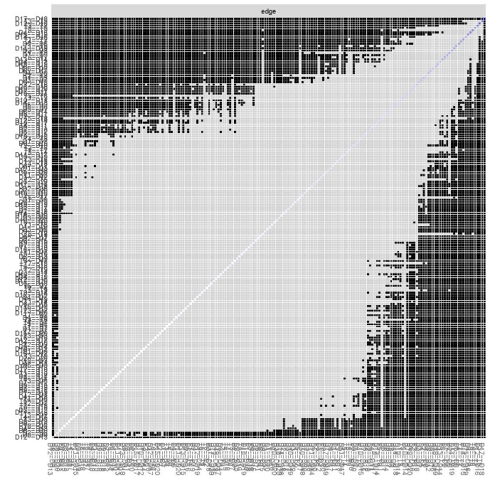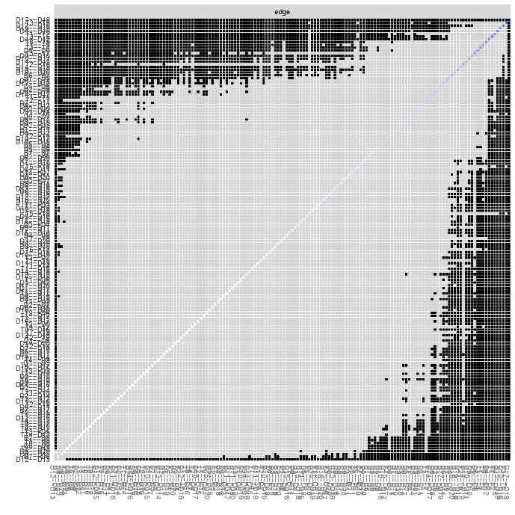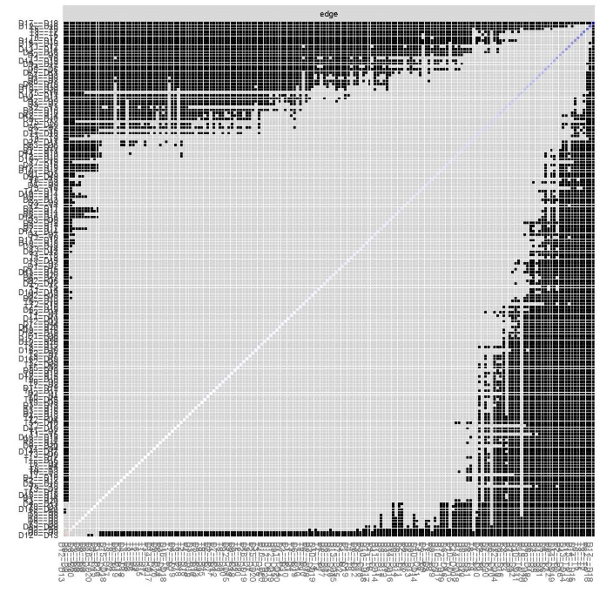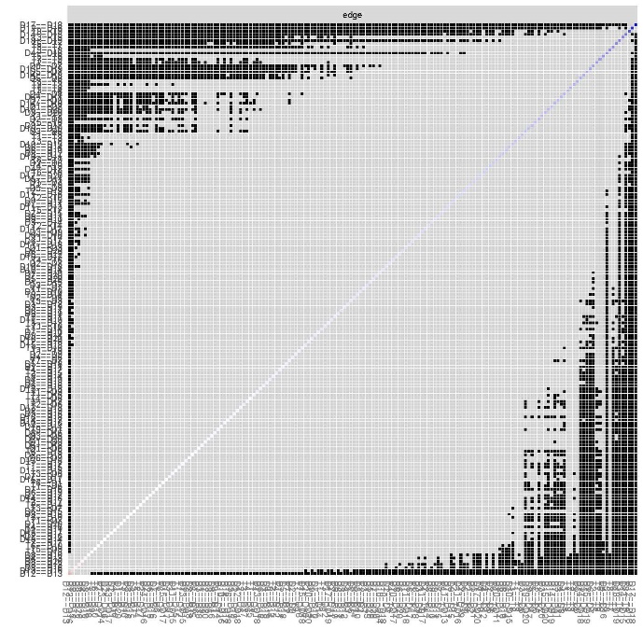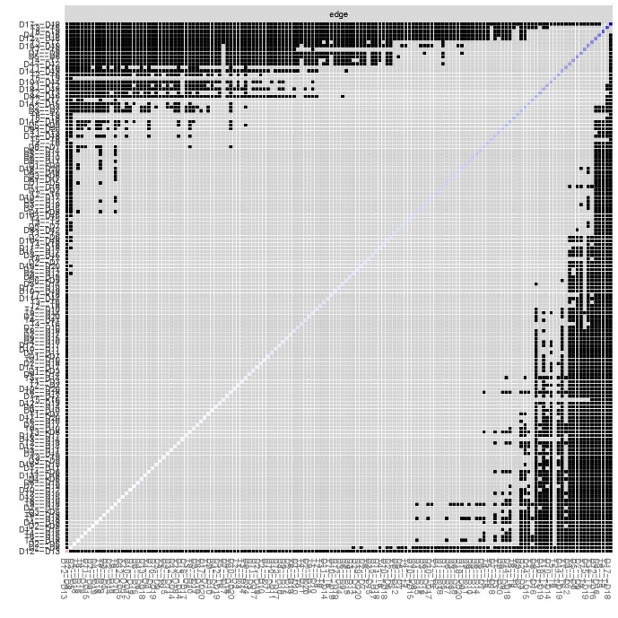

Fig S5. Nonparametric bootstrapped difference test for EI for total, girl and boy samples, respectively. Grey boxes indicate no significant difference, whereas black boxes indicate a statistically significant difference (p < .050). Diagonal values represent the strength score of each node. The left is the result of the accuracy test at W1, and the right is at W2.
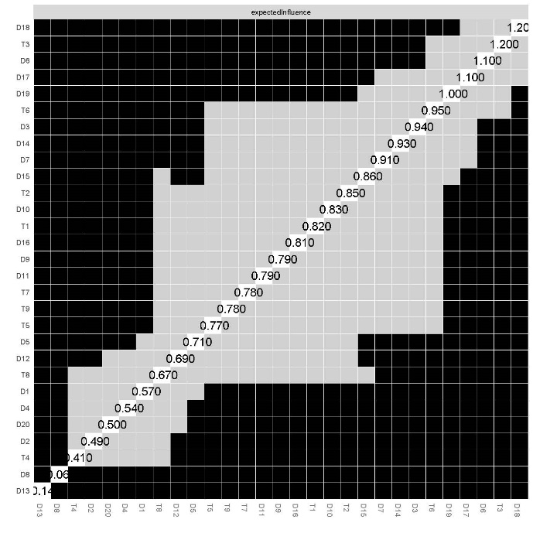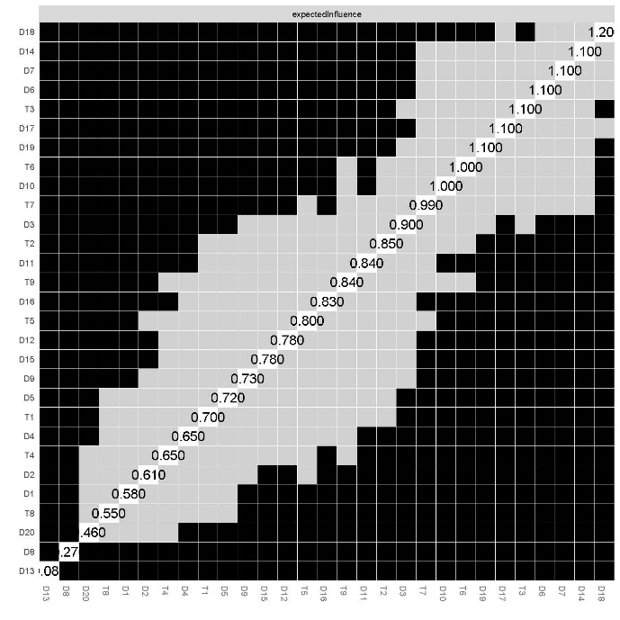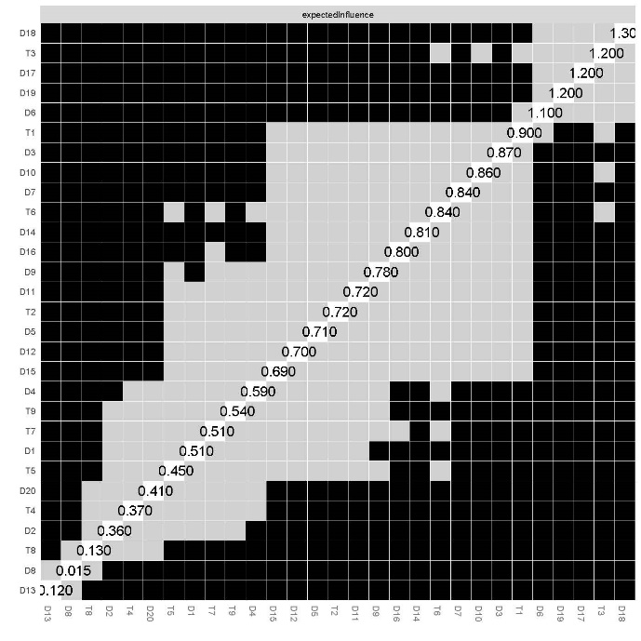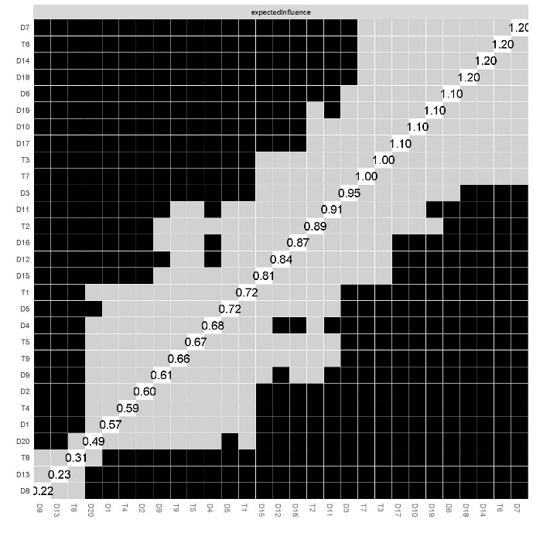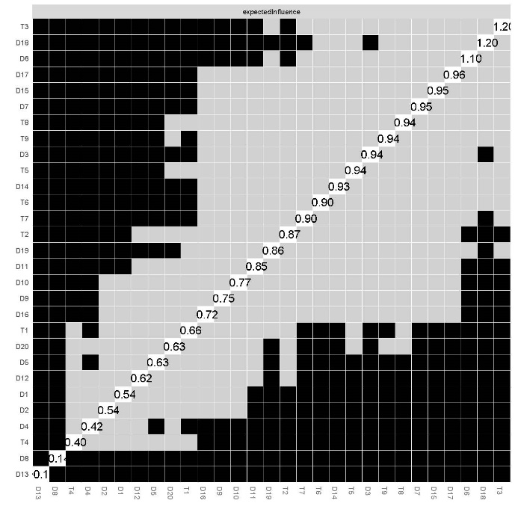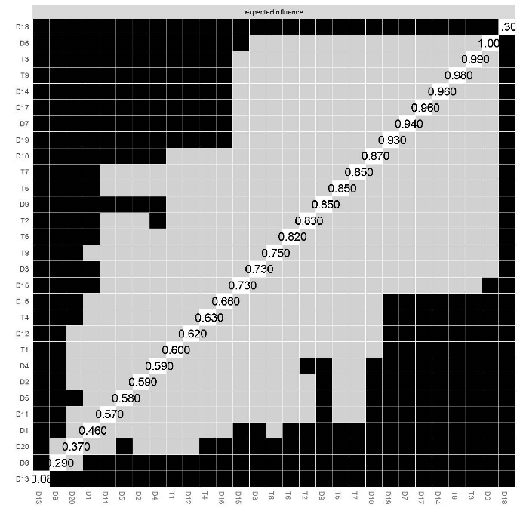

Fig S6. Cross−Lagged panel network of total, girl and boy sample. The edges represent cross−lagged effects and denote the direction of prediction with arrows.
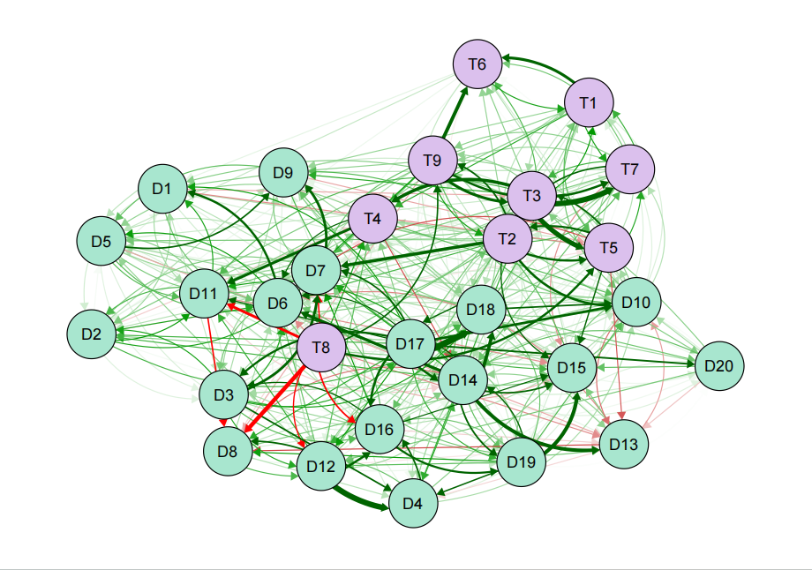
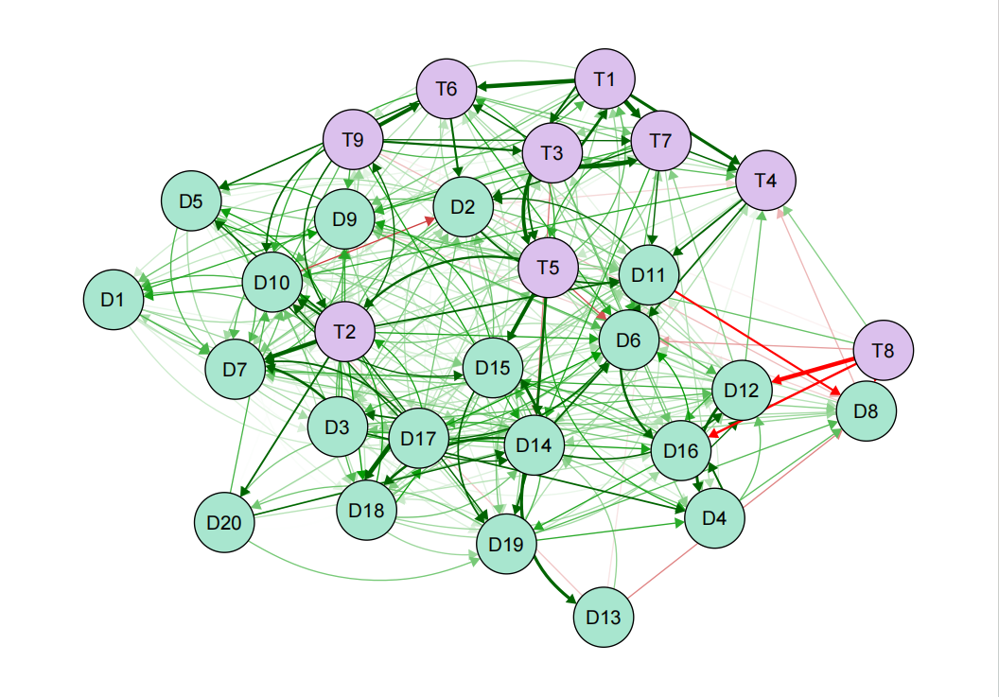
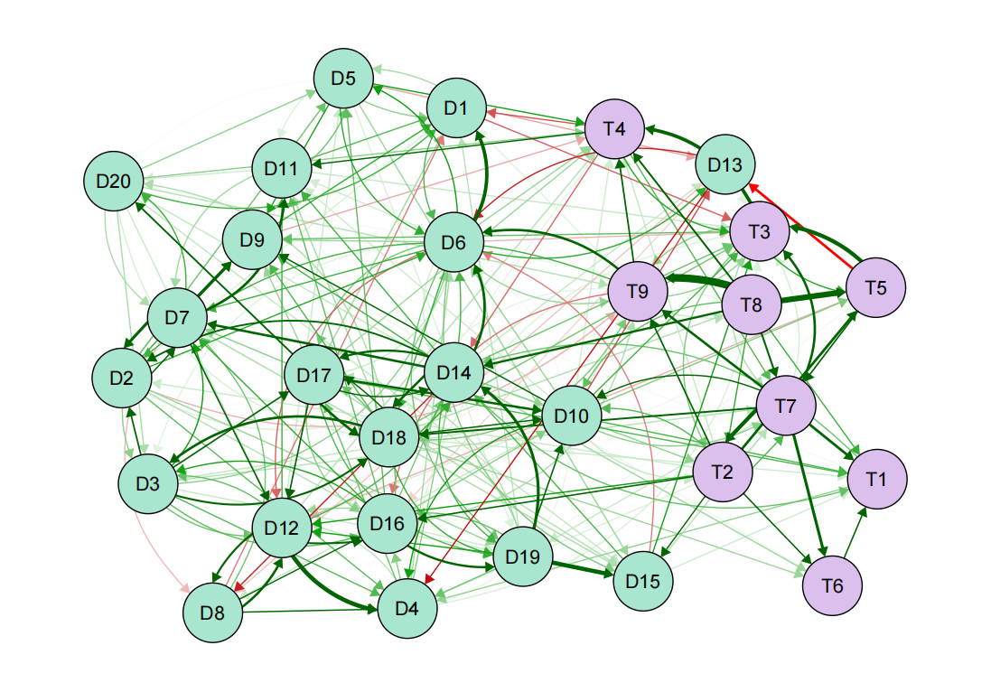

Fig S7. Stability estimations of in−prediction and out−prediction centrality indices using the case−drop bootstrapping method for total, girl, and boy samples, respectively.
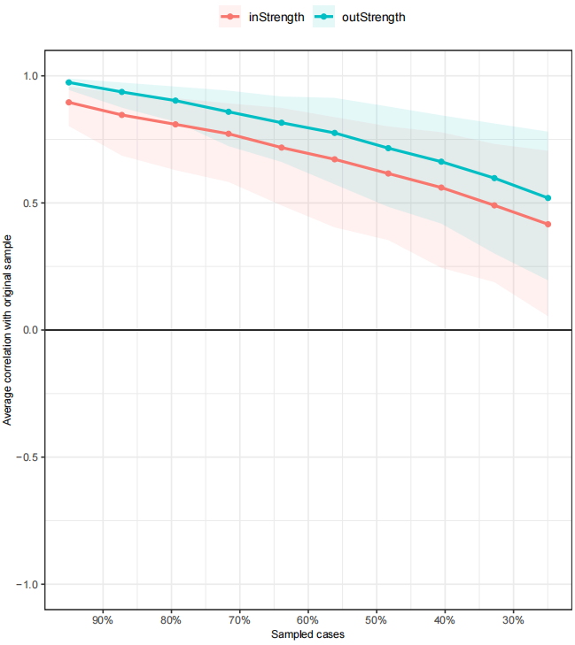
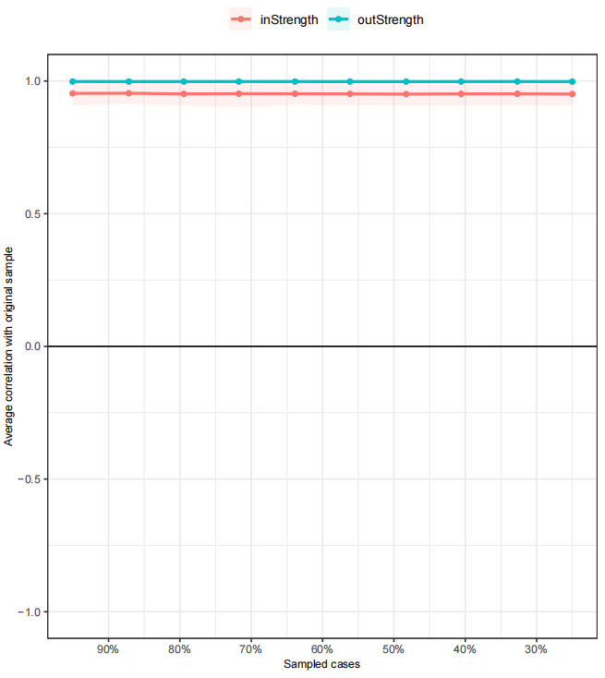
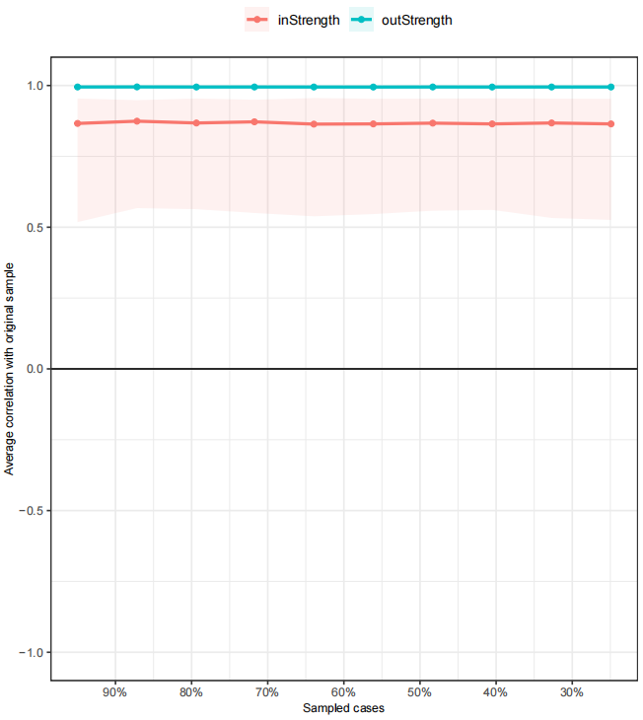

Fig S8. NSSI and depression symptoms interrelation accuracy plots with 1,000 bootstrap iterations for the total, girl and boy CLPNs, respectively. Plots show the sample interrelations (i.e., edge weights) with the red dots, the means of the bootstrapped interrelations (i.e., edge weights) with black dots, and the bootstrap confidence intervals.
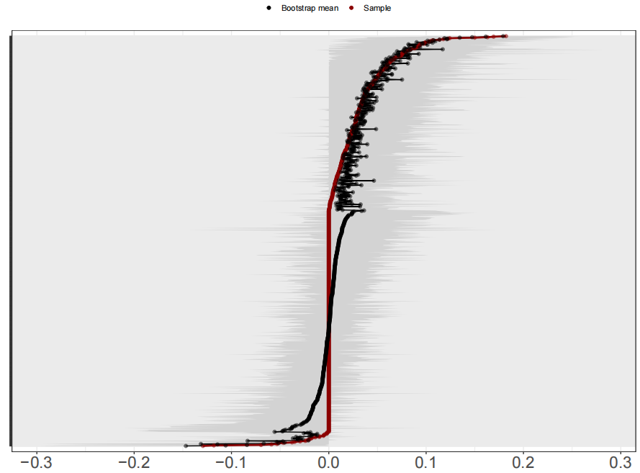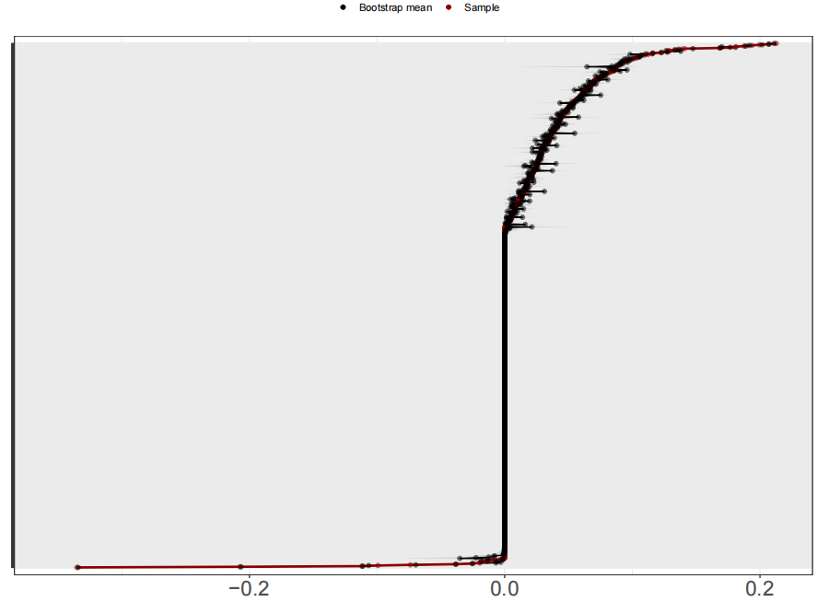
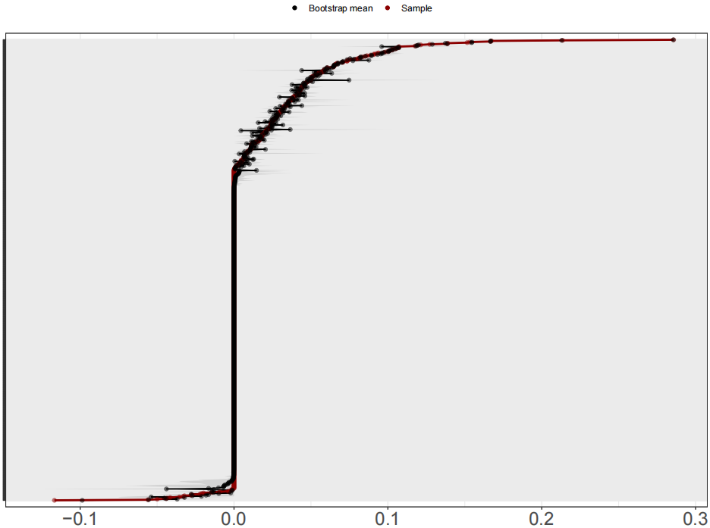

Fig S9. Nonparametric bootstrapped difference test for edges of total, girl and boy CLPNs, respectively.
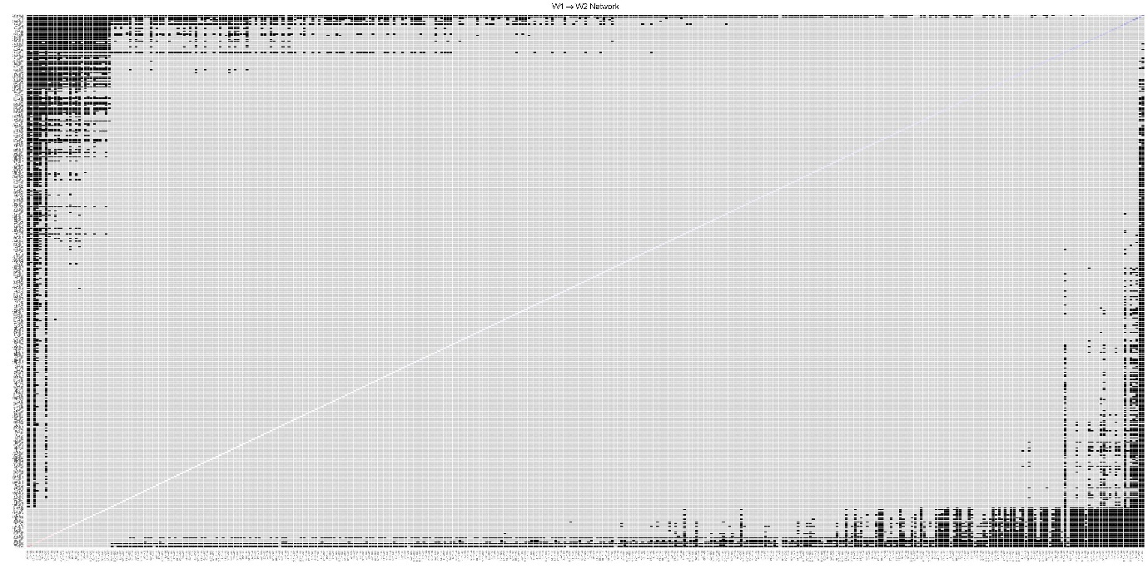
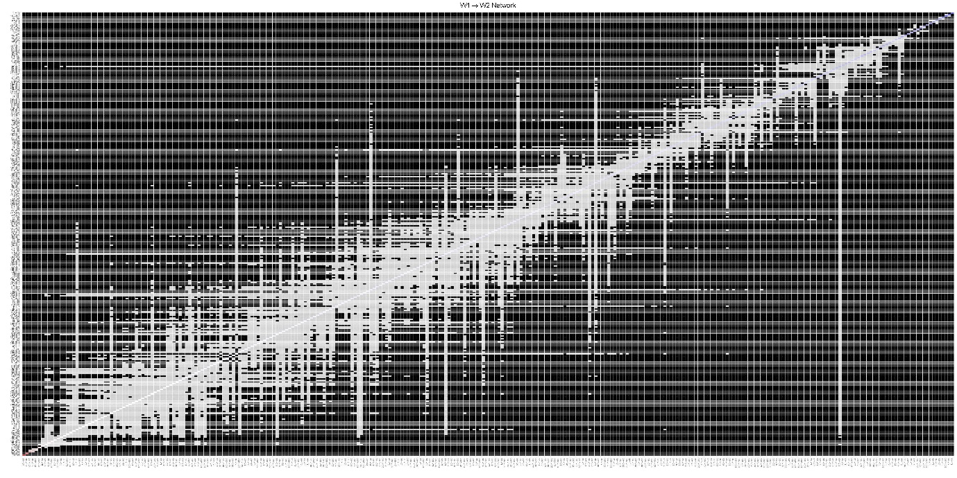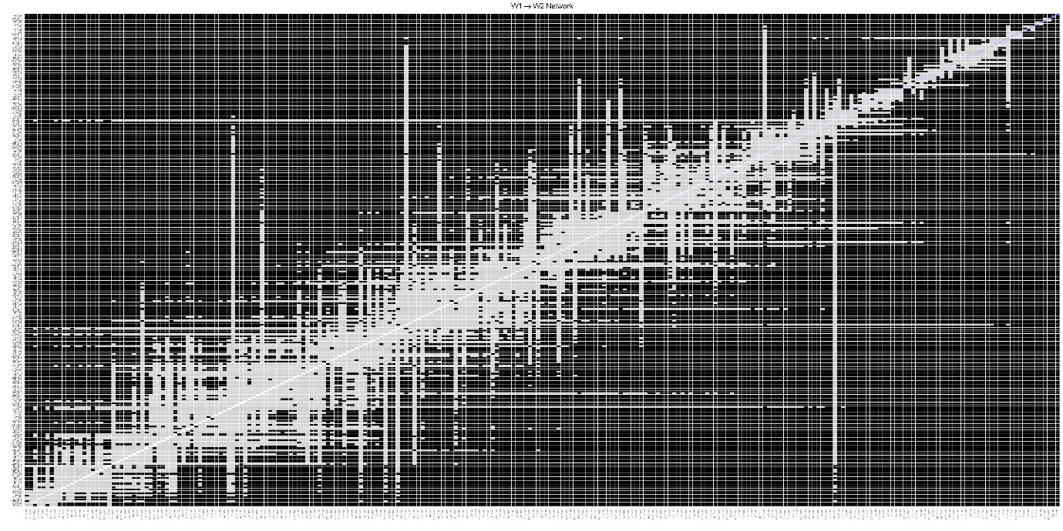
Fig S10. Nonparametric bootstrapped difference test for in−prediction and out−prediction for total, girl and boy samples, respectively. The left is the result of the accuracy test for in−prediction, and the right is for out−prediction.
