Supplementary material 1
eFigure 1 - eFigure 7 The image-based educational tool.
eFigure 8 - eFigure 13 The preliminary image-based educational tool.
eTable 1 Comments from the participants and relevant revisions

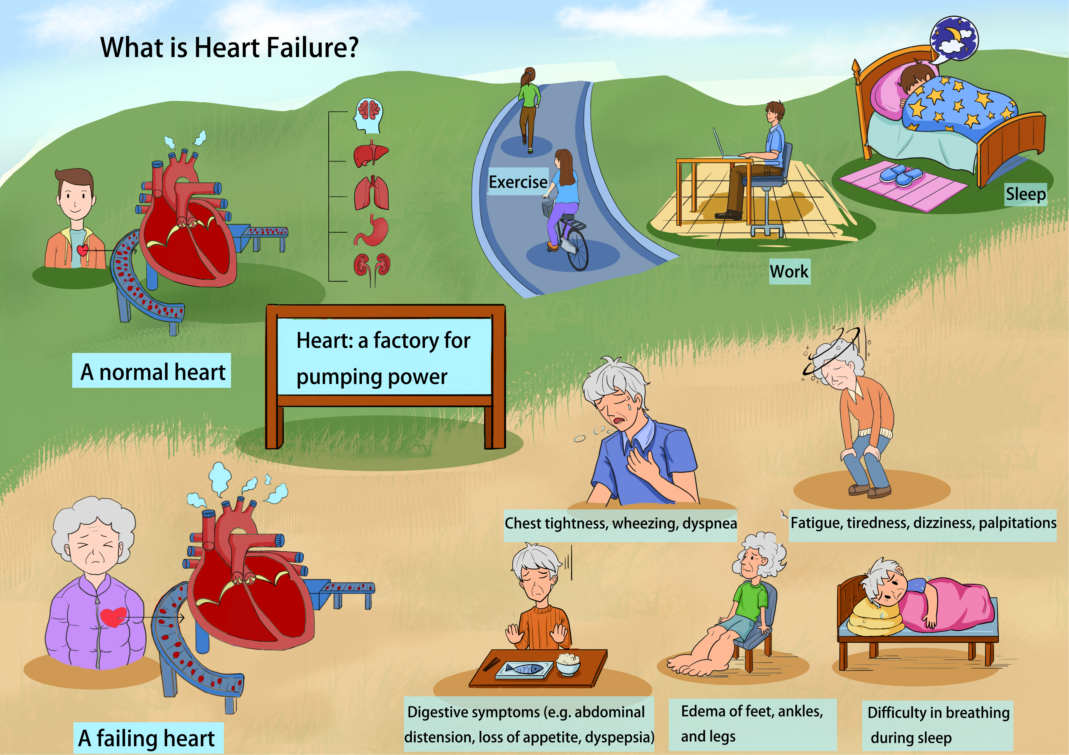
eFigure 1 What is heart failure?

Accompanying language:
In my youth, my heart was healthy, its size akin to that of a clenched fist. The heart was like a powerful pump which drove blood through the vessels, circulating it throughout my body.
The heart was like a powerful pump, pushing the blood through the vessels and circulating it throughout my body. My brain, heart, lungs, liver, gastrointestinal tract, kidneys, and other organs all received the nutrients and oxygen they needed, allowing me to exercise, rest, and sleep easily. However, as I've aged, I've been diagnosed with "Heart Failure". My heart has enlarged significantly, and its pumping function is now inadequate, leading to a poor distribution of blood throughout my body. Consequently, my vital organs are starved of the nutrients and oxygen they require. Additionally, the heart's diastolic function is weakened, hindering the return of blood to the heart from the periphery. I may now experience symptoms such as chest tightness, wheezing, dyspnea, fatigue, dizziness, palpitations, abdominal bloating, loss of appetite, indigestion, lower limb edema, and even the inability to lie flat while sleeping.

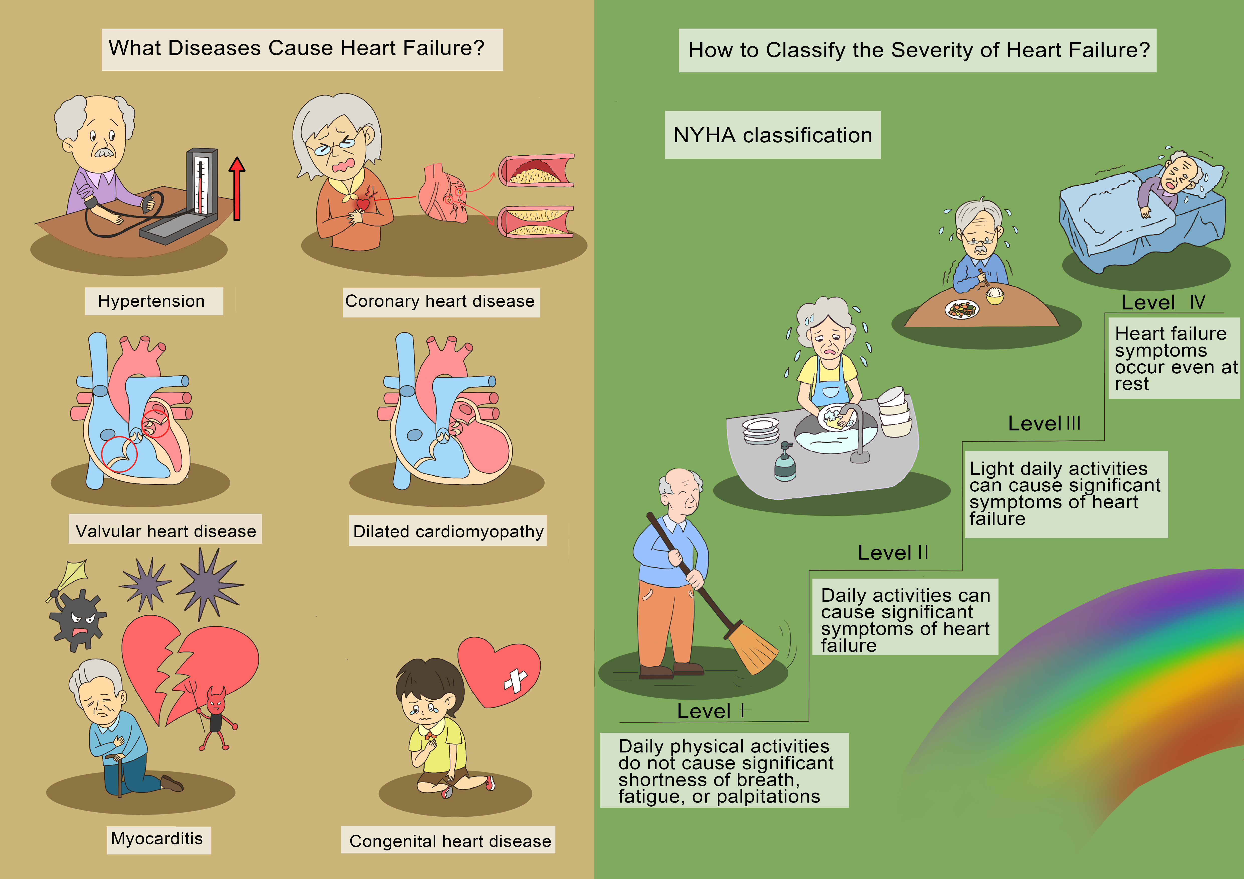
eFigure 2 Cause and classification of HF.

Accompanying language:
Why did heart failure develop? It is the terminal stage of various cardiac conditions. A range of diseases, including long-term uncontrolled or untreated hypertension, coronary heart disease, valvular heart disease, dilated cardiomyopathy, myocarditis, and congenital heart disease, can precipitate heart failure. I have suffered from these conditions, never imagining they would lead to such a critical state. Moving forward, I am committed to managing these diseases properly, taking my medication regularly, and keeping up with regular check-ups to prevent further progression of heart failure.
Additionally, I have heart failure. Is my heart failure severe? The severity of heart failure can be gauged against an international classification system with four levels. Level I describes no significant shortness of breath, fatigue, or palpitations with daily physical activities. Level II indicates that routine tasks like washing dishes or sweeping can trigger noticeable heart failure symptoms. Level III signifies that even light daily activities can cause significant symptoms, while Level IV means symptoms occur even at rest. In essence, the higher the level, the more severe the heart failure. If I do not actively manage heart failure, I may become incapacitated, unable to perform even the most basic daily tasks like eating and sleeping
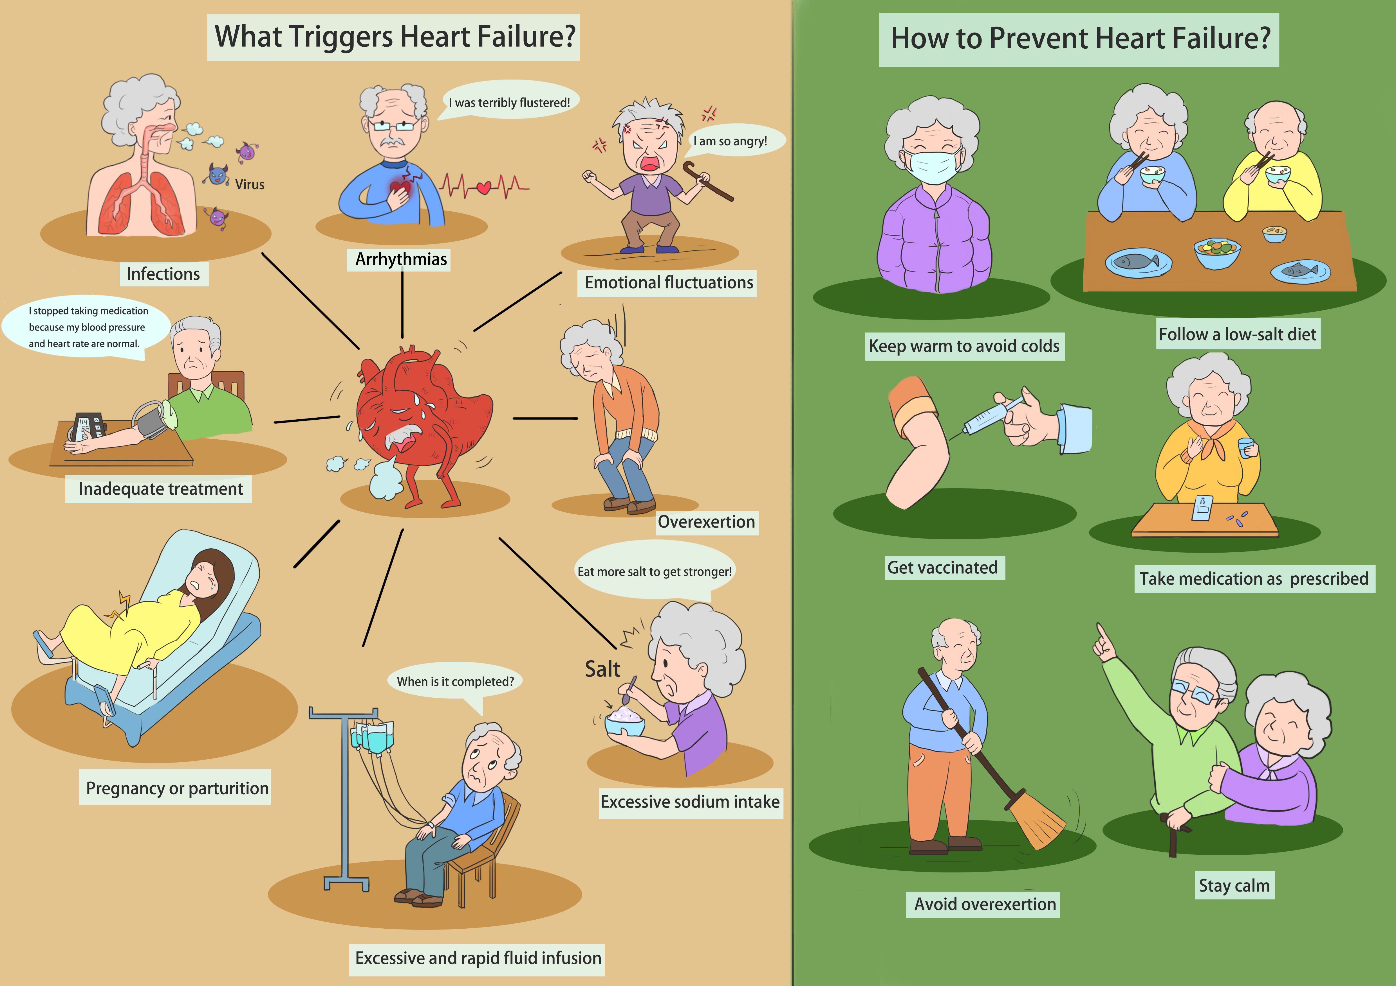
eFigure 3 Inducing factors and prevention of HF.

Accompanying language:
What factors can trigger heart failure episodes in daily life? The onset of heart failure is associated with infections, arrhythmias, emotional fluctuations, overexertion, excessive salt intake, rapid fluid infusion, pregnancy, parturition, and the arbitrary discontinuation of medication. To effectively prevent heart failure episodes, I can focus on keeping warm to avoid colds, getting vaccinated on time, adhering to a low-salt diet, taking medication as prescribed, avoiding overexertion, and maintaining emotional stability.
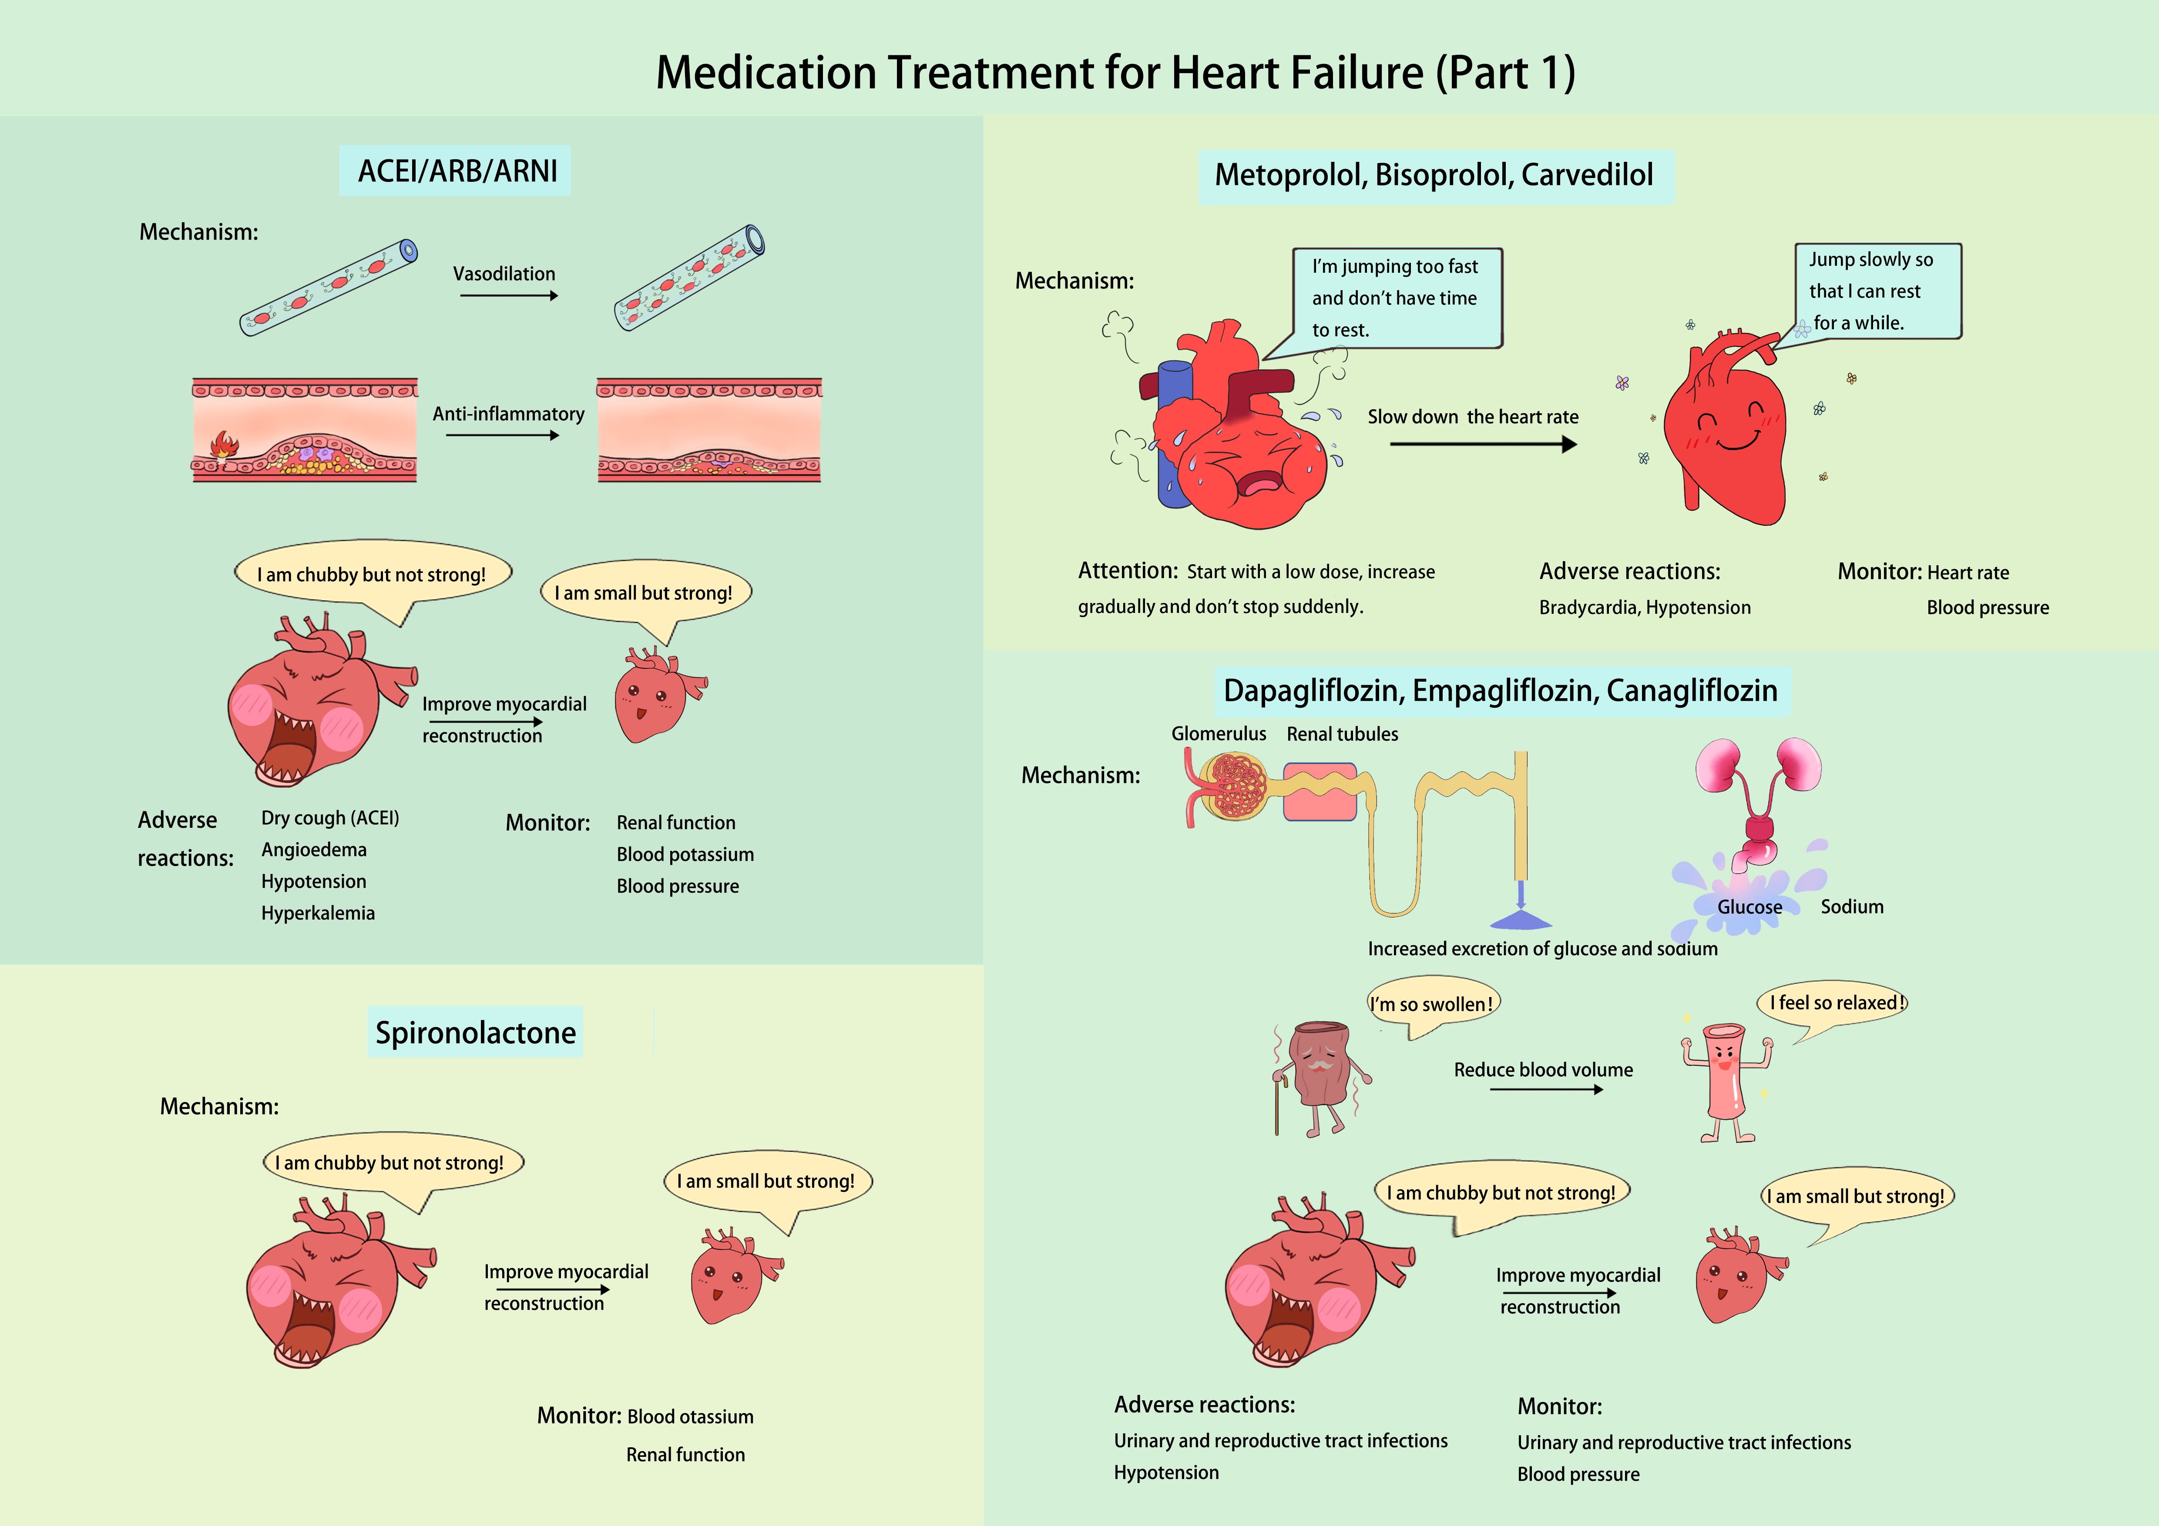
eFigure 4 Medication treatments for HF (part 1).

Accompanying language:
There are eight types of drugs for heart failure, and your doctor has selected the most suitable ones for you. We use easy-to-understand comics to illustrate the mechanisms of action and long-term benefits of these drugs. Adherence to your medication regimen can effectively control heart failure and prevent its recurrence to the greatest extent. Let's examine each one (explained selectively based on the patient's medication):
1. ACE inhibitors, angiotensin II receptor blockers, and sacubitril valsartan can dilate blood vessels, lower blood pressure, combat inflammation, repair endothelial damage, and make an enlarged heart return to its normal size. They may cause dry cough, angioedema, hypotension, and hyperkalemia. Long-term use requires monitoring of kidney function, blood potassium, and blood pressure.
2. The mechanism of metoprolol, bisoprolol and carvedilol is to slow the heart rate and allow the heart to rest as much as possible. These drugs should be initiated at a low dose, gradually increased, and not abruptly stopped. Adverse reactions include bradycardia and hypotension. Long-term use requires heart rate and blood pressure monitoring.
3. Spironolactone is used to make an enlarged heart return to its normal size. Long-term use requires monitoring of blood potassium and renal function.
4. Dapagliflozin, empagliflozin, and canagliflozin can promote urinary excretion of glucose and sodium, reducing blood volume and cardiac burden. They can also make an enlarged heart return to its normal size. They may cause genitourinary infections and hypotension. It's advised to drink an extra half glass of water when taking these medications. Long-term use requires monitoring for genitourinary infections and blood pressure.
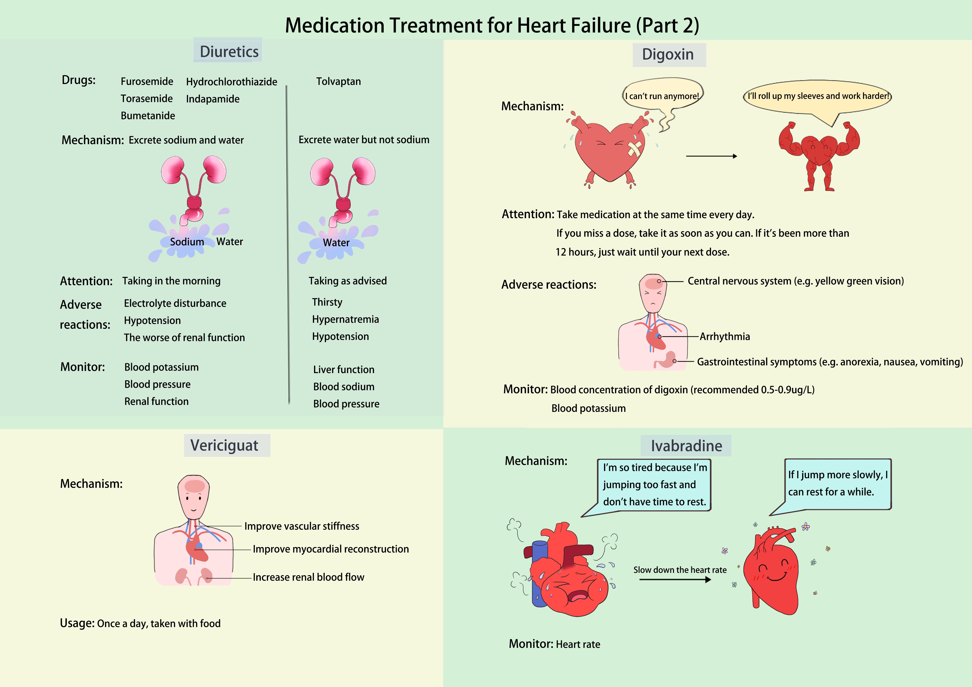
eFigure 5 Medication treatments for HF (part 2).

Accompanying language:
5. Diuretics act on the kidneys to remove excess water. Furosemide, torsemide, bumetanide, hydrochlorothiazide, and indapamide also remove sodium and should be started at low doses, preferably in the morning. Adverse reactions include electrolyte imbalances and hypotension. Long-term use requires monitoring of blood electrolytes, blood pressure, and renal function. Tolvaptan, another diuretic, removes water but not sodium and has a strong diuretic effect, requiring timely discontinuation when fluid retention subsides. Adverse reactions include thirst, hypernatremia, and hypotension.
6. Digoxin can make the heart muscle contract more strongly. It should be taken at the same time daily. If a dose is missed, take it within 12 hours; otherwise, skip it. Adverse reactions include visual disturbances, arrhythmias, anorexia, nausea, and vomiting. Long-term use requires monitoring of digoxin blood levels, ideally within the range of 0.5-0.9 μg/L.
7. Ivabradine slows the heart rate, allowing the heart to rest. Long-term use requires heart rate monitoring.
8. Vericiguat improves vascular stiffness and protects the heart and kidneys.
It's crucial to take the prescribed medications properly, as non-adherence can easily induce a recurrence of heart failure.


eFigure 6 Exercise and self-management of HF.
Accompanying language:
Can I still exercise? For people with stable heart failure, regular exercise can really improve their quality of life. Starting with a few minutes and gradually increasing to 20, 30, or even 60 minutes is feasible. Activities like walking, tai chi, cycling, baduanjin, dancing, and more can be chosen based on physical condition and personal preference. The goal is to exercise for 20 to 60 minutes at a time, at least five times a week. A 5 to 10-minute warm-up before each exercise is recommended. Resistance exercises complement aerobic exercise, including dumbbell lifting, ankle weights, and elastic bands. Flexibility exercises are mainly about stretching muscles. And breathing muscle training can effectively improve breathing difficulties in heart failure patients, including lip pursing and abdominal breathing exercises. Practice pursed-lip breathing by slowly inhaling through your nose while counting to 12. Purse your lips as if you would to whistling. Then exhale slowly, counting to 1234. The inhalation-to-exhalation ratio should be 1:2. Abdominal breathing training involves inhaling deeply through the nose while puffing up the abdomen and exhaling through the mouth while drawing in the abdomen, aiming to extend exhalation time as long as possible.Do the exercise 3 to 4 times a day for 5 to 10 minutes, increasing the duration with time.
In addition, a low-fat diet, avoiding overeating, controlling weight and limiting sodium intake to <6g per day are essential. During episodes of heart failure, sodium intake should be limited to <2g per day. Adhering to a low-salt diet can be challenging, but it reduces fluid retention and the risk of excess water in the body. Daily fluid management is also important, with the aim of maintaining a urine output minus fluid intake of about 500ml. Use measuring tools to track daily fluid intake, aiming for under 1500ml and not exceeding 2000ml. Use a urine pitcher to measure 24-hour urine output. Weighing oneself every morning after urinating on an empty stomach can indicate fluid retention if weight increases by >1.5kg in one day or >2.0kg in three days, requiring a reduction in fluid intake or adjustment of the diuretic dose.
Furthermore, consistently measuring blood pressure and heart rate, quitting smoking, limiting alcohol, and following up at the hospital 1-2 months after discharge, along with psychological counseling, can maintain a positive and optimistic attitude, all of which contribute to heart failure management.

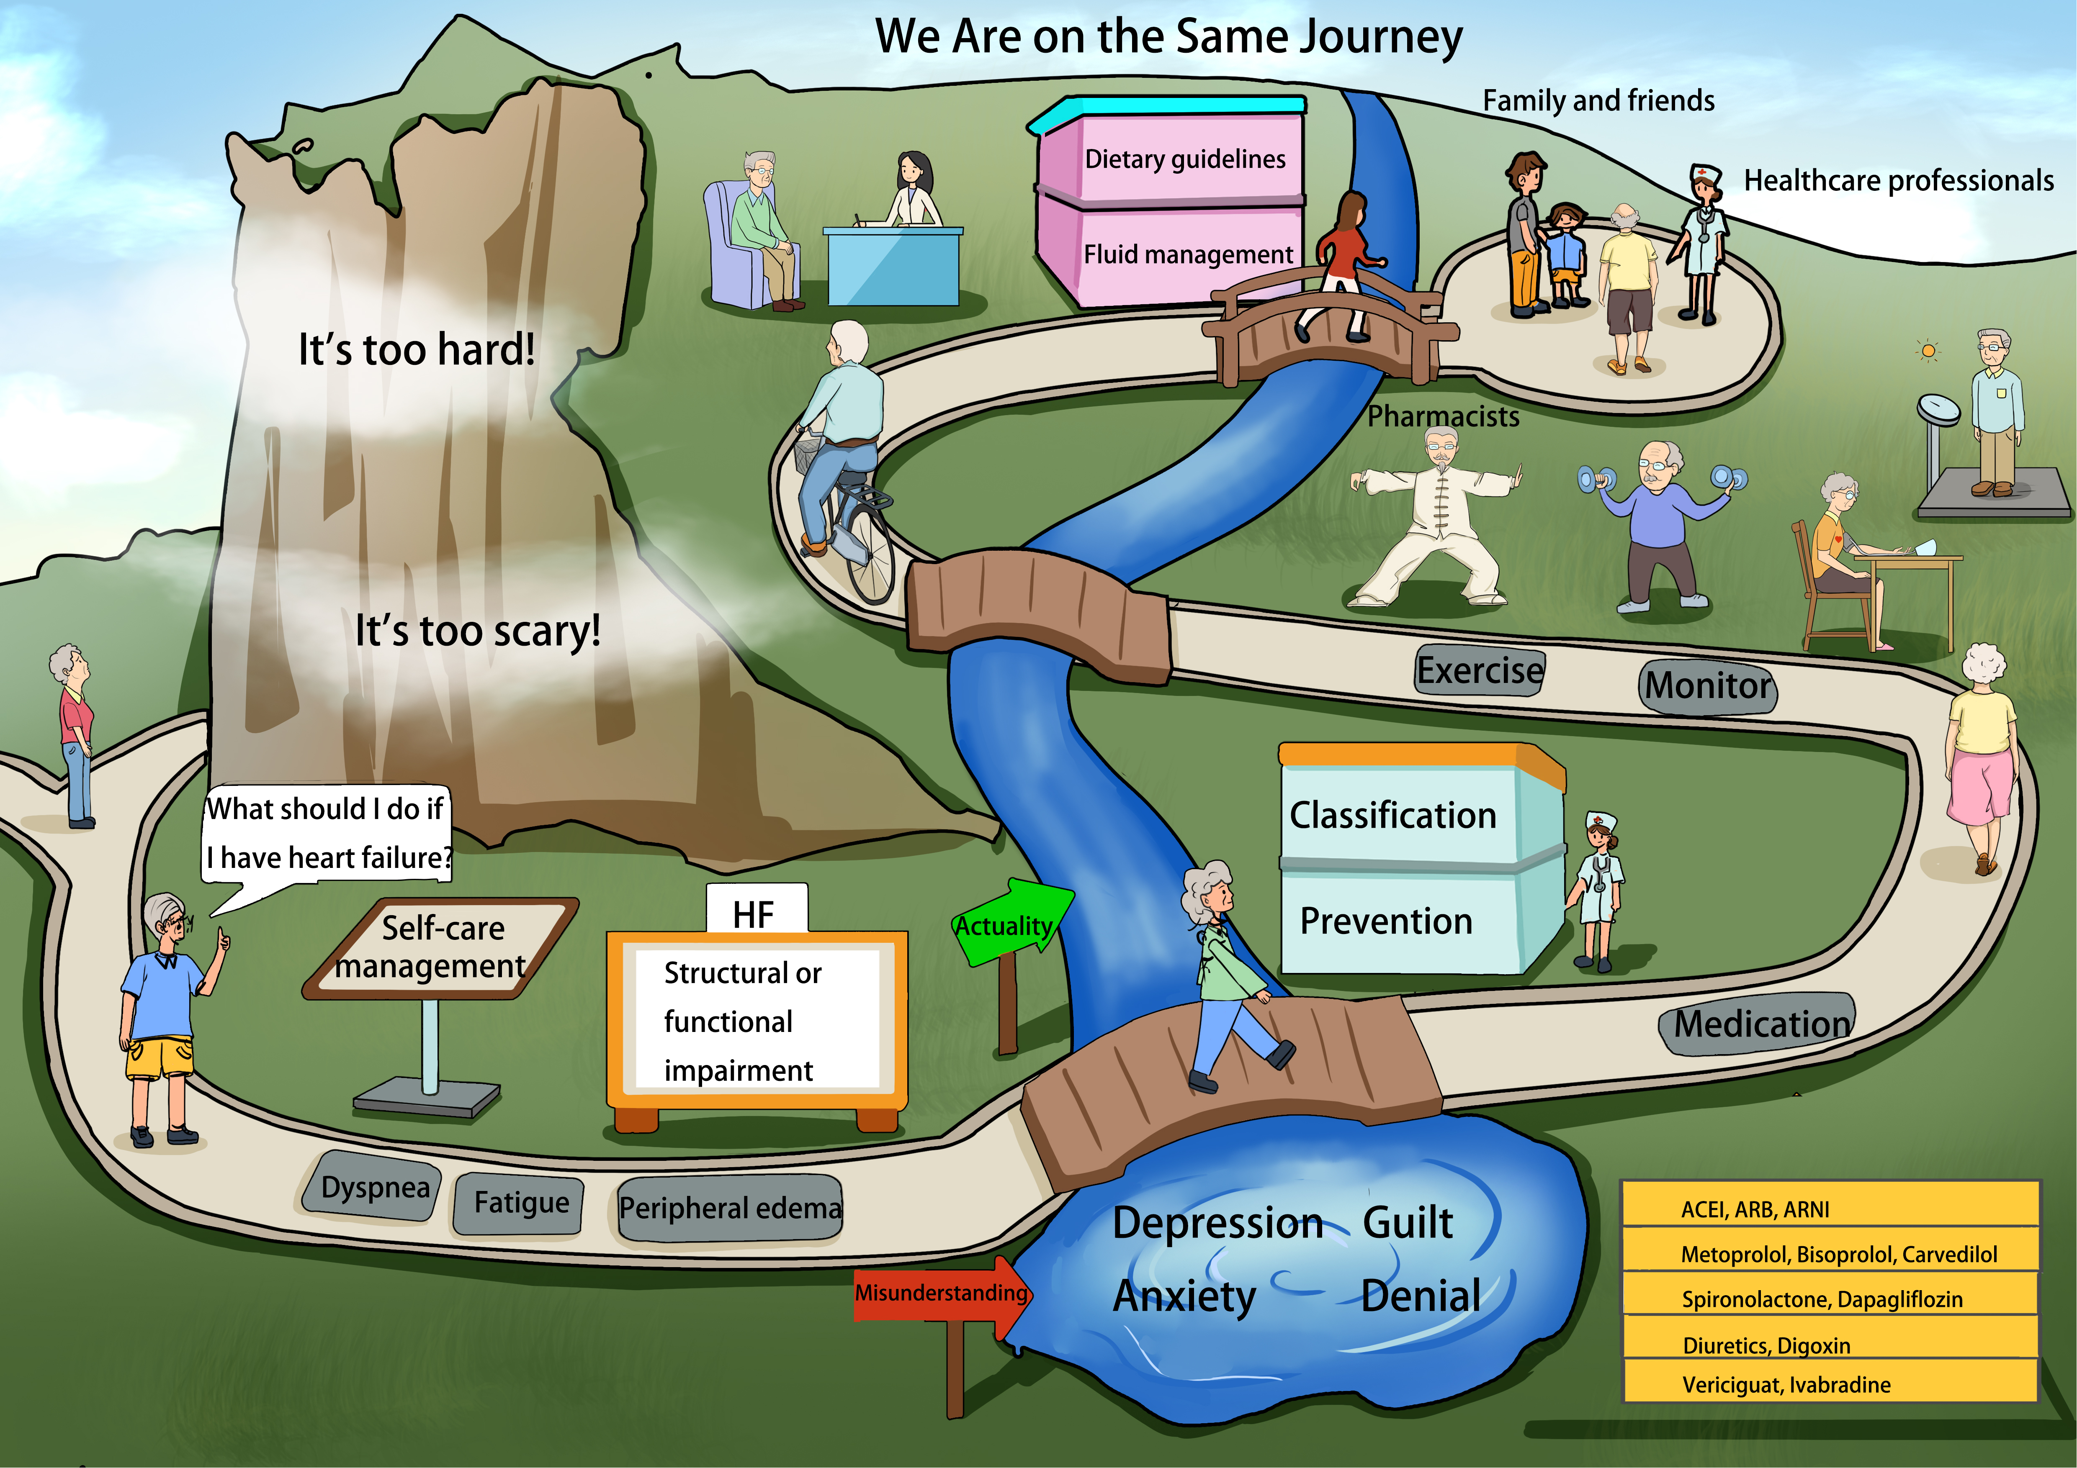
eFigure 7 We are on the same journey.

Accompanying language:
After experiencing heart failure, feelings of depression and anxiety are common. But with the guidance of professionals, the path forward becomes clearer. Learning to manage heart failure involves understanding its impact on contractile and diastolic heart function, recognizing symptoms like dyspnea, fatigue, and peripheral edema, and knowing the severity levels of heart function. Preventative measures such as staying warm, getting vaccinated, adhering to a low-salt diet, taking medication as prescribed, avoiding overwork, and maintaining emotional stability can effectively prevent heart failure. There are eight drugs used to treat heart failure. These drugs can reduce heart size, slow the heart rate, eliminate excess water, and strengthen myocardial contraction. It's imperative to take medications as prescribed and manage weight, diet, fluid intake, blood pressure, heart rate, exercise, and hospital follow-ups regularly. With the support of pharmacists, healthcare professionals, family, and friends, managing this condition becomes easier.

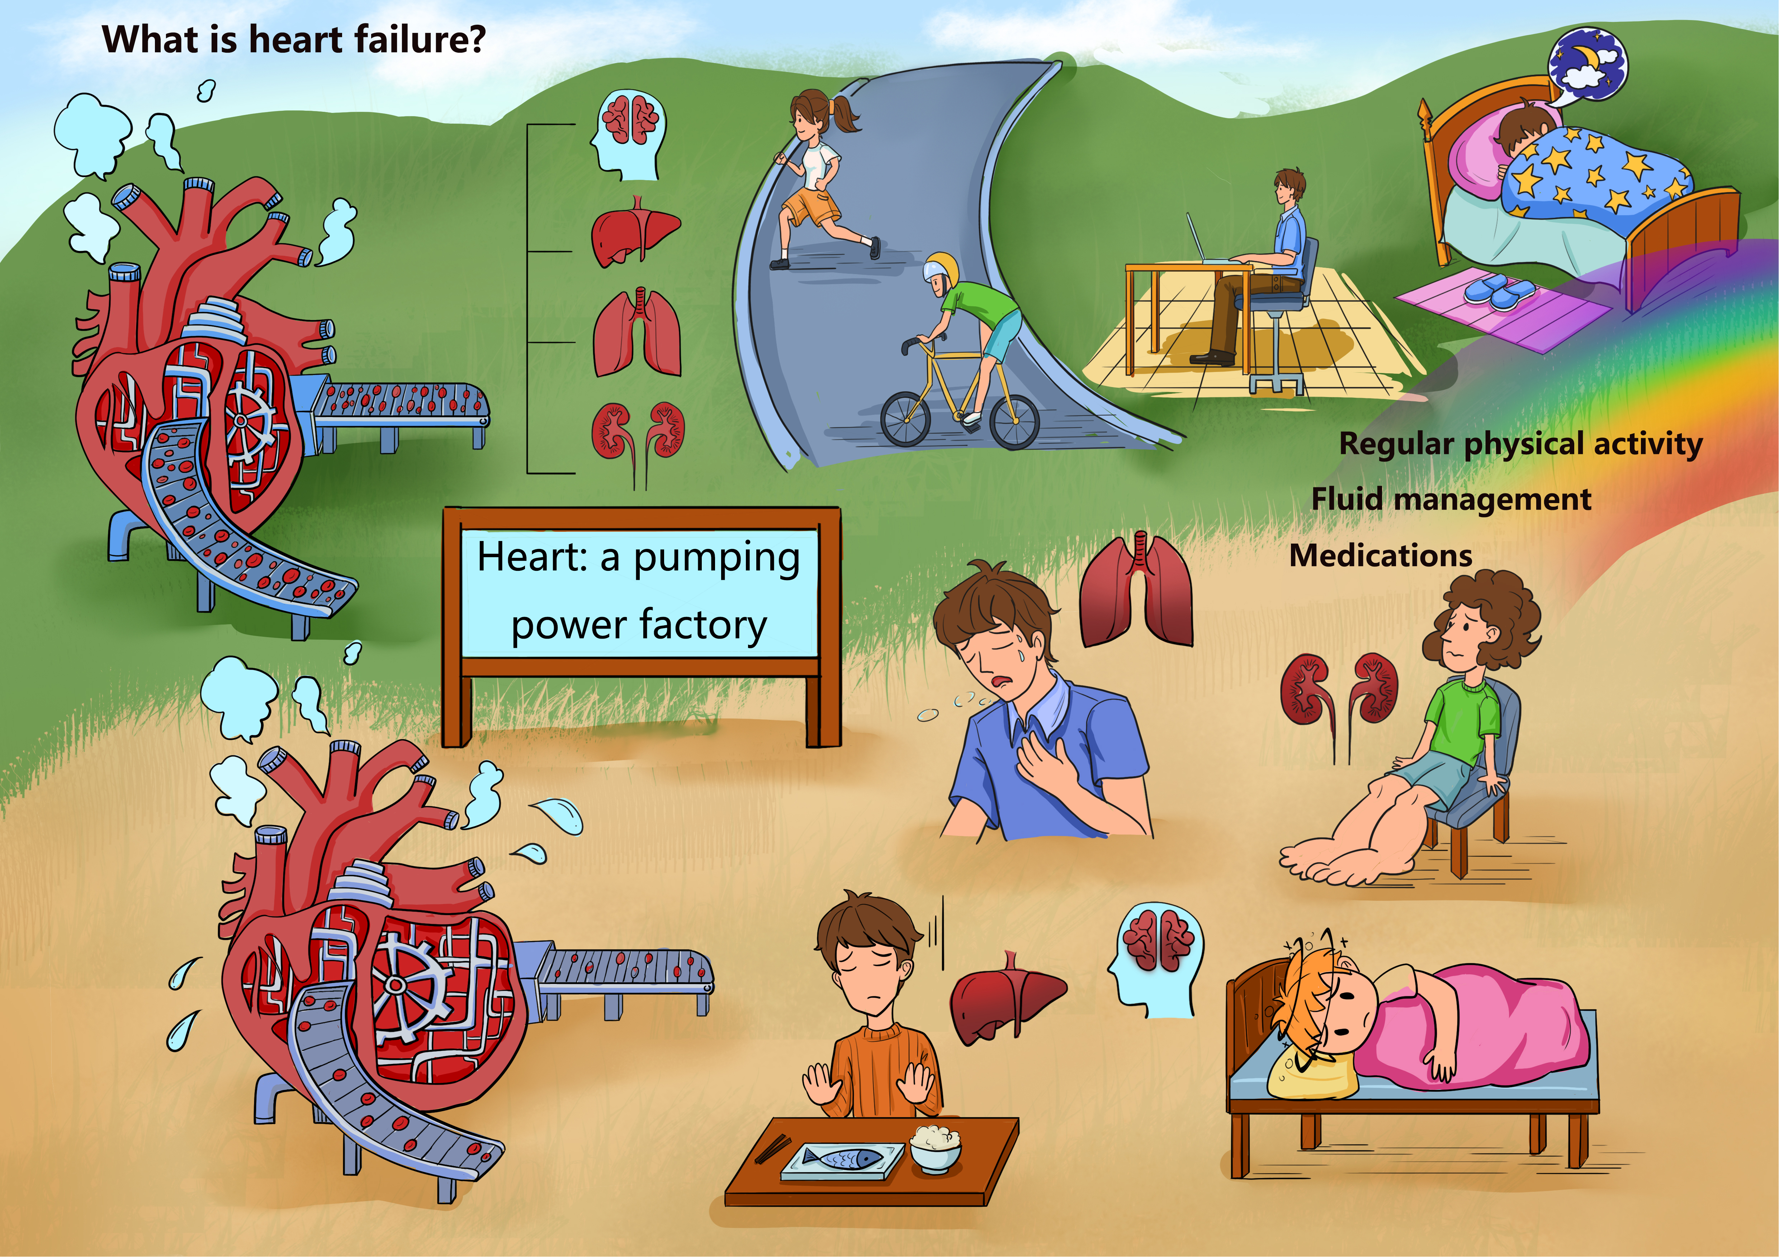
eFigure 8 What is heart failure?

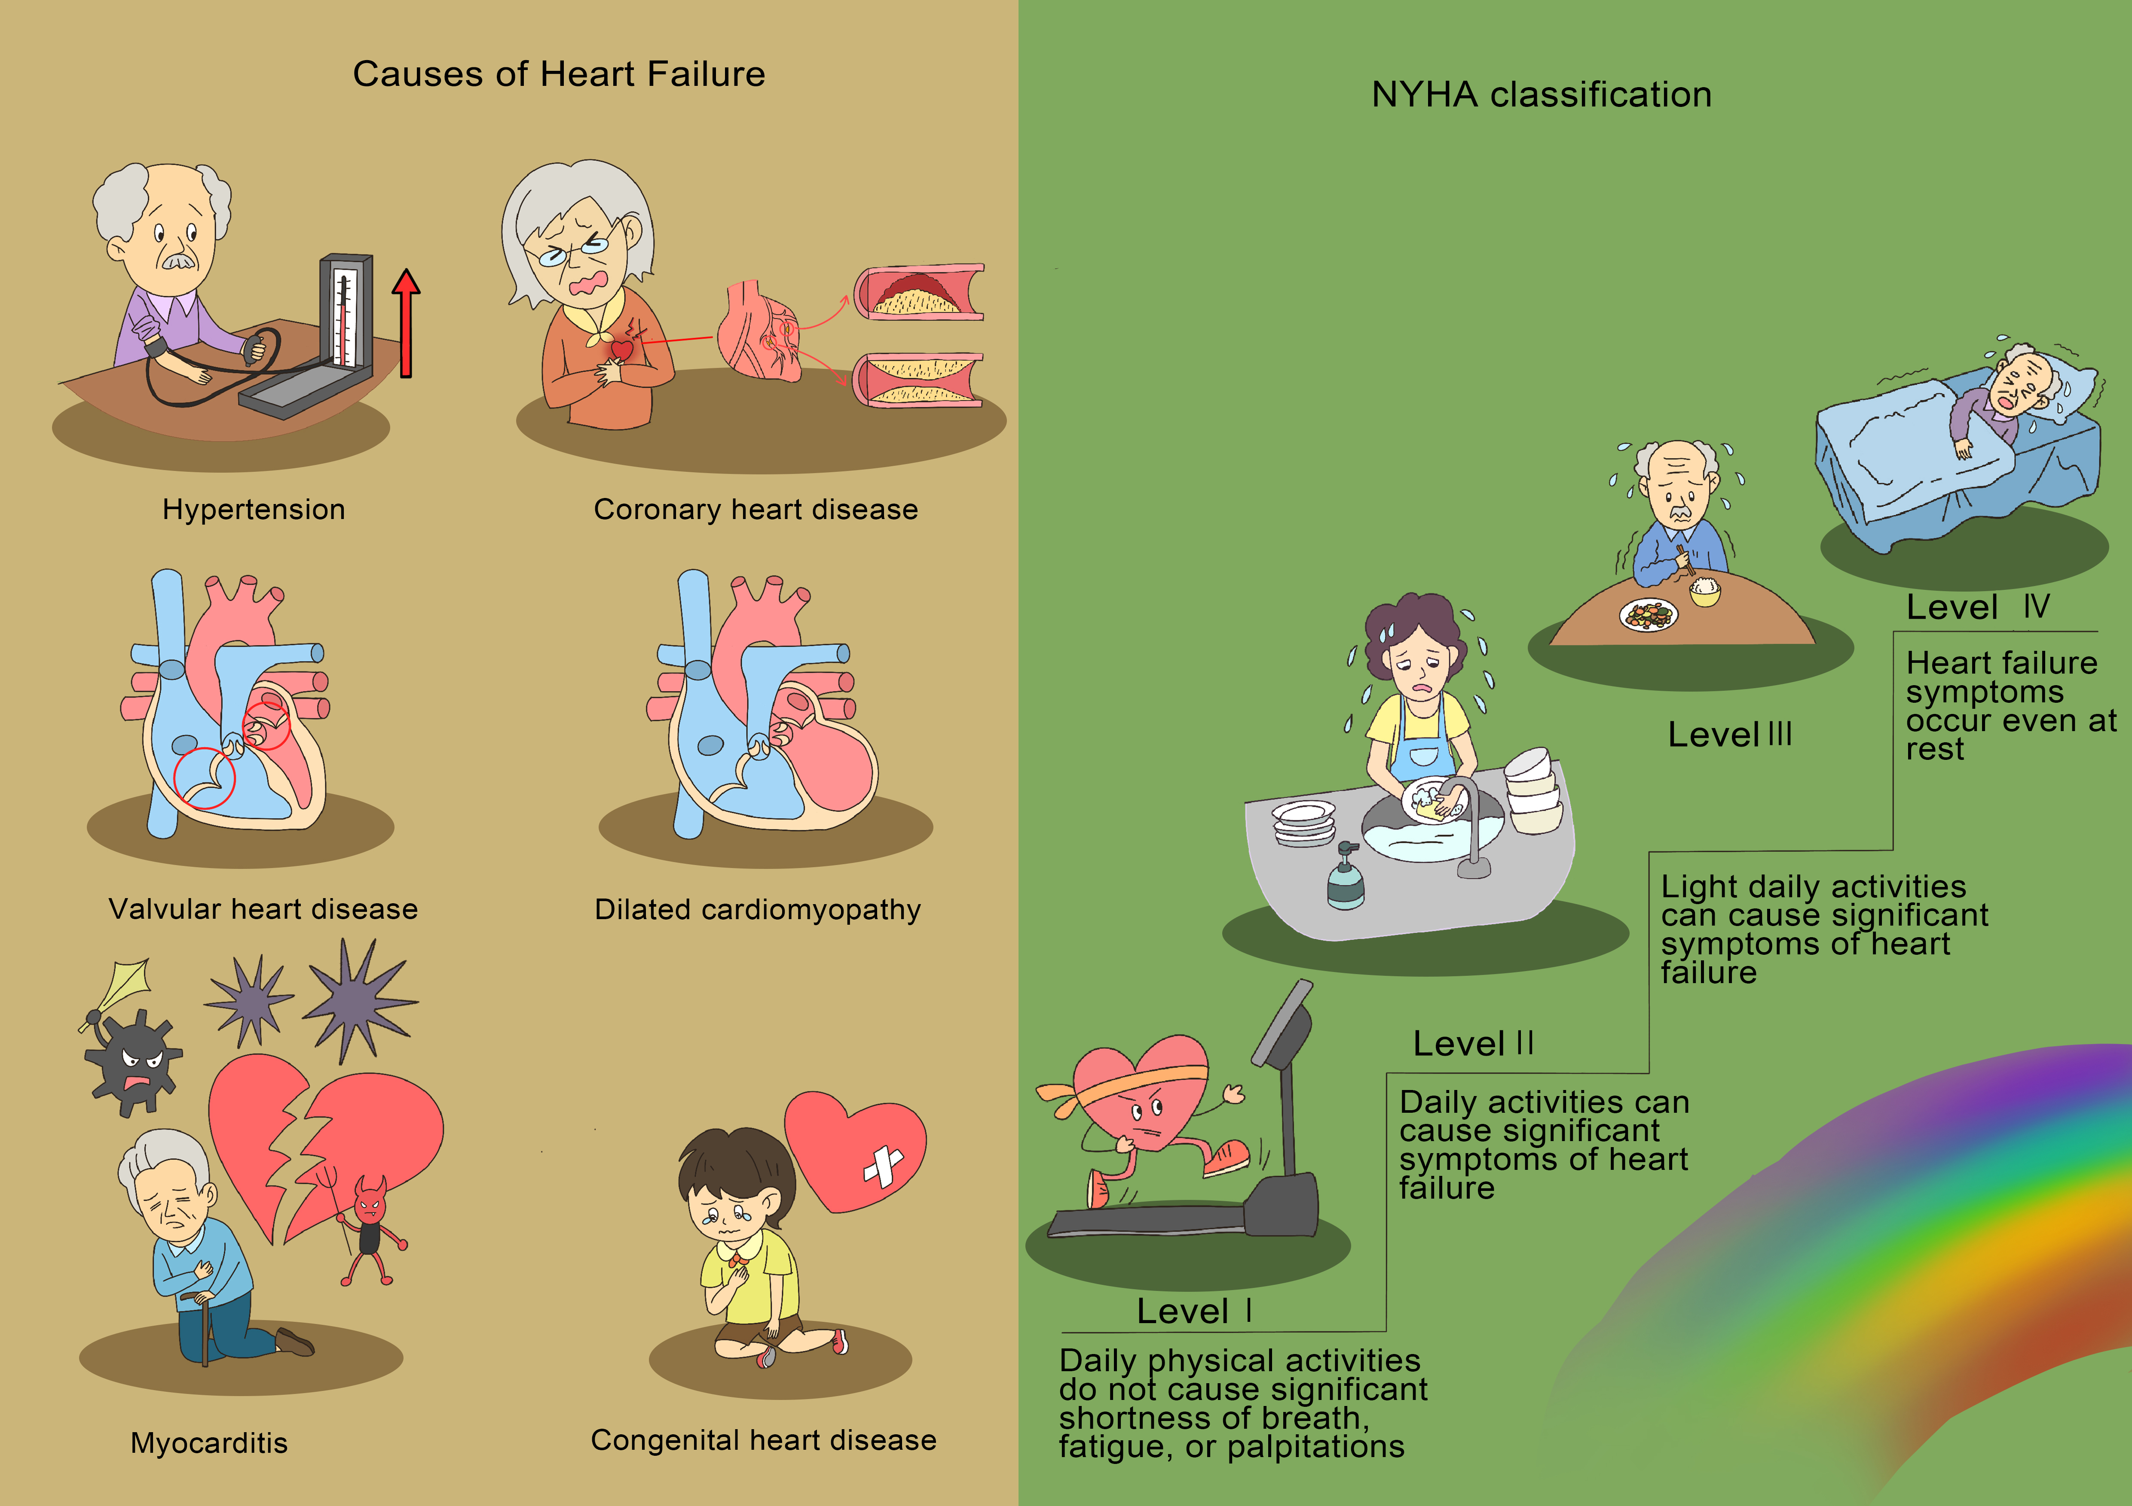
eFigure 9 Cause and classification of HF.

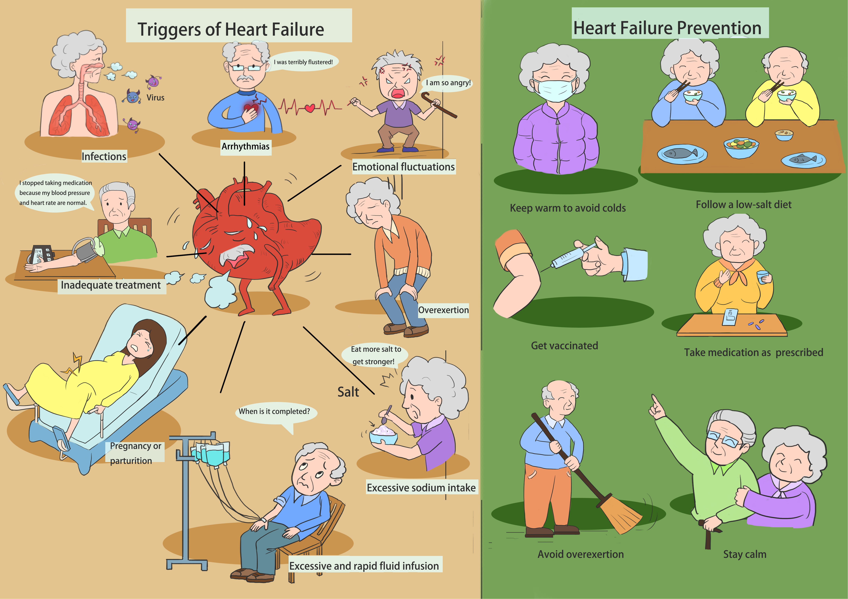
eFigure 10 Inducing factors and prevention of HF.

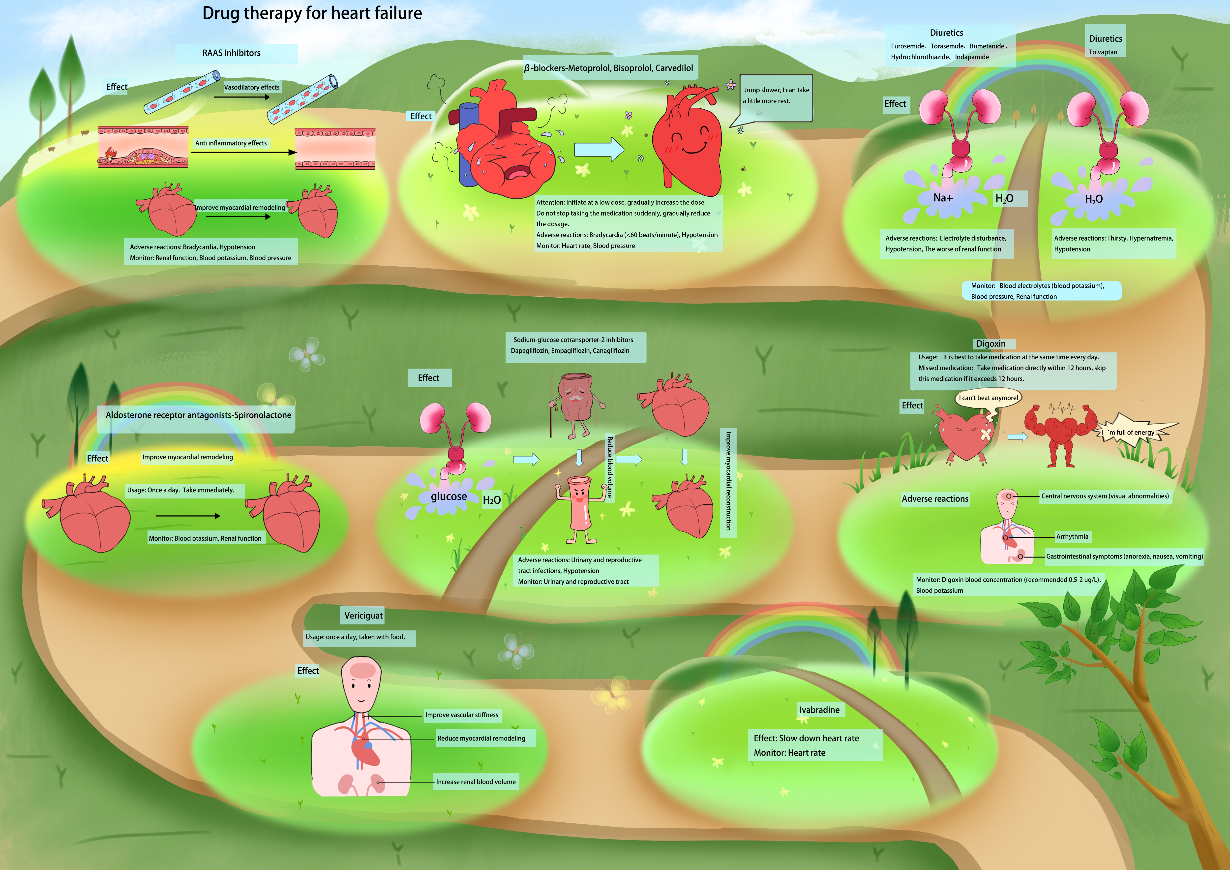

eFigure 11 Medication treatments for HF.

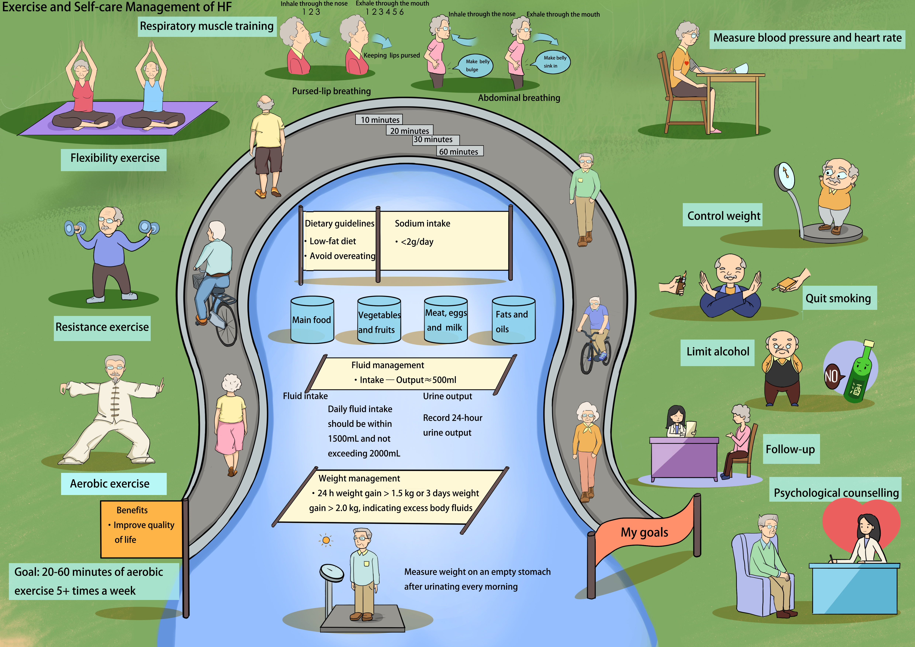
eFigure 12 Exercise and self-management of HF.

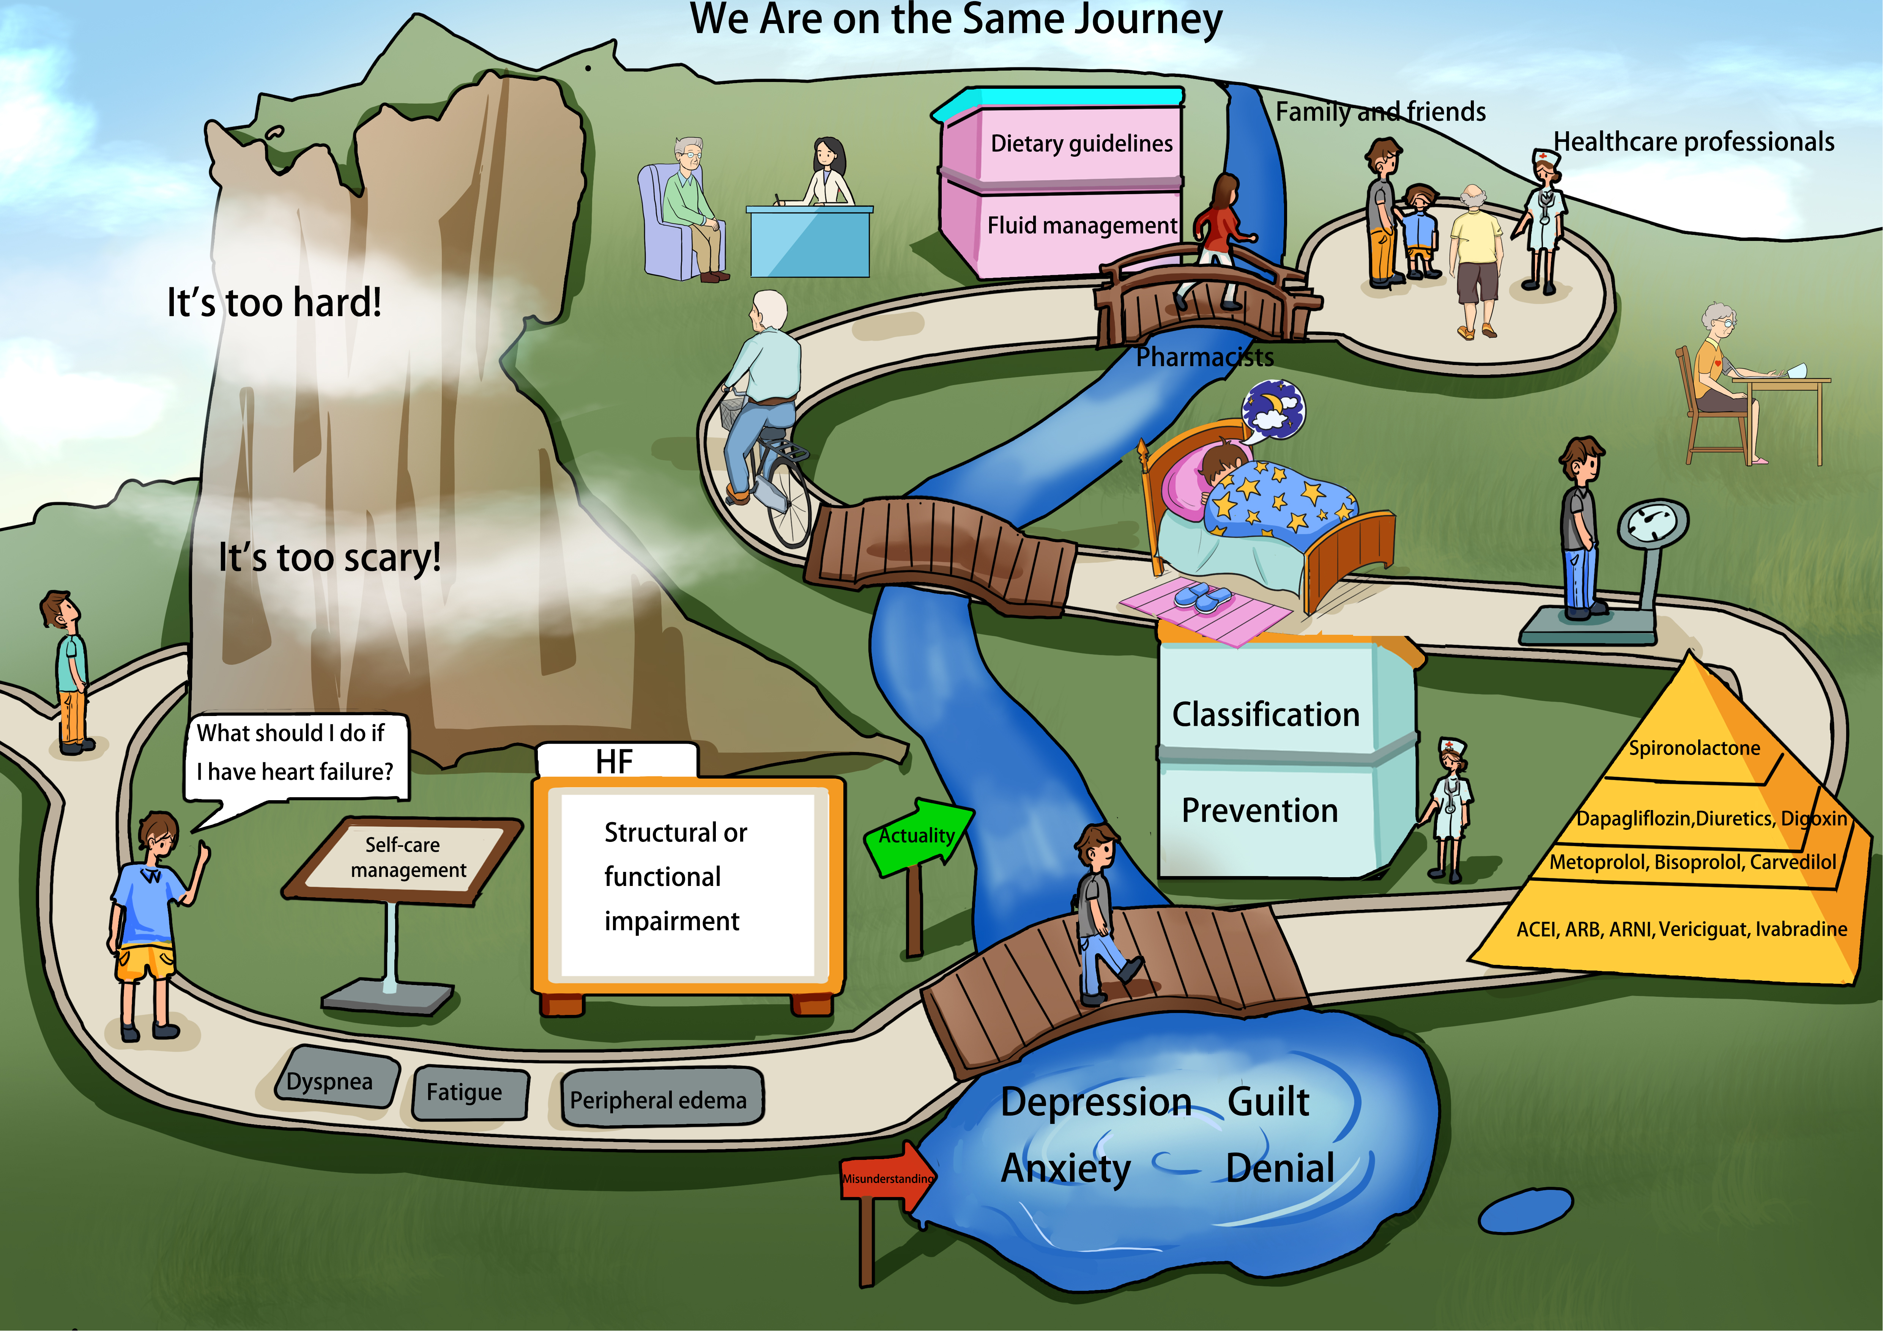

eFigure 13 We are on the same journey.

eTable 1 Comments from the participants and relevant revisions
Sections | Comments | Revisions
Cognition of HF | Doctor A: The structure of the heart shown in Figure 1 is too complex and should be simplified. The characteristics of a normal heart and a heart with HF should be more prominent. | Simplified heart structure. Highlight the characteristics of normal heart and HF heart.
Cognition of HF | Doctor B: The heart valve shown in Figure 2 was not in the correct position. | Modify the heart valve to ensure it is in the correct position.
Cognition of HF | Pharmacist B: Classification of HF shown in Figure 2, the cartoon image of slow jogging was not appropriate for level I. Images of daily physical activities such as sweeping the floor should be used. | Using sweeping the floor instead of jogging.
Cognition of HF | Pharmacist C: The layout of Figure 3 was not appropriate, the images and text were a little too large and it looked too cramped. | Optimizing the layout.
Cognition of HF | Patient A: Since most HF patients are elderly, the characters suffering from HF should be elderly to increase the sense of intimacy. | All the characters suffering from HF are replaced with older people.
Medication treatment of HF | Patient B: It is recommended that the eight drugs be placed on two sheets of paper, as they are too crowded on one sheet. The horizontal layout of adverse reactions and monitoring is not very reasonable and scattered. Can it be changed to a vertical layout? | Eight drugs are scattered over two sheets of paper. Adverse reactions and monitoring are changed to a vertical layout.
Medication treatment of HF | Pharmacist B: Terms such as “renin-angiotensin system inhibitors”, “beta-blockers”, “aldosterone receptor antagonists” and “sodium-dependent glucose transporter 2 inhibitors” are too technical for patients to understand! | Using representative drugs as headings instead of technical terms.
Medication treatment of HF | Doctor A: Although ACEI/ARB/ARNI drugs have anti-inflammatory properties and can repair the vascular endothelium, the image shows that they can directly make the vascular endothelium completely smooth, which is exaggerated and will mislead patients! | Modified the image of ACEI/ARB/ARNI drugs that can make vascular endothelium smoother.
Medication treatment of HF | Pharmacist C: ACEI/ARB/ARNI drugs have the effect of improving myocardial reconstruction. That's a bit too obscure to understand. Can you make it more simply? | Myocardial reconstruction can be described as returning an enlarged heart to its normal size.
Medication treatment of HF | Doctor A: ACEI/ARB/ARNI drugs have the effect of dilating blood vessels and lowering blood pressure. The image doesn't show it very clearly, and I didn't even notice that the blood vessels had become thinner! | Reducing the thickness of blood vessels.
Medication treatment of HF | Pharmacist C: The difference between a failure heart and a normal heart is not obvious in the part of beta-blockers. A heart with HF should be more painful, while a normal heart should be more relaxed. | Adding expressions of pain and pleasure.
Medication treatment of HF | Pharmacist E: To enhance clarity in the part of beta-blockers, consider adding words such as “I'm so tired because I'm jumping too fast and don't have time to rest”, and “If I jump more slowly, I can rest for a while”. | Adding “I'm so tired because I'm jumping too fast and don't have time to rest”, and “If I jump more slowly, I can rest for a while”.
Medication treatment of HF | Pharmacist C: SGLT-2i acts on the renal tubules to excrete sugar and sodium, which removes excess water. The excretion of sodium and water is not shown in the diagram. | Adding excretion of sodium and water in the diagram.
Medication treatment of HF | Pharmacist D: The figure does not clearly show how SGLT-2i protects the heart and kidneys. SGLT-2i acts on the kidney to excrete excess sugar and sodium, and also to remove excess water from the body. It has been shown to reduce blood volume. | Refinement how SGLT-2i protects the heart and kidneys using a more understandable approach.
Medication treatment of HF | Doctor A: Tolvaptan should not be taken every day. It can be stopped once there is no more oedema. The recommendation is described as taking tolvaptan as prescribed. | Tolvaptan should be taken as prescribed.
Medication treatment of HF | Pharmacist C: The description of the diuretic process is not vivid enough. It is suggested that running water from the tap would be more intuitive. | Running water from the tap is used to describe the diuretic process.
Medication treatment of HF | Pharmacist D: Add some words to make it more lively, like “I can't run anymore” and “I'll roll up my sleeves and work harder”. | Adding “I can't run anymore” and “I'll roll up my sleeves and work harder”.
Medication treatment of HF | Pharmacist E: Among the side effects of digoxin, the yellow-green vision should be highlighted. The drug concentration of digoxin in the blood of HF patients is not 0.5-2 μg/L, but 0.5-0.9 μg/L. | Yellow-green vision is highlighted. The drug concentration of digoxin in the blood of HF patients is 0.5-0.9 μg/L.
Management of HF | Pharmacist A: The description of pursed-lip breathing training is unclear. It is recommended to increase the font size, simplify the images, and highlight the features. | As suggested, fonts are enlarged, images are simplified, and features are highlighted.
Management of HF | Doctor B: Sodium intake for patients with stable HF is not <2g/day, but <6g/day. | Sodium intake for patients with stable HF is <6g/day.
Management of HF | Doctor B: The volume calculation tool recommends using a measuring cup or measuring cylinder. | Adding a measuring cup and a measuring cylinder to calculate the volume.
Management of HF | Doctor C: The formula for fluid management should indicate that it is for stable HF. | Adding stable HF in the formula for fluid management.
Management of HF | Patient A: The definition of fluid overload is not clear and should be clearly marked. | 24h weight gain >1.5kg or 3 days weight gain >2.0kg, indicating excess body fluids.
Management of HF | Patient D: The description of quitting smoking is unclear. | Making quitting smoking clearer.
Management of HF | Nurse A: It is recommended to include nurses as they are also the medical caregivers of HF patients. | Nurses are added in healthcare professionals.
Management of HF | Pharmacist C: The pyramid is not suitable for a list of medicines because it has a hierarchy. It is recommended to list the drugs in a table. | A table is replaced to list the drugs.

