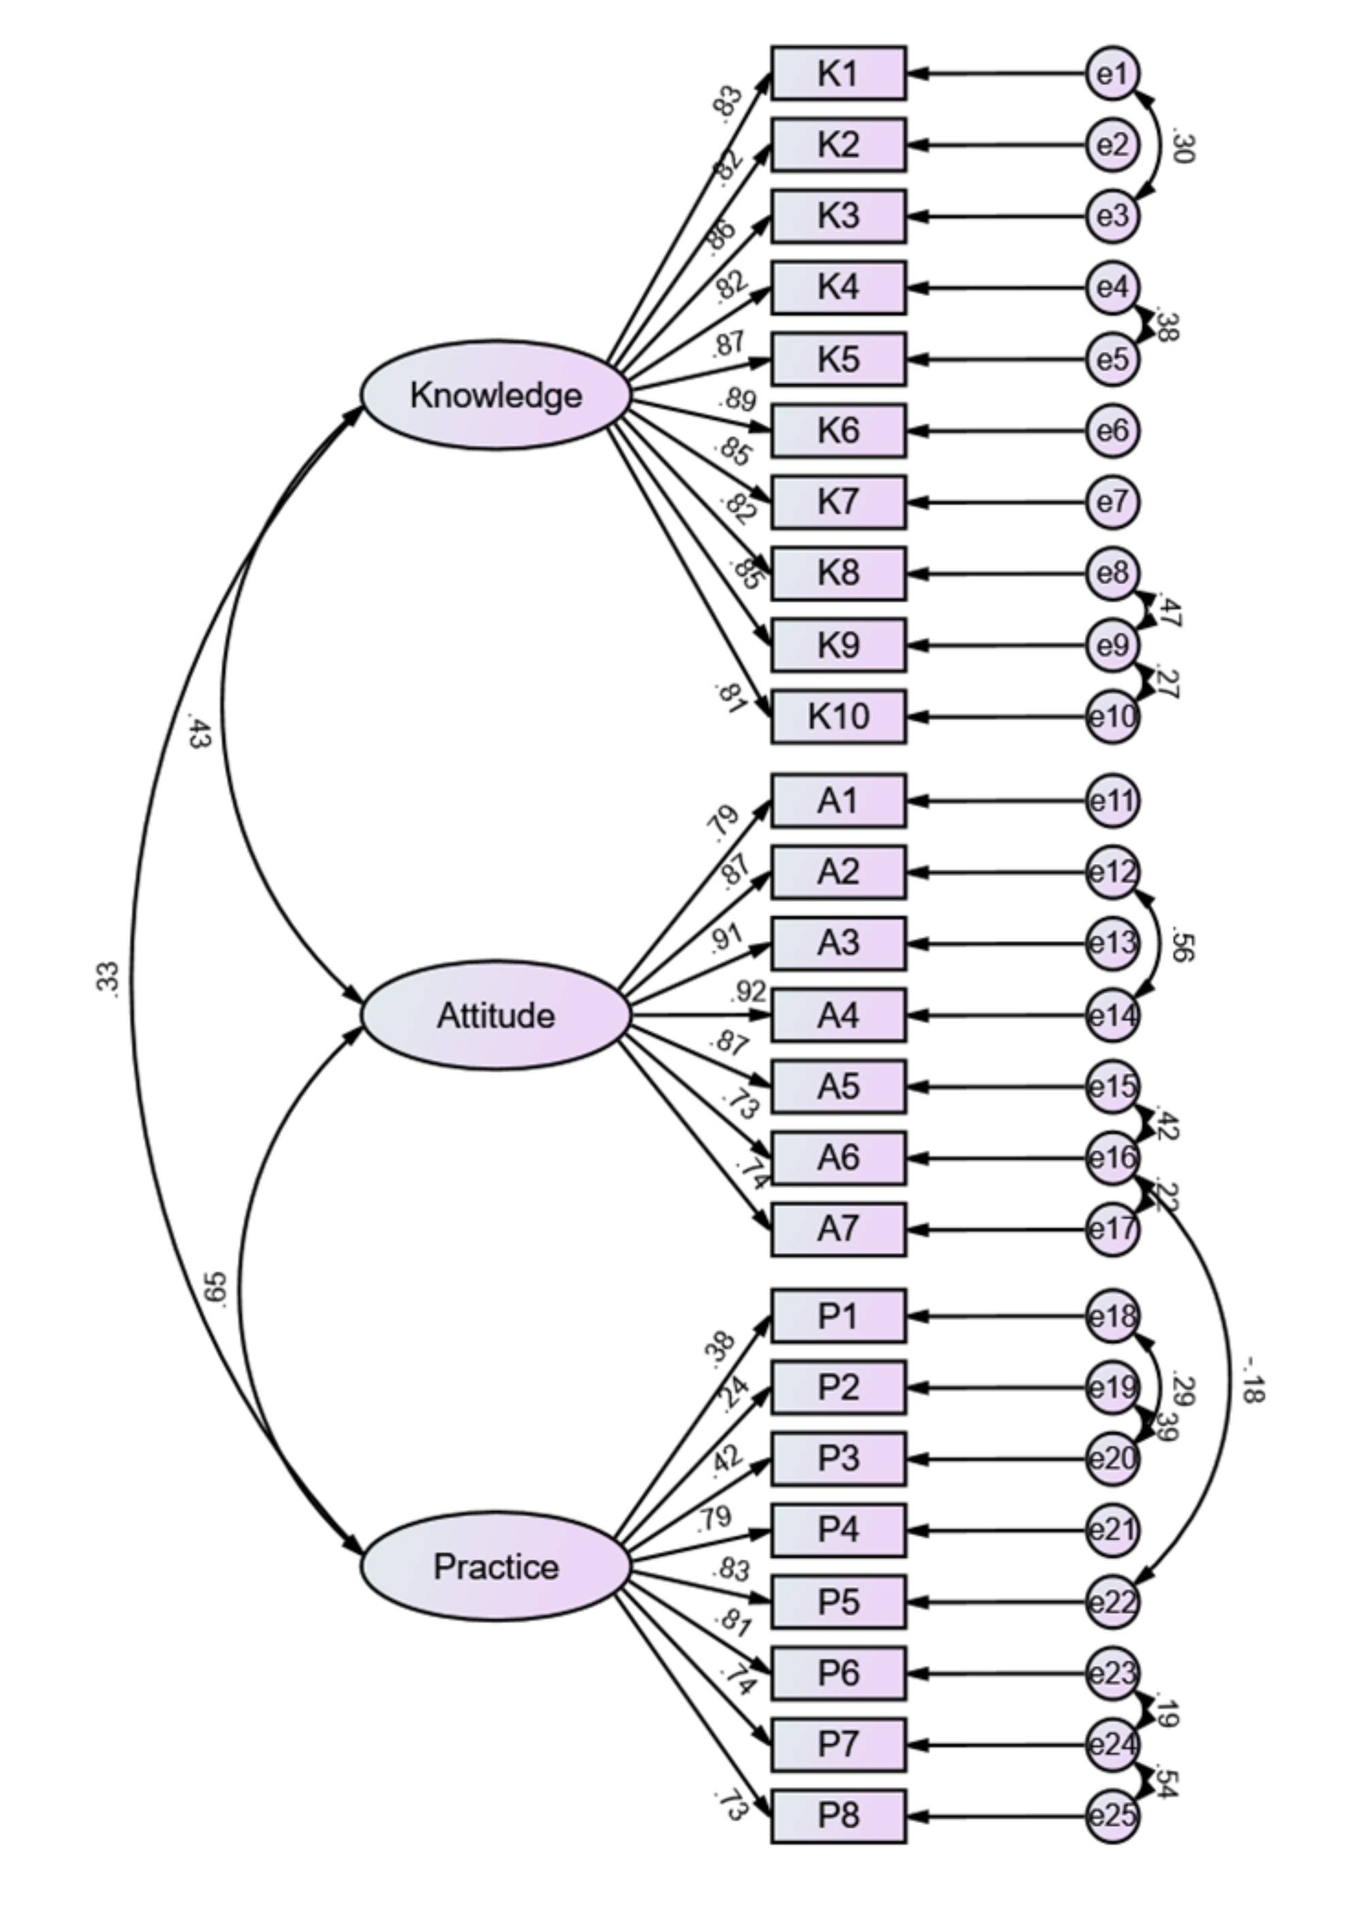Figure S1. Confirmatory factor analysis (CFA) model

Table S1. Post-Hoc Tests of Baseline Characteristics
 |  | Knowledge |  | Attitude |  | Practice
 |  | P | Bonferroni P | P | Bonferroni P | P | Bonferroni P
BMI | Underweight VS Normal | 0.002 | 0.011 | 0.671 | 1.000 | 0.106 | 0.639
BMI | Underweight VS Overweight | <0.001 | 0.001 | 0.675 | 1.000 | 0.086 | 0.519
BMI | Underweight VS Obesity | <0.001 | 0.003 | 0.228 | 1.000 | 0.008 | 0.049
BMI | Normal VS Overweight | 0.136 | 0.814 | 0.986 | 1.000 | 0.767 | 1.000
BMI | Normal VS Obesity | 0.312 | 1.000 | 0.006 | 0.037 | 0.045 | 0.271
BMI | Overweight VS Obesity | 0.836 | 1.000 | 0.011 | 0.064 | 0.103 | 0.617
Education | Junior high school or below VS High school/Technical school | 0.116 | 1.000 | 0.986 | 1.000 | 0.116 | 1.000
Education | Junior high school or below VS College | 0.019 | 0.191 | <0.001 | 0.004 | 0.087 | 0.874
Education | Junior high school or below VS Bachelor’s degree | <0.001 | 0.001 | <0.001 | 0.001 | <0.001 | 0.002
Education | Junior high school or below Master’s degree and above | <0.001 | 0.001 | <0.001 | 0.001 | <0.001 | 0.001
Education | High school/Technical school VS College | 0.439 | 1.000 | <0.001 | 0.001 | 0.985 | 1.000
Education | High school/Technical school VS Bachelor’s degree | <0.001 | 0.001 | <0.001 | 0.001 | 0.015 | 0.146
Education | High school/Technical school VS Master’s degree and above | <0.001 | 0.001 | <0.001 | 0.001 | 0.001 | 0.015
Education | College VS Bachelor’s degree | <0.001 | 0.004 | 0.277 | 1.000 | 0.005 | 0.047
Education | College VS Master’s degree and above | <0.001 | 0.001 | 0.020 | 0.200 | <0.001 | 0.008
Education | Bachelor’s degree VS Master’s degree and above | 0.054 | 0.544 | 0.082 | 0.820 | 0.081 | 0.806
Occupation | Employed VS Homemaker | 0.707 | 1.000 | 0.463 | 1.000 | 0.569 | 1.000
Occupation | Employed VS Freelancer | 0.089 | 0.537 | <0.001 | 0.001 | 0.040 | 0.242
Occupation | Employed VS Other | <0.001 | 0.002 | <0.001 | 0.002 | <0.001 | 0.001
Occupation | Homemaker VS Freelancer | 0.434 | 1.000 | 0.077 | 0.463 | 0.067 | 0.403
Occupation | Homemaker VS Other | 0.032 | 0.195 | 0.060 | 0.359 | 0.002 | 0.010
Occupation | Freelancer VS Other | 0.098 | 0.588 | 0.831 | 1.000 | 0.101 | 0.608
Pregnancy Trimester | Early pregnancy VS Mid-pregnancy | / | / | 0.001 | 0.004 | 0.003 | 0.009
Pregnancy Trimester | Early pregnancy VS Late pregnancy | / | / | <0.001 | 0.002 | 0.284 | 0.852
Pregnancy Trimester | Mid-pregnancy VS Late pregnancy | / | / | 0.704 | 1.000 | 0.008 | 0.025

Table S2. Confirmatory factor analysis fits
Indicators | Reference | Actual
CMIN/DF | 1-3: Excellent, 3-5: Good | 4.732
RMSEA | <0.08: Good | 0.079
IFI | >0.8: Good | 0.925
TLI | >0.8: Good | 0.913
CFI | >0.8: Good | 0.925

Table S3. Confirmatory factor analysis Regression Weights
 |  |  | Estimate | Standardized Estimate | S.E. | C.R. | P
K1 | <--- | Knowledge | 1.000 | 0.830
K2 | <--- | Knowledge | 0.959 | 0.815 | 0.041 | 23.588 | <0.001
K3 | <--- | Knowledge | 1.085 | 0.856 | 0.036 | 30.512 | <0.001
K4 | <--- | Knowledge | 1.084 | 0.821 | 0.046 | 23.813 | <0.001
K5 | <--- | Knowledge | 1.068 | 0.870 | 0.041 | 26.146 | <0.001
K6 | <--- | Knowledge | 1.134 | 0.889 | 0.042 | 27.133 | <0.001
K7 | <--- | Knowledge | 1.074 | 0.853 | 0.042 | 25.358 | <0.001
K8 | <--- | Knowledge | 0.992 | 0.824 | 0.041 | 23.993 | <0.001
K9 | <--- | Knowledge | 1.000 | 0.846 | 0.040 | 25.004 | <0.001
K10 | <--- | Knowledge | 1.007 | 0.807 | 0.043 | 23.220 | <0.001
A1 | <--- | Attitude | 1.000 | 0.790
A2 | <--- | Attitude | 1.119 | 0.871 | 0.047 | 23.797 | <0.001
A3 | <--- | Attitude | 1.070 | 0.911 | 0.042 | 25.453 | <0.001
A4 | <--- | Attitude | 1.080 | 0.918 | 0.042 | 25.697 | <0.001
A5 | <--- | Attitude | 1.163 | 0.874 | 0.048 | 24.026 | <0.001
A6 | <--- | Attitude | 1.040 | 0.727 | 0.055 | 18.830 | <0.001
A7 | <--- | Attitude | 0.964 | 0.742 | 0.050 | 19.346 | <0.001
P1 | <--- | Practice | 1.000 | 0.385
P2 | <--- | Practice | 0.622 | 0.237 | 0.132 | 4.718 | <0.001
P3 | <--- | Practice | 0.959 | 0.418 | 0.117 | 8.210 | <0.001
P4 | <--- | Practice | 1.536 | 0.789 | 0.173 | 8.859 | <0.001
P5 | <--- | Practice | 1.618 | 0.831 | 0.180 | 8.966 | <0.001
P6 | <--- | Practice | 1.661 | 0.810 | 0.186 | 8.910 | <0.001
P7 | <--- | Practice | 1.416 | 0.742 | 0.163 | 8.702 | <0.001
P8 | <--- | Practice | 1.306 | 0.731 | 0.150 | 8.684 | <0.001

