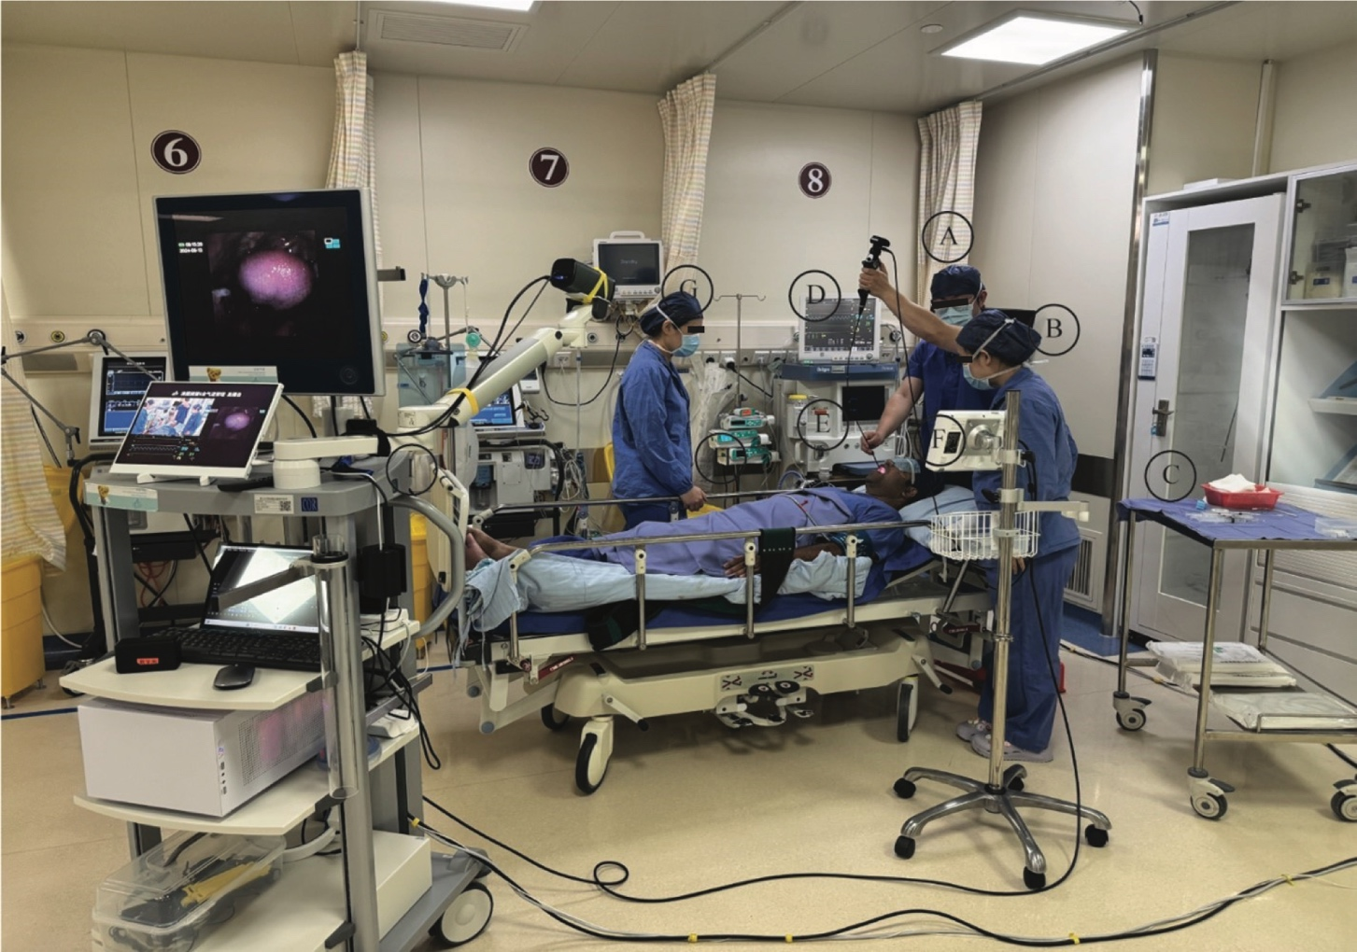
Supplementary Figure 1. Ergonomics during awake flexible bronchoscopy intubation. A) Operator. B) Assistant. C) Airway trolley. D) Patient monitor. E) Anesthesia machine, and suction. F) Video monitor. G) Second anesthetist. H) Fluid and pump. I) Recording system.

Supplementary Figure 2.Still image of a video of awake flexible bronchoscopy intubation: A) Outside view of the camera system. B) Endoscopic view of bronchoscope. C) Patient’s vital signs and hemodynamic parameters.

Supplementary Table 1: Hemodynamic changes of heart rate (HR), mean non-invasive blood pressure (MBP), and oxygen saturation (SpO₂) during awake flexible bronchoscopy intubation.
 | Overall | First Attempt Success  (n=128) | Multiple Attempts Success  (n=19) | P-Value
 | (n=147) | First Attempt Success  (n=128) | Multiple Attempts Success  (n=19) | P-Value
HR(bpm)
T1 | 78.58 ±14.17 | 77.92±14.04 | 83.00±14.66 | 0.146
T2 | 77.15±13.74 | 75.83±12.61 | 86.05±17.70 | 0.002
T3 | 75.30±12.92 | 74.48±12.36 | 80.84±15.43 | 0.045
T4 | 74.14±11.95 | 73.34±11.50 | 79.58±13.79 | 0.033
T5 | 75.78±14.64 | 74.70±14.12 | 83.05±16.40 | 0.020
T6 | 71.94±13.36 | 71.41±13.29 | 75.47±13.68 | 0.218
MBP (mmHg)
T1 | 103.37±12.50 | 102.94±12.63 | 106.32±11.46 | 0.273
T2 | 104.54±13.37 | 104.56±13.69 | 104.37±11.26 | 0.953
T3 | 102.97±15.89 | 102.70±16.00 | 104.74±15.49 | 0.604
T4 | 96.76±15.71 | 96.37±15.84 | 99.37±14.92 | 0.439
T5 | 94.29±13.90 | 93.99±13.74 | 96.32±15.20 | 0.498
T6 | 93.52±15.62 | 93.41±15.87 | 94.26±14.24 | 0.826
SpO₂ (%)
T1 | 98.87±1.64 | 98.86±1.70 | 98.95±1.18 | 0.828
T2 | 99.03±1.75 | 99.10±1.59 | 98.58±2.63 | 0.227
T3 | 98.90±1.51 | 98.97±1.46 | 98.42±1.80 | 0.141
T4 | 97.86±4.16 | 97.78±4.40 | 98.42±1.80 | 0.533
T5 | 97.85±2.74 | 97.88±2.82 | 97.68±2.14 | 0.778
T6 | 97.55±2.94 | 97.54±3.03 | 97.63±2.29 | 0.899
Note: Values are presented as mean±SD. The time points were defined as T1, the beginning of the procedure; T2, after the application of local anesthetics to the oral cavity; T3, after local anesthetics were applied to the supraglottic region; T4, after local anesthetics were applied to the subglottic region; T5, after the successful insertion of the endotracheal tube; and T6, at the end of the procedure.
Abbreviation: HR, heart rate; MBP; mean non-invasive blood pressure; SpO_{2,} Oxygen Saturation.

Supplementary Table 2: Sedation level variations during awake flexible bronchoscopy intubation.

 | Overall | First Attempt Success  (n=128) | Multiple Attempts Success  (n=19) | P-Value
 | (n=147) | First Attempt Success  (n=128) | Multiple Attempts Success  (n=19) | P-Value
T1
Sedation Score |  |  |  | 1
1 | 101 (68.71%) | 88 (68.75%) | 13 (68.42%)
2 | 46 (31.29%) | 40 (31.25%) | 6 (31.58%)
3 | 0 | 0 | 0
T2
Sedation Score |  |  |  | 0.534
1 | 2 (1.36%) | 2 (1.56%) | 0
2 | 139 (94.56%) | 120 (93.75%) | 19 (100.00)
3 | 6 (4.08%) | 6 (4.69%) | 0
T3
Sedation Score |  |  |  | 0.904
1 | 81(55.10%) | 70 (54.69%) | 11 (57.89%)
2 | 65 (44.22%) | 57 (44.53%) | 8 (42.11%)
3 | 1 (0.68%) | 1 (0.78%) | 0
T4
Sedation Score |  |  |  | 0.796
1 | 101 (68.71%) | 87 (67.97%) | 14 (73.68%)
2 | 40 (27.21%) | 36 (28.12%) | 4 (21.05%)
3 | 6 (4.08%) | 5 (3.91%) | 1 (5.26%)
T5
Sedation Score |  |  |  | 0.449
1 | 25 (17.01%) | 20 (15.62%) | 5 (26.32%)
2 | 108 (73.47%) | 95 (74.22%) | 13 (68.42%)
3 | 14 (9.52%) | 13 (10.16%) | 1 (5.26%)
T6
Sedation Score |  |  |  | 0.193
1 | 15 (10.20%) | 12 (9.38%) | 3 (15.79%)
2 | 115 (78.23%) | 99 (77.34%) | 16 (84.21%)
3 | 17 (11.56%) | 17 (13.28%) | 0
Note: Values are presented as n (%). The time points were defined as T1, the beginning of the procedure; T2, after the application of local anesthetics to the oral cavity; T3, after local anesthetics were applied to the supraglottic region; T4, after local anesthetics were applied to the subglottic region; T5, after the successful insertion of the endotracheal tube; and T6, at the end of the procedure.Sedation Score was defined as 1: Ramsay Sedation Score 1, 2: Ramsay Sedation Score 2, 3: Ramsay Sedation Score 3.

