Supplementary Information
1. TEM and SEM of PC.
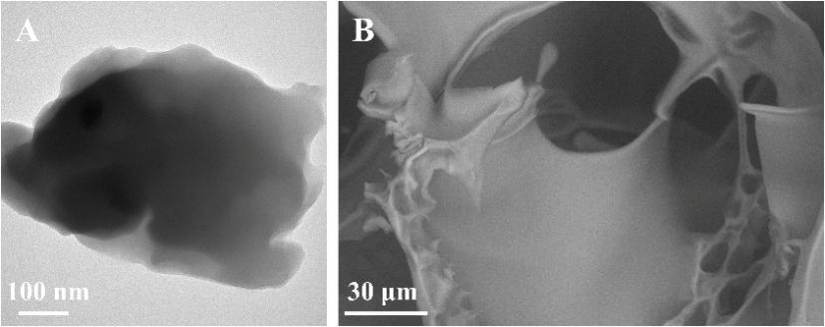
Figure S1 A) TEM image of PC. B) SEM image of PC.
2. EDS of PCA, PA, and CA.
Figure S2 EDS images of PCA, PA, and CA.
3. FTIR of PC.
Figure S3 FTIR spectra of PC.
4. Isolation of HDPSCs Using the Tissue Explant Method.
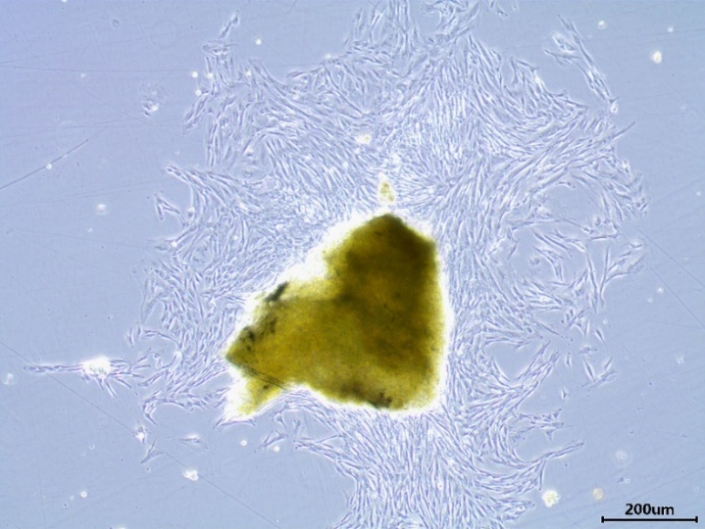
Figure S4 Morphological Characterization of HDPSCs Isolated via Tissue Explant.
5. Flow Cytometric Analysis of HDPSCs.
Figure S5 Flow Cytometric Analysis of Surface Markers in HDPSCs.

