Supplementary Material for

Combined ε-Toxin Nanovaccine with Enhanced Immunity for Effective Protection in a Murine Model

This PDF file includes:
1. Figure S1 to S12
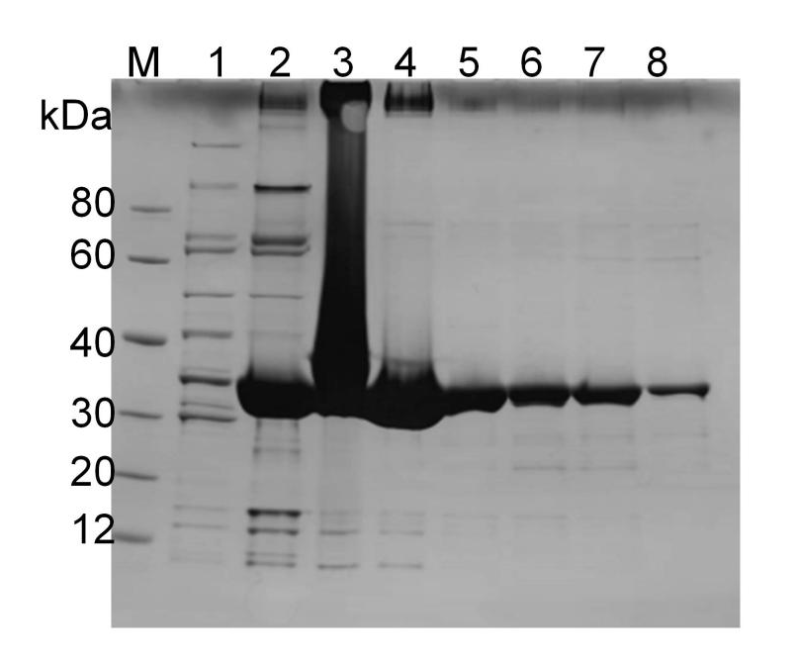
Figure S1. SDS-PAGE electrophoresis of purified ETX^{Y196E} protein, the theoretical molecular weight of the ETX^{Y196E} protein is approximately 32 kDa. Lane M is the protein marker, lane 1~8 are the purified protein solutions.
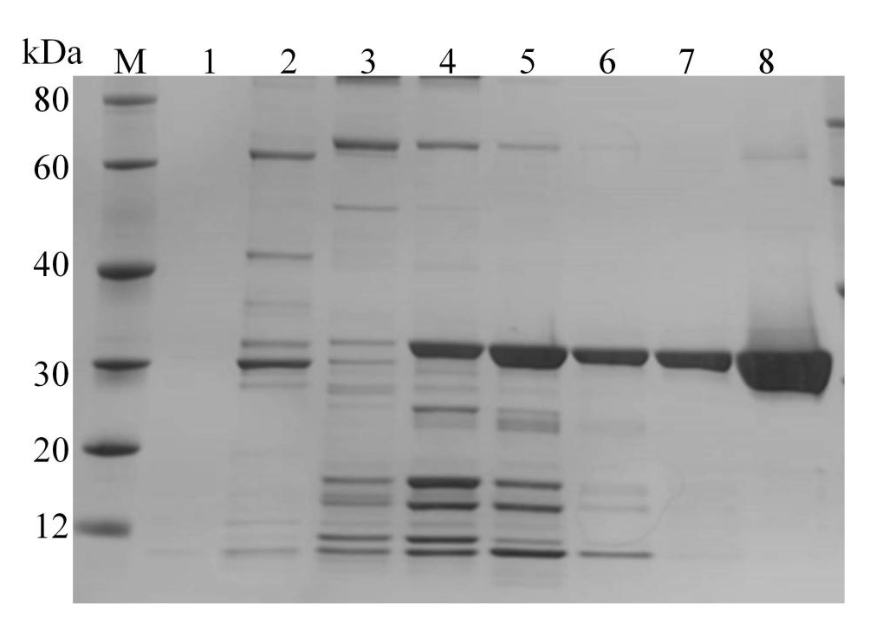
Figure S2. SDS-PAGE electrophoresis of purified HIS-ETX protein, the theoretical molecular weight of the HIS-ETX protein is approximately 32 kDa. Lane M is the protein marker, lane 1~8 are the purified protein solutions.
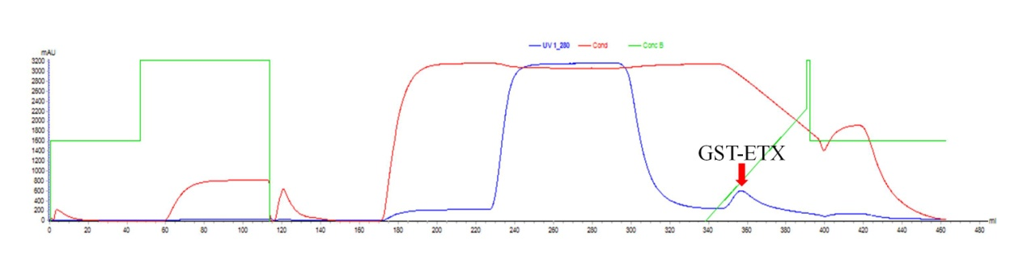
Figure S3. The affinity chromatographic profiles of protein GST-ETX.
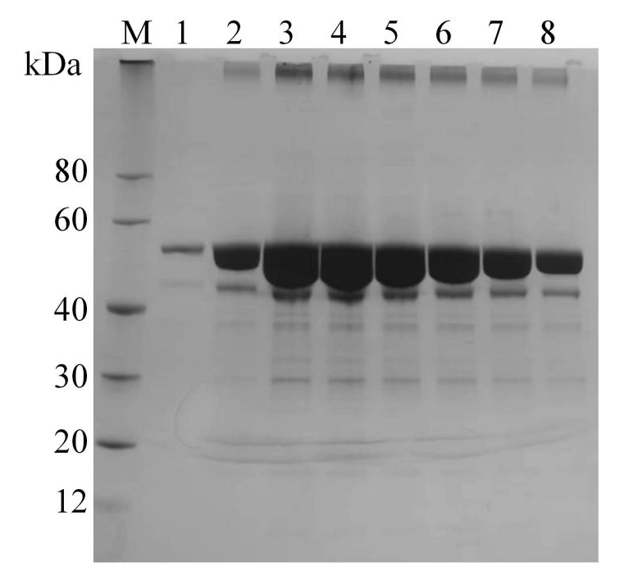
Figure S4. SDS-PAGE electrophoresis of purified GST-ETX protein, the theoretical molecular weight of the GST-ETX protein is approximately 56 kDa. Lane M is the protein marker, lane 1~8 are the purified protein solutions.
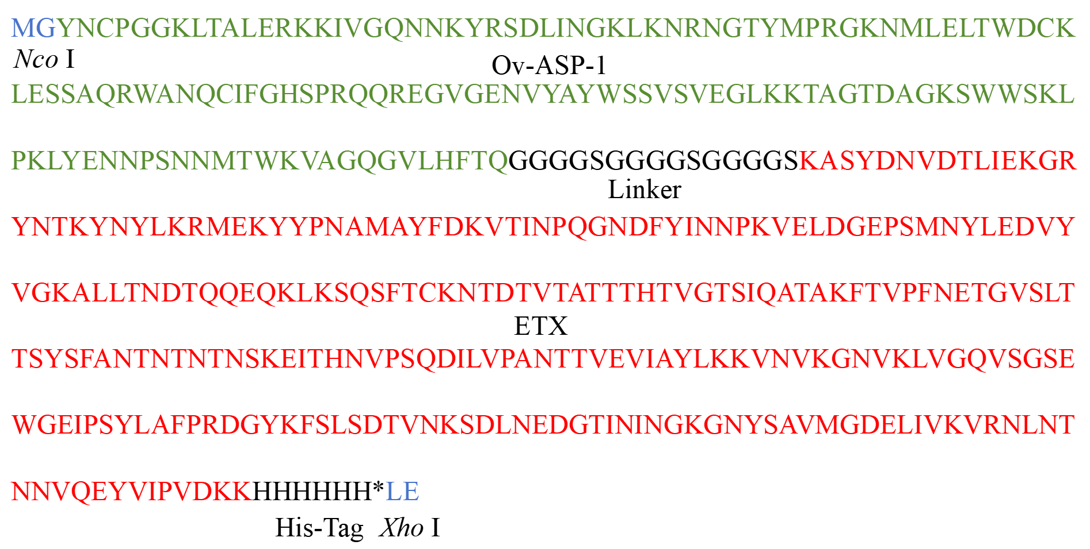
Figure S5. Amino acid sequence of ASP-ETX recombinant protein. The Ov-ASP-1 17~152 AAs, 3 flexible Linkers (GGGGS), ETX, 6 × HIS tag and according to the cleavage site of pET-28a, Nco Ⅰ (CCATGG) and Xho Ⅰ (CTCGAG) cleavage sites were introduced at both ends of the sequence. *: Terminator.
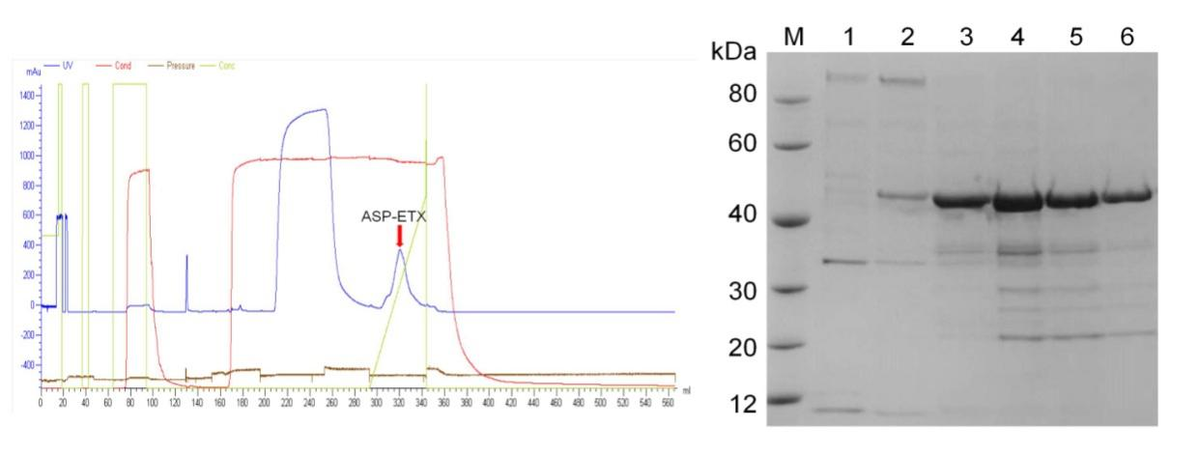
Figure S6. SDS-PAGE electrophoresis of purified ASP-ETX protein, the theoretical molecular weight of the ASP-ETX protein is approximately 46 kDa. Lane M is the protein marker, lane 1~6 are the purified protein solutions.
Figure S7. In vitro toxicities of HIS-ETX (n=3).
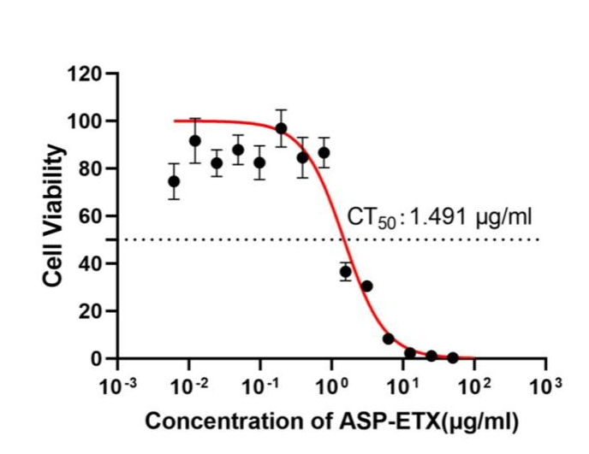
Figure S8. In vitro toxicities of ASP-ETX (n=3).
Figure S9. In vitro toxicities of GST-ETX.
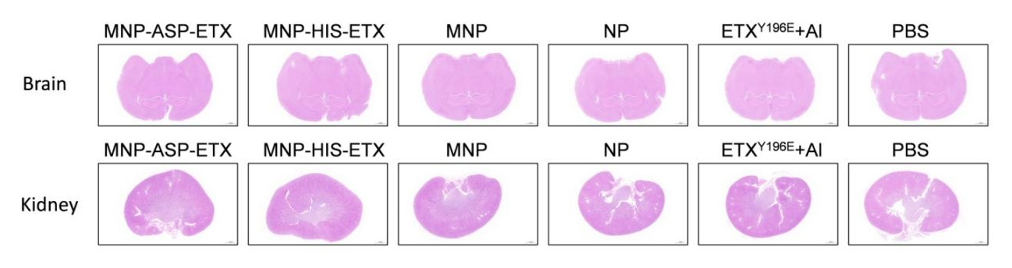
Figure S10. Representative sections of mouse brain and kidney in safety experiments, stained with H&E (scale bar: 1 mm).

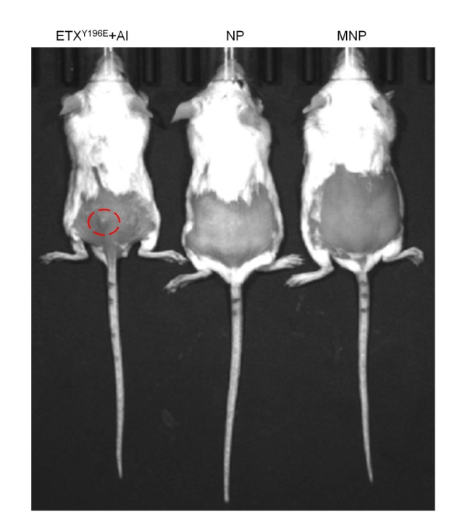
Figure S11. The injection site nodules of mice injected with ETX^{Y196E}+Al (n=3). The red circle part was obvious s.c. nodule generation in ETXY196E + Al.
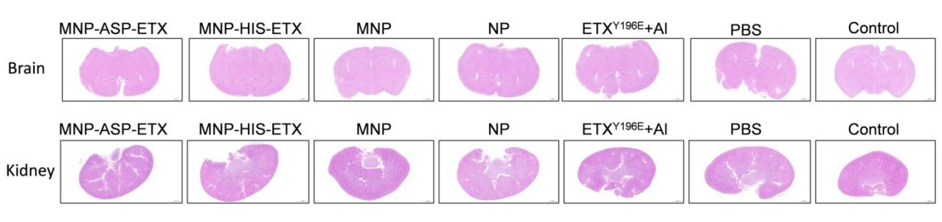
Figure S12. Representative sections of mouse brain and kidney in protection experiments, stained with H&E (scale bar: 1 mm).

