The short- and long-term efficacy of Non-Invasive Brain Stimulation for migraine: A Meta-Analysis

Supplementary Files

Catalog of supplementary materials

Supplementary 1. PRISMA 2020 Checklist
Supplementary 2. Search strategy
Supplementary 3. Meta-regression analysis
Supplementary 4. Funnel plot analysis

Supplementary 1. PRISMA 2020 Checklist
Section and Topic | Item # | Checklist item | Location where item is reported
TITLE
Title | 1 | Identify the report as a systematic review. | Page 1
ABSTRACT
Abstract | 2 | See the PRISMA 2020 for Abstracts checklist. | Page 1
INTRODUCTION
Rationale | 3 | Describe the rationale for the review in the context of existing knowledge. | Page 2
Objectives | 4 | Provide an explicit statement of the objective(s) or question(s) the review addresses. | Page 3
METHODS
Eligibility criteria | 5 | Specify the inclusion and exclusion criteria for the review and how studies were grouped for the syntheses. | Page 4
Information sources | 6 | Specify all databases, registers, websites, organisations, reference lists and other sources searched or consulted to identify studies. Specify the date when each source was last searched or consulted. | Page 4
Search strategy | 7 | Present the full search strategies for all databases, registers and websites, including any filters and limits used. | Page 4
Selection process | 8 | Specify the methods used to decide whether a study met the inclusion criteria of the review, including how many reviewers screened each record and each report retrieved, whether they worked independently, and if applicable, details of automation tools used in the process. | Page 4
Data collection process | 9 | Specify the methods used to collect data from reports, including how many reviewers collected data from each report, whether they worked independently, any processes for obtaining or confirming data from study investigators, and if applicable, details of automation tools used in the process. | Page 5
Data items | 10a | List and define all outcomes for which data were sought. Specify whether all results that were compatible with each outcome domain in each study were sought (e.g. for all measures, time points, analyses), and if not, the methods used to decide which results to collect. | Page 4-5
Data items | 10b | List and define all other variables for which data were sought (e.g. participant and intervention characteristics, funding sources). Describe any assumptions made about any missing or unclear information. | Page 5
Study risk of bias assessment | 11 | Specify the methods used to assess risk of bias in the included studies, including details of the tool(s) used, how many reviewers assessed each study and whether they worked independently, and if applicable, details of automation tools used in the process. | Page 5-6
Effect measures | 12 | Specify for each outcome the effect measure(s) (e.g. risk ratio, mean difference) used in the synthesis or presentation of results. | Page 6
Synthesis methods | 13a | Describe the processes used to decide which studies were eligible for each synthesis (e.g. tabulating the study intervention characteristics and comparing against the planned groups for each synthesis (item #5)). | Page 6-7
Synthesis methods | 13b | Describe any methods required to prepare the data for presentation or synthesis, such as handling of missing summary statistics, or data conversions. | Page 6-7
Synthesis methods | 13c | Describe any methods used to tabulate or visually display results of individual studies and syntheses. | Page 6-7
Synthesis methods | 13d | Describe any methods used to synthesize results and provide a rationale for the choice(s). If meta-analysis was performed, describe the model(s), method(s) to identify the presence and extent of statistical heterogeneity, and software package(s) used. | Page 6-7
Synthesis methods | 13e | Describe any methods used to explore possible causes of heterogeneity among study results (e.g. subgroup analysis, meta-regression). | Page 6-7
Synthesis methods | 13f | Describe any sensitivity analyses conducted to assess robustness of the synthesized results. | Page 6-7
Reporting bias assessment | 14 | Describe any methods used to assess risk of bias due to missing results in a synthesis (arising from reporting biases). | Page 5-6
Certainty assessment | 15 | Describe any methods used to assess certainty (or confidence) in the body of evidence for an outcome. | Page 5-6
RESULTS
Study selection | 16a | Describe the results of the search and selection process, from the number of records identified in the search to the number of studies included in the review, ideally using a flow diagram. | Page 7
Study selection | 16b | Cite studies that might appear to meet the inclusion criteria, but which were excluded, and explain why they were excluded. | Page 7
Study characteristics | 17 | Cite each included study and present its characteristics. | Page 7-8
Risk of bias in studies | 18 | Present assessments of risk of bias for each included study. | Page 8
Results of individual studies | 19 | For all outcomes, present, for each study: (a) summary statistics for each group (where appropriate) and (b) an effect estimate and its precision (e.g. confidence/credible interval), ideally using structured tables or plots. | Page 8-12
Results of syntheses | 20a | For each synthesis, briefly summarise the characteristics and risk of bias among contributing studies. | Page 8-12
Results of syntheses | 20b | Present results of all statistical syntheses conducted. If meta-analysis was done, present for each the summary estimate and its precision (e.g. confidence/credible interval) and measures of statistical heterogeneity. If comparing groups, describe the direction of the effect. | Page 8-12
Results of syntheses | 20c | Present results of all investigations of possible causes of heterogeneity among study results. | Page 8-12
Results of syntheses | 20d | Present results of all sensitivity analyses conducted to assess the robustness of the synthesized results. | Page 8-12
Reporting biases | 21 | Present assessments of risk of bias due to missing results (arising from reporting biases) for each synthesis assessed. | Page 8
Certainty of evidence | 22 | Present assessments of certainty (or confidence) in the body of evidence for each outcome assessed. | Page 8
DISCUSSION
Discussion | 23a | Provide a general interpretation of the results in the context of other evidence. | Page 12
Discussion | 23b | Discuss any limitations of the evidence included in the review. | Page 13
Discussion | 23c | Discuss any limitations of the review processes used. | Page 13
Discussion | 23d | Discuss implications of the results for practice, policy, and future research. | Page 13
OTHER INFORMATION
Registration and protocol | 24a | Provide registration information for the review, including register name and registration number, or state that the review was not registered. | Page 4
Registration and protocol | 24b | Indicate where the review protocol can be accessed, or state that a protocol was not prepared. | Page 4
Registration and protocol | 24c | Describe and explain any amendments to information provided at registration or in the protocol. | Page 4
Support | 25 | Describe sources of financial or non-financial support for the review, and the role of the funders or sponsors in the review. | Page 14
Competing interests | 26 | Declare any competing interests of review authors. | Page 14
Availability of data, code and other materials | 27 | Report which of the following are publicly available and where they can be found: template data collection forms; data extracted from included studies; data used for all analyses; analytic code; any other materials used in the review. | Page 14

Supplementary 2. Search strategy
Pubmed-290
1 AND ( 2 OR 3 OR 4 ) AND 5
(((((((((((((((((((((((((((((((((((((("Migraine Disorders"[Mesh]) OR (Disorder, Migraine)) OR (Disorders, Migraine)) OR (Migraine Disorder)) OR (Migraine)) OR (Migraines)) OR (Migraine Headache)) OR (Headache, Migraine)) OR (Headaches, Migraine)) OR (Migraine Headaches)) OR (Acute Confusional Migraine)) OR (Acute Confusional Migraines)) OR (acute confusional migraine)) OR (Migraine, Acute Confusional)) OR (Migraines, Acute Confusional)) OR (Status Migrainosus)) OR (Hemicrania Migraine)) OR (Hemicrania Migraines)) OR (Migraines, Hemicrania)) OR (Migraine Variants)) OR (Variant, Migraine)) OR (Variants, Migraine)) OR (Sick Headache)) OR (Headache, Sick)) OR (Headaches, Sick)) OR (Sick Headaches)) OR (Abdominal Migraine)) OR (Migraine, Abdominal)) OR (Migraines, Abdominal)) OR (Cervical Migraine Syndrome)) OR (Cervical Migraine Syndromes)) OR (Migraine Syndrome, Cervical)) OR (Migraine Syndromes, Cervical)) OR (migraine with aura)) OR (migraine without aura)) OR (headache disorders)) OR (chronic migraine)) AND ((((((((((("Transcranial Magnetic Stimulation"[Mesh]) OR (Magnetic Stimulation, Transcranial)) OR (Magnetic Stimulations, Transcranial)) OR (Stimulation, Transcranial Magnetic)) OR (Transcranial Magnetic Stimulation, Single Pulse)) OR (Transcranial Magnetic Stimulation, Paired Pulse)) OR (Transcranial Magnetic Stimulation, Repetitive)) OR (Stimulations, Transcranial Magnetic)) OR (Transcranial Magnetic Stimulations)) OR (((((((((((((((((((((((((("Transcranial Direct Current Stimulation"[Mesh]) OR (tDCS)) OR (Cathodal Stimulation Transcranial Direct Current Stimulation)) OR (Cathodal Stimulation tDCS)) OR (Cathodal Stimulation tDCSs)) OR (Stimulation tDCS, Cathodal)) OR (Stimulation tDCSs, Cathodal)) OR (tDCS, Cathodal Stimulation)) OR (tDCSs, Cathodal Stimulation)) OR (Transcranial Random Noise Stimulation)) OR (Transcranial Alternating Current Stimulation)) OR (Transcranial Electrical Stimulation)) OR (Electrical Stimulation, Transcranial)) OR (Electrical Stimulations, Transcranial)) OR (Stimulation, Transcranial Electrical)) OR (Stimulations, Transcranial Electrical)) OR (Transcranial Electrical Stimulations)) OR (Anodal Stimulation Transcranial Direct Current Stimulation)) OR (Anodal Stimulation tDCS)) OR (Anodal Stimulation tDCSs)) OR (Stimulation tDCS, Anodal)) OR (Stimulation tDCSs, Anodal)) OR (tDCS, Anodal Stimulation)) OR (tDCSs, Anodal Stimulation)) OR (Repetitive Transcranial Electrical Stimulation)) OR (electric stimulation))) OR ((((((NIBS) OR (NIBSs)) OR (Non-invasive brain stimulation)) OR (Non-invasive brain stimulations)) OR (noninvasive brain stimulation)) OR (noninvasive brain stimulations)))) AND ((("Randomized Controlled Trial" [Publication Type]) OR ("Randomized Controlled Trials as Topic"[Mesh])) OR ((((((((Randomized Controlled Trials as Topic[Title/Abstract]) OR (Trials, Randomized Clinical[Title/Abstract])) OR (Controlled Clinical Trials, Randomized[Title/Abstract])) OR (controlled clinical trial[Title/Abstract])) OR (randomized[Title/Abstract])) OR (randomised[Title/Abstract])) OR (placebo[Title/Abstract])) OR (randomly[Title/Abstract])))

Cochrane-373（trails）：
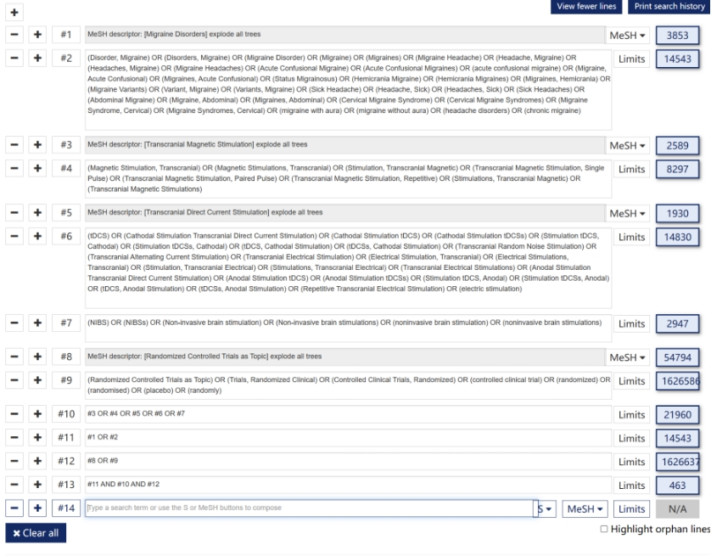
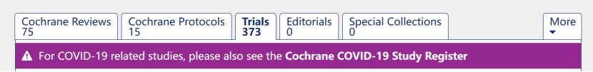

WOS-26
# | Search Query | Database | Results
1 | ((((((((((((((((((((((((((((((((((((TS=(Disorder, Migraine)) OR TS=(Disorders, Migraine)) OR TS=(Migraine Disorder)) OR TS=(Migraine)) OR TS=(Migraines)) OR TS=(Migraine Headache)) OR TS=(Headache, Migraine)) OR TS=(Headaches, Migraine)) OR TS=(Migraine Headaches)) OR TS=(Acute Confusional Migraine)) OR TS=(Acute Confusional Migraines)) OR TS=(acute confusional migraine)) OR TS=(Migraine, Acute Confusional)) OR TS=(Migraines, Acute Confusional)) OR TS=(Status Migrainosus)) OR TS=(Hemicrania Migraine)) OR TS=(Hemicrania Migraines)) OR TS=(Migraines, Hemicrania)) OR TS=(Migraine Variants)) OR TS=(Variant, Migraine)) OR TS=(Variants, Migraine)) OR TS=(Sick Headache)) OR TS=(Headache, Sick)) OR TS=(Headaches, Sick)) OR TS=(Sick Headaches)) OR TS=(Abdominal Migraine)) OR TS=(Migraine, Abdominal)) OR TS=(Migraines, Abdominal)) OR TS=(Cervical Migraine Syndrome)) OR TS=(Cervical Migraine Syndromes)) OR TS=(Migraine Syndrome, Cervical)) OR TS=(Migraine Syndromes, Cervical)) OR TS=(migraine with aura)) OR TS=(migraine without aura)) OR TS=(headache disorders)) OR TS=(chronic migraine)) OR TS=(Migraine Disorders) | all | 146875
? | TS=(Migraine Disorders) or TS=(Disorder, Migraine) or TS=(Disorders, Migraine) or TS=(Migraine Disorder) or TS=(Migraine) or TS=(Migraines) or TS=(Migraine Headache) or TS=(Headache, Migraine) or TS=(Headaches, Migraine) or TS=(Migraine Headaches) or TS=(Acute Confusional Migraine) or TS=(Acute Confusional Migraines) or TS=(Migraine, Acute Confusional) or TS=(Migraines, Acute Confusional) or TS=(Status Migrainosus) or TS=(Hemicrania Migraine) or TS=(Hemicrania Migraines) or TS=(Migraine, Hemicrania) or TS=(Migraines, Hemicrania) or TS=(Migraine Variant) or TS=(Migraine Variants) or TS=(Variant, Migraine) or TS=(Variants, Migraine) or TS=(Sick Headache) or TS=(Headache, Sick) or TS=(Headaches, Sick) or TS=(Sick Headaches) or TS=(Abdominal Migraine) or TS=(Abdominal Migraines) or TS=(Migraine, Abdominal) or TS=(Migraines, Abdominal) or TS=(Cervical Migraine Syndrome) or TS=(Cervical Migraine Syndromes) or TS=(Migraine Syndrome, Cervical) or TS=(Migraine Syndromes, Cervical) | all | 108957
2 | ((((((((TS=(Transcranial Magnetic Stimulation)) OR TS=(Magnetic Stimulation, Transcranial)) OR TS=(Magnetic Stimulations, Transcranial)) OR TS=(Stimulation, Transcranial Magnetic)) OR TS=(Transcranial Magnetic Stimulation, Single Pulse)) OR TS=(Transcranial Magnetic Stimulation, Paired Pulse)) OR TS=(Transcranial Magnetic Stimulation, Repetitive)) OR TS=(Stimulations, Transcranial Magnetic)) OR TS=(Transcranial Magnetic Stimulations) | all | 45478
3 | (((((((((((((((((((((((((TS=(Transcranial Direct Current Stimulation)) OR TS=(tDCS)) OR TS=(Cathodal Stimulation Transcranial Direct Current Stimulation)) OR TS=(Cathodal Stimulation tDCS)) OR TS=(Cathodal Stimulation tDCSs)) OR TS=(Stimulation tDCS, Cathodal)) OR TS=(Stimulation tDCSs, Cathodal)) OR TS=(tDCS, Cathodal Stimulation)) OR TS=(tDCSs, Cathodal Stimulation)) OR TS=(Transcranial Random Noise Stimulation)) OR TS=(Transcranial Alternating Current Stimulation)) OR TS=(Transcranial Electrical Stimulation)) OR TS=(Electrical Stimulation, Transcranial)) OR TS=(Electrical Stimulations, Transcranial)) OR TS=(Stimulation, Transcranial Electrical)) OR TS=(Stimulations, Transcranial Electrical)) OR TS=(Transcranial Electrical Stimulations)) OR TS=(Anodal Stimulation Transcranial Direct Current Stimulation)) OR TS=(Anodal Stimulation tDCS)) OR TS=(Anodal Stimulation tDCSs)) OR TS=(Stimulation tDCS, Anodal)) OR TS=(Stimulation tDCSs, Anodal)) OR TS=(tDCS, Anodal Stimulation)) OR TS=(tDCSs, Anodal Stimulation)) OR TS=(Repetitive Transcranial Electrical Stimulation)) OR TS=(electric stimulation) | all | 233681
4 | (((((TS=(NIBS)) OR TS=(NIBSs)) OR TS=(Non-invasive brain stimulation)) OR TS=(Non-invasive brain stimulations)) OR TS=(noninvasive brain stimulation)) OR TS=(noninvasive brain stimulations) | all | 25196
5 | ((((((((TS=(Randomized Controlled Trials as Topic)) OR TS=(Randomized Controlled Trials as Topic)) OR TS=(Trials, Randomized Clinical)) OR TS=(Controlled Clinical Trials, Randomized)) OR TS=(controlled clinical trial)) OR TS=(randomized)) OR TS=(randomised)) OR TS=(placebo)) OR TS=(randomly) | all | 2815281
6 | #2 AND #3 AND #4 | all | 3618
7 | #1 AND #5 AND #6 | all | 26

Embase-309
# | Search Query | Results | 检索日期
1 | 'migraine disorders'/exp OR 'migraine disorders' OR 'disorder, migraine' OR 'disorders, migraine' OR 'Migraine Disorder' or 'Migraine' OR 'Migraines' OR 'Migraine Headache' OR 'Headache, Migraine' OR 'Headaches, Migraine' OR 'Migraine Headaches' OR 'Acute Confusional Migraine' OR 'Acute Confusional Migraines' OR 'acute confusional migraine' OR 'Migraine, Acute Confusional' OR 'Migraines, Acute Confusional' OR 'Status Migrainosus' OR 'Hemicrania Migraine' OR 'Hemicrania Migraines' OR 'Migraines, Hemicrania' OR ' Migraine Variants' OR 'Variant, Migraine' OR 'Variants, Migraine' OR 'Sick Headache' OR 'Headache, Sick' OR 'Headaches, Sick' OR 'Sick Headaches' OR 'Abdominal Migraine' OR 'Migraine, Abdominal' OR 'Migraines, Abdominal' OR 'Cervical Migraine Syndrome' OR 'Cervical Migraine Syndromes' OR 'Migraine Syndrome, Cervical' OR 'Migraine Syndromes, Cervical' OR 'migraine with aura' OR 'migraine without aura' OR 'headache disorders' OR 'chronic migraine' | 93892
2 | 'Transcranial Magnetic Stimulation' OR 'Magnetic Stimulation, Transcranial' OR 'Magnetic Stimulations, Transcranial' OR 'Stimulation, Transcranial Magnetic' OR 'Transcranial Magnetic Stimulation, Single Pulse' OR 'Transcranial Magnetic Stimulation, Paired Pulse' OR 'Transcranial Magnetic Stimulation, Repetitive' OR 'Stimulations, Transcranial Magnetic' OR 'Transcranial Magnetic Stimulations' | 36284
3 | 'Transcranial Direct Current Stimulation' OR 'tDCS' OR 'Cathodal Stimulation Transcranial Direct Current Stimulation' OR 'Cathodal Stimulation tDCS' OR 'Cathodal Stimulation tDCSs' OR 'Stimulation tDCS, Cathodal' OR 'Stimulation tDCSs, Cathodal' OR 'tDCS, Cathodal Stimulation' OR 'tDCSs, Cathodal Stimulation' OR 'Transcranial Random Noise Stimulation' OR 'Transcranial Alternating Current Stimulation' OR 'Transcranial Electrical Stimulation' OR 'Electrical Stimulation, Transcranial' OR 'Electrical Stimulations, Transcranial' OR 'Stimulation, Transcranial Electrical' OR 'Stimulations, Transcranial Electrical' OR 'Transcranial Electrical Stimulations' OR 'Anodal Stimulation Transcranial Direct Current Stimulation' OR 'Anodal Stimulation tDCS' OR 'Anodal Stimulation tDCSs' OR 'Stimulation tDCS, Anodal' OR 'Stimulation tDCSs, Anodal' OR 'tDCS, Anodal Stimulation' OR 'tDCSs, Anodal Stimulation' OR 'Repetitive Transcranial Electrical Stimulation' OR 'electric stimulation' | 22608
4 | 'NIBS' OR 'NIBSs' OR 'Non-invasive brain stimulation' OR 'Non-invasive brain stimulations' OR 'noninvasive brain stimulation' OR 'noninvasive brain stimulations' | 8092
5 | 'Randomized Controlled Trial' OR 'Randomized Controlled Trials as Topic' OR 'Randomized Controlled Trials as Topic' OR 'Trials, Randomized Clinical' OR 'Controlled Clinical Trials, Randomized' OR 'controlled clinical trial' OR 'randomized' OR 'randomised' OR 'placebo' OR 'randomly' | 2291237
6 | #2 OR #3 OR #4 | 57762
7 | #1 AND #6 AND #5 | 309

Scoups-759
( ( ALL ( "migraine disorders" ) OR ALL ( "disorder, migraine" ) OR ALL ( "disorders, migraine" ) OR ALL ( "migraine disorder" ) OR ALL ( "migraine" ) OR ALL ( "migraines" ) OR ALL ( "migraine headache" ) OR ALL ( "headache, migraine" ) OR ALL ( "headaches, migraine" ) OR ALL ( "migraine headaches" ) OR ALL ( "acute confusional migraine" ) OR ALL ( "acute confusional migraines" ) OR ALL ( "acute confusional migraine" ) OR ALL ( "migraine, acute confusional" ) OR ALL ( "migraines, acute confusional" ) OR ALL ( "status migrainosus" ) OR ALL ( "hemicrania migraine" ) OR ALL ( "hemicrania migraines" ) OR ALL ( "migraines, hemicrania" ) OR ALL ( "migraine variants" ) OR ALL ( "variant, migraine" ) OR ALL ( "variants, migraine" ) OR ALL ( "sick headache" ) OR ALL ( "headache, sick" ) OR ALL ( "headaches, sick" ) OR ALL ( "sick headaches" ) OR ALL ( "abdominal migraine" ) OR ALL ( "migraine, abdominal" ) OR ALL ( "migraines, abdominal" ) OR ALL ( "cervical migraine syndrome" ) OR ALL ( "cervical migraine syndromes" ) OR ALL ( "migraine syndrome, cervical" ) OR ALL ( "migraine syndromes, cervical" ) OR ALL ( "migraine with aura" ) OR ALL ( "migraine without aura" ) OR ALL ( "headache disorders" ) OR ALL ( "chronic migraine" ) ) ) AND ( ( ( ALL ( "nibs" ) OR ALL ( "nibss" ) OR ALL ( "non-invasive brain stimulation" ) OR ALL ( "non-invasive brain stimulations" ) OR ALL ( "noninvasive brain stimulation" ) OR ALL ( "noninvasive brain stimulations" ) ) ) OR ( ( ALL ( "transcranial direct current stimulation" ) OR ALL ( "tdcs" ) OR ALL ( "cathodal stimulation transcranial direct current stimulation" ) OR ALL ( "cathodal stimulation tdcs" ) OR ALL ( "cathodal stimulation tdcss" ) OR ALL ( "stimulation tdcs, cathodal" ) OR ALL ( "stimulation tdcss, cathodal" ) OR ALL ( "tdcs, cathodal stimulation" ) OR ALL ( "tdcss, cathodal stimulation" ) OR ALL ( "transcranial rom noise stimulation" ) OR ALL ( "transcranial alternating current stimulation" ) OR ALL ( "transcranial electrical stimulation" ) OR ALL ( "electrical stimulation, transcranial" ) OR ALL ( "electrical stimulations, transcranial" ) OR ALL ( "stimulation, transcranial electrical" ) OR ALL ( "stimulations, transcranial electrical" ) OR ALL ( "transcranial electrical stimulations" ) OR ALL ( "anodal stimulation transcranial direct current stimulation" ) OR ALL ( "anodal stimulation tdcs" ) OR ALL ( "anodal stimulation tdcss" ) OR ALL ( "stimulation tdcs, anodal" ) OR ALL ( "stimulation tdcss, anodal" ) OR ALL ( "tdcs, anodal stimulation" ) OR ALL ( "tdcss, anodal stimulation" ) OR ALL ( "repetitive transcranial electrical stimulation" ) OR ALL ( "electric stimulation" ) ) ) OR ( ( ALL ( "transcranial magnetic stimulation" ) OR ALL ( "magnetic stimulation, transcranial" ) OR ALL ( "magnetic stimulations, transcranial" ) OR ALL ( "stimulation, transcranial magnetic" ) OR ALL ( "transcranial magnetic stimulation, single pulse" ) OR ALL ( "transcranial magnetic stimulation, paired pulse" ) OR ALL ( "transcranial magnetic stimulation, repetitive" ) OR ALL ( "stimulations, transcranial magnetic" ) OR ALL ( "transcranial magnetic stimulations" ) ) ) ) AND ( TITLE-ABS-KEY ( random* ) ) AND ( LIMIT-TO ( DOCTYPE , "ar" ) )

Supplementary 3. Meta-regression analyses

short-term changes in migraine attack frequency 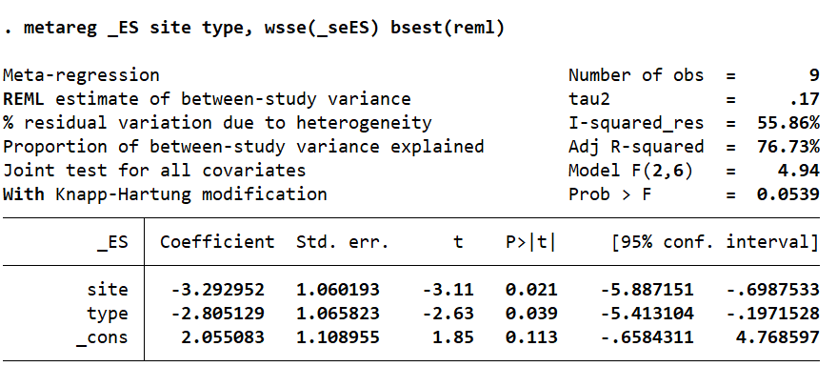

short-term changes in pain intensity 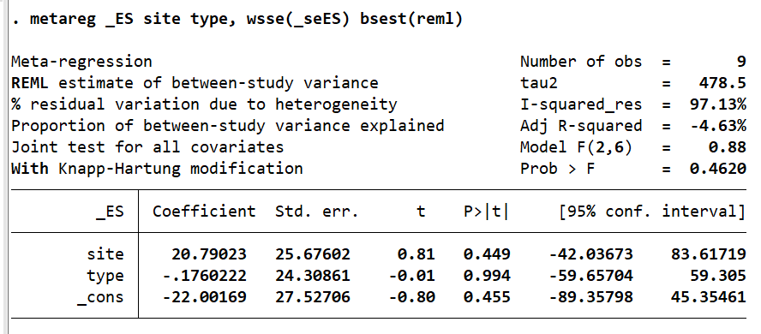

Painkiller Intake
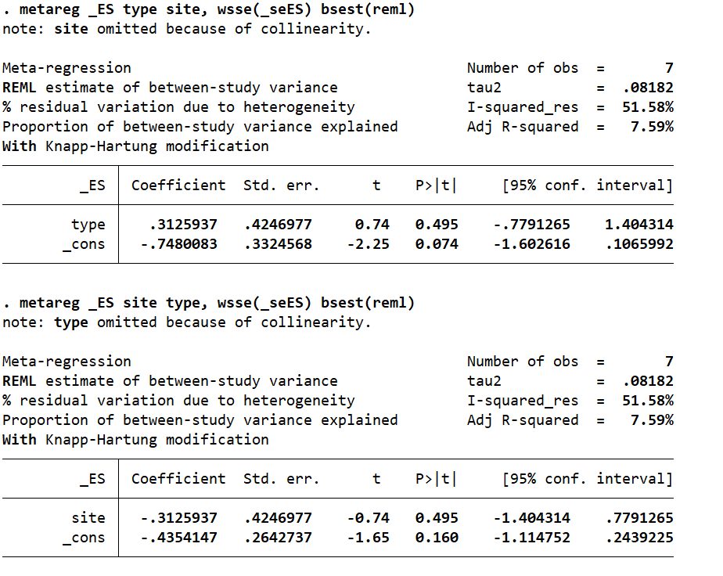

Supplementary 4. Funnel plot analysis
Funnel plot analysis
Headache frequency - Immediate effects after intervention 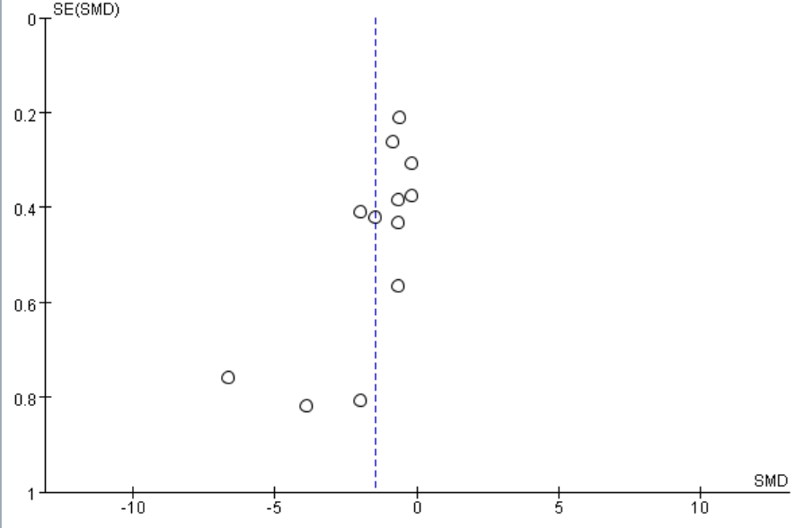
Pain Intensity - Immediate effects after intervention 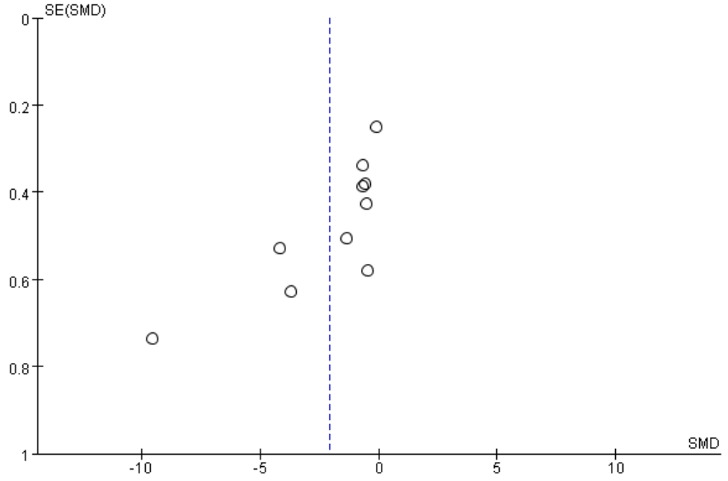

Painkiller Intake 