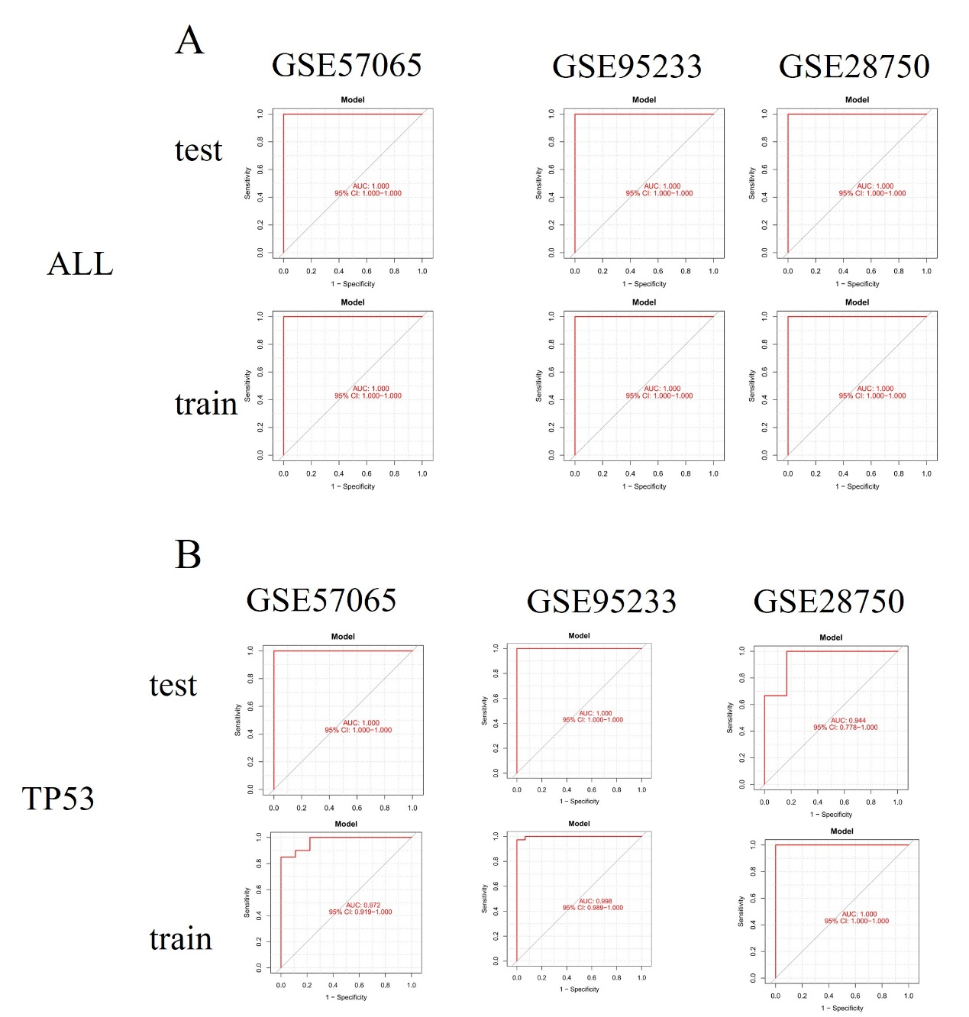
Supplementary Figure 1. (A) The ROC curve shows the predictive performance of the model constructed using 34 differentially expressed FRGs across three datasets.(B) The ROC curve shows the predictive performance of the model constructed based on the differential expression of TP53 in three datasets.

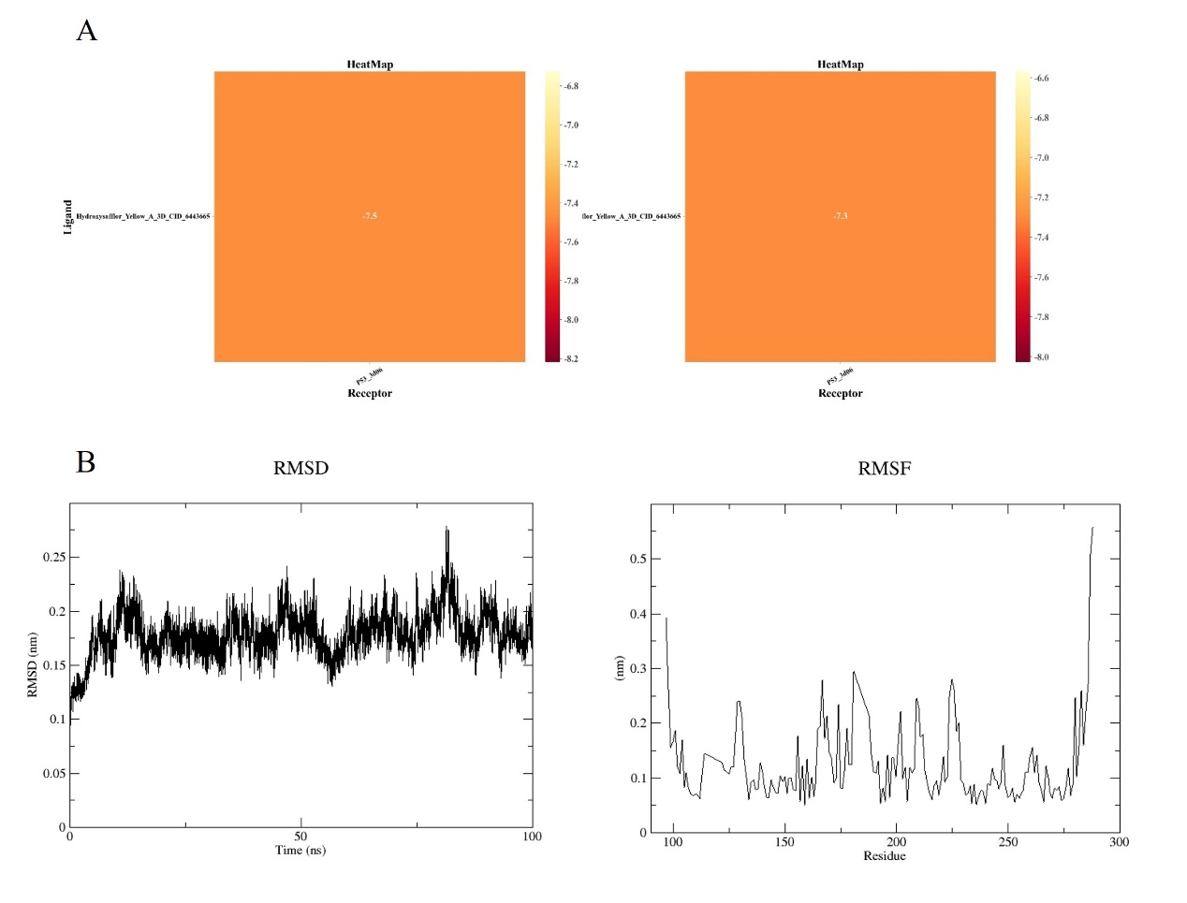
Supplementary Figure 2.
(A) Results of the other two molecular docking simulations.
(B) Results of molecular dynamics simulations.

