Supporting Information
Iron-Oxide Labeled Stem Cells With Specific Magnetic Occurrence For Effective In Mouse Model Of Cisplatin-induced Acute Kidney Injury
Ke Wang^{1,2#}, Ye Zhao^{3#}, Huiying Lv¹, Xiuying Li¹*
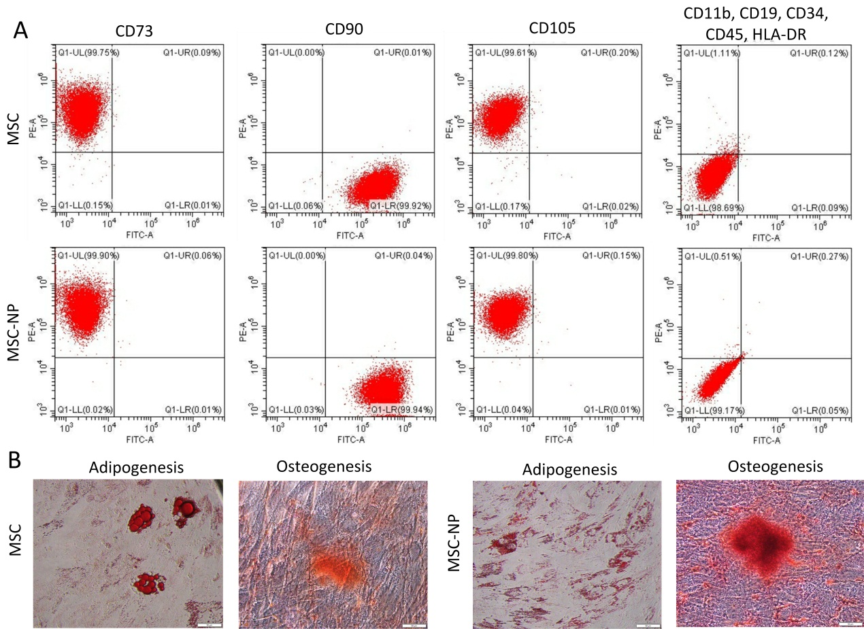
Figure S1. Fe₃O₄ NPs did not affect the stem cell characteristics of PL-MSCs. (A) Surface marker expression of NP-labeled and unlabeled MSCs. (B) Differentiation potency of NP-labeled and unlabeled MSCs.

