Supplementary Figure S1: Flow diagram.

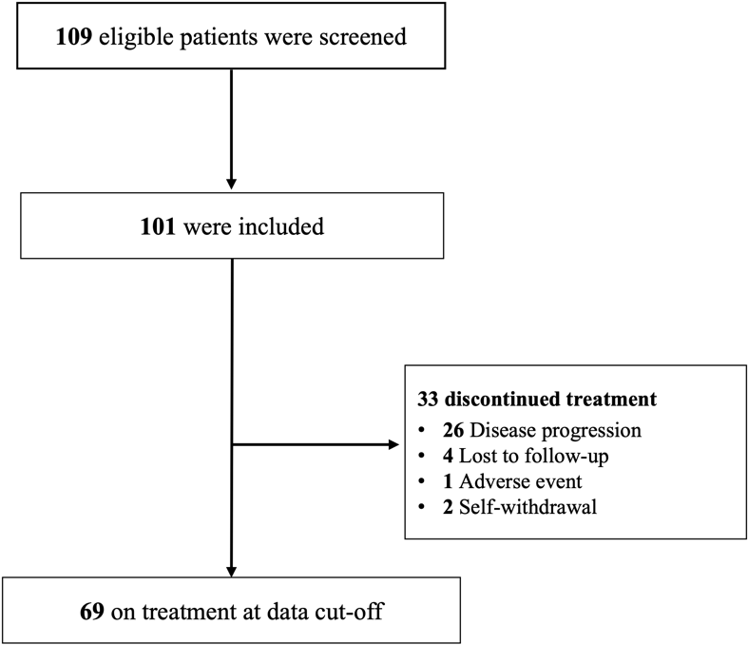

Supplementary Table S1. AEs leading to treatment interruption, PARPi dose reduction and discontinuation
Terms | Treatment interruption (N=40) |  | Dose reduction (N=38) |  | Discontinuation (N=7)
Terms | Any grade  (No.) | Grade ≥3  (No.) | Any grade  (No.) | Grade ≥3  (No.) | Any grade  (No.) | Grade ≥3  (No.)
Hematological AEs
Anemia | 7 | 7 | 7 | 7 | 0 | 0
Platelet count decreased | 15 | 6 | 14 | 6 | 1 | 1
Neutrophil count decreased | 3 | 3 | 2 | 2 | 0 | 0
Platelet count decreased with Neutrophil count decreased | 2 | 2 | 2 | 2 | 0 | 0
Non-hematological AEs
Gastrointestinal AEs | 5 | 0 | 5 | 0 | 1 | 0
Insomnia | 1 | 0 | 1 | 0 | 0 | 0
Hypertensionª | 2 | 1 | 2 | 1 | 0 | 0
Palpitation | 2 | 0 | 2 | 0 | 0 | 0
Others | 3^{b} | 0 | 3^{b} | 0 | 5^{c} | 0
ª Treatment interruptions and dose reductions of PARPi were observed in two patients due to hypertension; one patient experienced grade 1 hypertension, while the other had grade 2 hypertension accompanied by severe renal failure.
^{b} Three patients, including one elderly patient with grade 1 hematological adverse event (anemia, platelet count decreased, and neutrophil count decreased), one patient with financial difficulties, and one patient with interstitial pneumonia during treatment.
^{c} Five patients discontinued treatment: three due to low willingness to undergo maintenance treatment, and two due to death from a disease unrelated to the treatment (intracranial infection and cardiac-cerebral vascular disease).

Supplementary Table S2. Correlations of TEAEs and PFS in patients treated with different doses and initiation time
 | Initial dose | Stable dose | Patients, No. | Any TEAE,  n (%) | ≥3 TEAE,  n (%) | mPFS (months) | P-value
ISD | 100 mg | 100 mg | 2 | 1 (50%) | 1 (50%) | – | –
ISD | 200 mgª | 100 mg | 20 | 19 (95%) | 10 (50%) | 16.9 | 0.0539
ISD | 200 mgª | 200 mg | 70 | 51 (72.8%) | 6 (8.6%) | NE | 0.0539
ISD | 200 mgª | 100/200 mg alternative | 1 | 1 (100%) | 0 (0%) | – | –
ISD | 300 mg | 300 mg | 1 | 0 | 0 | – | –
Non-ISD | 100 mgª | 100 mg | 1 | 1 (100%) | 0 | – | –
Initiation time of maintenance |  |  | Patients, No.^{b} | Any TEAE,  n (%) | ≥3 TEAE,  n (%) | mPFS (months) | P-value
< 12 weeks |  |  | 85 | 64 | 18 | 23.8 | 0.4059
≥ 12 weeks |  |  | 15 | 14 | 3 | NE | 0.4059
ISD, individualized starting dose; NE, not estimable.
ª Six patients in the initial dose of 200 mg group and one patient in the initial dose of 100 mg group discontinued treatment due to adverse events or other reasons.
^{b} Two patients missing the date of last chemotherapy.

