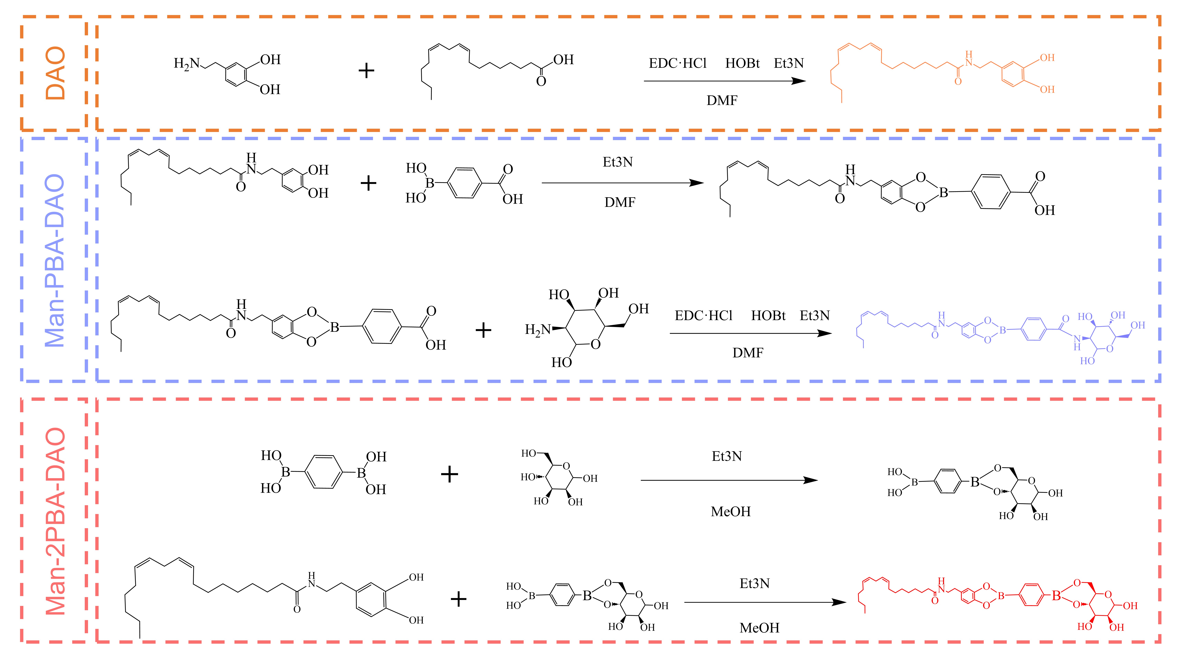
Figure S1 Schematic Illustration of DAO Man-PBA-DAO and Man-2PBA-DAO Synthesis. Infrared spectra of

Table S2 Relationship between nanoparticles with different ratios of TPGS and Man-PBA-DAO and particle size
TPGS : Man-PBA-DAO (w/w) | Size (nm) | PDI
1.0 : 0.02 | 79.66 ± 6.580 | 0.281 ± 0.044
1.0 : 0.06 | 95.22 ± 4.574 | 0.263 ± 0.031
1.0 : 0.10 | 62.34 ± 9.236 | 0.332 ± 0.019
1.0 : 0.14 | 114.8 ± 13.77 | 0.222 ± 0.039
1.0 : 0.18 | 134.2 ± 8.570 | 0.198 ± 0.045
Table S3 Relationship between nanoparticles with different ratios of TPGS and Man-2PBA-DAO and particle size
TPGS : Man-2PBA-DAO (w/w) | Size (nm) | PDI
1.0 : 0.65 | 147.3 ± 3.279 | 0.346 ± 0.014
1.0 : 0.70 | 193.6 ± 1.476 | 0.441 ± 0.007
1.0 : 0.75 | 119.9 ± 3.318 | 0.293 ± 0.003
1.0 : 0.80 | 471.6 ± 21.05 | 0.761 ± 0.050
1.0 : 0.85 | 407.4 ± 0.613 | 0.733 ± 0.126

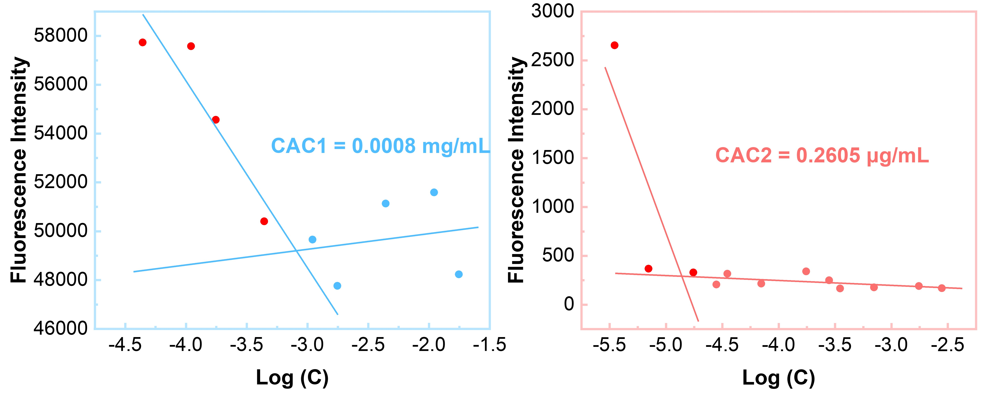
Figure S4. CAC1 and CAC2 of nanoparticles with TPGS/MB-PBA-DAO=1:0.10 (Left) and TPGS/MB-2PBA-DAO=1:0.75 (Right)

Figure S5. Nanoparticle chromatogram (Left) and Cur chromatogram (Right)
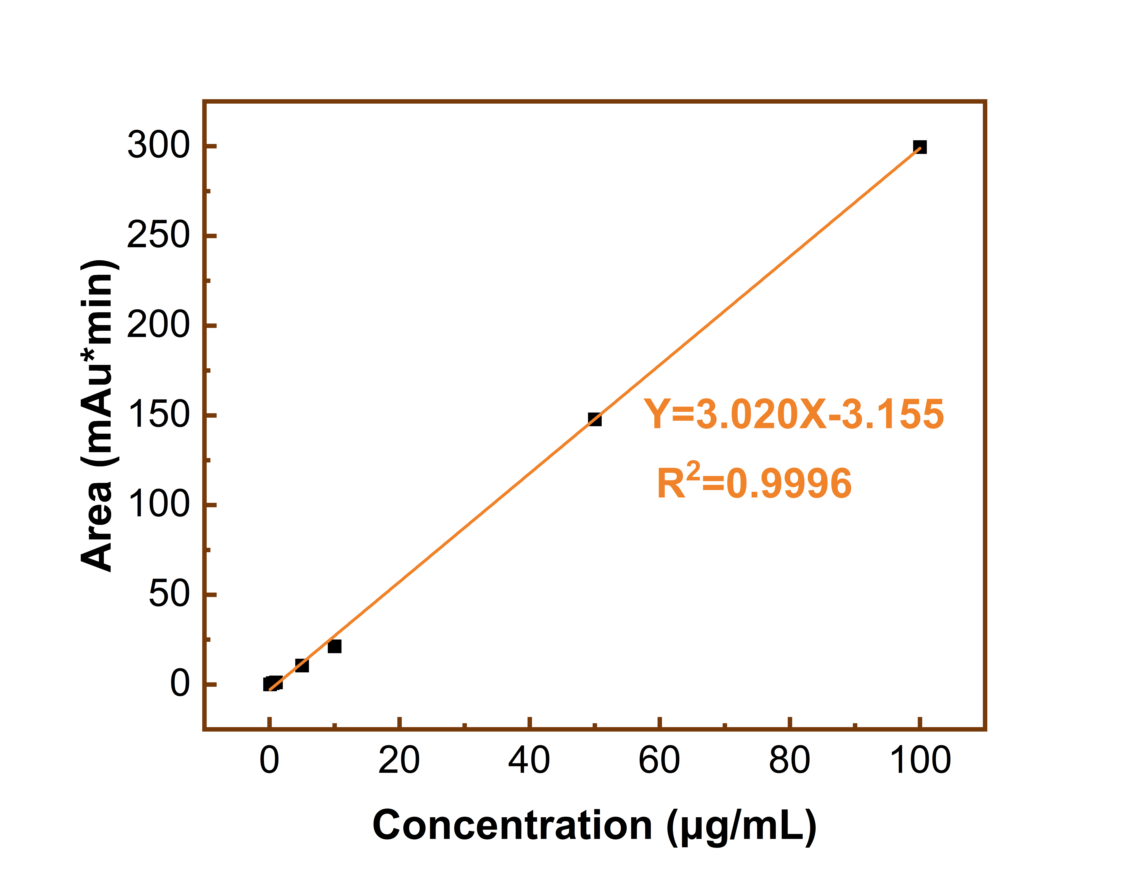
Figure S6. Cur standard curve

Chromatographic conditions
Cloum: YMC-Pack ODS-AQ (250 × 4.6 mm, S-5 μm, 12 nm, YMC, JP)
Mobile phase: aceto nitrile and 4% acetic acid solution ‘50:50, v/v’
Flow rate: 1.0 mL/min.
The injection volume: 10 μL
Detection wavelength: 450 nm
Tempreture: 35 ℃

