Table S1 RT-PCR primer sequences in this study
Primer name | Sequence (5'-3') | Organism
GAPDH-F | GGAGCGAGATCCCTCCAAAAT | human
GAPDH-R | GGCTGTTGTCATACTTCTCATGG | human
TM9SF1-F | GCACCCTGTCGCACCAAG | human
TM9SF1-R | GACAAAGAAGAGGATGCCGTAC | human
FOXP3-F | TCTTCCTTGAACCCCATGCC | human
FOXP3-R | AAATGTGGCCTGTCCTGGAG | human
TNF-α-F | GACAGATGTGGGGTGTGAGAA | human
TNF-α-R | TCTGTGTGCCAGACACCCTA | human
IFN-γ-F | TCCAGTTACTGCCGGTTTGA | human
IFN-γ-R | TGGAAGCACCAGGCATGAAA | human
IL-17A-F | TAATGGCCCTGAGGAATGGC | human
IL-17A-R | AGGAAGCCTGAGTCTAGGGG | human
IL-6-F | GTCCAGTTGCCTTCTCCCTG | human
IL-6-R | CTGAGATGCCGTCGAGGATG | human

Table S2 The association between TM9SF1 mRNA expression and important clinical parameters in patients with sepsis
Clinical parameters | R | 95%CI | P value
WBC | 0.627 | 0.501-0.790 | 0.002
PLT | 0.619 | 0.496-0.803 | 0.017
CRP | 0.705 | 0.668-0.825 | <0.001
ESR | 0.773 | 0.695-0.893 | <0.001
NEU% | 0.528 | 0.430-0.746 | 0.003
LYM% | 0.633 | 0.527-0.854 | 0.018
MON% | 0.589 | 0.438-0.726 | 0.021
NLR | 0.676 | 0.597-0.841 | 0.004
MLR | 0.721 | 0.568-0.894 | 0.019
PLR | 0.594 | 0.501-0.725 | 0.038
D-dimer | 0.791 | 0.623-0.889 | 0.006
Lactate | 0.827 | 0.709-0.931 | <0.001
WBC, white blood cells; PLT, platelets; CRP, C-reactive protein; ESR, erythrocyte sedimentation rate; NEU%, neutrophil %; LYM%, lymphocyte %; MON%, monocyte %; NLR, neutrophil-lymphocyte ratio; MLR, monocyte lymphocyte ratio; PLR, platelet lymphocyte ratio; CI, confidence interval.

Table S3 The association between TM9SF1 expression and the severity of sepsis
 | OR (95% CI)ª | OR (95% CI)^{b}
TM9SF1 level | 47.81 (8.33-274.41)*** | 47.14 (8.06-275.65)***
Subgroup
low level | Reference | Reference
high level | 3.30 (1.91-5.70)*** | 3.29 (1.88-5.78)***
***P<0.001.
ª Univariate analysis.
^{b} Adjusted for age, sex, smoke status, drink status and diseases history.
OR, odds ratio; CI, confidence interval.

Table S4 The association between TM9SF1 expression and the prognosis of sepsis shock
 | HR (95% CI)ª | HR (95% CI)^{b}
TM9SF1 level | 47.90 (17.03-134.71)*** | 37.21 (12.80-108.21)***
Subgroup
low level | Reference | Reference
high level | 9.98 (3.96-25.18)*** | 11.12 (4.35-28.45)***
***P<0.001.
ª Univariate analysis.
^{b} Adjusted for age, sex, smoke status, drink status and diseases history.
HR, hazard ratio; CI, confidence interval.

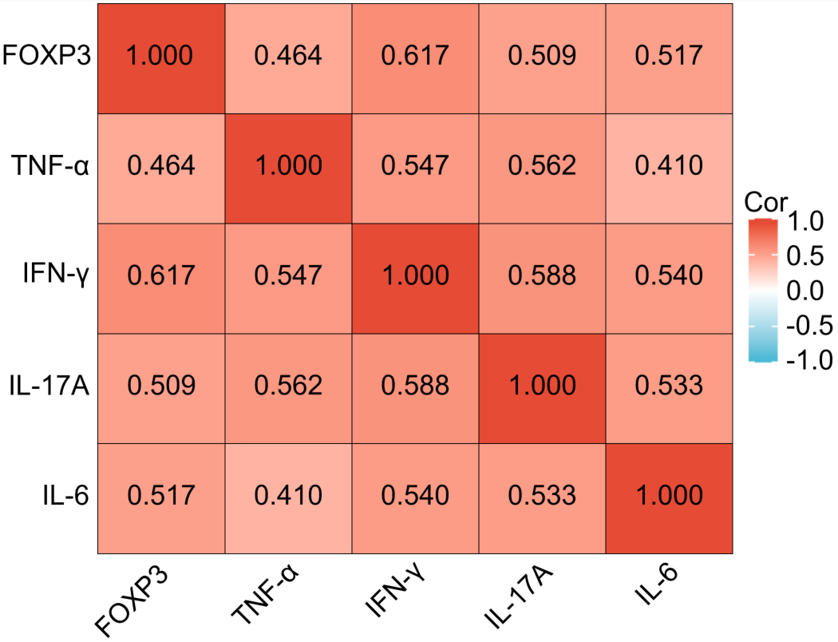
Fig S1 Heatmap for the association between expression level of each cytokines in patients with sepsis (all p < 0.001)

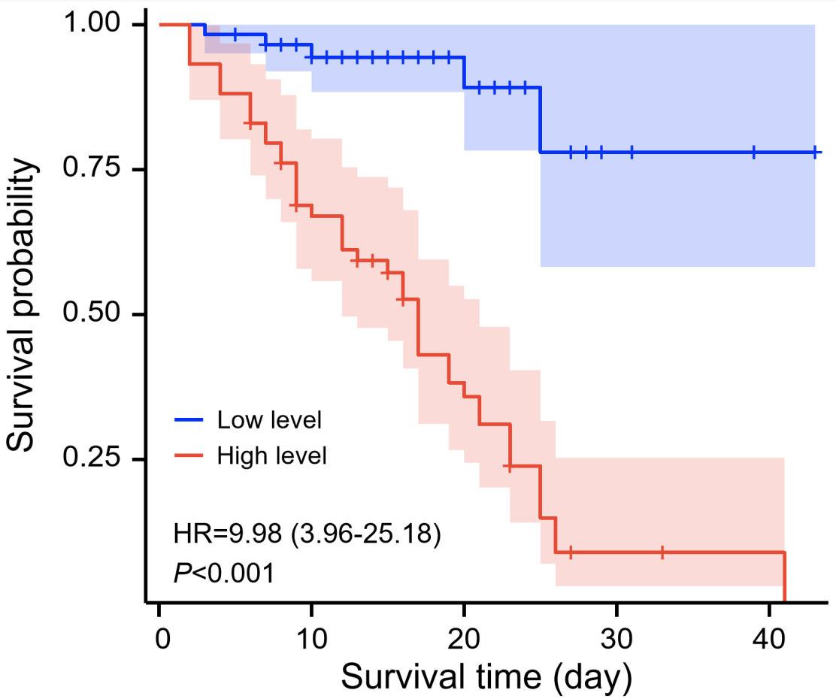

Fig S2 Kaplan-Meier survival curve analysis in patients with sepsis shock. The curve is stratified by the median value of TM9SF1 expression level (0.22) in patients with sepsis shock.

