Supplementary information

Table S1. Information of six institutions in this study
Institutions | NO.of patients enrolled | No.of in-hospital deaths | in-hospital death rate (%)
A | 1,655 | 27 | 1.63
B | 318 | 8 | 2.52
C | 12,116 | 457 | 3.77
D | 1,072 | 29 | 2.71
E | 844 | 12 | 1.42
F | 1,416 | 23 | 1.62
Total | 17,421 | 556 | 3.19

Table S2. Top 10 primary diagnoses
Primary Diagnosis | Number of cases | Proportion (%)
type 2 diabetes mellitus | 11,712 | 67.23
type 2 diabetes with multiple complications | 1,479 | 8.49
type 2 diabetic Retinopathy | 1,199 | 6.88
type 2 diabetes peripheral neuropathy | 677 | 3.89
type 2 diabetes nephropathy | 374 | 2.14
binocular diabetes cataract | 137 | 0.79
diabetic foot | 103 | 0.59
hypoglycemic coma | 90 | 0.52
hyperosmolar non-ketotic coma | 74 | 0.42
type 2 diabetes diabetic ketoacidosis | 73 | 0.42
others | 1,503 | 8.63

Table S3. Baseline characteristics of patients in the external validation set
Variables | External validation set (N=1416)
Demographics
Age (years) | 74.47±7.06
Gender (n, %)
female | 750(52.97)
male | 666(47.03)
History of surgery (n, %)
no | 658(46.47)
yes | 758(53.53)
Smoking history (n, %)
no | 941(66.45)
yes | 475(33.55)
Drinking history (n, %)
no | 1074(75.85)
yes | 342(24.15)
Baseline clinical data
CCI score (n, %)
<4 | 728(51.41)
≥4 | 688(48.59)
Hypertension (n, %)
no | 432(30.51)
yes | 984(69.49)
CHD (n, %)
no | 989(69.84)
yes | 427(30.16)
CI (n, %)
no | 1,100(77.68)
yes | 316(22.32)
Hyperlipidemia (n, %)
no | 1,360(96.05)
yes | 56(3.95)
COPD (n, %)
no | 1,244(87.85)
yes | 172(12.15)
HF (n, %)
no | 1,250(88.28)
yes | 166(11.72)
SBP (mmHg) | 141.92±23.77
DBP (mmHg) | 78.64±13.22
TC (mmol/l) | 4.32±1.26
TG (mmol/l) | 1.35(0.93,1.96)
SCR (umol/l) | 74.01(60.39,95.13)
LDL-C (mmol/L) | 2.49±0.93
HDL-C (mmol/L) | 1.24±0.36
ALB (g/L) | 39.98±5.38
HbA1c (%) | 8.14±2.68
Fasting glucose (mmol/l) | 8.30(6.66,11.76)
Medications
Nutritional support drug use (n, %)
no | 887(62.64)
yes | 529(37.36)
Statin drug use (n, %)
no | 655(46.26)
yes | 761(53.74)
Antiplatelet and anticoagulant drug use (n, %)
no | 550(38.84)
yes | 866(61.16)
Antiosteoporotic drug use (n, %)
no | 1,300(91.81)
yes | 116(8.19)
Antibiotic drug use (n, %)
no | 689(48.66)
yes | 727(51.34)
CCI: Charlson comorbidity index; CHD: coronary heart disease; CI: cerebral infarction; COPD: chronic obstructive pulmonary disease; HF: heart failure; SBP: systolic blood pressure; DBP: diastolic blood pressure; TC: total cholesterol; TG: triglycerides; SCR: serum levels of creatinine; LDL-C: low-density lipoprotein cholesterol; HDL-C: high-density lipoprotein cholesterol; ALB: albumin; HbA1c: glycated hemoglobin.

Table S4. Distributions of variables with missing data comparing observed complete case data to results from pooling the datasets with imputed variables from multiple imputation
 | Missing variables | Number (%) with missing data | Complete case | Multiple imputation
Training set | SBP (mmHg) | 266(2.37) | 139.75±22.27 | 139.71±22.30
 | DBP (mmHg) | 267(2.38) | 77.56±12.22 | 77.52±12.24
 | TC (mmol/l) | 2,883(25.73) | 4.34±1.28 | 4.32±1.24
 | TG (mmol/l) | 2,883(25.73) | 1.38(1.00,1.96) | 1.38(0.99,1.95)
 | SCR (umol/l) | 1,174(10.48) | 72.10(57.80,95.80) | 72.00(57.70,95.40)
 | LDL-C (mmol/L) | 2,958(26.40) | 2.40±0.95 | 2.39±0.93
 | HDL-C (mmol/L) | 2,946(26.30) | 1.16±0.36 | 1.15±0.36
 | ALB (g/L) | 1,347(12.02) | 38.33±5.18 | 38.33±5.18
 | HbA1c (%) | 3,922(35.01) | 8.41±3.48 | 8.29±3.43
 | Fasting glucose (mmol/l) | 1,887(16.84) | 8.05(6.18,11.32) | 8.00(6.14,11.30)
Internal validation set | SBP (mmHg) | 122(2.54) | 139.49±21.38 | 139.44±21.41
 | DBP (mmHg) | 120(2.50) | 77.68±12.1 | 77.71±12.13
 | TC (mmol/l) | 1,143(23.80) | 4.33±1.22 | 4.31±1.22
 | TG (mmol/l) | 1,142(23.78) | 1.37(1.00,1.91) | 1.37(0.99,1.90)
 | SCR (umol/l) | 485(10.10) | 72.60(58.00,96.90) | 72.60(58.00,96.58)
 | LDL-C (mmol/L) | 1,185(24.68) | 2.42±0.93 | 2.40±0.92
 | HDL-C (mmol/L) | 1,176(24.49) | 1.15±0.35 | 1.15±0.36
 | ALB (g/L) | 555(11.56) | 38.36±5.11 | 38.32±5.14
 | HbA1c (%) | 1,640(34.15) | 8.43±3.37 | 8.33±3.22
 | Fasting glucose (mmol/l) | 756(15.74) | 8.10(6.14,11.26) | 8.08(6.12,11.30)
External validation set | SBP (mmHg) | 92(6.50) | 142.1±23.9 | 141.92±23.77
 | DBP (mmHg) | 92(6.50) | 78.76±13.19 | 78.64±13.22
 | TC (mmol/l) | 515(36.37) | 4.32±1.29 | 4.32±1.26
 | TG (mmol/l) | 514(36.30) | 1.37(0.96,1.99) | 1.35(0.93,1.96)
 | SCR (umol/l) | 91(6.43) | 74.14(60.59,95.21) | 74.01(60.39,95.13)
 | LDL-C (mmol/L) | 514(36.30) | 2.5±0.97 | 2.49±0.93
 | HDL-C (mmol/L) | 514(36.30) | 1.22±0.34 | 1.24±0.36
 | ALB (g/L) | 92(6.50) | 39.99±5.37 | 39.98±5.38
 | HbA1c (%) | 351(24.79) | 8.14±2.66 | 8.14±2.68
 | Fasting glucose (mmol/l) | 397(28.04) | 8.34(6.63,11.74) | 8.30(6.66,11.76)
SBP: systolic blood pressure; DBP: diastolic blood pressure; TC: total cholesterol; TG: triglycerides; SCR: serum levels of creatinine; LDL-C: low-density lipoprotein cholesterol; HDL-C: high-density lipoprotein cholesterol; ALB: albumin; HbA1c: glycated hemoglobin.

Table S5. Complete case sensitivity analysis
 | Missing variables | Survival group | Death group | P_{Multiple imputation} | Survival group | Death group | P_{Complete case}
Training set | SBP (mmHg) | 139.94±22.14 | 133.33±25.70 | <0.001 | 141.33±22.32 | 137.25±26.64 | <0.001
 | DBP (mmHg) | 77.63±12.11 | 74.41±15.20 | <0.001 | 77.87±12.22 | 74.71±16.03 | <0.001
 | TC (mmol/l) | 4.34±1.24 | 4.02±1.33 | <0.001 | 4.36±1.27 | 3.87±1.40 | <0.001
 | TG (mmol/l) | 1.38(1.00,1.96) | 1.19(0.92,1.72) | <0.001 | 1.40(1.01,1.98) | 1.18(0.88,1.62) | <0.001
 | SCR (umol/l) | 71.40(57.40,93.90) | 97.80(68.20,167.10) | <0.001 | 71.00(57.00,93.40) | 105.90(74.80,179.05) | <0.001
 | LDL-C (mmol/L) | 2.40±0.93 | 2.28±1.00 | 0.006 | 2.40±0.94 | 2.07±0.95 | <0.001
 | HDL-C (mmol/L) | 1.15±0.35 | 0.96±0.36 | <0.001 | 1.18±0.36 | 0.99±0.35 | <0.001
 | ALB (g/L) | 38.54±5.04 | 32.72±5.87 | <0.001 | 38.95±4.73 | 34.06±5.53 | <0.001
 | HbA1c (%) | 8.31±3.43 | 7.79±3.25 | <0.001 | 8.27±2.90 | 7.80±2.14 | 0.020
 | Fasting glucose (mmol/l) | 8.00(6.14,11.28) | 8.22(6.04,11.75) | 0.733 | 8.26(6.30,11.79) | 8.70(6.52,11.92) | 0.406
Internal validation set | SBP (mmHg) | 139.64±21.33 | 133.10±23.15 | <0.001 | 140.75±21.25 | 134.90±23.78 | <0.001
 | DBP (mmHg) | 77.80±12.10 | 74.75±12.78 | 0.003 | 77.79±12.02 | 73.79±12.95 | 0.033
 | TC (mmol/l) | 4.33±1.22 | 3.85±1.18 | <0.001 | 4.37±1.20 | 3.88±0.87 | 0.001
 | TG (mmol/l) | 1.37(1.00,1.90) | 1.20(0.92,1.94) | 0.093 | 1.38(1.00,1.94) | 1.18(0.98,1.75) | 0.193
 | SCR (umol/l) | 72.00(57.90,95.38) | 90.90(67.10,149.35) | <0.001 | 72.00(57.40,93.40) | 91.80(66.30,132.75) | <0.001
 | LDL-C (mmol/L) | 2.41±0.92 | 2.04±0.85 | <0.001 | 2.43±0.90 | 2.14±0.77 | 0.025
 | HDL-C (mmol/L) | 1.15±0.35 | 1.01±0.43 | <0.001 | 1.18±0.35 | 1.08±0.34 | <0.001
 | ALB (g/L) | 38.47±5.05 | 33.25±5.43 | <0.001 | 38.93±4.62 | 34.31±5.10 | <0.001
 | HbA1c (%) | 8.34±3.24 | 7.95±2.61 | 0.157 | 8.27±2.55 | 7.72±2.48 | 0.165
 | Fasting glucose (mmol/l) | 8.06(6.11,11.20) | 9.22(6.41,13.42) | 0.027 | 8.30(6.31,11.72) | 8.67(6.23,12.49) | 0.047
External validation set | SBP (mmHg) | 142.25±23.72 | 121.87±18.30 | <0.001 | 144.31±24.56 | 118.75±12.74 | 0.038
 | DBP (mmHg) | 78.80±13.21 | 68.96±9.53 | <0.001 | 79.54±13.43 | 67.50±6.61 | 0.034
 | TC (mmol/l) | 4.32±1.25 | 4.50±1.39 | 0.492 | 4.41±1.32 | 3.82±1.05 | 0.370
 | TG (mmol/l) | 1.36(0.93,1.95) | 1.33(0.82,2.44) | 0.961 | 1.40(0.96,2.00) | 1.02(0.95,1.13) | 0.188
 | SCR (umol/l) | 73.96(60.35,94.83) | 81.48(65.95,156.55) | 0.059 | 74.97(61.11,92.06) | 137.55(115.60,148.83) | 0.074
 | LDL-C (mmol/L) | 2.49±0.93 | 2.40±0.92 | 0.655 | 2.56±0.98 | 1.97±0.73 | 0.233
 | HDL-C (mmol/L) | 1.24±0.36 | 1.38±0.54 | 0.210 | 1.23±0.33 | 1.15±0.30 | 0.605
 | ALB (g/L) | 40.09±5.28 | 33.55±7.02 | <0.001 | 40.93±4.69 | 31.65±5.50 | <0.001
 | HbA1c (%) | 8.14±2.68 | 7.75±2.67 | 0.487 | 8.02±2.30 | 6.33±0.68 | 0.141
 | Fasting glucose (mmol/l) | 8.30(6.65,11.76) | 10.01(7.30,12.91) | 0.293 | 8.00(6.53,11.11) | 5.73(3.93,8.13) | 0.138
SBP: systolic blood pressure; DBP: diastolic blood pressure; TC: total cholesterol; TG: triglycerides; SCR: serum levels of creatinine; LDL-C: low-density lipoprotein cholesterol; HDL-C: high-density lipoprotein cholesterol; ALB: albumin; HbA1c: glycated hemoglobin.

Table S6. Comparison of Model Performance
 | AUROC (95%CI) | P value | NRI (95%CI) | P value
Munsakul et al. model | 0.710 (0.684-0.736) | < 0.001 | 0.112 (0.054-0.171) | < 0.001
Liu et al. model | 0.701 (0.674-0.729) | < 0.001 | 0.141 (0.062-0.221) | < 0.001
Our model | 0.873 (0.857-0.889) | / | / | /
AUROC: area under the receiver operating characteristic curve; NRI, net reclassification improvement; CI, confidence interval

Figure S1. Patient flow diagram
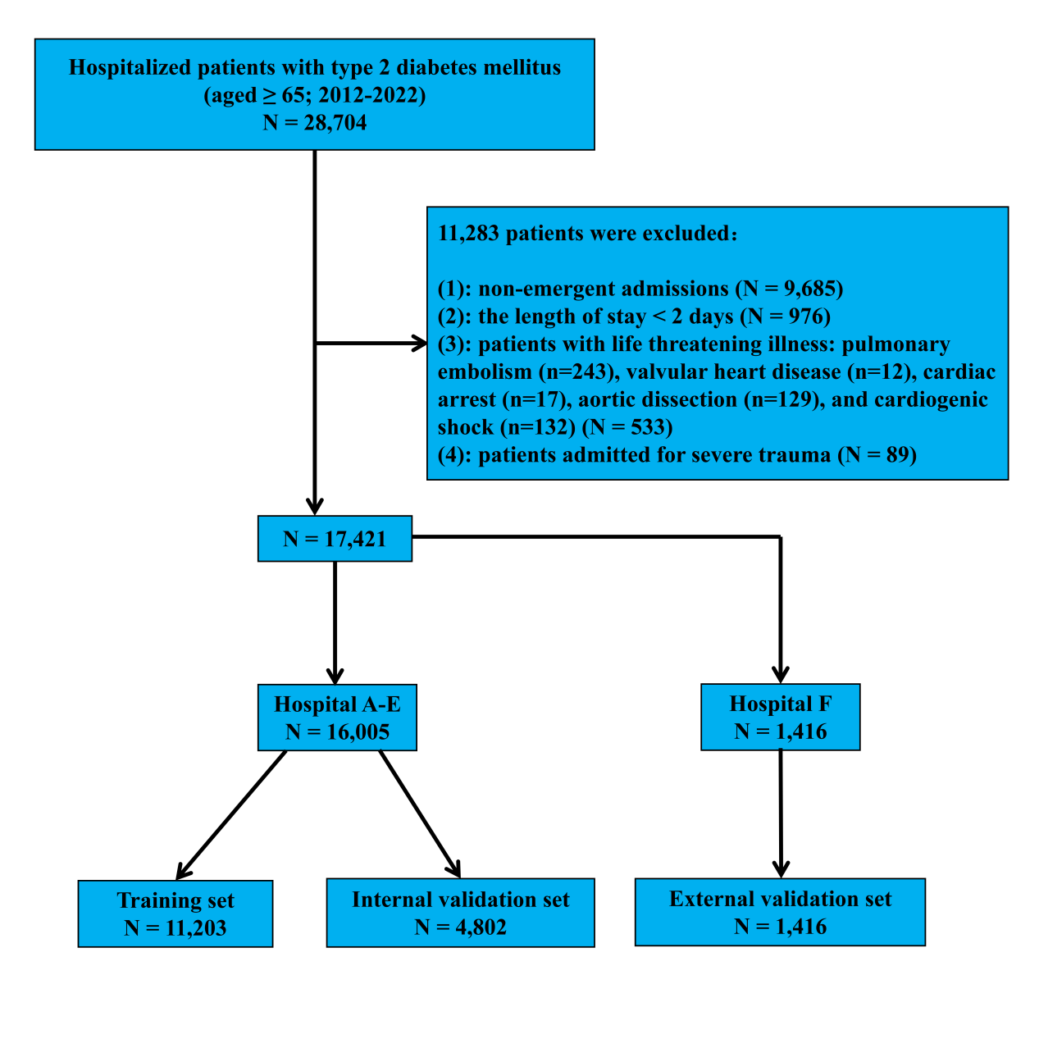

Figure S2. The predictive performance of the model in hypertensive population

