Supplementary Table S1. Worst-state ECOG scores relative to baseline (N=40)
n (%) | Baseline Scores |  |  |  |  |  | Total  No. (%)
n (%) | 0 | 1 | 2 | 3 | 4 | 5 | Total  No. (%)
Worst-state Scores
0 | 25 (69.4) | 3 (8.3) |  |  |  |  | 28 (77.8)
1 |  | 8 (22.2) |  |  |  |  | 8 (22.2)
2
3
4
5
Total | 25 (69.4) | 11 (30.6)
ECOG, Eastern Cooperative Oncology Group.
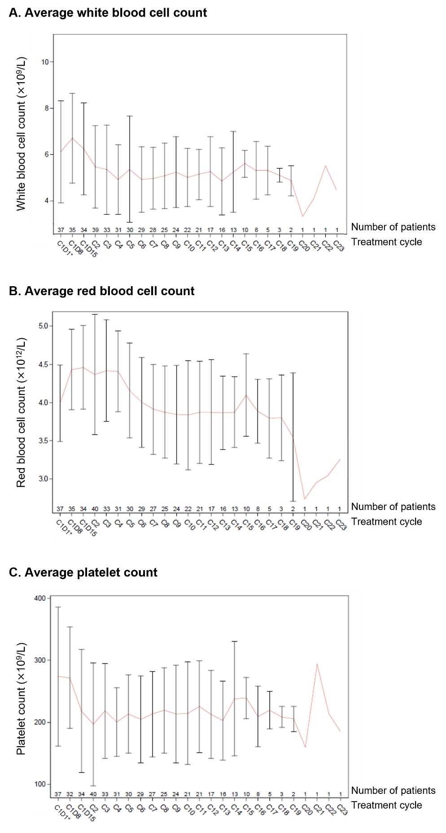
Supplemental Figure S1. Complete blood count in the intention-to-treat population (N=40). *For some patients, the data used were from the screening period. A. Average white blood cell counts across treatment cycles. B. Average red blood cell counts across treatment cycles. C. Average platelet counts across treatment cycles.

