Supplementary material 1_Informed_Consent

INFORMED CONSENT FOR FOCUS GROUP
We have contacted you to conduct a focus group as part of the project NANOBIOSENSOR PLATFORM FOR THERAPEUTIC DRUG MONITORING (TDM) AS A STRATEGY TO MINIMIZE ANTIMICROBIAL RESISTANCE from the Faculty of Medicine at the University of La Sabana. This study has been reviewed and approved by the Ethics Committee of the University of La Sabana.
The objective of the research is to determine the factors to consider for including the teaching of nanotechnological tools to minimize antimicrobial resistance in medical-surgical postgraduate programs.
Before starting the activity, we need you to carefully read the following information:
- Your participation in this in-person focus group is entirely voluntary and free; you will not receive any monetary or in-kind compensation for your participation, and it will not cause you any benefit or risk.
- There will be no penalty if you decide not to participate, nor will there be any penalty if you decide to withdraw from the activity at any time after it has started, should you choose to do so.
- The confidentiality of your data is guaranteed by the Habeas Data law and its modifications on personal data protection so that what you say cannot be identified.
- If you decide to participate, please be aware that the information you provide will be recorded and transcribed onto a computer for later analysis, with your name not appearing at any time.
- For analysis purposes, numerical codes will be used instead of your name, so these documents will not identify you.
- Additionally, no data that can identify you will be published, but the general results may be included in academic publications where participants cannot be identified.
- This meeting will take place from 2 pm to 4 pm on February 23, 2024.
If you understand the above and agree to participate, you accept that the information obtained from this activity is confidential.
You have the right to receive a signed copy of this document.
I, _____________________________________________________________________, with citizenship identification number _______________ from ___________________, give my consent to participate in this study.
Signed in Chía on February 23, 2024.

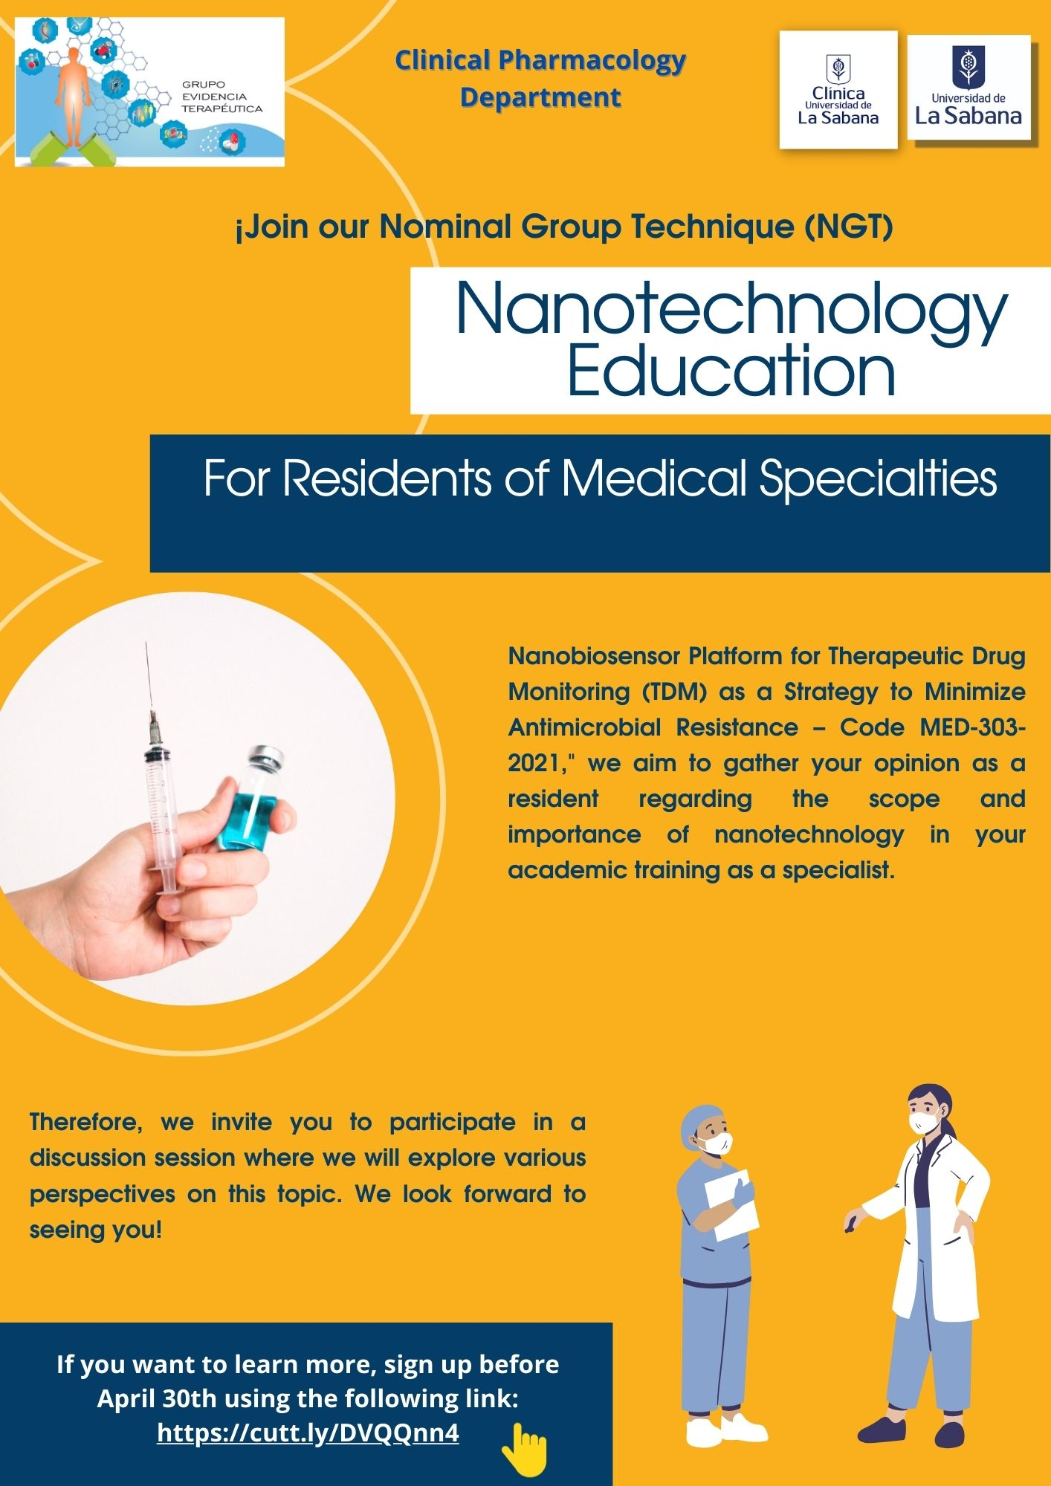

Figure 1S_Graphical Invitation

