Supplementary material
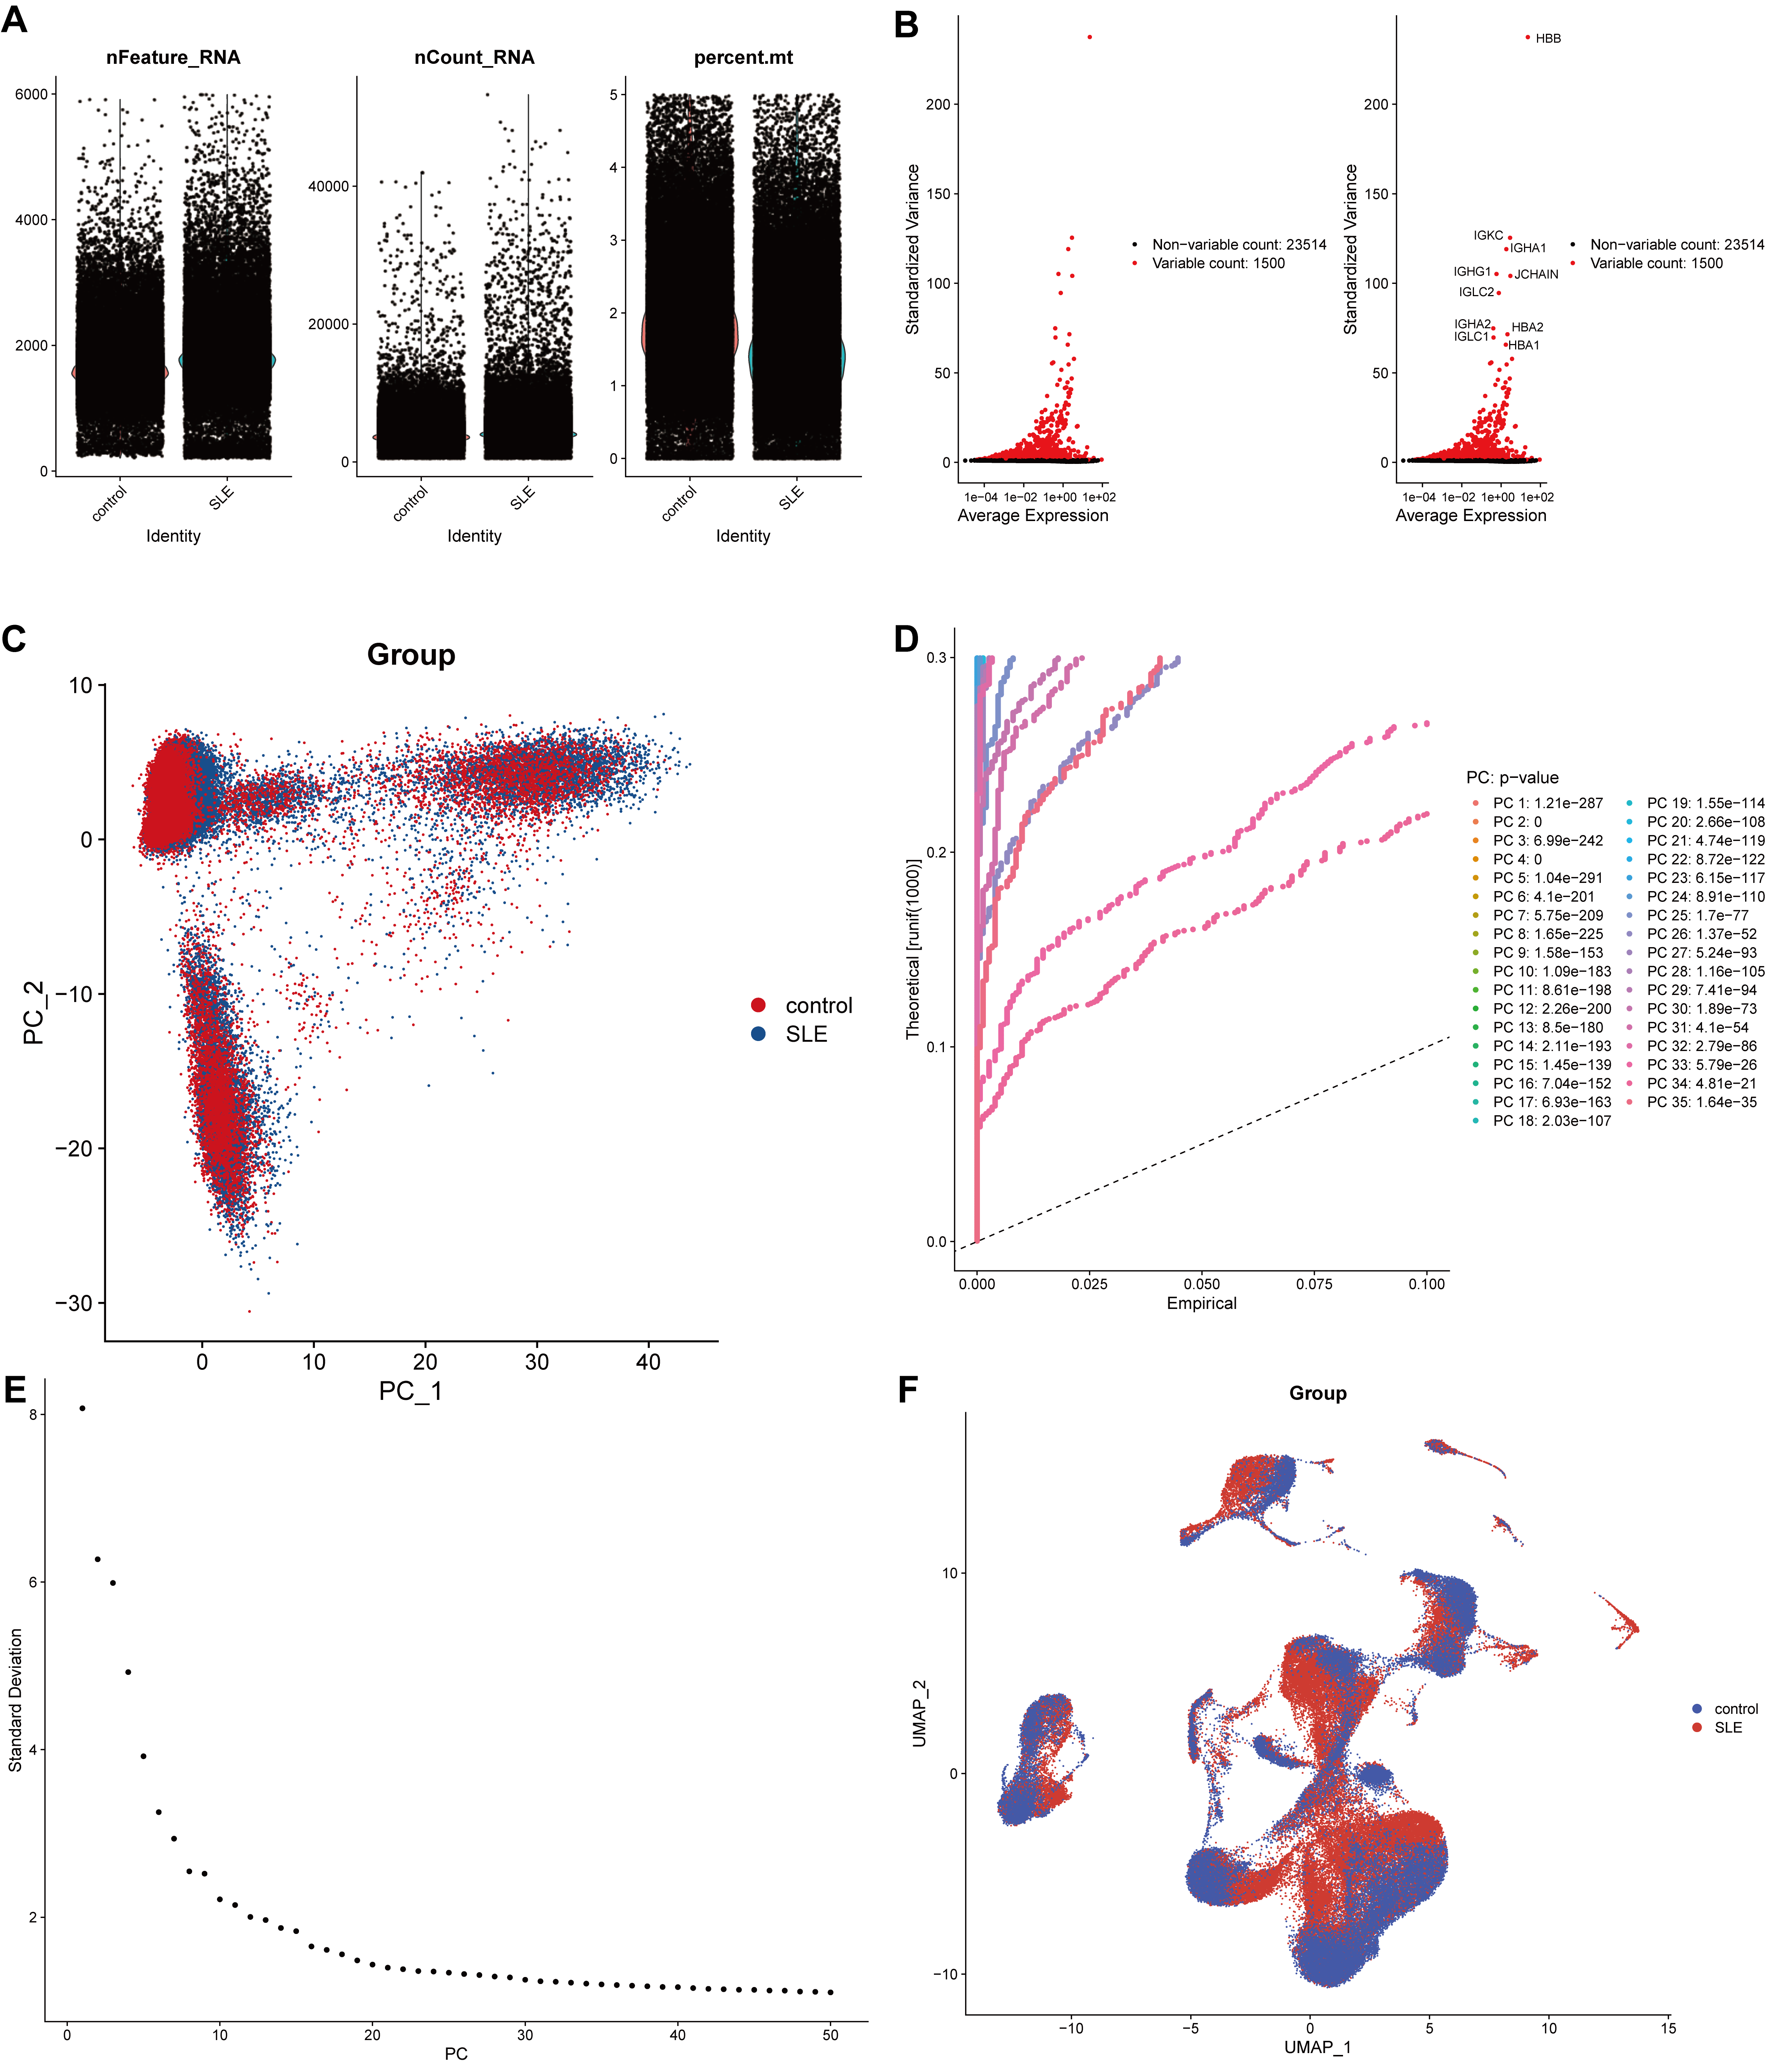
Figure S1. Single-cell RNA sequencing quality control and dimensionality reduction analysis
(A) The violin plot shows the quality control metrics of the single-cell RNA-seq data.(B) The scatter plot displays the gene expression variability between non-variable and variable genes.(C) Principal component analysis (PCA) of the control group and SLE group.(D) The scree plot shows the variance ratio for each principal component.(E) The elbow plot illustrates the distribution of standard deviations for the principal components.(F) The UMAP plot shows the clustering of cells from the control group and SLE group.
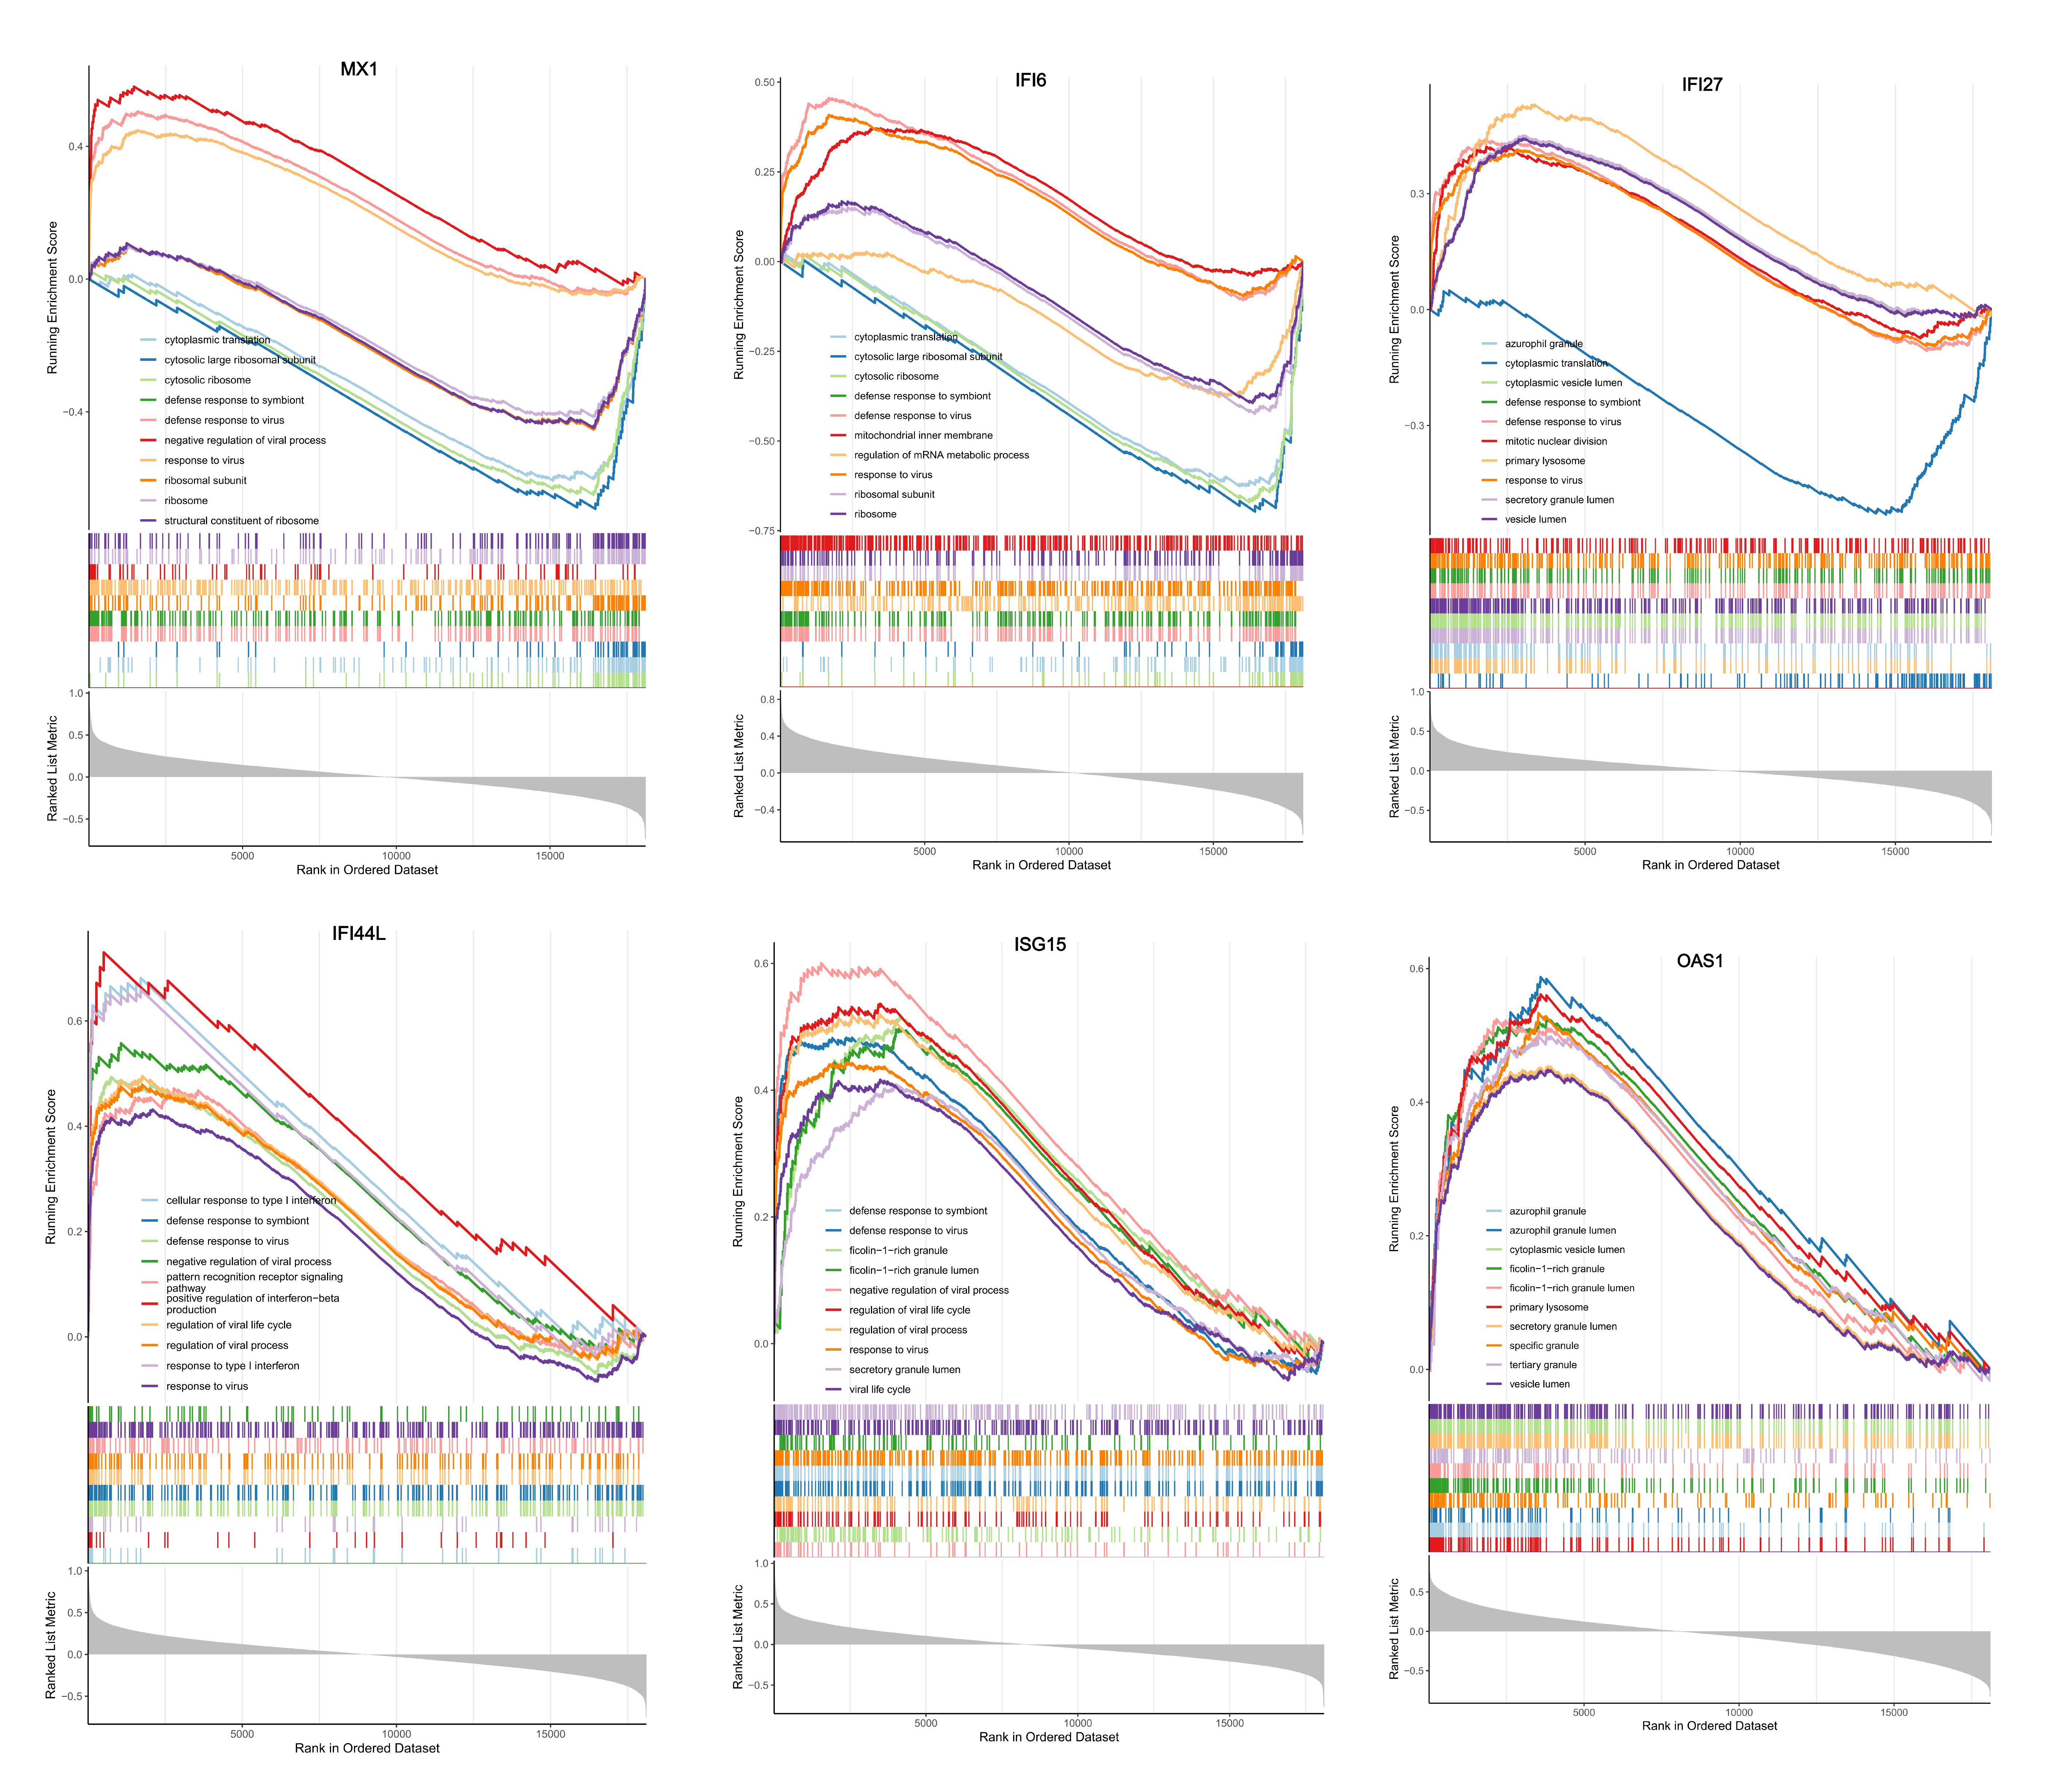Figure S2 Gene set enrichment analysis (GSEA) for individual genes shows the GO results for MX1, OAS1, IFI6, IFI27, IFI44L, and ISG5.

