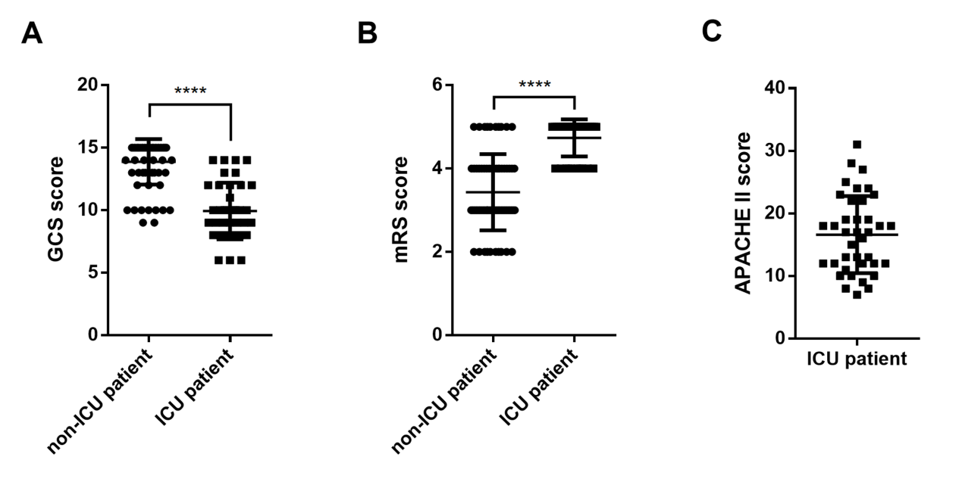
Figure S1 Clinical score distributions in A-GFAP-A patients with and without ICU admission
(A) Distribution of Glasgow Coma Scale (GCS) scores in non-ICU and ICU patients. (B) Distribution of modified Rankin Scale (mRS) scores in non-ICU and ICU patients. (C) Distribution of Acute Physiology and Chronic Health Evaluation II (APACHE II) scores in ICU patients. **** indicates a statistically significant difference between groups (p < 0.0001).
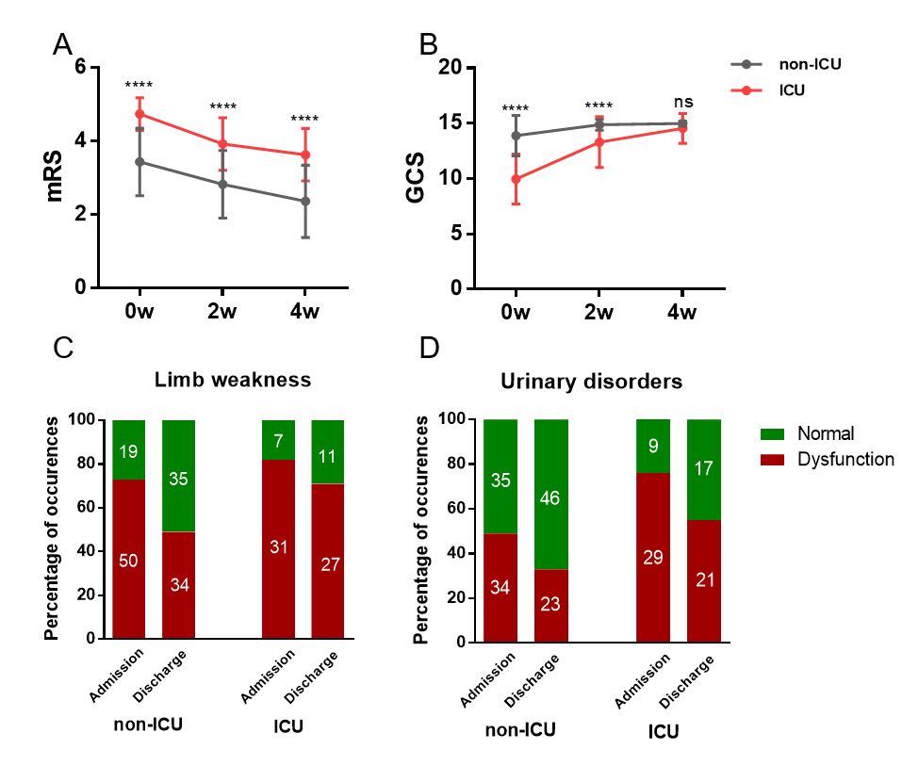
Figure S2 Comparison of clinical outcomes between GFAP-A patients admitted to the ICU and non-ICU.
(A-B) Glasgow Coma Scale (GCS) and modified Rankin Scale (mRS) scores at admission, 2 weeks post-admission, and 4 weeks post-admission between two groups (p<0.001). (C-D) Limb weakness and urinary dysfunction at admission and discharge.
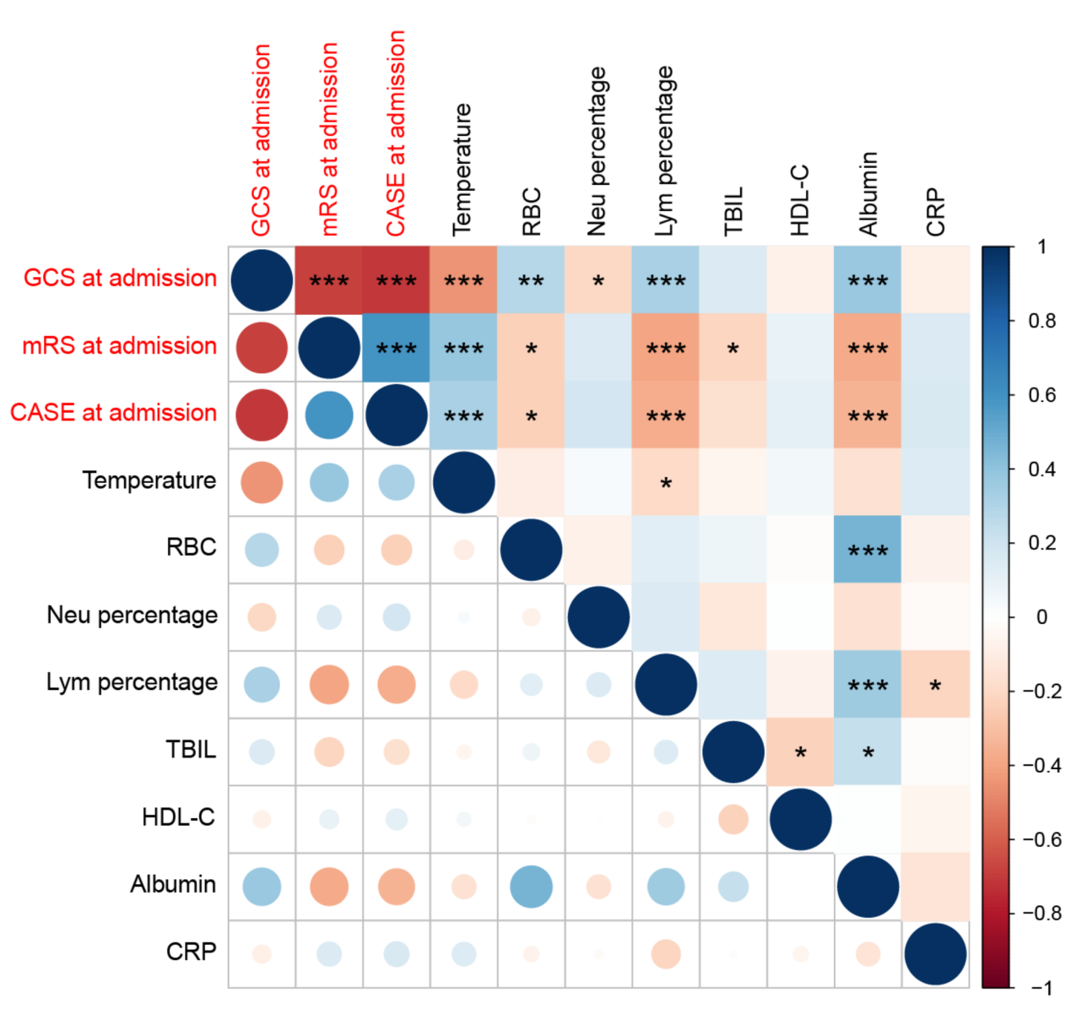
Figure S3 Correlation matrix of predictive variables considered for ICU admission in A-GFAP-A patients.
A heatmap displaying the pairwise Pearson correlation coefficients among all candidate predictive variables analyzed. The color gradient indicates correlation magnitude: darker red denotes stronger negative correlations, while blue shades represent stronger positive correlations. *P < 0.05; **P < 0.01; ***P < 0.001.
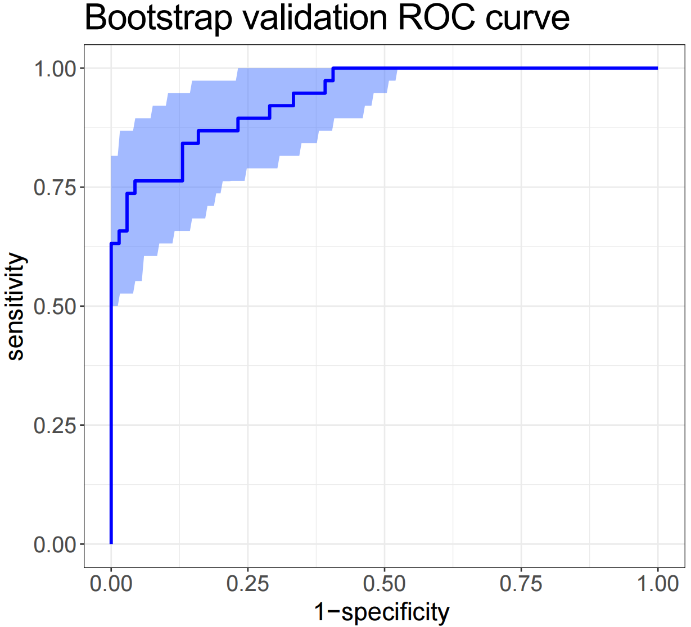
Figure S4 Bootstrap validation ROC curve for the nomogram predicting ICU admission in A-GFAP-A patients.
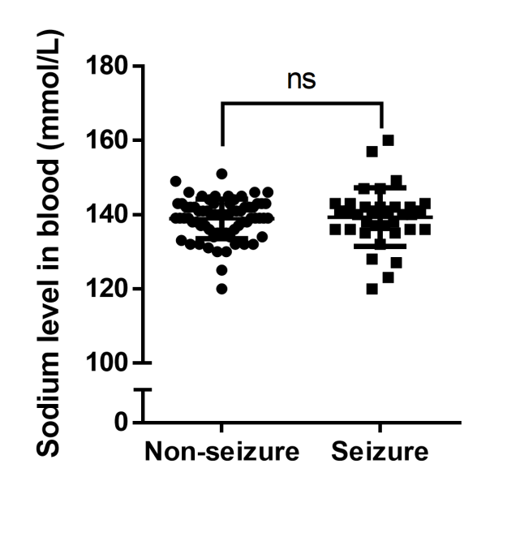
Figure S5 Blood sodium level in A-GFAP-A patients with and without seizures

Table S1. Treatment strategies.
 |  | ICU admission in GFAP-A patients
Variables | The study cohort (training and validation, N=107) | non-ICU admission  (N=69) | ICU admission  (N=38) | P
Treatment and outcomes, n(%)
Steroid pulse therapy | 86 (80.4) | 59 (85.5) | 27 (71.1) | 0.122
Efgartigimod | 23 (21.5) | 14 (20.3) | 9 (23.7) | 0.87
Immunoadsorption | 11 (10.3) | 5 (7.2) | 6 (15.8) | 0.289
IVIG | 42 (39.3) | 30 (43.5) | 12 (31.6) | 0.318
Mycophenolate mofetil | 54 (50.5) | 37 (53.6) | 17 (44.7) | 0.498
Azathioprine | 4 (3.7) | 3 (4.3) | 1 (2.6) | 1
Monoclonal antibody | 19 (17.8) | 11 (15.9) | 8 (21.1) | 0.691
Note: IVIG=Intravenous immunoglobulin; IQR=Inter-Quartile Range.

Table S2. Outcome measures and complications.
 |  | ICU admission in GFAP-A patients
Variables | The study cohort (training and validation, N=107) | non-ICU admission  (N=69) | ICU admission  (N=38) | P
Scores, n (%)
GCS 2W, n(%) |  |  |  | <0.001
3-7 | 0 (0.0) | 0 (0.0) | 0 (0.0)
8 | 2 (1.9) | 0 (0.0) | 2 (5.3)
9 | 0 (0.0) | 0 (0.0) | 0 (0.0)
10 | 7 (6.5) | 0 (0.0) | 7 (18.4)
11 | 0 (0.0) | 0 (0.0) | 0 (0.0)
12 | 3 (2.8) | 1 (1.4) | 2 (5.3)
13 | 3 (2.8) | 1 (1.4) | 2 (5.3)
14 | 11 (10.3) | 5 (7.2) | 6 (15.8)
15 | 81 (75.7) | 62 (89.9) | 19 (50.0)
GCS 4W, n(%) |  |  |  | 0.176
3-8 | 0 (0.0) | 0 (0.0) | 0 (0.0)
9 | 1 (0.9) | 0 (0.0) | 1 (2.6)
10 | 1 (0.9) | 0 (0.0) | 1 (2.6)
11 | 0 (0.0) | 0 (0.0) | 0 (0.0)
12 | 1 (0.9) | 0 (0.0) | 1 (2.6)
13 | 1 (0.9) | 0 (0.0) | 1 (2.6)
14 | 5 (4.7) | 3 (4.3) | 2 (5.3)
15 | 98 (91.6) | 66 (95.7) | 32 (84.2)
mRS 2W, n(%) |  |  |  | <0.001
0 | 0 (0.0) | 0 (0.0) | 0 (0.0)
1 | 5 (4.7) | 5 (7.2) | 0 (0.0)
2 | 22 (20.6) | 21 (30.4) | 1 (2.6)
3 | 32 (29.9) | 24 (34.8) | 8 (21.1)
4 | 41 (38.3) | 19 (27.5) | 22 (57.9)
5 | 7 (6.5) | 0 (0.0) | 7 (18.4)
mRS 4W, n(%) |  |  |  | <0.001
0 | 2 (1.9) | 2 (2.9) | 0 (0.0)
1 | 9 (8.4) | 9 (13.0) | 0 (0.0)
2 | 33 (30.8) | 30 (43.5) | 3 (7.9)
3 | 28 (26.2) | 18 (26.1) | 10 (26.3)
4 | 33 (30.8) | 10 (14.5) | 23 (60.5)
5 | 2 (1.9) | 0 (0.0) | 2 (5.3)
Urinary dysfunction at first discharge | 44 (41.1) | 23 (33.3) | 21 (55.3) | 0.045
Limb weakness at first discharge | 61 (57.0) | 34 (49.3) | 27 (71.1) | 0.048
Length of stay, median [IQR] | 14 [11,20] | 13 [10,18] | 16 [13,23] | 0.02
Note: GCS=Glasgow Coma Scale; mRS=modified Rankin Scale; IQR=Inter-Quartile Range. Bolded P values indicate statistically significant differences (p<0.05).

