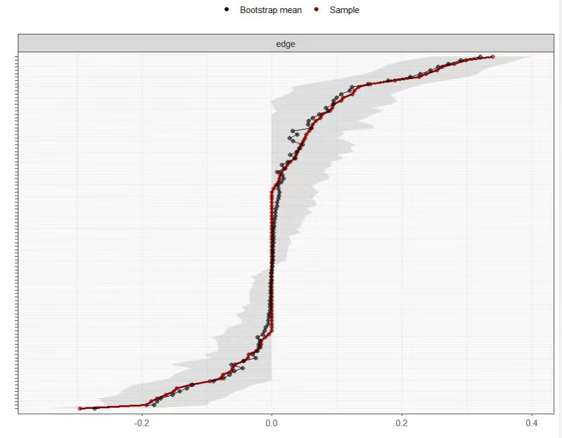
Appendix Figure 1 Accuracy test of side weights

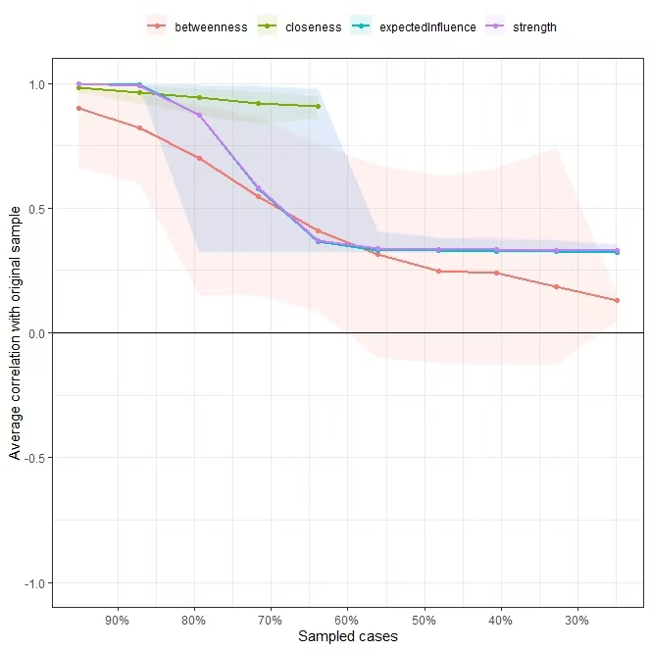

Appendix Figure 2 Node stability test

