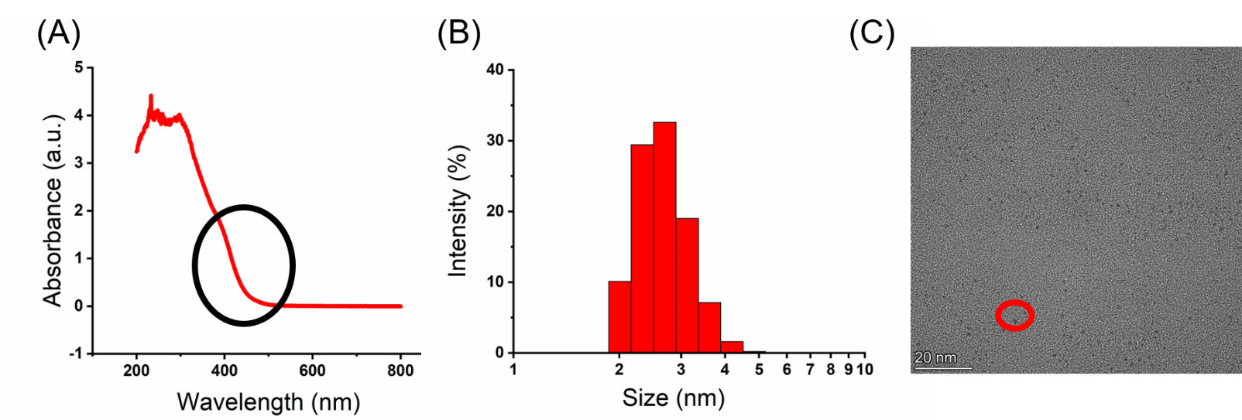
Fig. S1 Characterization and Morphology of Au_{x}.
(A) UV-vis absorption spectrum, (B) size distribution histogram and (C) TEM image. In Fig. A, the black circles represent the characteristic peaks of the Au nanoclusters; The red circles in Fig. C represent nanocluster particles.

Fig. S2 Antibacterial effect of each material on E. coli.
*p < 0.05, compared to the control; #p < 0.05, compared with TA group. (n=5, mean ± SD)
Fig. S3 Effect of concentration of photocatalyst on photocatalytic antibacterial activity. (n=5, mean ± SD)

Fig. S4 Effect of illumination intensity on photocatalytic sterilization. (n=5, mean ± SD)

Fig. S5 Effect of the ratio of Au_{x} to TiO₂ on photocatalytic sterilization. (n=5, mean ± SD)

Fig. S6 Effect of photocatalytic repetition times on photocatalytic sterilization.
*p < 0.05, compared with TA group. (n=5, mean ± SD)

Fig. S7 Effect of the content of photocatalyst in the dressing on the antibacterial effect. (n=5, mean ± SD)

Fig. S8 Antibacterial effect of dressings in vitro.
(A) E. coli, (B) S. aureus, (C) A. baumannii, (D) P. aeruginosa. *p < 0.05, compared to the blank; #p < 0.05, compared with the corresponding TA/PDMS and TAB/PDMS, respectively. (n=5, mean ± SD)
Fig. S9 Effects of different concentrations of Au_{x}, TiO₂, TA and TAB on the viability of 3T3 cells. (n=5, mean ± SD)

Fig. S10 Effects of different concentrations of PDMS, TA/PDMS and TAB/PDMS extracts on the viability of 3T3 cells. (n=5, mean ± SD)
Fig. S11 Morphological characteristics of dressing.
SEM image of (A) plane section and (B) cross section.

Table S1 Zeta potential values of different samples
Sample | Au_{x} | TiO₂ | TiO₂+BPEI | TA | TAB
Zeta potential value (mV) | -7.59±0.36 | 7.48±0.92 | 35.80±1.63 | -30.3±0.40 | 5.61±0.22

