SUPPLEMENTARY MATERIALS
1. SUPPLEMENTARY METHODS
Study design and participants
This longitudinal cohort study were conducted between Nov, 2023 and Feb, 2024 in Beijing Hospital, nearly one year after SARS-CoV-2 infection, ensuring that any observed fatigue and other symptoms were persistent and not related to the acute phase of infection. We initially performed telephone follow-up in 206 elderly COPD patients, who are in the long-term follow-up of Beijing Hospital, assessing whether they were suitable for this research based on the inclusion and exclusion criteria (Supplementary Table 1). After screening, 85 elderly COPD patients were eligible for this research, and agreed to attend the face-to-face interview in hospital. They were all aged 65 or above and were clinically stable, with laboratory confirmed SARS-CoV-2 infection between Dec 1, 2022 and Feb 28, 2023. As fatigue is the most dominant complaint of long COVID [1, 2], 43 of the 85 patients reported persistent and remarkable fatigue within 1 year after SARS-CoV-2 infection in this face-to-face questionnaires and were divided into the Long-COVID group. The remaining 42 patients without fatigue were assigned to the Control group. Notably, fatigue is a new symptom after COVID-19 and these patients all did not feel obvious fatigue before SARS-CoV-2 infection.
The recruited 85 patients all completed questionnaire assessment, blood tests, and pulmonary function tests. Except for one patient in the Long-COVID group, the rest of the patients all performed chest CT examination (Figure 1). To explore the possible mechanisms of long COVID development in elderly COPD patients, we employed a random number generator to randomly select 30 patients from each of the two groups, ensuring the representativeness and validity of our findings, making a total of 60 patients for the serum proteomic analysis. Finally, the clinical and proteomics data of the 60 patients were used for machine learning model training, to identify important features of elderly COPD patients with long COVID (Supplementary Figure 1).
Face-to-face follow-up questionnaires of both psychological and somatic symptom
The face-to-face follow-up questionnaires were conducted by well-trained medical staff. Questionnaires mainly collected baseline demographic information, such as age, gender, height, weight, cigarette smoking, career, COVID-19 vaccination status, comorbidities, course of COPD, duration and severity of COVID-19. Other questionnaires include the modified Medical Research Council (mMRC) dyspnea scale, the EuroQol Visual Analogue Scale (EQ-VAS) to assess quality of life, the Generalized Anxiety Disorder-7 (GAD-7) to screen for anxiety, Fatigue Severity Scale (FSS), and the Patient Health Questionnaire-9 (PHQ-9) to screen for depression. In addition, patients also completed the COPD Assessment Test (CAT) to assess the burden of symptoms and impact on daily life of COPD patients.
Health physical examination
The health physical examination included routine blood tests and pulmonary function tests (PFTs), and chest CT. Venous blood was collected on empty stomach at early morning for complete blood count, biochemical test, C-reactive protein (CRP), and serum amyloid A (SAA). PFTs were conducted at Beijing Hospital under the supervision of well-trained technicians using a Vmax 622 pulmonary function instrument (SensorMedics, USA) and plethysmograph (SensorMedics, USA) according to pulmonary function test guidelines of China. Each test was repeated three times and the best value was considered for analysis to ensure accuracy and reliability. All subjects underwent a bronchodilator test which required the administration of 400μg of salbutamol via a metered dose inhaler. Spirometry was then repeated 15 minutes after short-acting β2-agonist administration. Multiple lung function parameters were assessed, including forced vital capacity (FVC), forced expiratory volume in one second (FEV1), peak expiratory flow (PEF), maximum voluntary ventilation (MVV), total lung capacity (TLC), diffusing capacity for carbon monoxide (DL_{CO}) and their respective percentage of the predicted values. Besides, these patients have had PFTs in Beijing Hospital one or two years before COVID-19 epidemic and the corresponding lung function parameters were extracted from electronic medical care data. We then compared lung function results before COVID-19 epidemic with lung function results of this time, and calculated the annual variation according to the time interval between the two pulmonary function tests. Chest CT was performed using the uCT 760 128-slice CT scanner and the 256-slice GE Revolution CT. Emphysema, bronchial wall thickening, and interstitial changes were evaluated visually by well-trained radiologist. Severity of emphysema was evaluated according to the visual classification system of the Fleischner Society [3], trace referring to centrilobular emphysema involving less than 0.5% of the lung zone, mild involving 0.5%-5% of the lung zone, and moderate involving more than 5% of the lung zone. Bronchial wall thickening was evaluated visually as follows: grade 0, bronchial wall < 30% adjacent pulmonary artery diameter; grade 1, 30% ⩽ bronchial wall < 50% adjacent pulmonary artery diameter; and grade 2, bronchial wall ⩾ 50% adjacent pulmonary artery diameter [4]. In this study, mild bronchial wall thickening means grade1, moderate grade2. Interstitial lesions primarily manifest as grid shadows, honeycomb change, ground-glass opacities, and traction bronchiectasis in HRCT (quantitative high resolution computed tomography). Goh visual scoring was used to estimate the extent of interstitial changes [5]. In this study, mild interstitial changes means Goh score ≤ 10%, and moderate means Goh score ≤ 20%.
Serum isolation
Venous blood samples were collected from the elected 85 patients and placed for one hour at room temperature, after which supernatants of these blood samples were isolated by centrifugation at 1300 g for 10 min at 4°C and then stored at -80°C freezers until thawed for further proteomic analysis.
DIA (data-independent acquisition) proteomic analysis
60 serum samples, including 30 samples from the Control group and 30 sample from the Long-COVID group, were processed for the DIA proteomic analysis. Briefly, the cellular debris of the serum samples were removed by centrifugation at 12,000 g at 4 °C for 10 min. Then Pierce™ Top 14 Abundant Protein Depletion Spin Columns Kit (Thermo Fisher Scientific) was used to remove the top 14 high abundance proteins. Next, the protein concentration was measured with BCA kit in line with the manufacturer’s instructions.
Protein reduction was conducted with 5 mM dithiothreitol for 30 min at 56 °C, and alkylation with 11 mM iodoacetamide for 15 min at room temperature in darkness, followed by overnight trypsin digestion at 1:50 trypsin-to-protein mass ratio and then a second 4 h-digestion at 1:100 trypsin-to-protein mass ratio. Lastly, the digested peptides were desalted using C18 SPE column.
The tryptic peptides were dissolved in solvent A, and then directly loaded onto a home-made reversed-phase analytical column (25-cm length, 100μm i.d.) with EASY-nLC 1200 UPLC system (Thermo Fisher Scientific). The separated peptides were analyzed in Orbitrap Exploris 480 with a nano-electrospray ion source.
The raw data were processed using Spectronaut (v.18) software coupled with Pulsar search engine, and searched against Homo_sapiens_9606_SP_20231220.fasta (20429 entries) concatenated with reverse decoy database. Proteins with fold change > 1.2 or < 0.83 and P value < 0.05 (Student’s t-test) were identified as differentially expressed proteins (DEPs). Fisher’s exact test was used to analyze the significance of Gene ontology (GO) and Kyoto Encyclopedia of Genes and Genomes (KEGG) enrichment of differentially expressed proteins (using the identified protein as the background). Functional terms with P value < 0.05 were considered as significant.
Machine learning model training
The clinical data (such as demographic, medical history, blood tests, pulmonary function test, and chest CT data) and proteomics data obtained above were used for machine learning model training, to identify the important features of COPD patients developing long COVID compared with these not. As illustrated in Supplementary Figure 1, before model training, all features underwent initial screening based on their missing rates (no more than 0.1), inter-group P value (< 0.1), and variances (not equal to zero). Next, the filtered 31 features underwent missing data imputation. For proteomic variables, missing values were primarily due to low abundance, and were imputed as 0. For other numerical data, after normalization to a range of 0-1, missing values are filled with -0.5 to differentiate them from non-missing numerical values. For other categorical variables, one-hot encoding was used to represent them as a 0, 1 vector format, with missing values treated as a separate category.
Samples were then stratified sampled based on the outcome by a ratio of 2:1 for model training and internal validation, namely 40 patients in the training dataset and 20 patients in the internal validation dataset. Boruta is a feature selection method based on Random Forest, and was used to select the important features in the filtered 31 features for machine learning models. Three machine learning algorithms, including Random Forest, Support Vector Machine (SVM), and Ridge Regression, were used for model training based on the selected important features by Boruta. To achieve better prediction efficiency, we used hyperparameter tuning and 5-fold cross-validation. The performance of these models was then comprehensively evaluated using various metrics, including sensitivity, specificity, accuracy, the ROC curve, and its corresponding area under the curve in the internal validation dataset. SHAP (Shapley Additive exPlanations) is a library grounded in Shapley values, designed to elucidate the predictions made by machine learning models. Finally, the analysis of feature importance was conducted using SHAP values.
Reactome pathway analysis of DEPs
Reactome is a freely available open-source relational database that contains reactions, pathways and biological processes. Reactome pathways of identified DEPs were used as the initial pathways (low level). Based on the hierarchical relationship of reactome pathways, parent pathways (high level) were obtained by recursive query from the initial pathways. The strip width represents the DEPs number of corresponding reactome pathways. Then non-review literatures in Pubmed were queried using “the name of each pathway” AND “long COVID” as keywords. The color of nodes represents the number of related literatures.
Ethical approval
This study was approved by the Research Ethics Committee of Beijing Hospital (2023BJYYEC-355-02). Prior to participation, written informed consent was obtained from all study participants.
Statistical analysis
Baseline demographic characteristics are presented as median (IQR) or mean ± SD for continuous variables, and n/N (%) for categorical variables. For continuous variables, P values were calculated using Student’s t test or Mann-Whitney U test. Categorical variables were compared by Fisher’s exact test or Pearson’s chi(2) test. A two-sided P value less than 0.05 was considered statistically significant. Statistical analysis was performed using IBM SPSS Statistics version 25.0.

SUPPLEMENTARY FIGURES and TABLES
Supplementary Figure 1. Schematic representation of the machine learning model training.
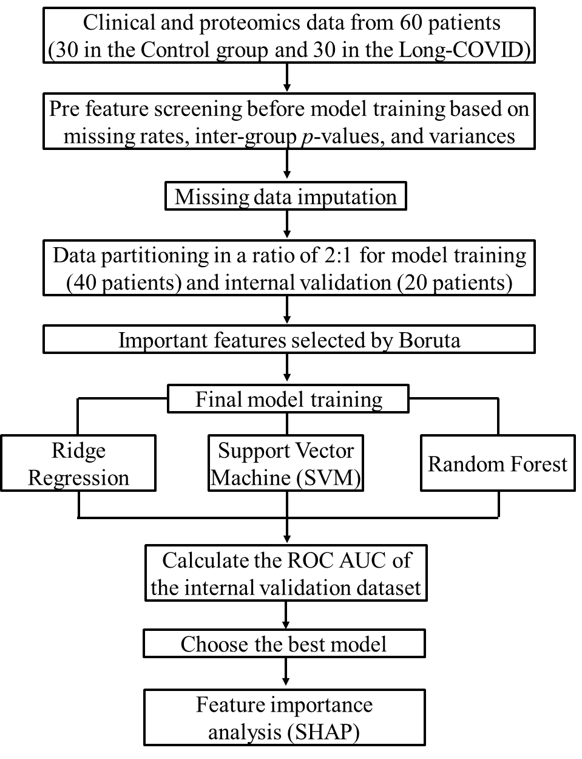

Supplementary Figure 2. Proteomics of serum from 30 patients in the Control group and 30 patients in the Long-COVID group. a) Volcano plot showing differentially expressed proteins between the two groups. Protein with a fold change > 1.2 or < 0.83 and a P value < 0.05 was considered a significantly differentially expressed protein. The red dots represent up-regulated proteins, and the blue dots represent down-regulated ones, while the grey dots represent no differentially expressed proteins. b) Bubble plot of GO (biological process, BP) enrichment analysis of the up-regulated DEPs. c) Bubble plot showing the results of KEGG pathway enrichment analyses performed for up-regulated DEPs. The size of each bubble indicates the number of differentially expressed proteins in each enrichment term, and the color represents the corresponding P value. Abbreviations: DEPs, differentially expressed proteins.
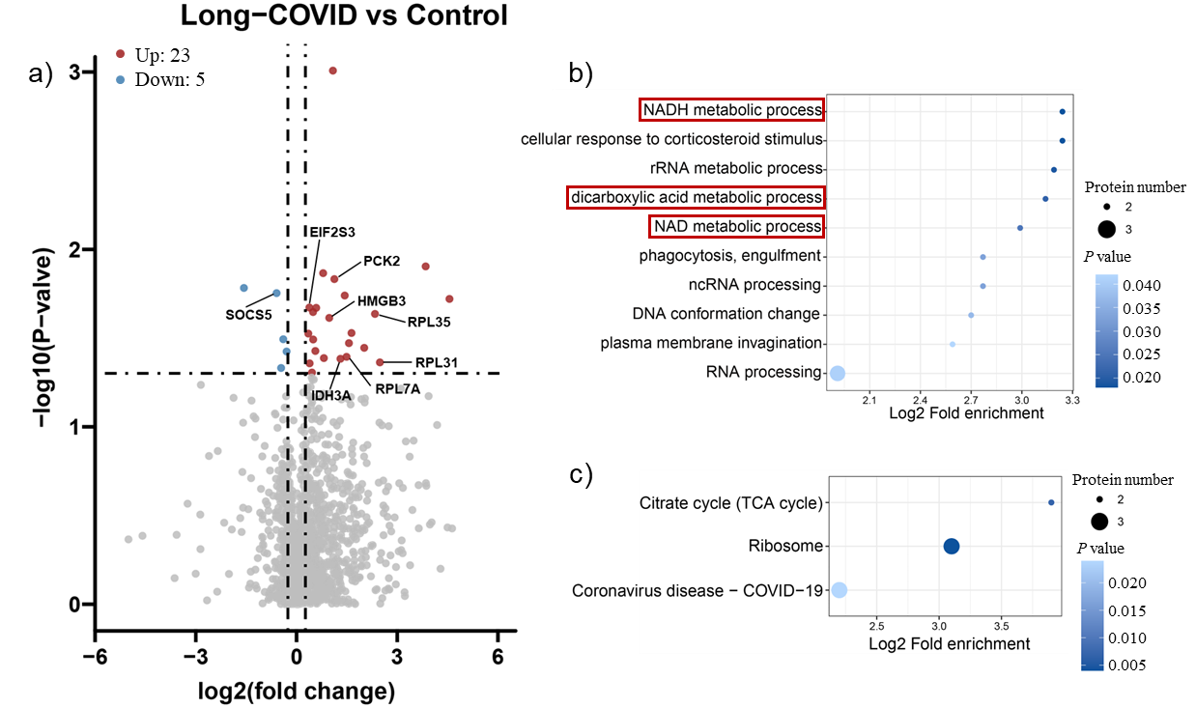

Supplementary Figure 3. Reactome pathways of DEPs. This figure shows the hierarchical relationships of reactome pathways, from low level to high level. The strip width represents the DEP number of the corresponding reactome pathways. The colour of the nodes represents the number of non-review literatures, queried in PubMed using “the name of each pathway” AND “long COVID” as keywords. Abbreviations: DEPs, differentially expressed proteins.
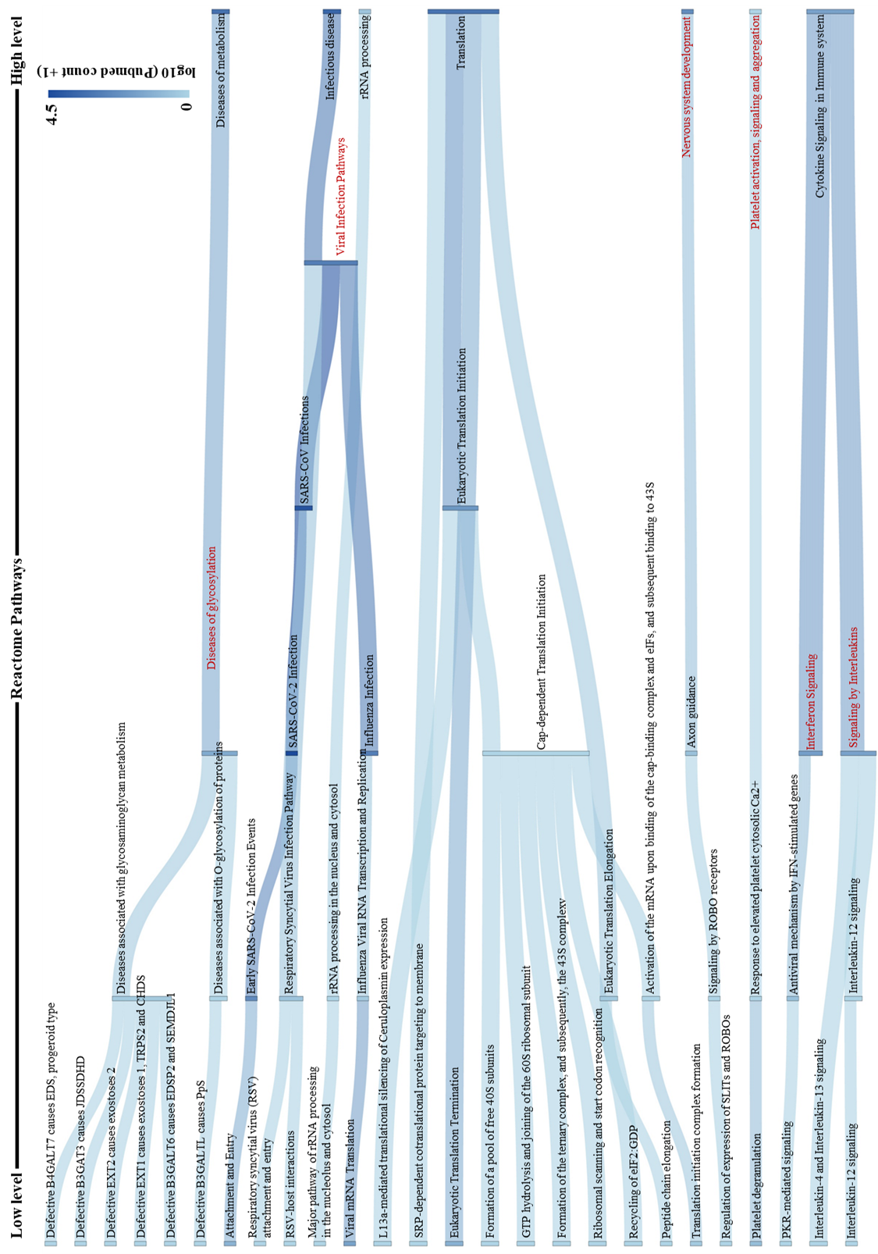
Supplementary Figure 4. The details of the five identified key features in the two groups by SVM machine learning model. a) Wheezing; b) The duration of SARS-CoV-2 infection; c) EIF2S3 (eukaryotic translation initiation factor 2 subunit gamma); d) Current FEV1/FVC (%); e) The course of COPD.
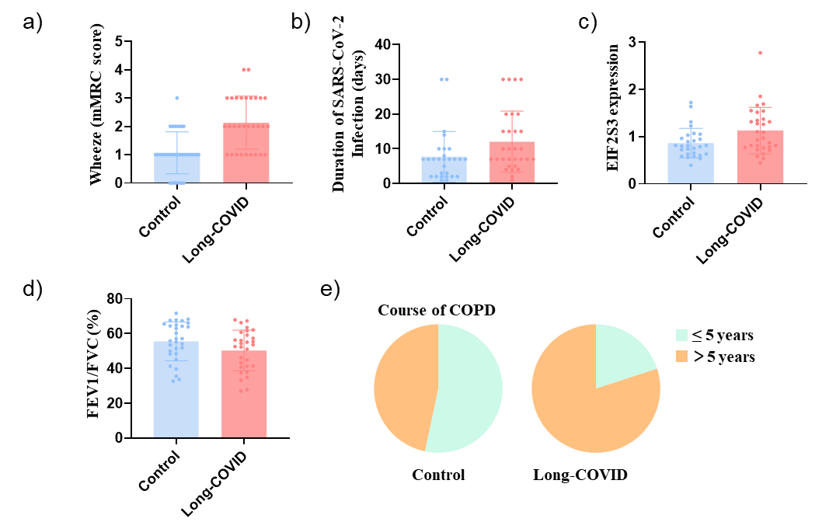

Supplementary Table 1. Inclusion and exclusion criteria of this study.
Inclusion criteria | - Age 65 years old and above  - COPD diagnosed according to the GOLD guidelines  - Clinically stable with no exacerbation within a month  - SARS-CoV-2 infection between Dec 1, 2022 and Feb 28, 2023
Exclusion criteria | - Patients who are risky to participate in the study  - Lack of necessary clinical data  - A history of recreational drug abuse or allergy  - Participation in other studies within the past 3 months  - Poor compliance  - Recent disturbance of consciousness due to cerebrovascular disease and incapacity due to mental illness  - Patients who are suffering from acute COPD exacerbation, late-stage cancer, autoimmune diseases, using immunosuppressive drugs or unable to complete the questionnaire due to other reasons.

Supplementary Table 2. There was no remarkable difference in the complete blood test and biochemistry test between the two groups.
Characteristic | Control  N=42 | Long-COVID  N=43 | P Value
RBC (10¹²) | 4.77 (4.37-5.09) | 4.63 (4.39-5.00) | 0.629
WBC (10¹²) | 6.42 (5.03-7.87) | 6.57 (5.10-7.42) | 0.979
NEUT% | 63.6 (56.23-69.70) | 65.90 (58.10-69.70) | 0.871
LYMPH% | 24.35 (18.65-31.25) | 23.00 (17.50-28.40) | 0.458
MONO% | 6.70 (5.68-8.10) | 6.80 (5.70-8.10) | 0.874
EOS% | 2.55 (1.48-3.33) | 2.30 (1.20-3.60) | 0.215
HGB | 150.00 (136.75-157.00) | 146.00 (135.00-153.00) | 0.228
PLR | 137.18 (105.67-174.96) | 135.29 (98.67-193.21) | 0.812
NLR | 2.74 (1.88-3.72) | 2.88 (2.02-3.82) | 0.719
CRP (mg/L) | 1.65 (0.70-5.43) | 1.40 (0.60-4.90) | 0.705
SAA (mg/L) | 2.05 (0.00-6.03) | 2.00 (0.00-8.90) | 0.967
TC (mmol/L) | 4.26 (3.26-5.22) | 4.24 (3.47-4.91) | 0.874
TG (mmol/L) | 1.23 (0.91-1.67) | 1.06 (0.84-1.57) | 0.183
HDL-C (mmol/L) | 1.19 (0.97-1.48) | 1.38 (1.06-1.64) | 0.064
LDL-C (mmol/L) | 2.49 (1.68-3.13) | 2.29 (1.89-2.75) | 0.515
Note. The date are presented as the median (IQR). P values were calculated using the Mann-Whitney U test. A two-sided P value less than 0.05 was considered statistically significant. Abbreviations: PLR, platelets-lymphocyte ratio; NLR, neutrophils-lymphocyte ratio.

Supplementary Table 3. The FSS, EQ-VAS, GAD-7, and PHQ-9 assessment between the two groups.
 | Control  N=42 | Long-COVID  N=43 | P Value
FSS | 1.10 (0.00-3.40) | 4.60 (3.70-5.10) | < 0.001
EQ-VAS | 80.0 (70.0-90.0) | 60.0 (50.0-70.0) | < 0.001
GAD-7  Minimal (0-4)  Mild (5-9)  Moderate (10-14)  Severe (15-21) | 39/42 (92.8%)  2/42 (4.8%)  1/42 (2.4%)  0 | 35/43 (81.4%)  6/43 (14.0%)  2/43 (4.6%)  0 | 0.399
PHQ-9  Minimal (0-4)  Mild (5-9)  Moderate (10-14)  Moderately severe (15-19)  Severe (20-27) | 35/42 (83.3%)  5/42 (11.9%)  1/42 (2.4%)  1/42 (2.4%)  0 | 16/43 (37.2%)  18/43 (41.8%)  6/43 (14.0%)  3/43 (7.0%)  0 | < 0.001
Note. The date are presented as the median (IQR) or n/N (%). For continuous variables, P values were calculated using the Mann-Whitney U test. Categorical variables were compared by Fisher’s exact test or Pearson’s chi(2) test. A two-sided P value less than 0.05 was considered statistically significant. ***P < 0.001. ns = not significant. Abbreviations: FSS, Fatigue Severity Scale; EQ-VAS, EuroQol Visual Analogue Scale; GAD-7, Generalized Anxiety Disorder-7; PHQ-9, Patient Health Questionnaire-9.

Supplementary Table 4. Diffusing capacity (DL_{CO}) declined faster annually in the Long-COVID group than in the Control group after SARS-CoV-2 infection.
 | Control | Long-COVID | P Value
FVC (L/year) | 0.03 (-0.09 to 0.18) | -0.01 (-0.12 to 0.13) | 0.437
FEV1 (L/year) | -0.04 (-0.13 to 0.06) | -0.03 (-0.12 to 0.07) | 0.830
FEV1/FVC (%/year) | -1.59 (-4.06 to -0.10) | -1.77 (-4.17 to 1.87) | 0.621
FEV1/FVC improvement rate (%/year) | -0.30 (-2.25 to 2.57) | 0.50 (-4.11 to 4.60) | 0.808
PEF (% of predicted/year) | 0.05 (-2.87 to 4.51) | 0.06 (-4.72 to 4.64) | 0.583
MEF 75 (% of predicted/year) | -1.68 (-3.87 to 2.07) | -0.89 (-4.39 to 3.10) | 0.691
MEF 50 (% of predicted/year) | -2.36 (-5.68 to 0.71) | -1.60 (-4.59 to 1.90) | 0.443
MEF 25 (% of predicted/year) | -1.88 (-5.40 to 0.44) | -2.09 (-4.17 to 1.38) | 0.563
DL_{CO} (mmol/min/kPa/year) | 0.09 (-0.14 to 0.35) | -0.14 (-0.33 to 0.05) | 0.031
DL_{CO}/VA (mmol/min/kPa/L/year) | 0.00 (-0.02 to 0.04) | -0.02 (-0.04 to 0.03) | 0.650
Note. The date are presented as the median (IQR). P values were calculated using the Mann-Whitney U test. A two-sided P value less than 0.05 was considered statistically significant. *P < 0.05. ns = not significant.

Supplementary Table 5. Chest CT of the two groups.
Characteristic | Control  N=42 | Long-COVID  N=42 | P Value
Emphysema  None  Trace  Mild  Moderate | 13/42 (31.0%)  22/42 (52.4%)  7/42 (16.6%)  0 | 10/42 (23.8%)  18/42 (42.9%)  9/42 (21.4%)  5/42 (11.9%) | 0.115
Bronchial wall thickening  None  Mild  Moderate | 4/42 (9.5%)  38/42 (90.5%)  0 | 2/42 (4.8%)  39/42 (92.9%)  1/42 (2.3%) | 0.676
Interstitial changes  None  Mild  Moderate | 41/42 (97.6%)  1/42 (2.4%)  0 | 36/42 (85.7%)  5/42 (11.9%)  1/42 (2.4%) | 0.109
Tractive bronchiectasis  None  Mild  Moderate | 42/42 (100%)  0  0 | 39/42 (92.8%)  2/42 (4.8%)  1/42 (2.4%) | 0.241
Note. The date are presented as n/N (%). P values were compared by Fisher’s exact test or Pearson’s chi(2) test. A two-sided P value less than 0.05 was considered statistically significant.
Reference
1. Sandler CX, Wyller VBB, Moss-Morris R, et al. Long COVID and Post-infective Fatigue Syndrome: A Review. Open Forum Infect Dis. 2021;8(10):ofab440.
2. Aziz R, Siles N, Kelley M, et al. Clinical characteristics of Long COVID patients presenting to a dedicated academic post-COVID-19 clinic in Central Texas. Sci Rep. 2023;13(1):21971.
3. Lynch DA, Austin JH, Hogg JC, et al. CT-Definable Subtypes of Chronic Obstructive Pulmonary Disease: A Statement of the Fleischner Society. Radiology. 2015;277(1):192-205.
4. Kitaguchi Y, Fujimoto K, Kubo K, et al. Characteristics of COPD phenotypes classified according to the findings of HRCT. Respir Med. 2006;100(10):1742-52.
5. Goh NS, Desai SR, Veeraraghavan S, et al. Interstitial lung disease in systemic sclerosis: a simple staging system. Am J Respir Crit Care Med. 2008;177(11):1248-54.

