Supplementary Material

Video S1: Live imaging of iron oxide nanoparticle (IONP) uptake over 24 hours by H295R. Video S2: Live imaging of iron oxide nanoparticle (IONP) uptake over 24 hours by HAC15. Video S3: Live imaging of iron oxide nanoparticle (IONP) uptake over 24 hours by MUC-. ACC cells (MUC1, H295R, HAC15) were incubated with 10 µg/ml of IONP for 24 hours, and uptake was assessed using Confocal Microscopy. An image was taken every 15 minutes over 24 hours. Live imaging videos are in the supplementary section. Scalebar: 50 µm.

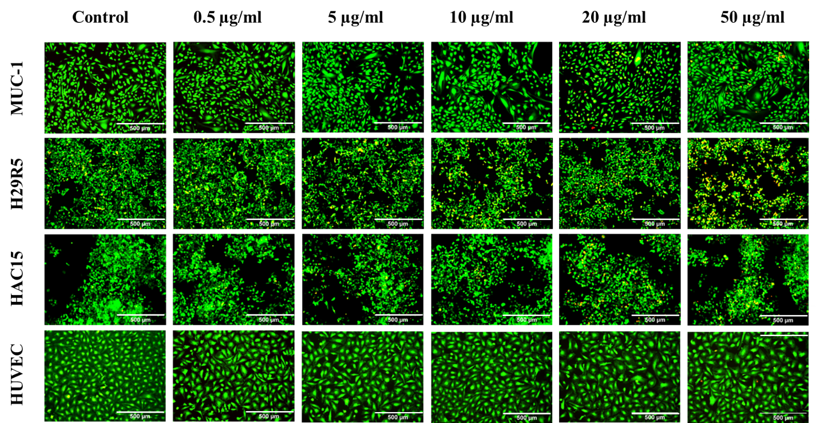
Figure S2: Cellular viability following 24 hours incubation. All cell types were incubated with 0.5, 5, 10, 20 and 50 µg/ml of IONP for 24 hours. Viability was assessed with fluorescent microscopy by staining all cell types with calcium AM and ethidium homodimer. Scalebar: 500 µm.
Morphological analysis indicated a change in morphology at 50 µg/ml for HAC15 and HUVEC cells. HAC15 cells showed a more rounded morphology and a reduction in cell spreading (Figure S4A). Ki67 expression analysis was performed to assess the effect of IONP concentration on cell proliferation. Ki-67 expression was not affected in by IONP concentrations of 0.5-50 µg/ml H295R and HAC15. A significant increase in Ki-67 expression was observed by MUC1 following incubation with 10, 20 and 50 µg/ml of IONP. Ki-67 expression was not affected by 10 µg/ml IONP, independent of cell type (Figure S4B,C).
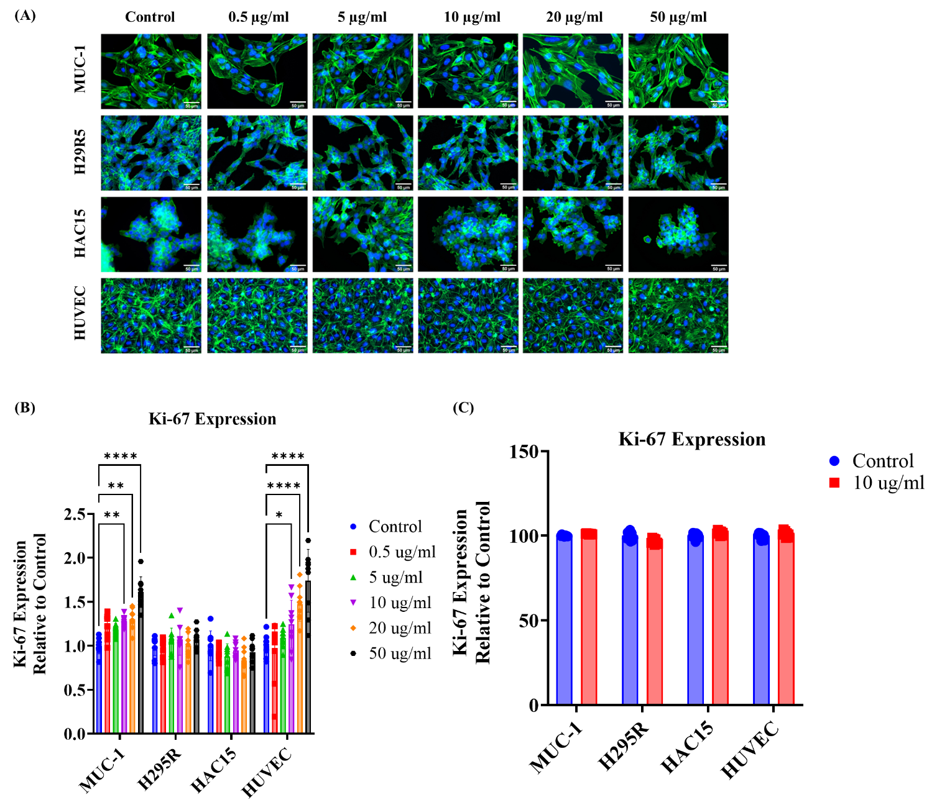
Figure S3: (A) Morphological assessment and Ki-67 expression of MUC1, H295R, HAC15 and HUVEC cells following incubation with 0.5, 5, 10, 20 and 50 µg/ml of IONP for 24 hours. Cytoskeleton was stained with FITC-Phalloidin, and nuclei was stained with DAPI. Data are represented as mean ± SD, (n=3), statistical comparisons were performed using ANOVA analysis, post-hoc. Statistical significance is denoted as *p<0.05, **p<0.01, ****p<0.001. Scalebar: 50 µM. A change in morphology at 50 µg/ml for HAC15 and HUVEC cells was demonstrated. HAC15 cells showed a more rounded morphology and a reduction in cell spreading; (B) Cell proliferation was assessed by Ki-67 staining following 24hrs, represented as MFI (AU) vs control; Ki-67 expression was not affected in by IONP concentrations of 0.5-50 µg/ml in H295R and HAC15. A significant increase in Ki-67 expression was observed in MUC1 following incubation with 10, 20 and 50 µg/ml of IONP. (C) Cell proliferation was assessed by Ki-67 staining following incubation with 10 µg/ml of IONP for 7 days, represented as MFI (AU) vs control. Ki-67 expression was not affected by 10 µg/ml IONP, independent of cell type.
Metabolic activity for all cell types was assessed with alamarBlue at day 1, 3 and 7. At day 3, IONP concentration of 50 µg/ml significantly reduced HAC15 metabolic activity (70.96 ±6 % vs 100% control, p<0.05). However, by day 7 metabolic activity of HAC15 at 50 µg/ml showed recovery (Day 3 = 70.96 ±6 % vs Day 7 = 79.4 ± 6 %). Cell metabolic activity remained stable at Day 7 for all cell types (Figure S4A). Seahorse FX24 extracellular analyser was used to assess the effect of the optimum IONP concentration of 10 µg/ml on the respiration of the cells by measuring mitochondrial function using the Mito Stress Test Kit (Figure S4B). Parameters such as spare respiration capacity, maximal respiration, ATP production and non-mitochondrial oxygen consumption were measured for MUC1, H295R and HAC15 cells. 10 µg/ml of IONP did not affect mitochondrial function of the ACC cells (Figure S4C).
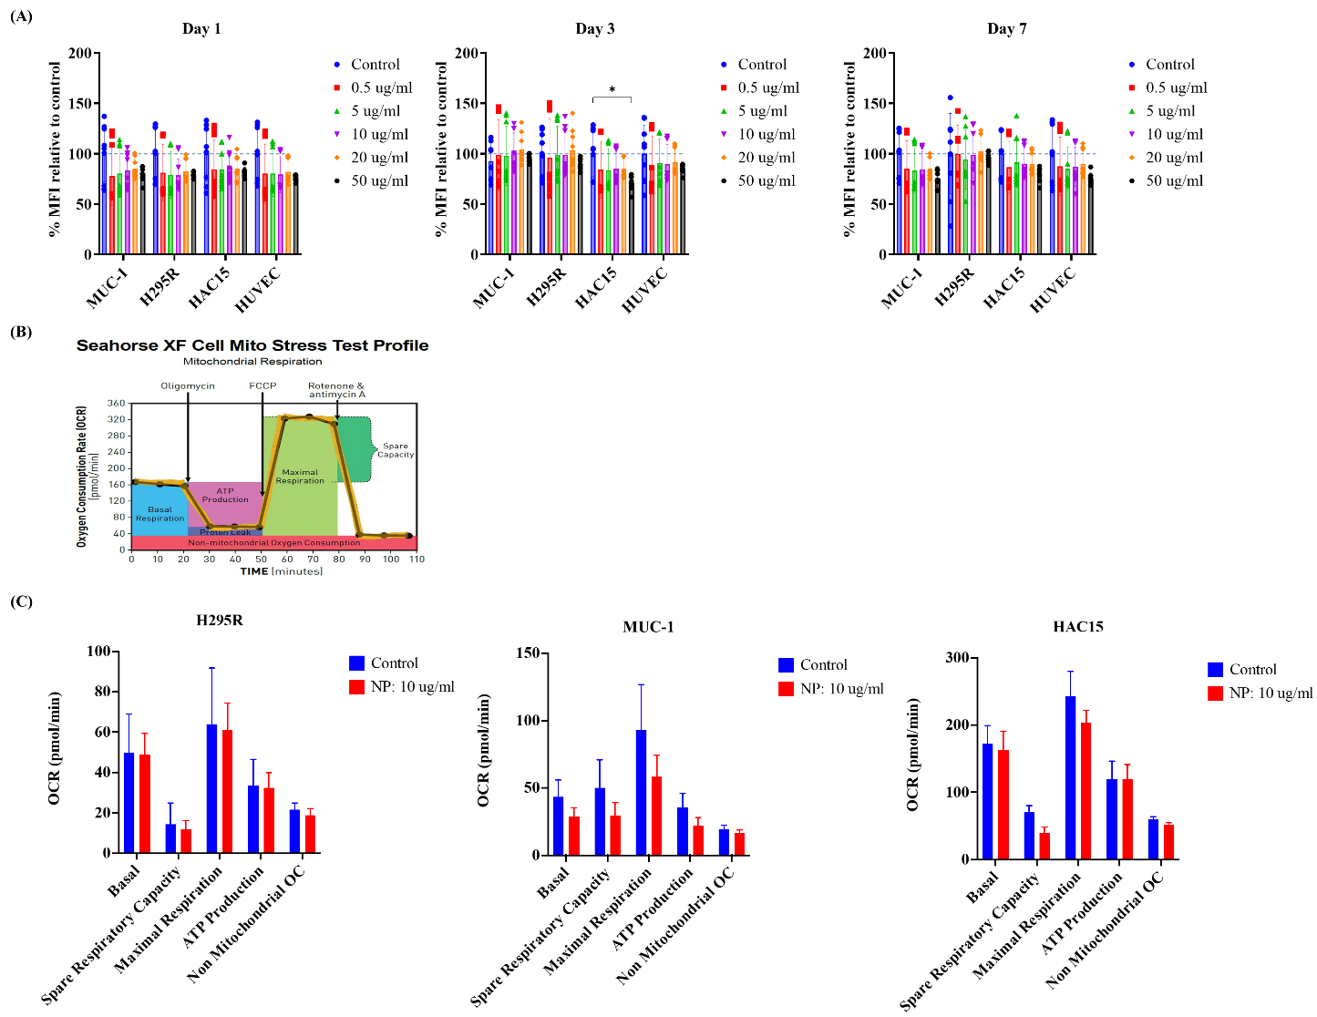
Figure S4: (A) Metabolic activity and Seahorse analysis following incubation with 0.5, 5, 10, 20 and 50 µg/ml of IONP for 1, 3 and 7 days using alamarBlue to assess metabolic activity. (B) Seahorse XF Cell Mito Stress Test profile showing oxygen consumption rate (OCR) over time in response to sequential addition of oligomycin, FCCP, and rotenone/antimycin A, highlighting key mitochondrial respiration parameters. (C) MUC1, H295R and HAC15 cells were incubated with 10 µg/ml of IONP for 24 hours and mitochondrial respiration was assessed with a Seahorse FX24 extracellular analyser in real time after addition of 2 µM oligomycin, and 0.125, 0.25 and 0.5 µM FCCP. Data are represented as mean ± SD, (n=3), statistical comparisons were performed using ANOVA analysis, post-hoc. Statistical significance is denoted as *p<0.05.
Video S5: Live imaging of IONP uptake over 24 hours by HUVEC cells. Video S6 Live imaging of IONP uptake over 24 hours by by Monocytes and Monocytes and HUVEC cells were incubated with 10 µg/ml of IONP and uptake was assessed using Confocal Microscopy. An image was taken every 15 minutes over 24 hours. Live imaging videos are in the supplementary section. Scalebar: 50 µm.

