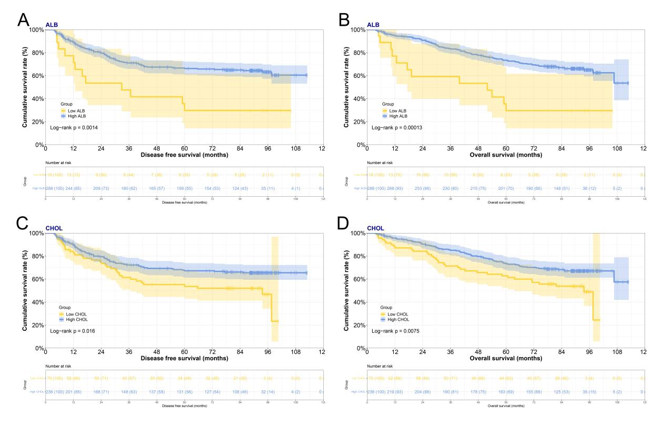
Figure S1 Kaplan-Meier survival analysis according to serum albumin level (ALB) / total cholesterol (CHOL) and group. (A) Significant differences in the disease free survival among stage III breast cancer patients were found with two groups by ALB (P=0.0014). (B) Significant differences in the overall survival among stage III breast cancer patients were found with two groups by ALB (P=0.0001). (C) Significant differences in the disease free survival among stage III breast cancer patients were found with two groups by CHOL (P=0.0158). (D) Significant differences in the overall survival among stage III breast cancer patients were found with two groups by CHOL (P=0.0075).

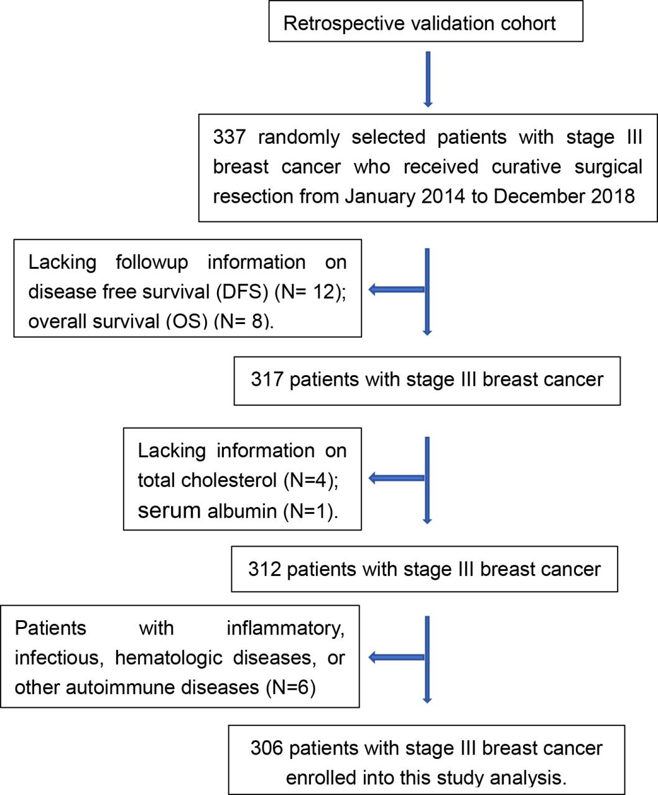
Figure S2 Flowchart for identifying the current study population.

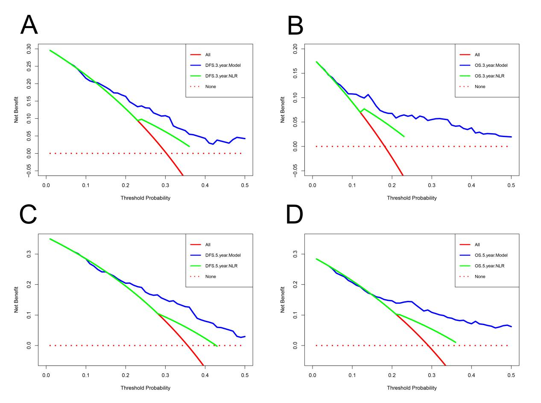
Figure S3 Decision curve analysis (DCA) curves for evaluating clinical usefulness of the condition survival Nomogram prognostic model and NLR for 3- and 5- year disease free survival (DFS) and overall survival (OS) rates. (A) DCA curves for evaluating clinical usefulness of the condition survival Nomogram prognostic model and NLR for 3- year DFS rate. (B) DCA curves for evaluating clinical usefulness of the condition survival Nomogram prognostic model and NLR for 3- year OS rate. (C) DCA curves for evaluating clinical usefulness of the condition survival Nomogram prognostic model and NLR for 5- year DFS rate. (D) DCA curves for evaluating clinical usefulness of the condition survival Nomogram prognostic model and NLR for 5- year OS rate.

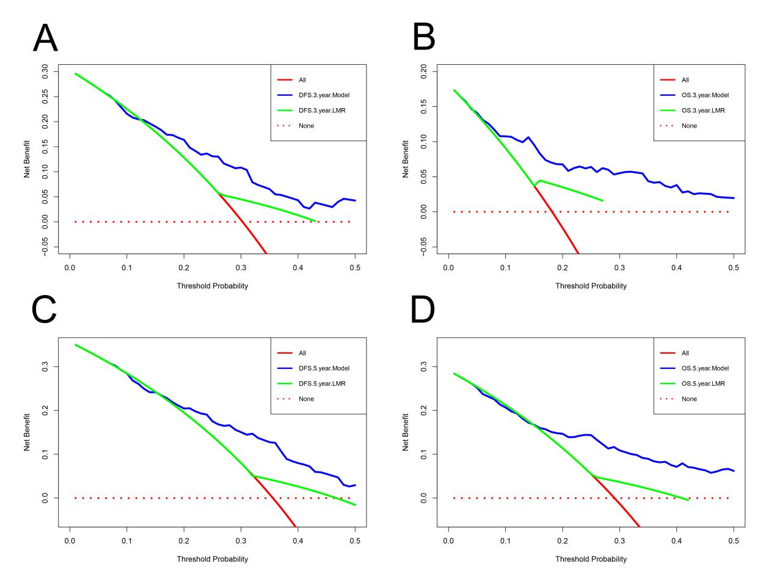
Figure S4 Decision curve analysis (DCA) curves for evaluating clinical usefulness of the condition survival Nomogram prognostic model and LMR for 3- and 5- year disease free survival (DFS) and overall survival (OS) rates. (A) DCA curves for evaluating clinical usefulness of the condition survival Nomogram prognostic model and LMR for 3- year DFS rate. (B) DCA curves for evaluating clinical usefulness of the condition survival Nomogram prognostic model and LMR for 3- year OS rate. (C) DCA curves for evaluating clinical usefulness of the condition survival Nomogram prognostic model and LMR for 5- year DFS rate. (D) DCA curves for evaluating clinical usefulness of the condition survival Nomogram prognostic model and LMR for 5- year OS rate.

