Supplemental Table 1. Knowledge
Knowledge | N (%)
Knowledge | Well-known | Heard of | Unknown
K1 Waldenström’s macroglobulinemia (WM) is a rare indolent lymphoma that primarily affects the elderly, with a median survival of 8 years. | 78(35.45) | 112(50.91) | 30(13.64)
K2 The clinical manifestations of WM are diverse. Some patients are asymptomatic at the time of diagnosis, while most develop symptoms related to the disease within 3 to 10 years after diagnosis. These symptoms include fatigue, discomfort, fever, and/or weight loss, along with numbness in the limbs. | 79(35.91) | 116(52.73) | 25(11.36)
K3 Not all patients diagnosed with WM require immediate treatment. Patients without treatment indications should be followed up every 3-6 months after diagnosis. Treatment should only be initiated in the presence of symptoms. | 102(46.36) | 108(49.09) | 10(4.55)
K4 Elevated IgM levels alone are not an indication to start treatment. | 90(40.91) | 99(45) | 31(14.09)
K5 Patients with symptomatic hyperviscosity should undergo plasmapheresis 2-3 times before systemic treatment. | 68(30.91) | 97(44.09) | 55(25)
K6 Genetic testing (such as MYD88 and CXCR4 mutations) is necessary for WM, and treatment decisions should be guided by the patient's genetic mutation status. | 109(49.55) | 90(40.91) | 21(9.55)
K7 WM is currently incurable, and most patients cannot achieve complete remission. The treatment goal is symptom relief and reducing the risk of organ damage. | 116(52.73) | 96(43.64) | 8(3.64)
K8 The onset of WM treatment is relatively slow. Unless there is clear evidence of disease progression, treatment regimens should not be changed frequently. | 85(38.64) | 113(51.36) | 22(10)

Supplemental Table 2. Attitude
Attitude | Strongly Agree | Agree | Neutral | Disagree | Strongly Disagree
A1 The illness has brought unbearable pain to me and my family. | 73(33.18) | 79(35.91) | 52(23.64) | 15(6.82) | 1(0.45)
A2. Adverse reactions to medication have made it challenging for me and my family to adhere to the prescribed treatment. | 31(14.09) | 46(20.91) | 94(42.73) | 41(18.64) | 8(3.64)
A3 Despite having WM, I feel fortunate that objective relief or even complete alleviation can be achieved through long-term standardized treatment and disease management. | 73(33.18) | 115(52.27) | 28(12.73) | 4(1.82) | 0
A4 I am greatly concerned about the possibility of passing on WM to my children through inheritance. | 91(41.36) | 43(19.55) | 26(11.82) | 2(0.91) | 0
A5. I would like to join a patient group to share experiences and receive emotional support. P | 139(63.18) | 73(33.18) | 8(3.64) | 0 | 0

Supplemental Table 3. Attitude Section, Non-Scored Questions
Attitude (Multiple choices) |  |  | No |  |  | Yes
6. Which of the following concerns or questions were you (the patient) hoping to address at that time? (Multiple choices allowed)
a. Why do I have WM? |  |  | 73(33.18) |  |  | 147(66.82)
b. Is WM a form of cancer (malignant tumor)? |  |  | 135(61.36) |  |  | 85(38.64)
c. Can WM be cured, and how long can one expect to live in the future? |  |  | 81(36.82) |  |  | 139(63.18)
d. What are the subsequent developments and changes following WM? |  |  | 38(17.27) |  |  | 182(82.73)
e. What treatment options are available after WM, and for what situations are they suitable? |  |  | 66(30) |  |  | 154(70)
f. How much does the treatment cost? |  |  | 88(40) |  |  | 132(60)
7. After being diagnosed with WM, how did you (the patient) feel? Do you need the following assistance? (Multiple selections allowed)
a. Can still manage and cope with the disease independently. |  |  | / |  |  | 157(71.36)
b. Struggled to cope with the disease and desired assistance from others. |  |  | / |  |  | 59(26.82)
c. Struggled to cope with the disease but preferred not to receive help from others. |  |  | / |  |  | 4(1.82)
8. How did the doctor initially communicate the treatment plan to you? (Multiple choices allowed)
a. The doctor directly instructed the use of a specific plan without allowing me to choose. |  |  | 152(69.09) |  |  | 68(30.91)
b. The doctor proposed multiple plans, briefly introduced them, and let you (the patient) make a choice. |  |  | 93(42.27) |  |  | 127(57.73)
c. In addition to the plans introduced by the doctor, you (the patient) actively inquired about the use of some plans. |  |  | 153(69.55) |  |  | 67(30.45)
9. Do you (the patient) wish to be more involved in treatment decision-making?
a. No need, I don't understand the treatment; let the doctor decide. |  |  | / |  |  | 53(24.09)
b. Yes, I want the authority to make decisions about my treatment. |  |  | / |  |  | 167(75.91)
10. What were the primary sources for you (the patient) to obtain information about WM?
a. Mainly obtained information through the assistance of children. |  |  | / |  |  | 84(38.18)
b. Mainly obtained information personally through channels such as the internet and WeChat. |  |  | / |  |  | 119(54.09)
c. Did not use additional channels to obtain information other than visiting the hospital. |  |  | / |  |  | 17(7.73)
11. When choosing a treatment drug, which aspect do you consider most important? | 1st | 2nd | 3rd | 4th | 5th |  | 6th | Did not select
a. Fast effectiveness, rapid relief of symptoms | 55(25) | 33(15) | 28(12.73) | 28(12.73) | 21(9.55) |  | 15(6.82) | 40(18.18)
b. Ability to extend life as much as possible. | 90(40.91) | 52(23.64) | 25(11.36) | 13(5.91) | 14(6.36) |  | 4(1.82) | 22(10)
c. Minimal side effects, avoiding suffering from medication | 43(19.55) | 72(32.73) | 59(26.82) | 14(6.36) | 10(4.55) |  | 1(0.45) | 21(9.55)
d. Low frequency of medication use, not having to take medicine every day | 4(1.82) | 3(1.36) | 15(6.82) | 53(24.09) | 38(17.27) |  | 50(22.73) | 57(25.91)
e. Convenient medication, oral administration at home, no need for hospitalization | 19(8.64) | 26(11.82) | 34(15.45) | 33(15) | 56(25.45) |  | 22(10) | 30(13.64)
f. Affordable cost. | 9(4.09) | 15(6.82) | 33(15) | 32(14.55) | 24(10.91) |  | 65(29.55) | 42(19.09)

Supplemental Table 4. Practice
Practice | Always | Often | Sometimes | Rarely | Never
P1 I regular follow-up appointments. | 95(43.18) | 76(34.55) | 37(16.82) | 10(4.55) | 2(0.91)
P2 I adhere to doctor's instructions and comply with medication treatment. | 158(71.82) | 47(21.36) | 9(4.09) | 4(1.82) | 2(0.91)
P3 I avoid crowded places such as airports and public transportation during cold and flu seasons. | 94(42.73) | 72(32.73) | 39(17.73) | 12(5.45) | 3(1.36)
P4 I maintain hand hygiene and refrain from touching the face, especially during cold and flu seasons. | 92(41.82) | 76(34.55) | 45(20.45) | 6(2.73) | 1(0.45)
P5 I receive the latest influenza and pneumonia vaccinations. | 25(11.36) | 11(5) | 26(11.82) | 46(20.91) | 112(50.91)
P6 I maintain a healthy and balanced diet, and get adequate sleep. | 77(35) | 104(47.27) | 32(14.55) | 7(3.18) | 0

Supplemental Table 5. Differences in knowledge scores among patients and family members
Knowledge | Patient (N=98)  Mean±SD | Family Members (N=122)  Mean±SD | P
K1 Waldenström’s macroglobulinemia (WM) is a rare indolent lymphoma that primarily affects the elderly, with a median survival of 8 years. | 1.34±0.69 | 1.11±0.63 | 0.006
K2 The clinical manifestations of WM are diverse. Some patients are asymptomatic at the time of diagnosis, while most develop symptoms related to the disease within 3 to 10 years after diagnosis. These symptoms include fatigue, discomfort, fever, and/or weight loss, along with numbness in the limbs. | 1.36±0.64 | 1.14±0.62 | 0.009
K3 Not all patients diagnosed with WM require immediate treatment. Patients without treatment indications should be followed up every 3-6 months after diagnosis. Treatment should only be initiated in the presence of symptoms. | 1.5±0.57 | 1.35±0.57 | 0.048
K4 Elevated IgM levels alone are not an indication to start treatment. | 1.37±0.71 | 1.18±0.66 | 0.021
K5 Patients with symptomatic hyperviscosity should undergo plasmapheresis 2-3 times before systemic treatment. | 1.10±0.75 | 1.02±0.74 | 0.440
K6 Genetic testing (such as MYD88 and CXCR4 mutations) is necessary for WM, and treatment decisions should be guided by the patient's genetic mutation status. | 1.52±0.66 | 1.30±0.64 | 0.006
K7 WM is currently incurable, and most patients cannot achieve complete remission. The treatment goal is symptom relief and reducing the risk of organ damage. | 1.59±0.58 | 1.40±0.54 | 0.006
K8 The onset of WM treatment is relatively slow. Unless there is clear evidence of disease progression, treatment regimens should not be changed frequently. | 1.32±0.65 | 1.25±0.62 | 0.347

Supplemental Table 6. Differences in attitude scores among patients and family members
Attitude | Patient (N=98)  Mean±SD | Family Members (N=122)  Mean±SD | P
A1 The illness has brought unbearable pain to me and my family. | 2.07±0.93 | 2.04±0.94 | 0.711
A2. Adverse reactions to medication have made it challenging for me and my family to adhere to the prescribed treatment. | 2.79±1.05 | 2.74±1.00 | 0.702
A3 Despite having WM, I feel fortunate that objective relief or even complete alleviation can be achieved through long-term standardized treatment and disease management. | 4.15±0.66 | 4.18±0.74 | 0.590
A4 I am greatly concerned about the possibility of passing on WM to my children through inheritance. | 2.13±1.07 | 2.24±0.92 | 0.224
A5. I would like to join a patient group to share experiences and receive emotional support. P | 4.63±0.56 | 4.56±0.56 | 0.294

Supplemental Table 7. Differences in practice scores among patients and family members
Practice | Patient (N=98)  Mean±SD | Family Members (N=122)  Mean±SD | P
P1 I regular follow-up appointments. | 4.31±0.86 | 4.00±0.94 | 0.008
P2 I adhere to doctor's instructions and comply with medication treatment. | 4.68±0.76 | 4.55±0.70 | 0.032
P3 I avoid crowded places such as airports and public transportation during cold and flu seasons. | 4.21±0.92 | 4.00±0.99 | 0.118
P4 I maintain hand hygiene and refrain from touching the face, especially during cold and flu seasons. | 4.30±0.77 | 4.01±0.91 | 0.021
P5 I receive the latest influenza and pneumonia vaccinations. | 2.04±1.42 | 2.05±1.31 | 0.551
P6 I maintain a healthy and balanced diet, and get adequate sleep. | 4.03±0.81 | 4.22±0.73 | 0.078

Supplementary Table 8. Subgroup comparison of item-level KAP scores by employment status
 | Items | P
Knowledge | K1 | 0.350
Knowledge | K2 | 0.692
Knowledge | K3 | 0.736
Knowledge | K4 | 0.903
Knowledge | K5 | 0.026
Knowledge | K6 | 0.229
Knowledge | K7 | 0.166
Knowledge | K8 | 0.708
Attitude | A1 | 0.780
Attitude | A2 | 0.031
Attitude | A3 | 0.081
Attitude | A4 | 0.507
Attitude | A5 | 0.230
Practice | P1 | 0.493
Practice | P2 | 0.789
Practice | P3 | 0.041
Practice | P4 | 0.158
Practice | P5 | 0.619
Practice | P6 | 0.015

Supplementary Table 9. Confirmatory Factor Analysis Model Fit Indices for the Measurement Model of Knowledge, Attitude, and Practice Constructs​
Indicators | Reference | Actual
CMIN/DF | 1-3: Excellent, 3-5: Good | 2.021
RMSEA | <0.08: Good | 0.068
IFI | >0.8: Good | 0.886
TLI | >0.8: Good | 0.867
CFI | >0.8: Good | 0.884
Abbreviation: CMIN/DF, Chi-square to degrees of freedom ratio; RMSEA, Root Mean Square Error of Approximation; IFI, Incremental Fit Index; TLI, Tucker-Lewis Index; CFI, Comparative Fit Index.

Supplementary Table 10. Factor Loadings from Confirmatory Factor Analysis of Knowledge, Attitude, and Practice Scales
 |  |  | Estimate | Standardized Estimate | S.E. | C.R. | P
K1 | <--- | Knowledge | 1.000 | 0.721
K2 | <--- | Knowledge | 1.016 | 0.759 | 0.094 | 10.858 | <0.001
K3 | <--- | Knowledge | 0.965 | 0.801 | 0.084 | 11.461 | <0.001
K4 | <--- | Knowledge | 1.128 | 0.783 | 0.101 | 11.196 | <0.001
K5 | <--- | Knowledge | 1.030 | 0.663 | 0.109 | 9.467 | <0.001
K6 | <--- | Knowledge | 0.962 | 0.703 | 0.096 | 10.050 | <0.001
K7 | <--- | Knowledge | 0.953 | 0.805 | 0.083 | 11.514 | <0.001
K8 | <--- | Knowledge | 1.013 | 0.764 | 0.093 | 10.932 | <0.001
A1 | <--- | Attitude | 1.000 | 0.692
A2 | <--- | Attitude | 0.984 | 0.623 | 0.213 | 4.626 | <0.001
A3 | <--- | Attitude | -0.026 | -0.024 | 0.091 | -0.285 | 0.775
A4 | <--- | Attitude | 0.677 | 0.445 | 0.156 | 4.346 | <0.001
A5 | <--- | Attitude | -0.173 | -0.200 | 0.075 | -2.301 | 0.021
P1 | <--- | Practice | 1.000 | 0.276
P2 | <--- | Practice | 0.964 | 0.334 | 0.343 | 2.815 | 0.005
P3 | <--- | Practice | 2.717 | 0.713 | 0.792 | 3.430 | <0.001
P4 | <--- | Practice | 2.452 | 0.718 | 0.715 | 3.431 | <0.001
P5 | <--- | Practice | 1.479 | 0.276 | 0.576 | 2.566 | 0.010
P6 | <--- | Practice | 1.616 | 0.528 | 0.494 | 3.274 | 0.001

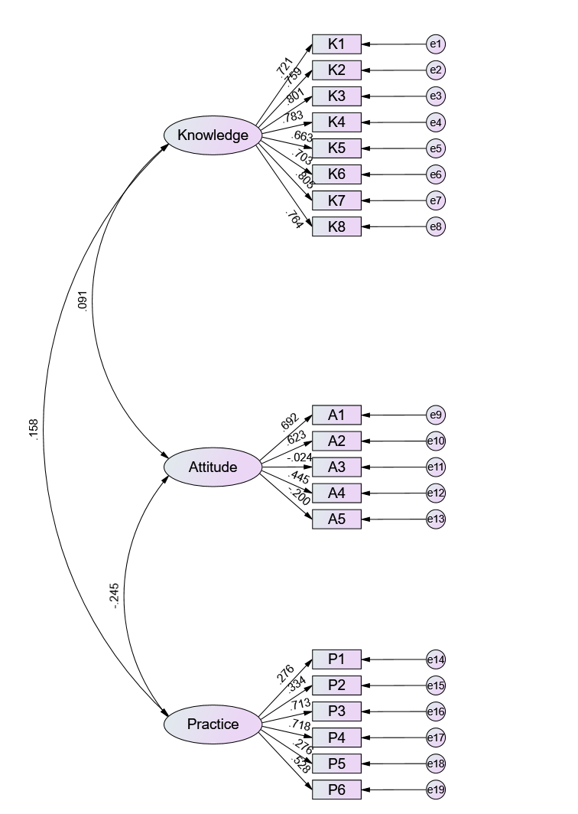
Supplementary Figure 1. Confirmatory Factor Analysis

