Supplementary Materials for SCI Manuscript

Contents

Supplementary Material 1: Fund support (22A360002) 2
Supplementary Material 2: Fund support (23A360010) 4
Supplementary Material 3: Fund support (222102310469) 6
Supplementary Material 4: Fund support (232102311209) 10
Supplementary Material 5: Fund support (242301420110) 15
Supplementary Material 6: Fund support (2021M701122) 20

Supplementary Material 1: Fund support (22A360002)

The Education Department of Henan Province

Notice on Henan provincial universities
key research project plan

Henan University of Traditional Chinese Medicine：
The following research topics declared by your unit, reviewed by experts and reviewed by the provincial Department of Education, have been listed as key scientific research project plans for colleges and universities in Henan Province, and approved by document No. 383 of Teaching Science and Technology (2021).
We hereby inform youas follows:
Grant number：22A360002
Title：To explore the mechanism of brain network integration in the treatment of
knee osteoarthritis by acupuncture based on CCN regulation
Project leader：Nan Wu
Project funding：50,000 yuan
Project study period：From January 1, 2022 to December 31, 2023
October 22, 2021

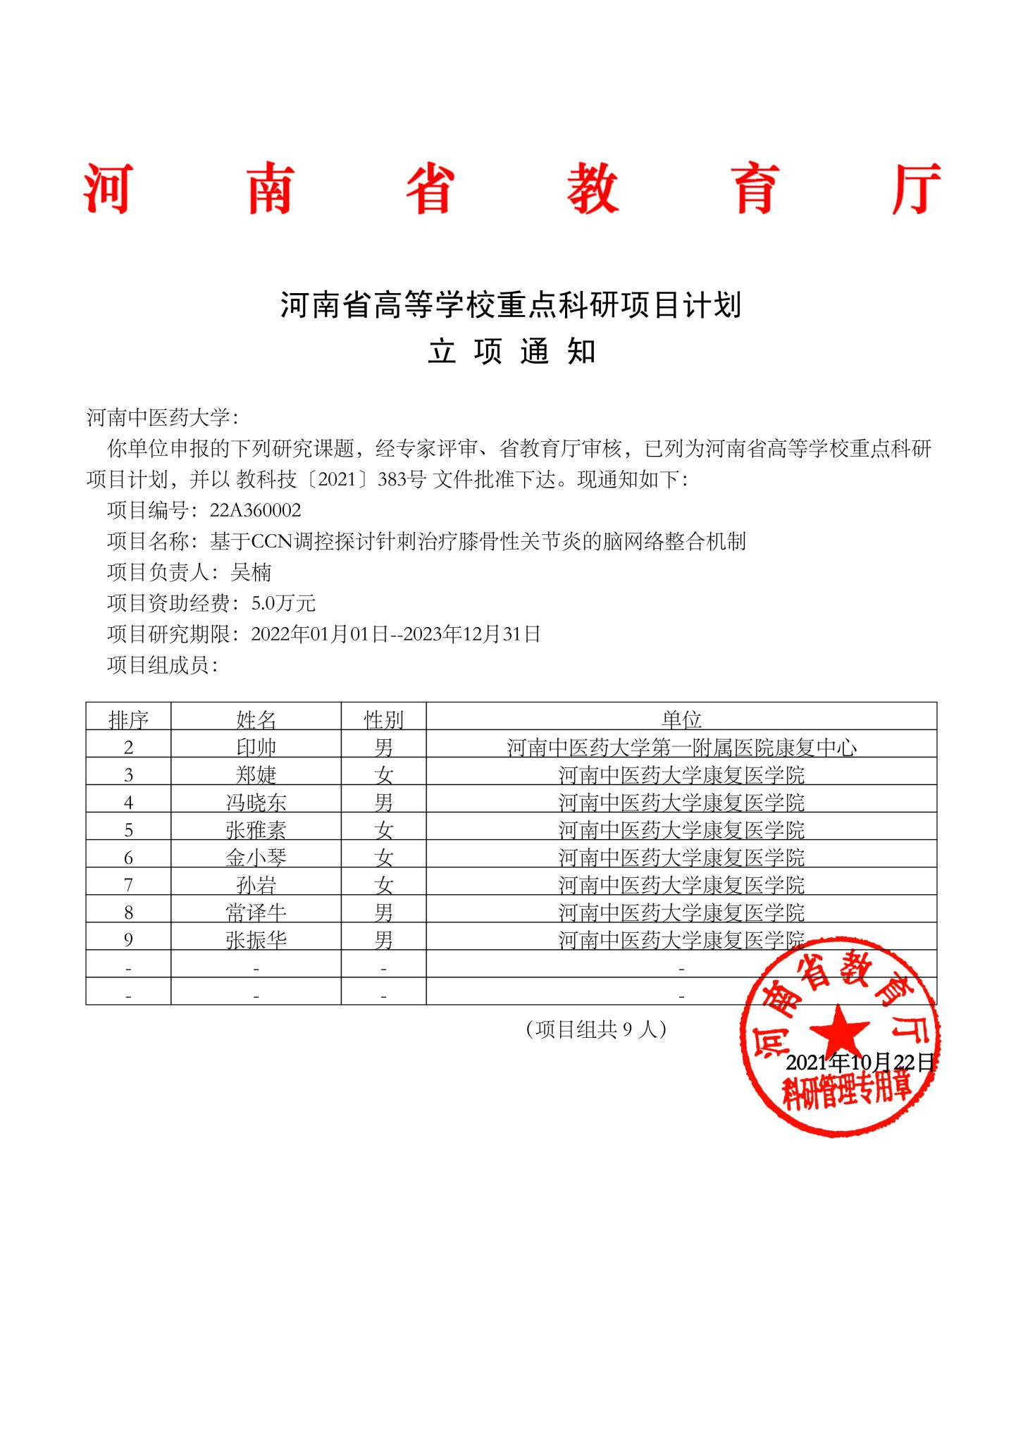

Supplementary Material 2: Fund support (23A360010)

The Education Department of Henan Province

Notice on Henan provincial universities
key research project plan

Henan University of Traditional Chinese Medicine：
The following research topics declared by your unit, reviewed by experts and reviewed by the provincial Department of Education, have been listed as key scientific research project plans for colleges and universities in Henan Province, and approved by document No. 309 of Teaching Science and Technology (2022).
We hereby inform youas follows:
Grant number：23A360010
Title：The mechanism of acupuncture on brain reward network in chronic pain of KOA based on the theory of "the knee is the house of tendons"
Project leader：Shuai Yin
Project funding：30,000 yuan
Project study period：From January 01, 2023 to December 31, 2024
September 21, 2022

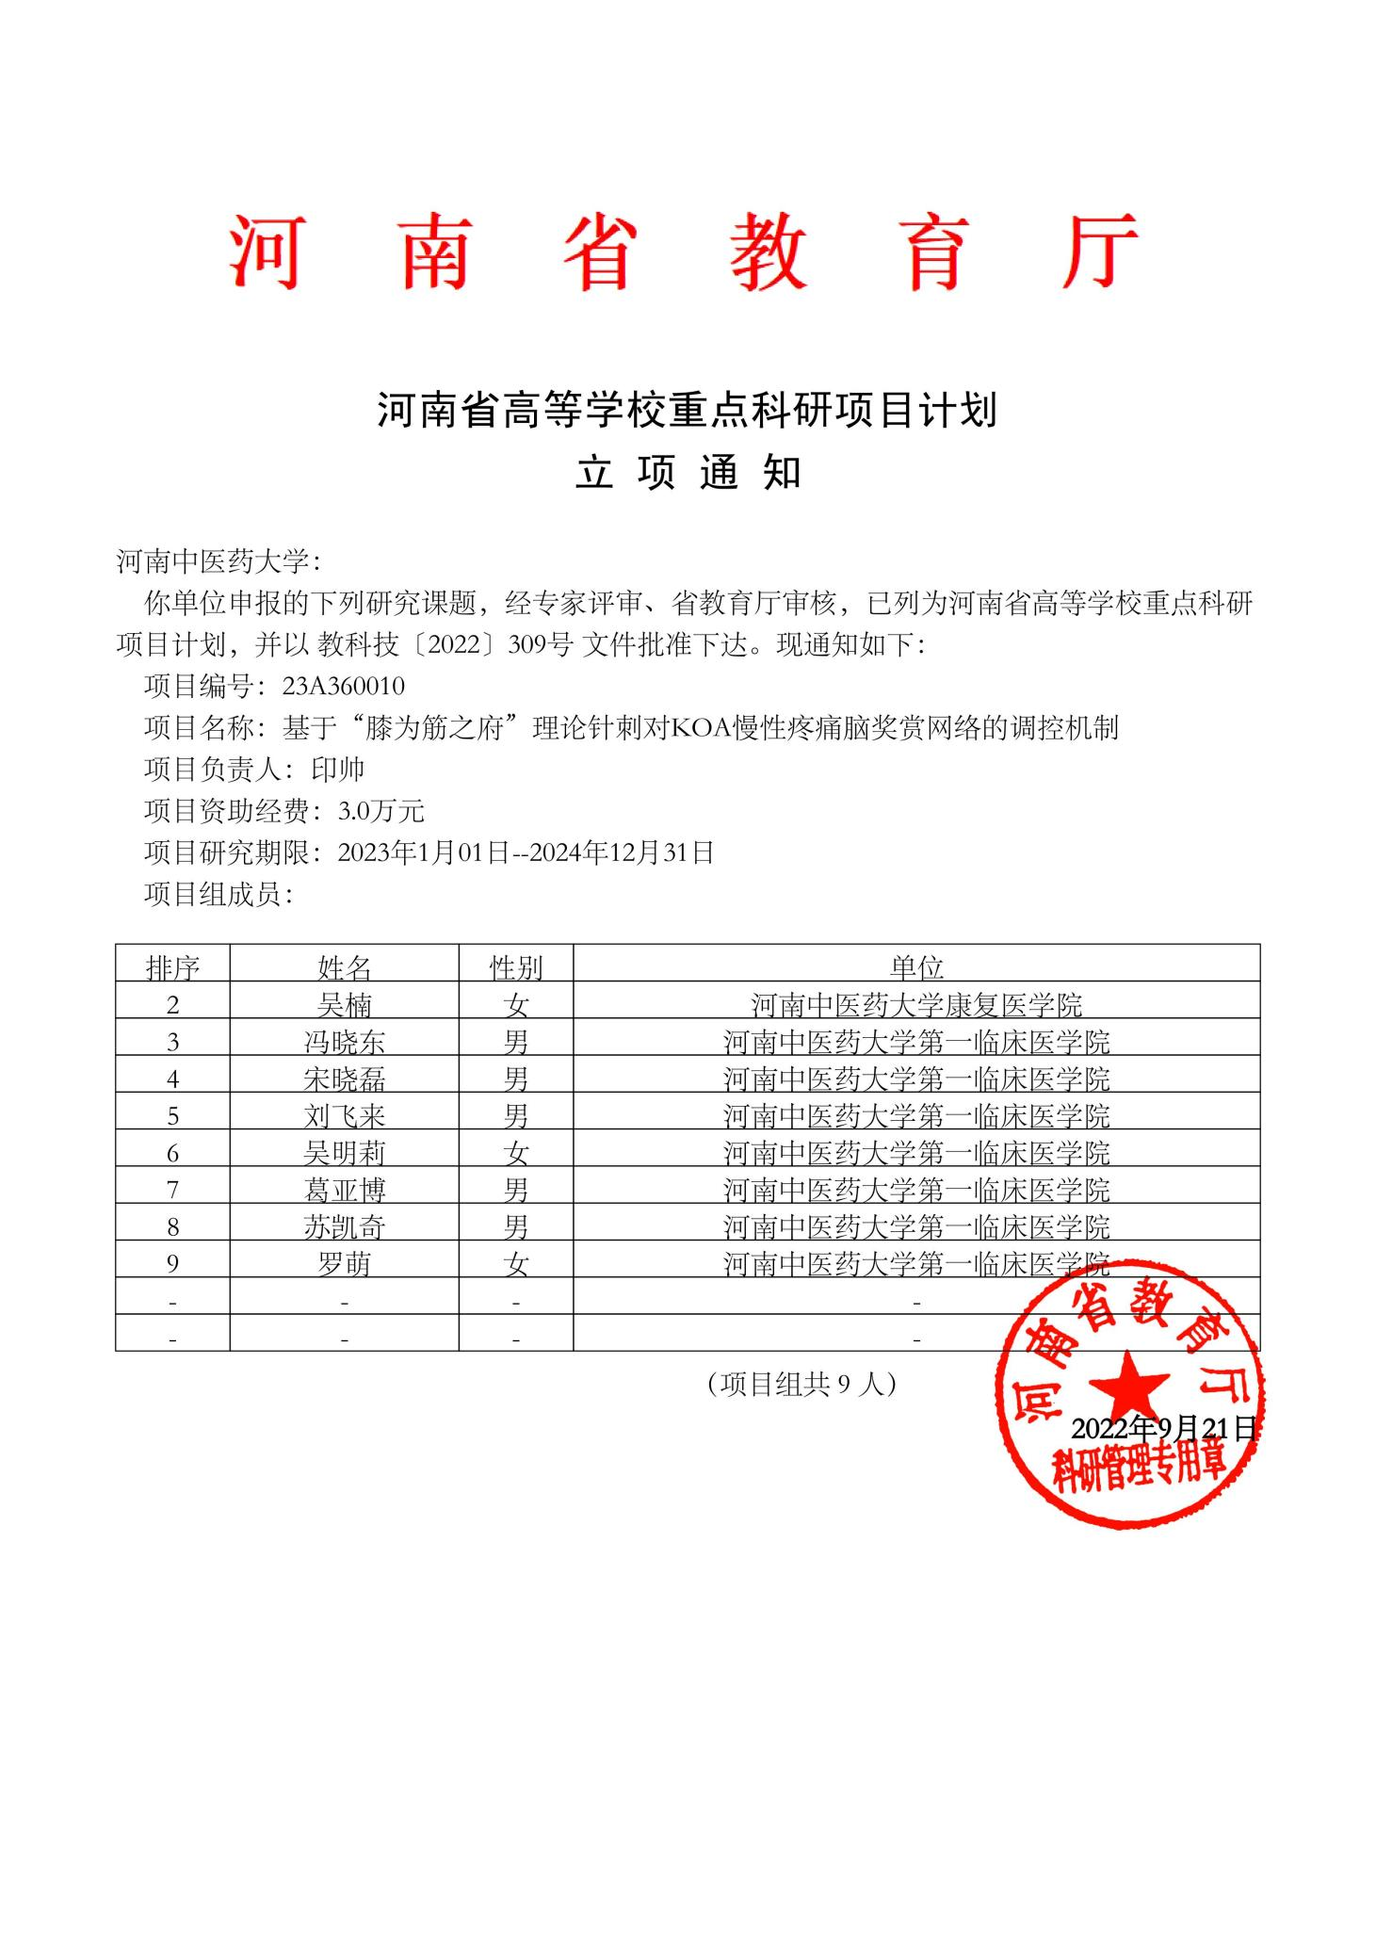

Supplementary Material 3: Fund support (222102310469)

Document of Science and Technology
Department of Henan Province

Yuke 〔2022〕 No. 13

Notice on the Science and Technology Development Plan of Henan Province in 2022

Science and technology bureau of the provincial cities, science and technology management department of Jiyuan Demonstration Zone Management Committee, science and technology management department of the counties (cities), Zhengzhou Airport Economic Comprehensive Experimental Zone, National high-tech Zone, Zhengzhou Economic and Technological Development Zone Management Committee, provincial relevant departments, and relevant units:
In accordance with the general idea of the development of science and technology during the "Fourteenth Five-Year Plan" period and the tasks of national economic and social development of our province, the "Science and Technology Development Plan of Henan Province in 2022" is hereby issued to all of you. Please do a good job in organizing and implementing according to the project objectives.

Attachment: Science and Technology Development Plan of Henan Province in 2022

January 26, 2022

Grant number: 222102310469

Title: Evaluation of clinical efficacy of different acupuncture methods in the treatment of KOA pain and study on the
regulatory mechanism of CCN brain network

Project undertaker: Henan University of Traditional Chinese Medicine

Competent department: The Education Department of Henan Province

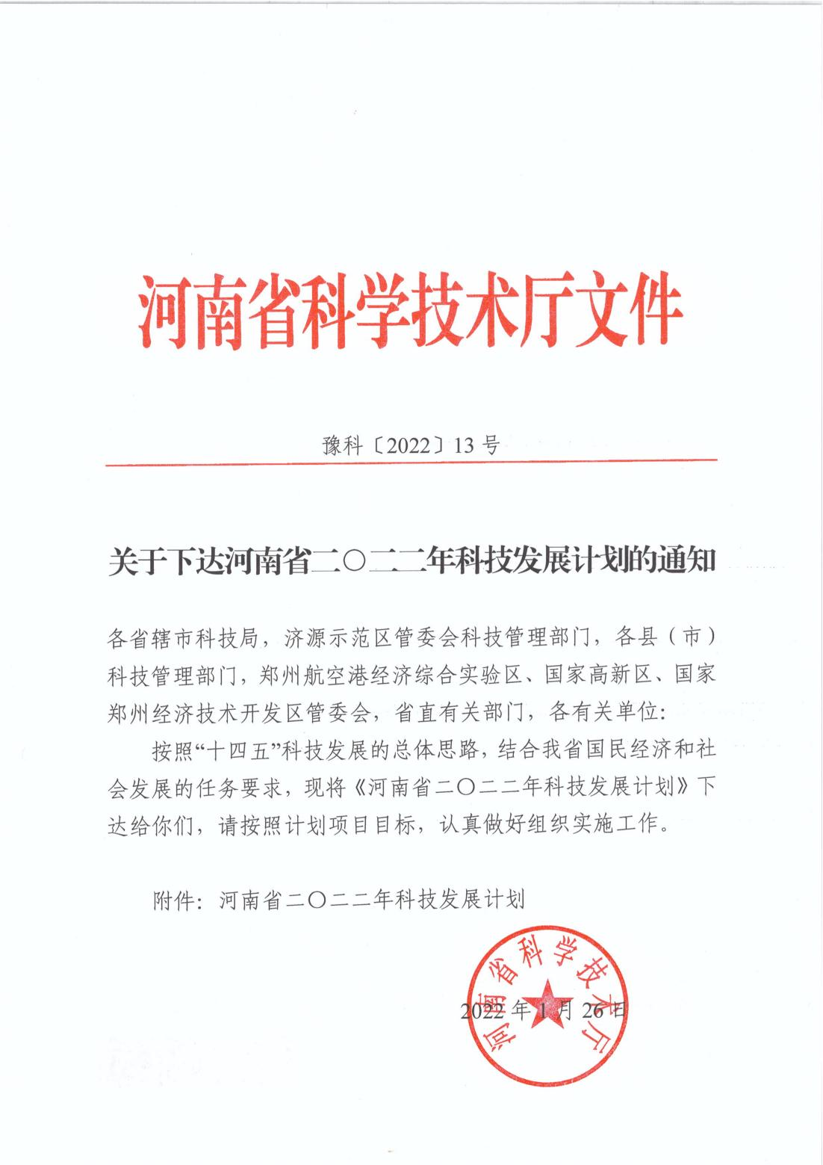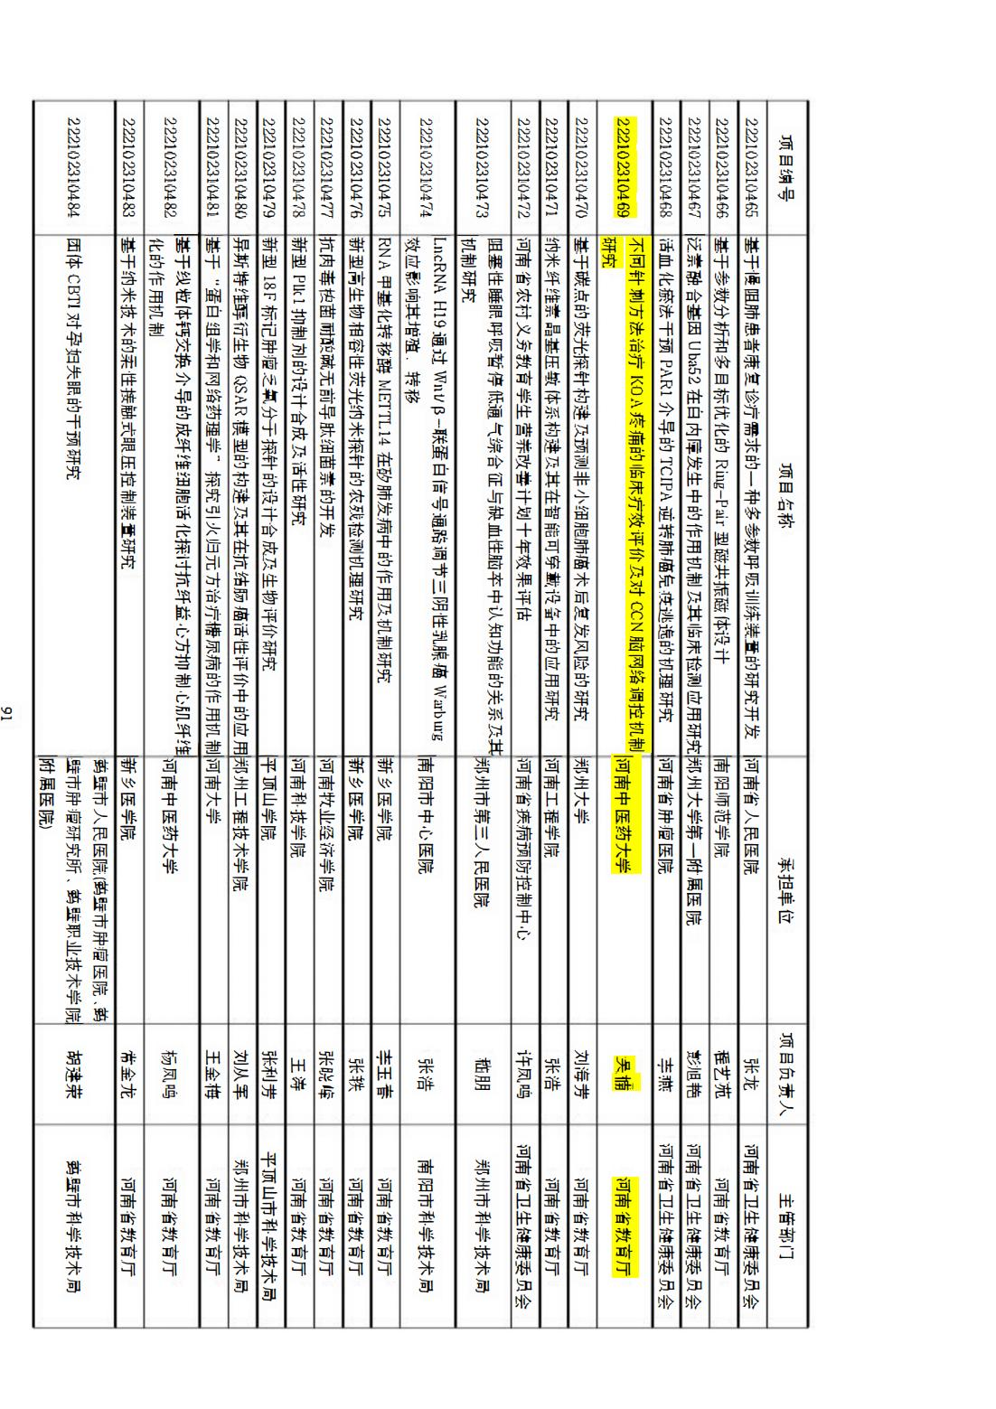

Supplementary Material 4: Fund support (232102311209)

Document of Science and Technology
Department of Henan Province

Yuke 〔2023〕 No. 26

Notice on the Science and Technology Development Plan of Henan Province in 2023

Science and technology bureau of the provincial cities, science and technology management department of Jiyuan Demonstration Zone Management Committee, science and technology management department of the counties (cities), Zhengzhou Airport Economic Comprehensive Experimental Zone, National high-tech Zone, Zhengzhou Economic and Technological Development Zone Management Committee, provincial relevant departments, and relevant units:
In accordance with the general idea of the development of science and technology during the "Fourteenth Five-Year Plan" period and the tasks of national economic and social development of our province, the "Science and Technology Development Plan of Henan Province in 2023" is hereby issued to all of you. Please do a good job in organizing and implementing according to the project objectives.

Attachment: Science and Technology Development Plan of Henan Province in 2023

March 13, 2023

Grant number: 232102311209

Title: To explore the regulatory mechanism of acupuncture on nucleus accumbens reward network in chronic pain of KOA
based on brain connectomics

Project undertaker: Henan University of Traditional Chinese Medicine

Competent department: The Education Department of Henan Province

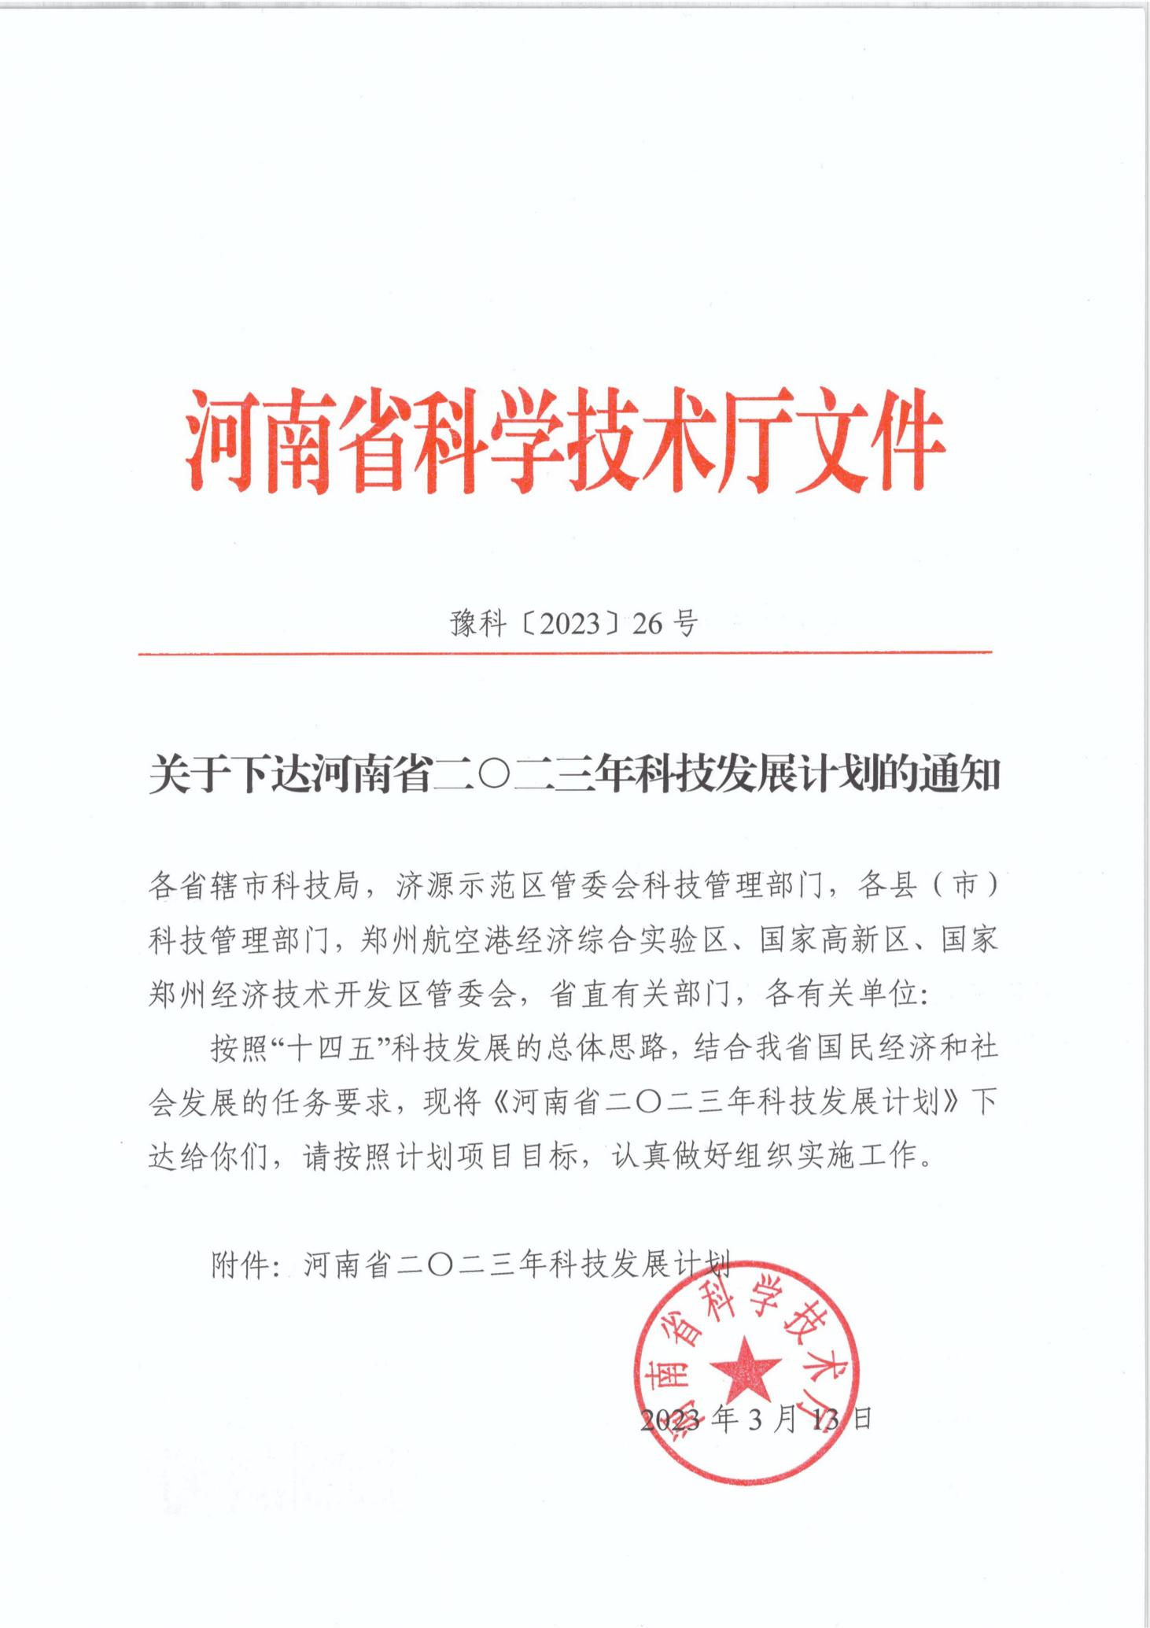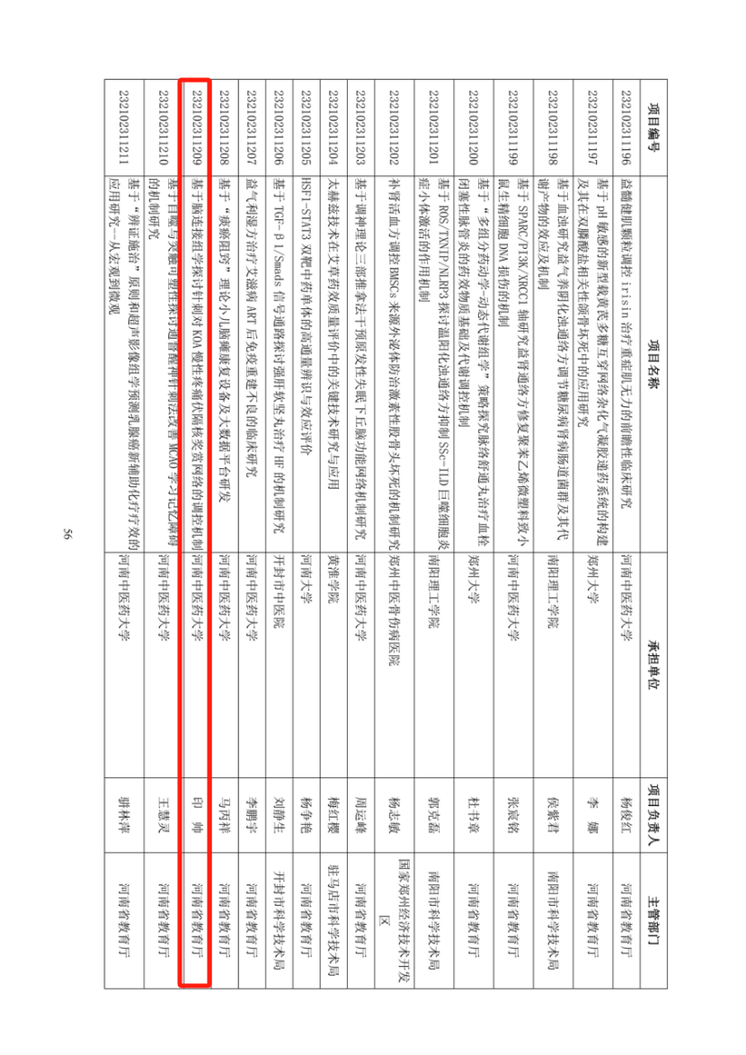

Supplementary Material 5: Fund support (242301420110)

Document of Science and Technology
Department of Henan Province

Yuke 〔2024〕 No. 141

Notice on issuing the third batch of Science and Technology
Development Plan of Henan Province in 2024

Science and technology bureau of the provincial cities, science and technology management department of Jiyuan Demonstration Zone Management Committee, science and technology management department of the counties (cities), Zhengzhou Airport Economic Comprehensive Experimental Zone, National high-tech Zone, Zhengzhou Economic and Technological Development Zone Management Committee, provincial relevant departments, and relevant units:
In accordance with the general idea of the development of science and technology during the "Fourteenth Five-Year Plan" period and the tasks of national economic and social development of our province, the "the third batch of Science and Technology Development Plan of Henan Province in 2024" is hereby issued to all of you. Please do a good job in organizing and implementing according to the project objectives.

Attachment: the third batch of Science and Technology Development Plan of Henan Province in 2024

October 17, 2024

Grant number: 242301420110

Title: Prediction of therapeutic effect and study of brain network mechanism based on neuroimaging acupuncture in the treatment of knee osteoarthritis Henan University of Chinese Medicine

Project undertaker: Henan University of Traditional Chinese Medicine

Competent department: The Education Department of Henan Province

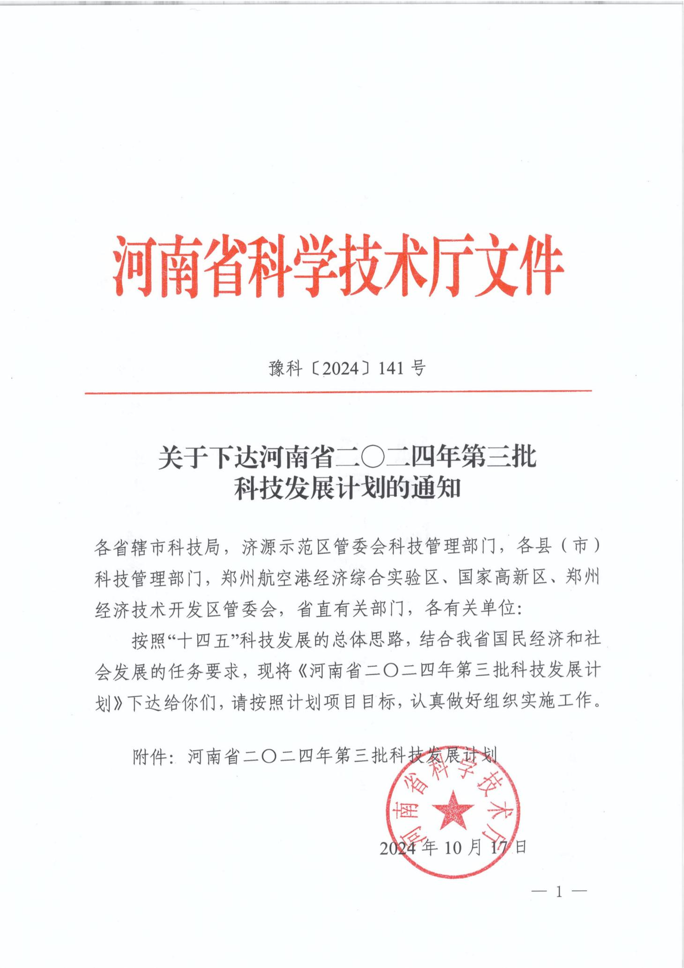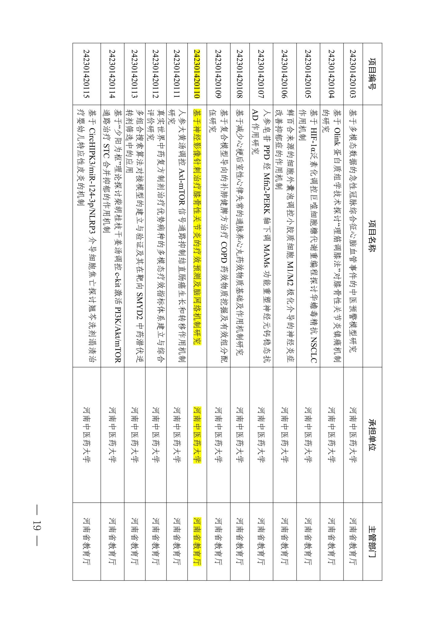

Supplementary Material 6: Fund support (2021M701122)
