Supplementary Material
Radiation-based multi-modal therapy combining with immunotherapy to develop a vaccine-like effective treatment for triple-negative breast cancer

Mengyan Dai ^{a,b*}, Zuhong Tian ^{b,d*}, Fanyuan Xu ^{b}, Bang Yao ^{b,e}, Hongxia Liang ^{a,b}, Dongyan Li ^{a,b}, Jiangang Wang ^{c}, Junyan Rong ^{b}, Tianshuai Liu ^{b}, Haili Tang ^{c#}, Hongbing Lu ^{b#}, Wenli Zhang ^{b#}

Corresponding author: Wenli Zhang and Hongbing Lu
School of Biomedical Engineering, The Fourth Military Medical University, 169th Changle West Road, Xi’an, Shaanxi, 710032, China
Email (mandatory) : wenli1121@fmmu.edu.cn and luhb@fmmu.edu.cn

a. The College of Life Sciences, NorthWest University, 229th Taibai North Road, Xi'an City, 710069, China
b. School of Biomedical Engineering, Shaanxi Provincial Key Laboratory of Bioelectromagnetic Detection and Intelligent Perception, The Fourth Military Medical University, 169th Changle West Road, Xi’an, Shaanxi, 710032, China
c. Department of General Surgery, the Second Affiliated Hospital of the Fourth Military Medical University, Xi’an 710038, China
d. State Key Laboratory of Holistic Integrative Management of Gastrointestinal Cancers and Xijing Hospital of Digestive Diseases, Fourth Military Medical University, Xi'an, 710032, China
e. School of Materials Science and Engineering, Shaanxi University of Science and Technology, Xi’an, Shaanxi, 710021, China

Mengyan Dai ^{a,b*}
Zuhong Tian ^{b,d*}
*These authors contributed equally to this work

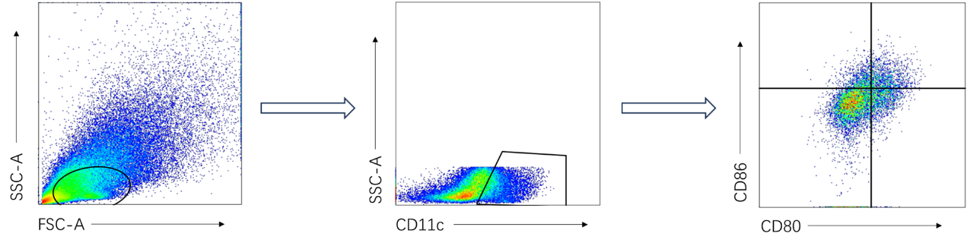
Figure S1. Lap-gate scheme for intratumoral mature dendritic cells.

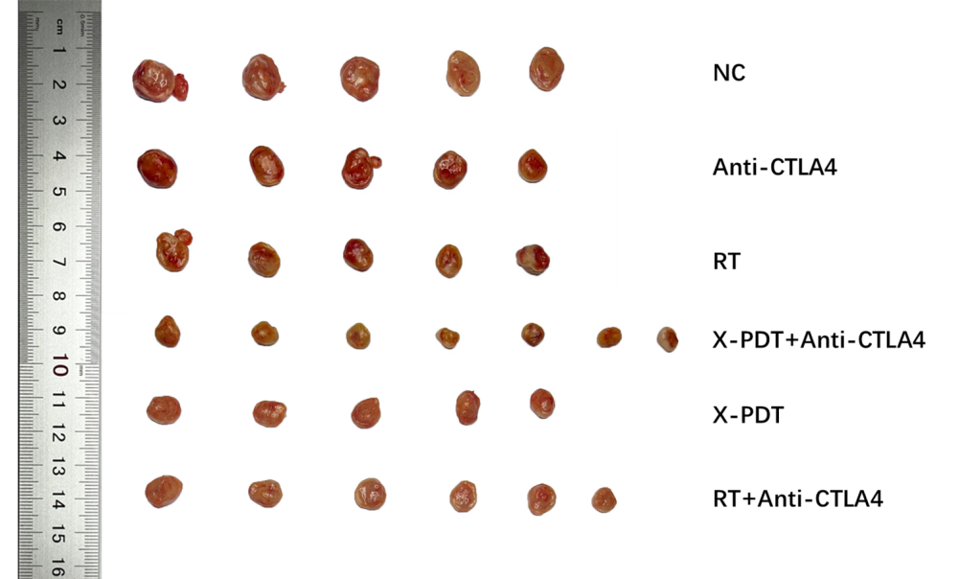
Figure S2. White light acquisition plots of isolated tumor tissue from each group dissected at the end of the experiment (n=8-10).

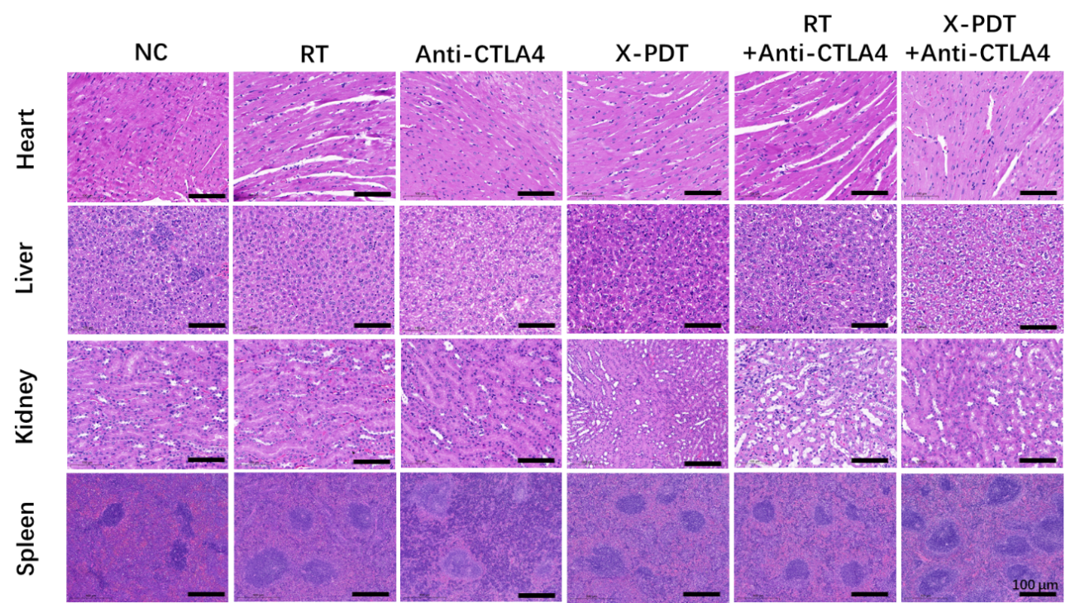
Figure S3. Representative H&E staining of major organs after different treatments (Scale bar: 100 μm).
Figure S4. Body weight of mice in each group during monitoring (n=8-10).

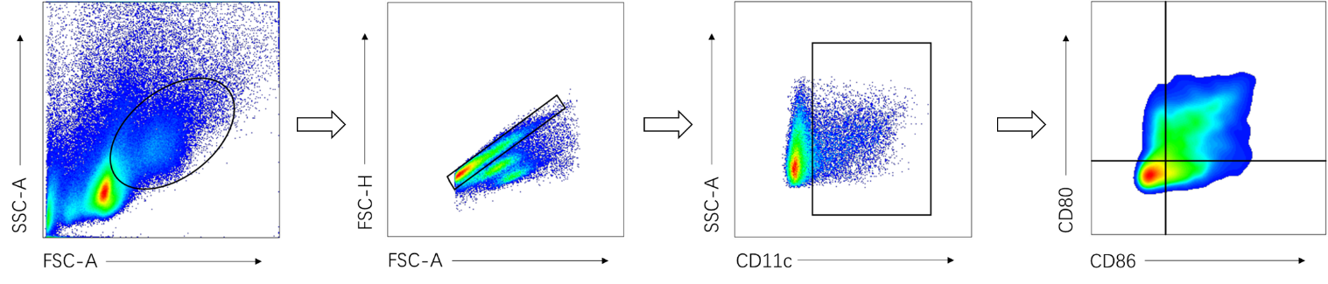
Figure S5. Lap-gate scheme for mature dendritic cells in tumor-draining lymph nodes.

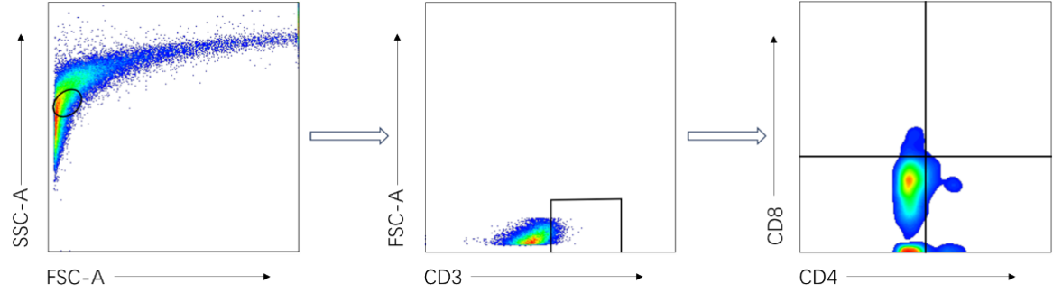
Figure S6. Lap-gate scheme for intratumorally infiltrating CD8⁺/CD4⁺ T cells.

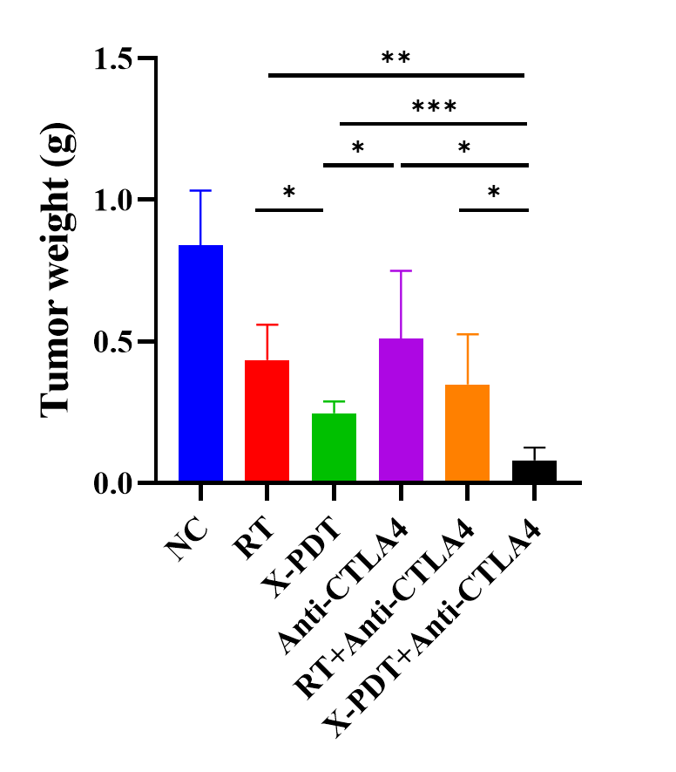
Figure S7. Tumor weights during monitoring of mice in each group of the long-term immune memory effect component (n=5 ;*, P＜0.05; **, P＜0.01; ***, P＜0.001).

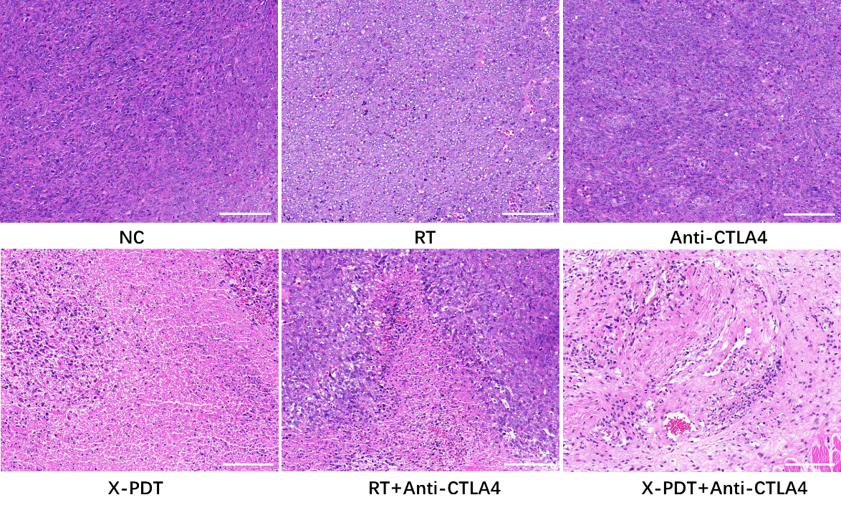
Figure S8. Recurrence tumor H&E staining images (scale bar: 100 μm).

Figure S9. Body weight during monitoring of mice in each group of the long-term immune memory effect component (n=5).

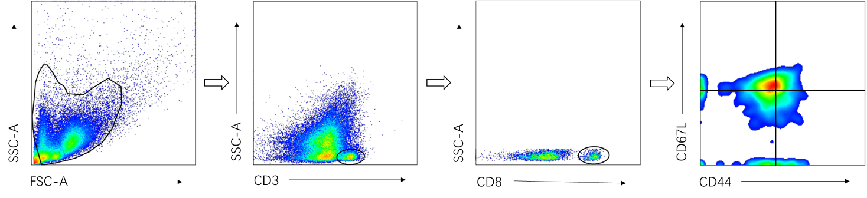
Figure S10. Spleen Tem cells lap-gate scheme.

Figure S11. Survival curves for each group of mice during monitoring (n=8-10).

