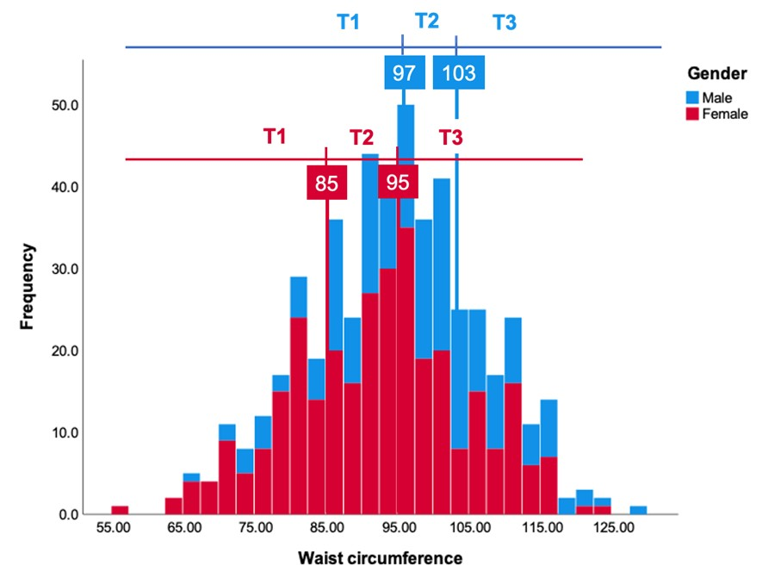
Figure S1. Histogram of Waist Circumference in Males (Blue) and Females (Red), categorized into distinct Tertile groups based on the histogram.

