Supplementary Materials
Supplementary Figure 1 Questionnaire responses of students’ experience of Class II cavity preparation and pulpotomy with both training systems
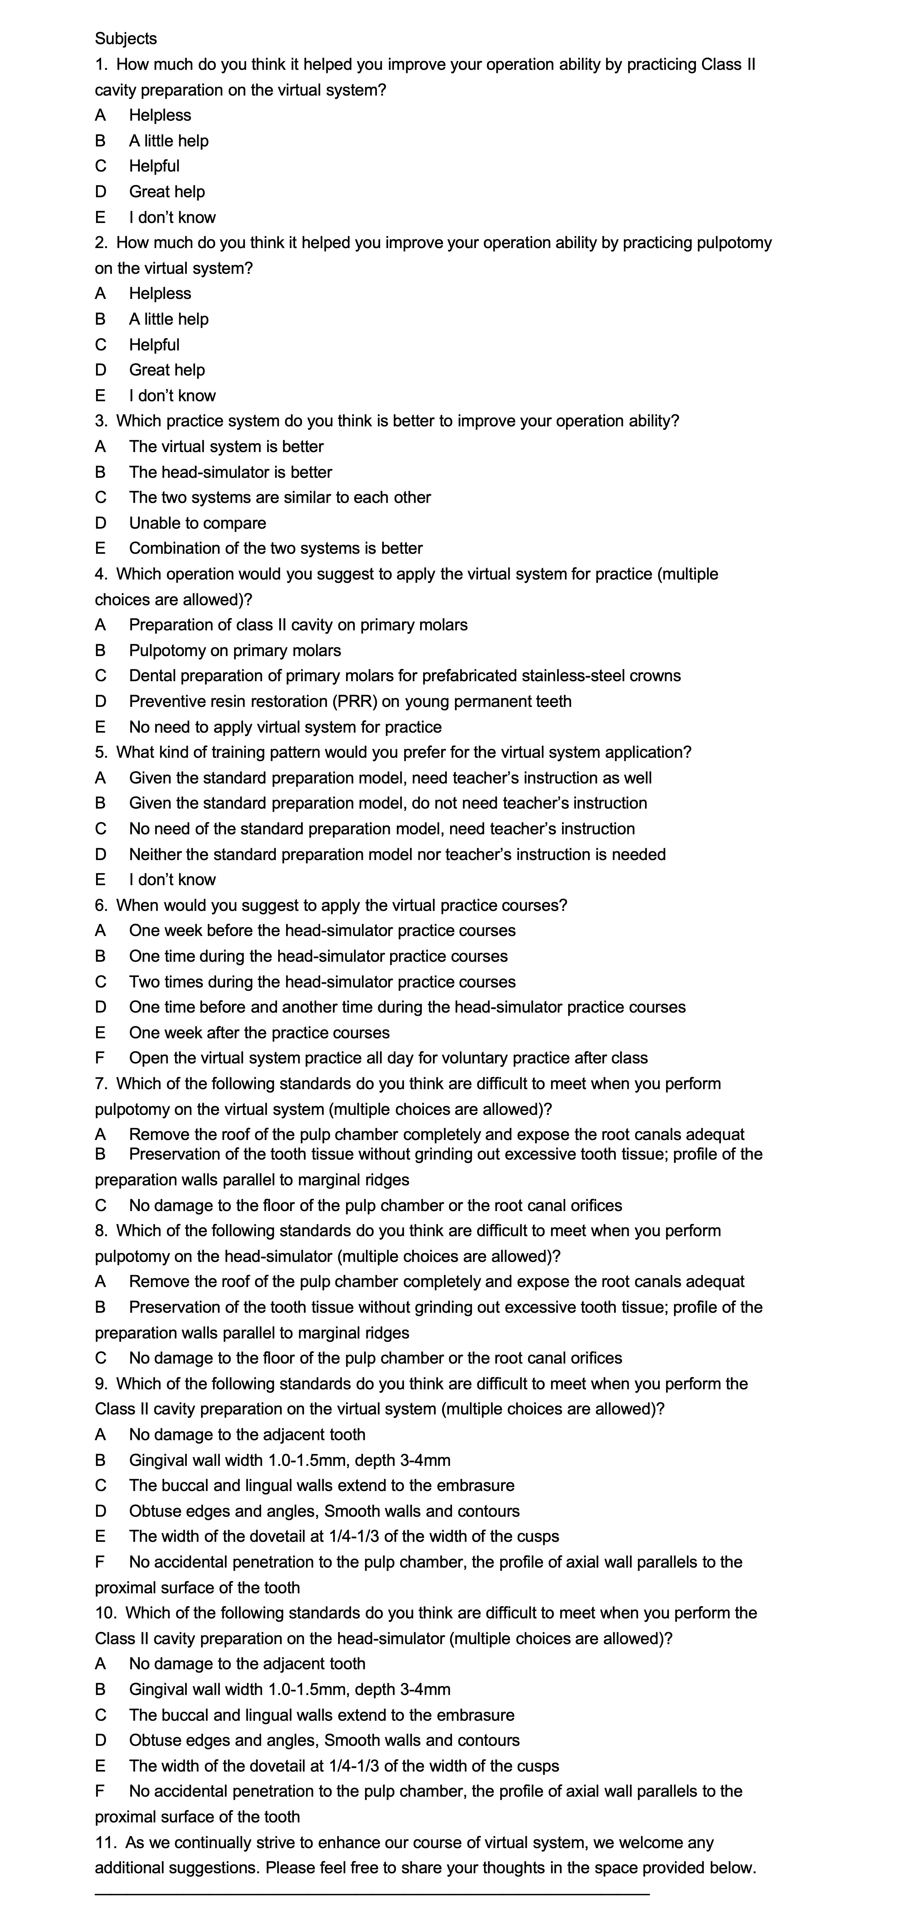

Supplementary Table 1 General information and examination results of the unified theory test.
 |  | Group A | Group B | p-Value
Gender | Male | 25 | 24 | 0.822†
 | Female | 16 | 17 | 0.822†
Exam Score |  | 84.1±5.3 | 84.0±5.0 | 0.938‡
Note: † Κ² test
‡ T test

Supplementary Table 2 Assessment scores of pulpotomy operation on the lower right second primary molar.
 | Pa | Pb | Pc | Pd | Psum
AS | 9.17  (7.92, 9.67)* | 30.62  (26.27, 34.97) | 7.42  (6.50, 8.33) | 37.50  (22.50, 40.00)* | 82.33  (68.00 , 89.42)*
A2 | 8.83  (8.05, 9.12)* | 32.06  (30.35, 33.77) | 7.50  (7.43, 8.10)* | 27.17  (19.67, 31.67)* | 76.34  (67.50, 81.73)*
A3 | 8.67  (7.33, 9.33)* | 32.17  (29.83, 33.75)* | 7.67  (7.25, 8.00)* | 24.33  (16.25 , 33.42)* | 71.00  (63.33, 82.33)*
A4 | 8.33  (7.67, 9.33)* | 33.00  (30.92, 35.00)* | 7.58  (6.91, 8.26) | 31.67  (24.58, 36.17)* | 80.50  (73.25, 85.42)*
B1 | 7.96  (6.49, 9.42) | 30.67  (27.58, 33.92)* | 7.16  (6.42, 7.89) | 20.68  (9.31, 32.04) | 66.18  (52.71, 79.64)
B2 | 8.13  (6.97, 9.03)* | 32.40  (31.50, 33.30)* | 7.80  (7.50, 8.10)* | 31.33  (24.25, 34.25)* | 78.95  (72.08, 83.33)*
BS | 8.50 (7.67, 9.33)* | 29.69 (25.41, 33.98) | 7.00 (6.33, 7.67)* | 37.00 (31.17, 39.58)* | 81.80 (74.48, 87.83)*
B4 | 8.67 (7.67, 9.92)* | 31.83 (26.92, 34.33)* | 7.50 (6.67, 7.92)* | 33.00 (23.33, 36.67)* | 77.50 (67.48, 85.20)*
Note: *median (Q1, Q3)

Supplementary Table 3 Assessment scores of Class II cavity preparation on the lower right first primary molar.
 | Ce | Cf | Cg | Ch | Ci | Cj | Csum
AS | 6.69  (5.58, 7.80) | 10.90  (9.59, 12.21) | 7.00  (5.67, 7.67)* | 7.13  (6.08, 8.19) | 11.27  (9.85, 12.68) | 7.00  (6.33, 8.00)* | 49.36  (43.30, 55.42)
A2 | 7.00  (6.33, 8.00) | 11.67 (10.67, 12.68) | 7.37  (6.46, 8.28) | 8.00  (7.67, 8.67)* | 11.91  (10.30, 13.52) | 7.73  (6.95, 8.52) | 53.89  (49.34, 58.44)
A3 | 7.04  (5.95, 8.13) | 11.67 (11.00, 12.00)* | 7.67  (7.33, 8.00)* | 8.67  (8.33, 9.00)* | 11.33  (10.67, 12.33)* | 7.24  (6.38, 8.09) | 53.14  (49.10, 57.18)
A4 | 7.33  (7.33, 7.67)* | 12.00 (11.00, 12.33)* | 7.67  (7.33, 8.33)* | 8.67  (7.67, 8.67)* | 11.65  (10.50, 12.80) | 7.20  (6.35, 8.04) | 53.88  (50.34, 57.42)
B1 | 6.19  (4.68, 7.69) | 11.00 (10.00, 11.67)* | 7.33  (6.33, 7.67)* | 8.67  (7.67, 9.00)* | 12.28  (10.66, 13.91) | 7.86  (6.78, 8.94) | 52.65  (47.01, 58.29)
B2 | 6.19  (4.68, 7.69) | 12.00 (11.33, 13.00)* | 7.76  (6.95, 8.56) | 8.00  (7.33, 8.67)* | 12.50  (11.14, 13.87) | 8.11  (7.57, 8.65) | 55.89  (51.75, 60.02)
BS | 6.03  (4.93, 7.13) | 10.89 (9.72, 12.05) | 6.49  (5.21, 7.76) | 7.02  (6.28, 7.77) | 11.24  (10.01, 12.46) | 7.00  (6.67, 7.67)* | 48.66  (44.10, 53.22)
B4 | 7.36  (6.55, 8.17) | 12.00 (11.67, 12.67)* | 8.33  (8.00, 8.67 )* | 8.67  (8.33, 9.33)* | 12.13  (11.28, 12.98) | 7.68  (6.83, 8.53) | 56.08  (52.84, 59.33)
Note: *median (Q1, Q3)

