Supplementary Table 1. The result of TACE on RFS and OS in subgroup analyses by different TNM stages
 | OS |  |  | RFS
TNM stage | HR | 95% CI | P-value | HR | 95% CI | P-value
I | 1.22 | 0.67-2.23 | 0.5200 | 1.44 | 0.85-2.44 | 0.1720
II | 0.78 | 0.42-1.43 | 0.4192 | 1.09 | 0.58-2.03 | 0.7905
III | 0.78 | 0.40-1.49 | 0.4468 | 2.65 | 1.46-4.82 | 0.0014
IV | 0.56 | 0.19-1.67 | 0.2959 | 5.77 | 1.69-19.69 | 0.0051
Cox proportional hazards model with the TACE treatment group (yes vs. no) as the primary exposure and adjusted for the significant covariates obtained after model selection.

Supplementary Table 2. The result of TACE on RFS and OS in subgroup analyses by different TNM stages
 | OS |  |  | RFS
TNM stage | HR | 95% CI | P-value | HR | 95% CI | P-value
Early Stage (  I & II) | 0.97 | 0.63-1.49 | 0.8779 | 1.27 | 0.85-1.91 | 0.2404
Advanced stage (III & IV) | 0.75 | 0.44-1.30 | 0.3122 | 3.06 | 1.78-5.26 | <0.0001
Cox proportional hazards model with the TACE treatment group (yes vs. no) as the primary exposure and adjusted for the significant covariates obtained after model selection.

Supplementary Figure 1. Forest plot of recurrence-free survival (RFS) hazard ratios stratified by TNM stage.
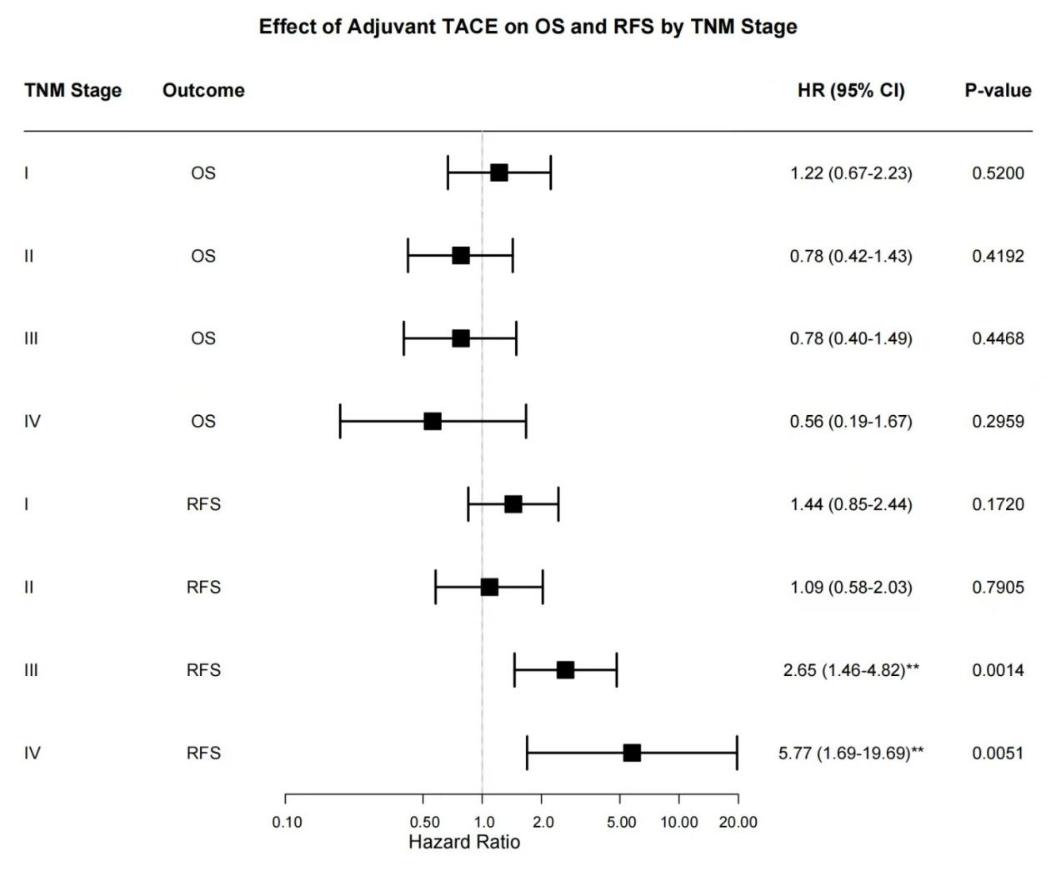
Notes: Cox proportional hazards models showing adjusted hazard ratios (HR) and 95% confidence intervals (CI) for recurrence risk. The vertical line (HR=1) indicates no effect.
Key findings:
Stage I: HR=1.44 (95% CI: 0.85–2.44, P=0.172)
Stage II: HR=1.09 (95% CI: 0.58–2.03, P=0.791)
Stage III: HR=2.65 (95% CI: 1.46–4.82, P=0.001)
Stage IV: HR=5.77 (95% CI: 1.69–19.69, P=0.005)
Heterogeneity test: I²=67%, P=0.02 (indicating significant variation across stages).
Caution: Stage IV subgroup included only 4 TACE-treated patients; results require validation in larger cohorts.

