Table S1 P value of correlation heatmap of COTE
Characteristics | COTE | Hospitalization | AE Events | mMRC | CAT | FEV1 | FEV1% | FEV1/FVC | MEF75/25% | HGB | BNP | HbA1c | Age | BMI
COTE
Hospitalization | 0
AE Events | 0 | 0
mMRC | 0 | 0 | 0
CAT | 0 | 0 | 0 | 0
FEV1 | 0 | 0.162 | 0.057 | 0.109 | 0.062
FEV1% | 0 | 0 | 0 | 0 | 0 | 0
FEV1/FVC | 0 | 0 | 0 | 0 | 0 | 0 | 0
MEF75/25% | 0.034 | 0.766 | 0.632 | 0.476 | 0.616 | 0 | 0 | 0
HGB | 0.001 | 0.349 | 0.545 | 0.941 | 0.992 | 0 | 0.691 | 0.343 | 0.321
BNP | 0.022 | 0.676 | 0.755 | 0.871 | 0.398 | 0.319 | 0.222 | 0.113 | 0.823 | 0
HbA1c | 0.004 | 0.707 | 0.787 | 0.163 | 0.262 | 0.013 | 0.98 | 0.86 | 0.355 | 0.054 | 0.099
Age | 0 | 0.368 | 0.618 | 0.301 | 0.144 | 0 | 0.054 | 0.001 | 0.832 | 0 | 0 | 0.205
BMI | 0.023 | 0.005 | 0.007 | 0.002 | 0.001 | 0.094 | 0.076 | 0 | 0.113 | 0.002 | 0.009 | 0 | 0.126
Notes:
Abbreviations: COTE, chronic obstructive pulmonary disease specific comorbidity test index; AE Events, acute exacerbation events; mMRC, modified British medical research council; CAT,chronic obstructive pulmonary disease assessment test; FEV1 , forced expiratory volume in one second; FEV1%, the percent predicted of forced expiratory volume in one second; FEV1/FVC, forced expiratory volume in one second / forced vital capacity; MEF75/25% , maximal expiratory flow at 25%-75% of the FVC has not been exhaled; HGB, hemoglobin; BNP, B-type natriuretic peptide; HbA1c, glycated hemoglobin; BMI, body mass index.
Table S2 Blood test and lung function between Pulmonary and Extrapulmonary comorbidities group
Characteristics | Pulmonary comorbidities group=124 | Extrapulmonary comorbidities group=189 | χ²/t/Z | P
Blood test
WBC (×10⁹/L) | 7.79±3.22 | 7.54±2.98 | 0.70 | 0.483
NE% (%) | 68.37±11.73 | 69.17±12.10 | -0.58 | 0.565
NE (×10⁹/L) | 4.59 (2.84, 6.62) | 4.33 (3.08, 6.16) | 0.63 | 0.528
EOS% (%) | 1.60 (1.10, 2.58) | 1.20 (0.44, 2.20) | 3.98 | <0.001
EOS (×10⁹/L) | 0.19 (0.12, 0.28) | 0.10 (0.04, 0.17) | 6.88 | <0.001
HGB (g/L) | 129.02±18.65 | 125.92±18.23 | 1.46 | 0.145
BNP (pg/ml) | 55.00 (25.00, 124.75) | 60.00 (28.50, 173.00) | -1.49 | 0.136
ALB (g/L) | 36.84±5.16 | 37.10±3.98 | -0.45 | 0.650
TG (mmol/L) | 1.11 (0.77, 1.59) | 1.08 (0.74, 1.65) | 0.26 | 0.792
TC (mmol/L) | 4.30±0.81 | 4.12±1.07 | 1.72 | 0.087
LDL (mmol/L) | 2.48±0.71 | 2.30±0.85 | 1.93 | 0.054
HDL (mmol/L) | 1.15 (0.91, 1.38) | 1.12 (0.91, 1.40) | 0.47 | 0.637
HbA1c (%) | 6.00 (5.70, 6.40) | 6.10 (5.80, 6.75) | -0.93 | 0.352
FeNO (ppb) | 30.50 (13.50, 68.00) | 27.00 (13.00, 56.50) | 1.50 | 0.133
Lung function
FEV₁ (L) | 1.24 (1.02, 1.72) | 1.26 (1.01, 1.61) | -0.67 | 0.505
FEV₁%pred (%) | 58.60 (43.57, 76.38) | 49.70 (43.10, 65.65) | 1.77 | 0.077
FEV₁/FVC (%) | 57.26 (50.83, 64.58) | 56.04 (46.49, 63.01) | 1.79 | 0.073
MEF_{50%} (%) | 26.18 (15.35, 37.38) | 27.30 (18.22, 37.57) | -1.11 | 0.266
MEF_{25%} (%) | 27.90 (18.09, 41.16) | 28.41 (19.79, 40.92) | -0.65 | 0.515
MEF_{75/25%} (%) | 23.07 (17.28, 33.28) | 24.90 (17.14, 34.73) | -0.96 | 0.334
DLCO (%) | 61.05 (6.53, 84.10) | 58.40 (6.30, 81.45) | 0.15 | 0.885
Notes:
Abbreviations: WBC, white blood cell; NE%, percentage of neutrophils NE, neutrophils; EOS%, percentage of eosinophils; EOS, eosinophil; HGB, hemoglobin; BNP, B-type natriuretic peptide; ALB, albumin; TG, triglyceride; TC, total cholesterol; LDL, low-density lipoprotein; HDL, high-density lipoprotein; HbA1c, glycated hemoglobin; FeNO, fractional exhaled nitric oxide; FEV₁ , forced expiratory volume in one second; FEV₁%pred, the percent predicted of forced expiratory volume in one second; FEV₁/FVC, forced expiratory volume in one second / forced vital capacity; MEF_{50%} , maximal expiratory flow at 50% of the FVC has not been exhaled; MEF_{25%} , maximal expiratory flow at 25% of the FVC has not been exhaled; MEF_{75/25%} , maximal expiratory flow at 25%-75% of the FVC has not been exhaled; DLCO, diffusing capacity of the lungs for carbon monoxide.

Figure S1 Lasso regression of moderate-to-severe acute exacerbation in COPD
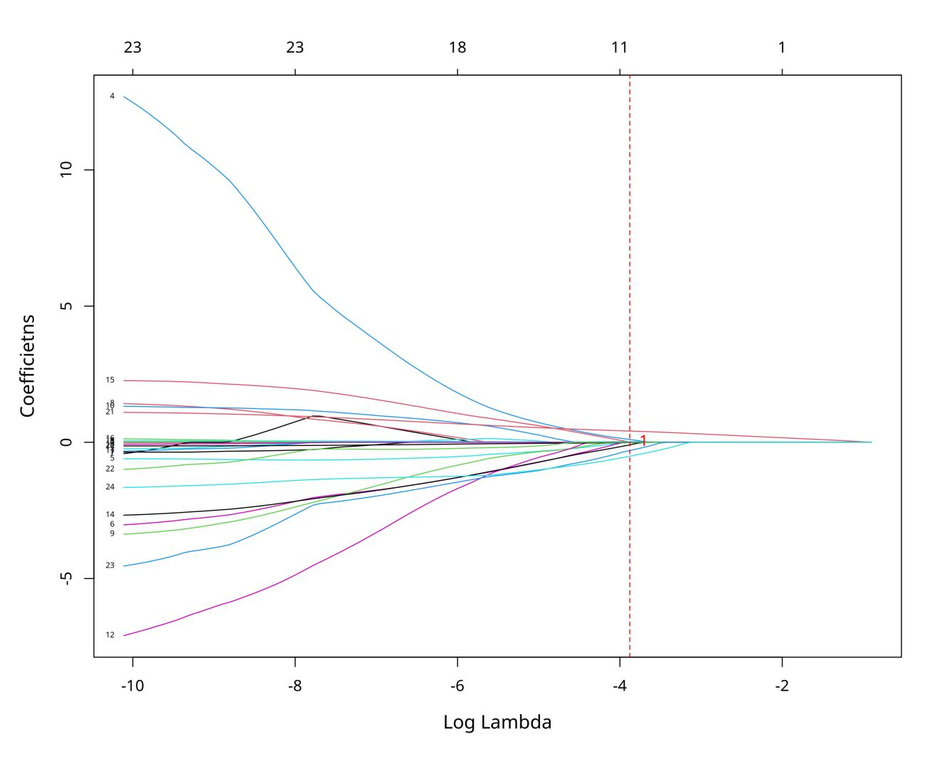

Figure S2 Lasso regression of moderate-to-severe acute exacerbation in COPD
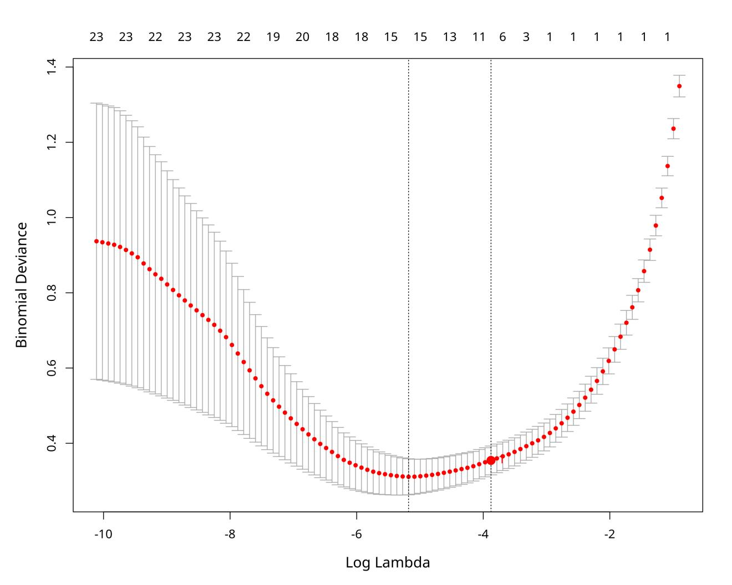

Figure S3 calibration curve of train set of moderate-to-severe acute exacerbation in COPD
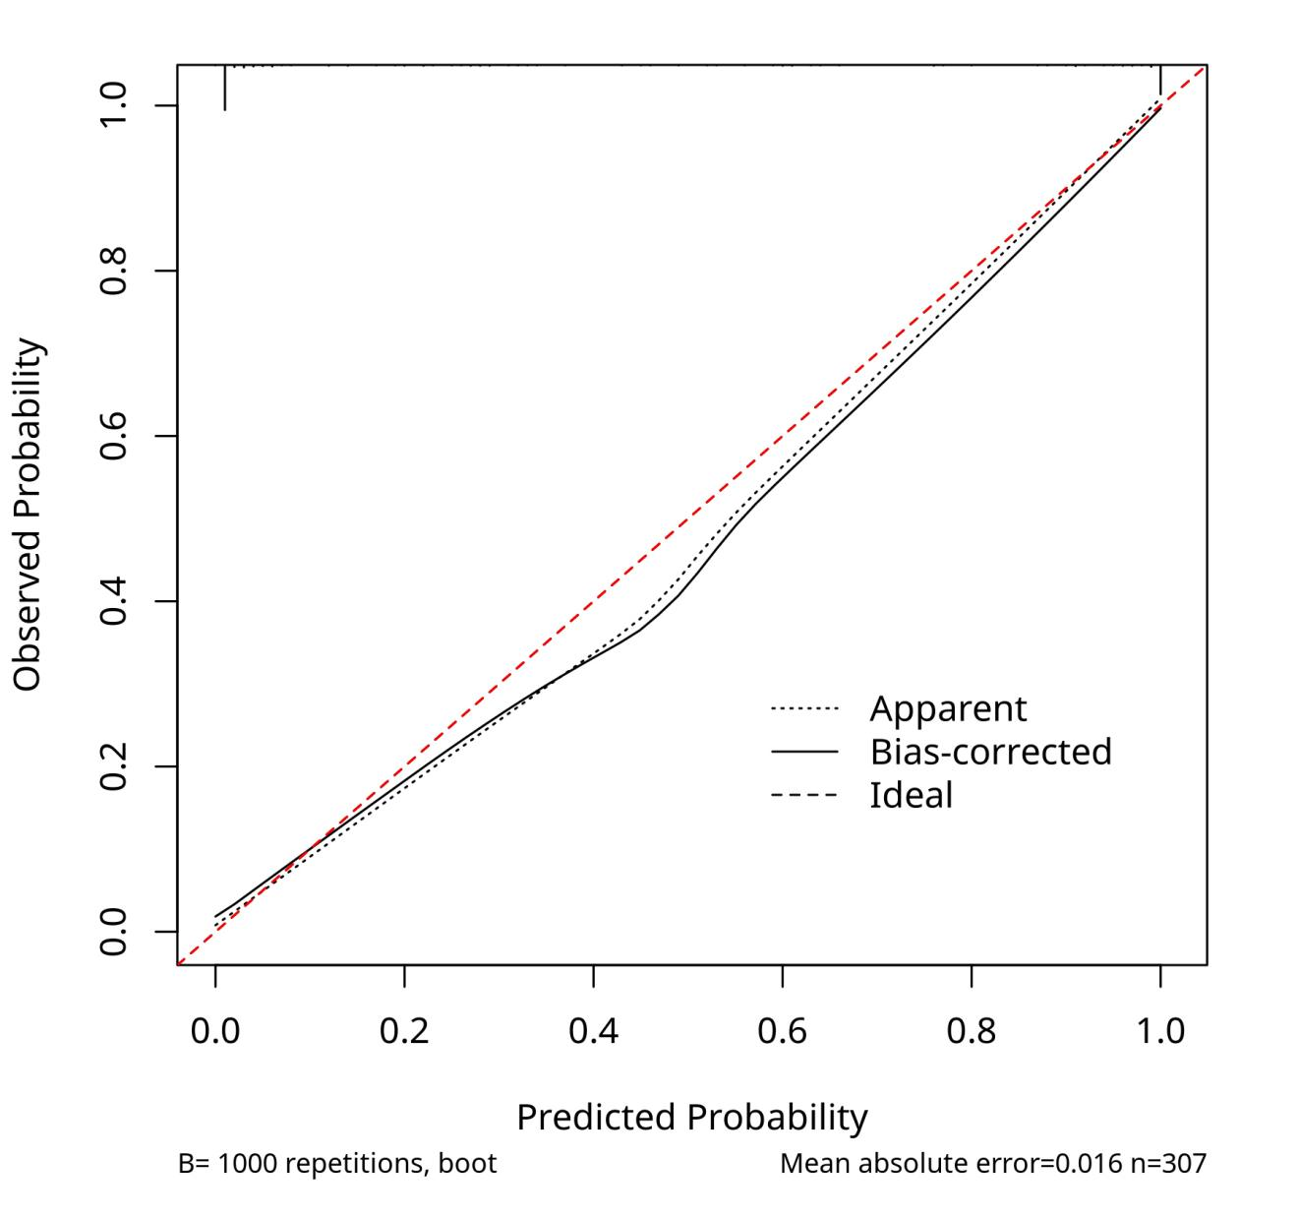

Figure S4 calibration curve of validation set of moderate-to-severe acute exacerbation in COPD
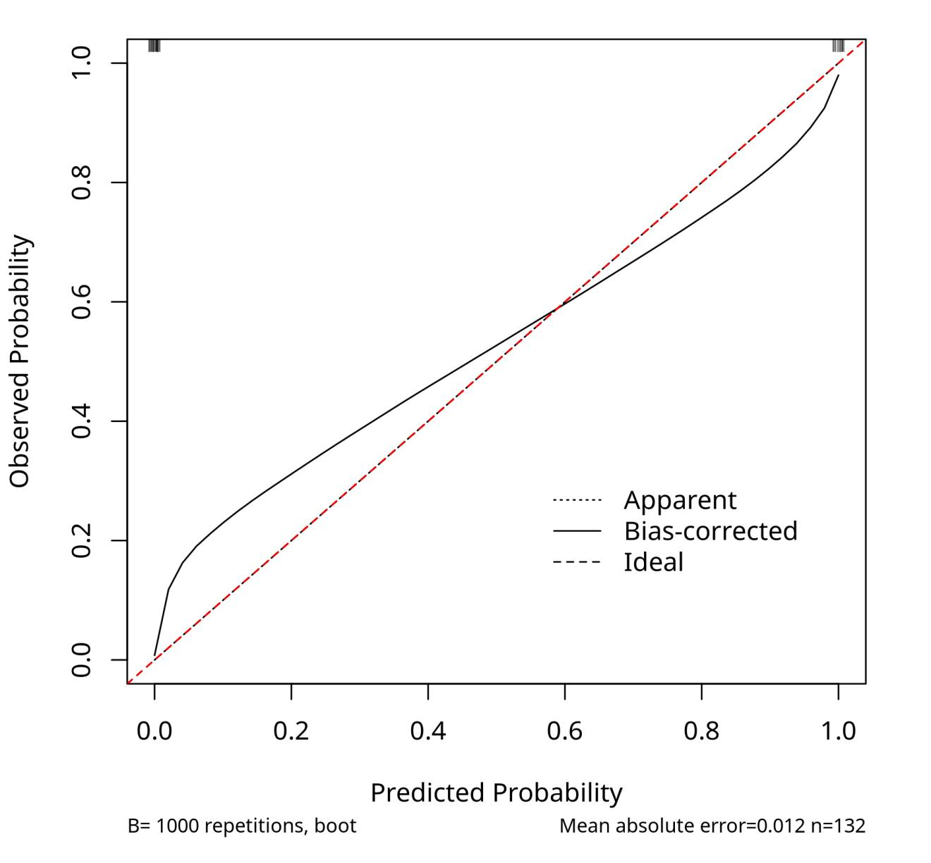

Figure S5 DCA of train set of moderate-to-severe acute exacerbation in COPD
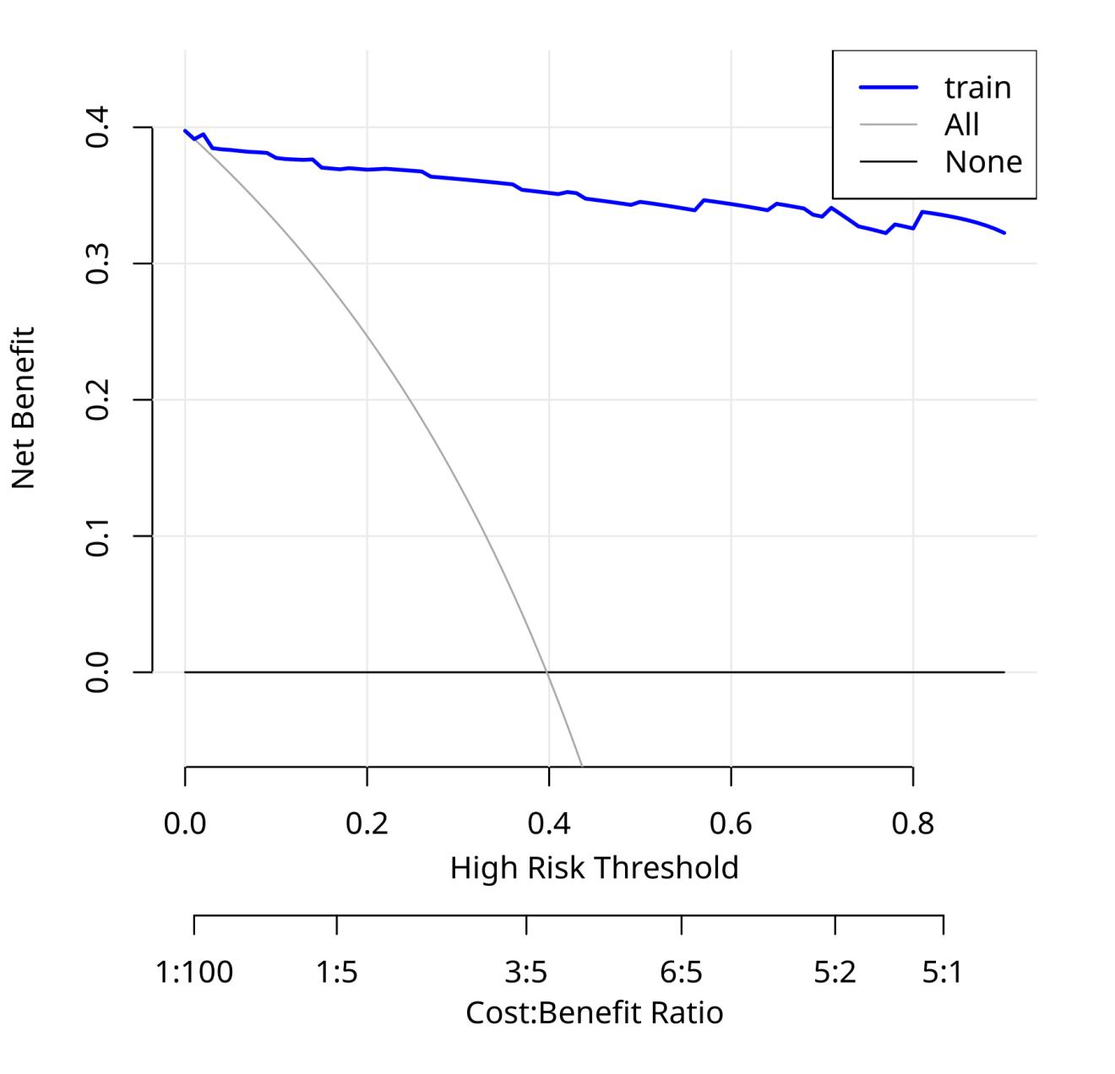

Figure S6 DCA of validation set of moderate-to-severe acute exacerbation in COPD
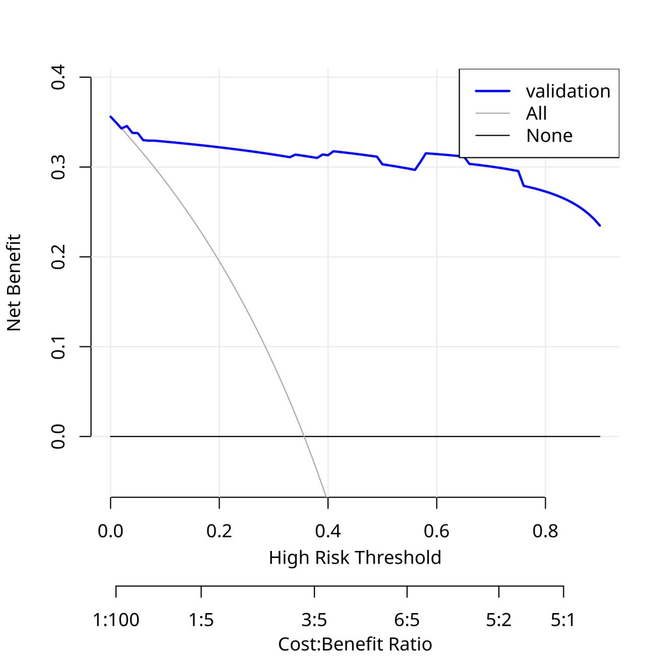

Figure S7 Lasso regression of hospitalization in COPD
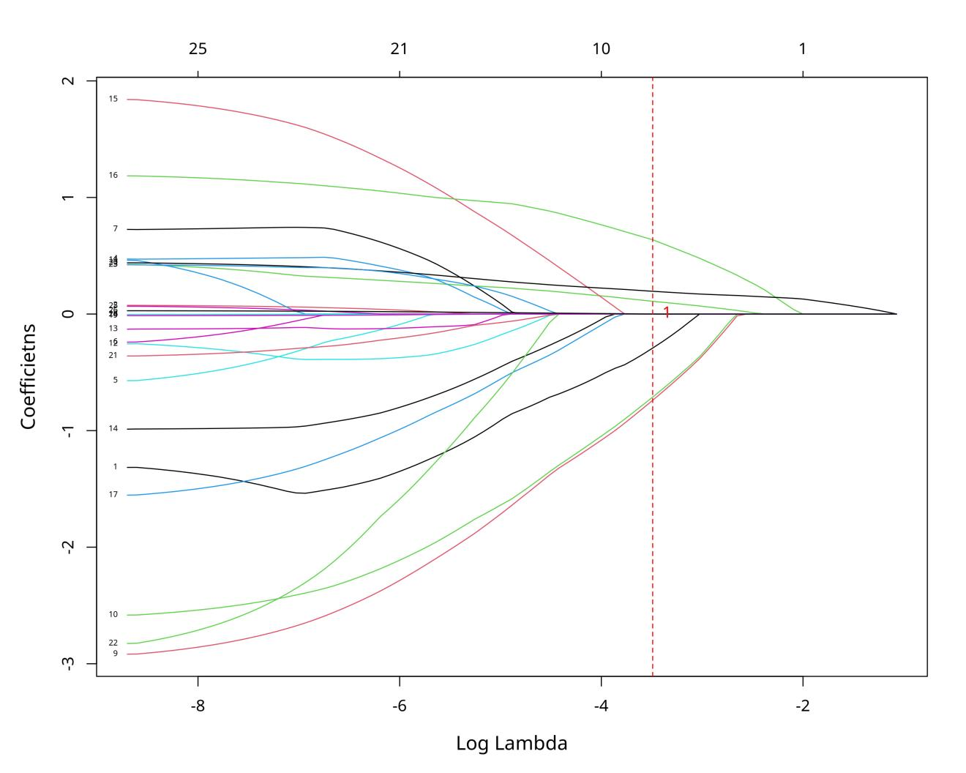

Figure S8 Lasso regression of hospitalization in COPD
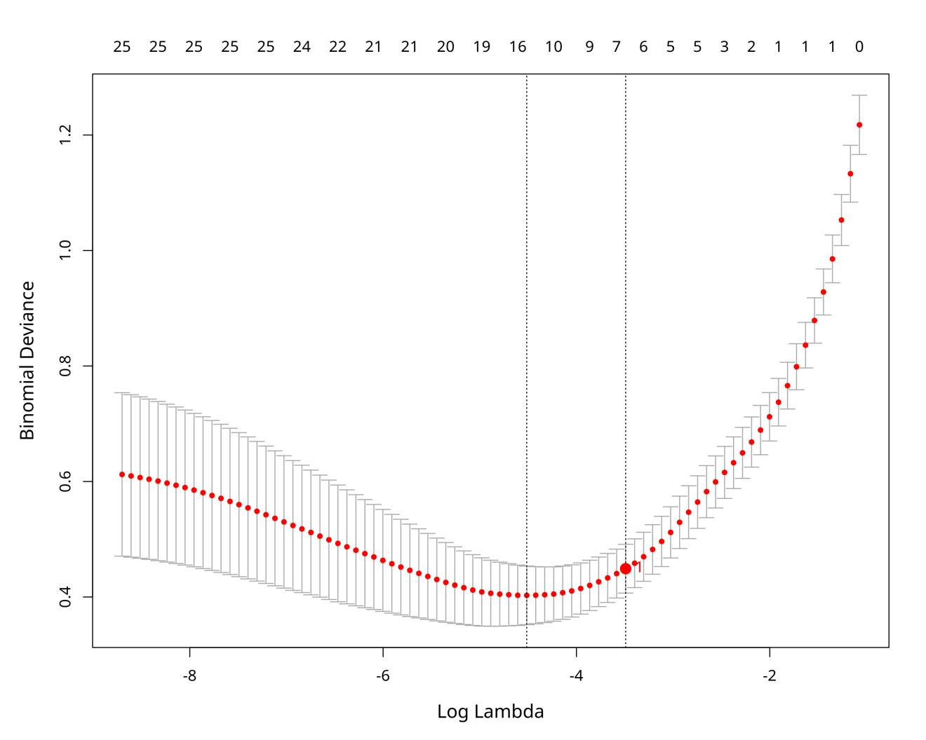

Figure S9 calibration curve of train set of hospitalization in COPD
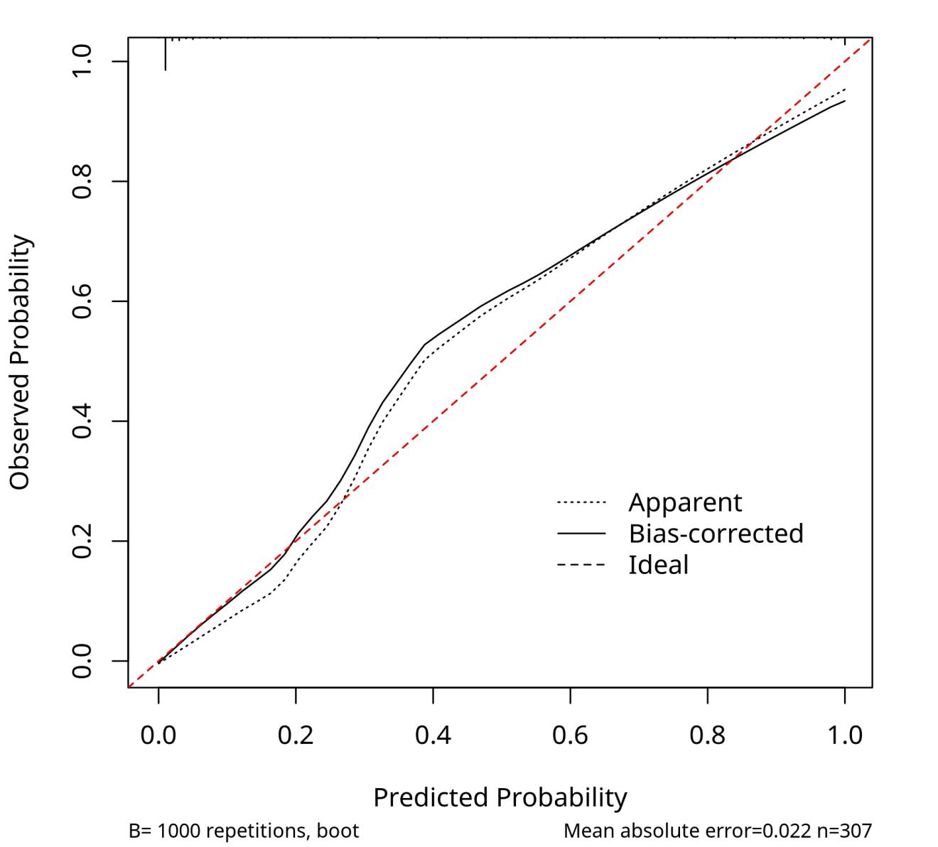

Figure S10 calibration curve of train set of hospitalization in COPD
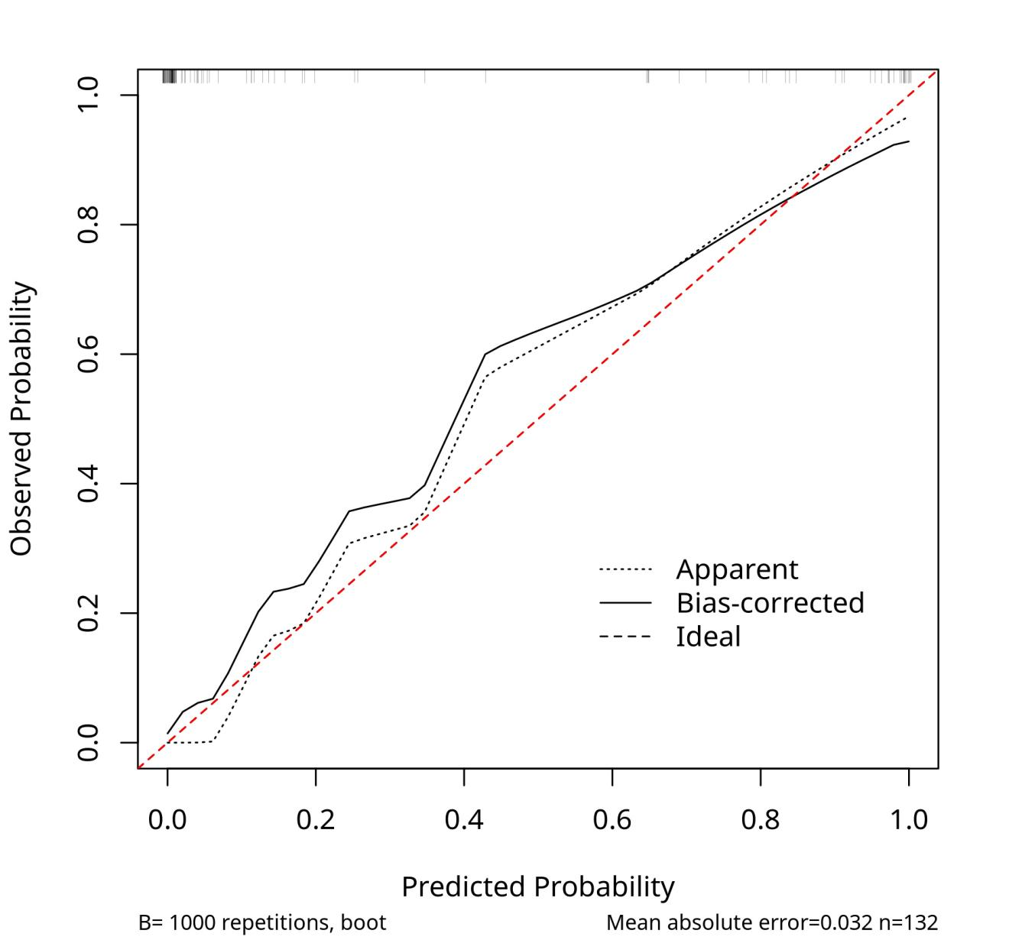

Figure S11 DCA of train set of hospitalization in COPD
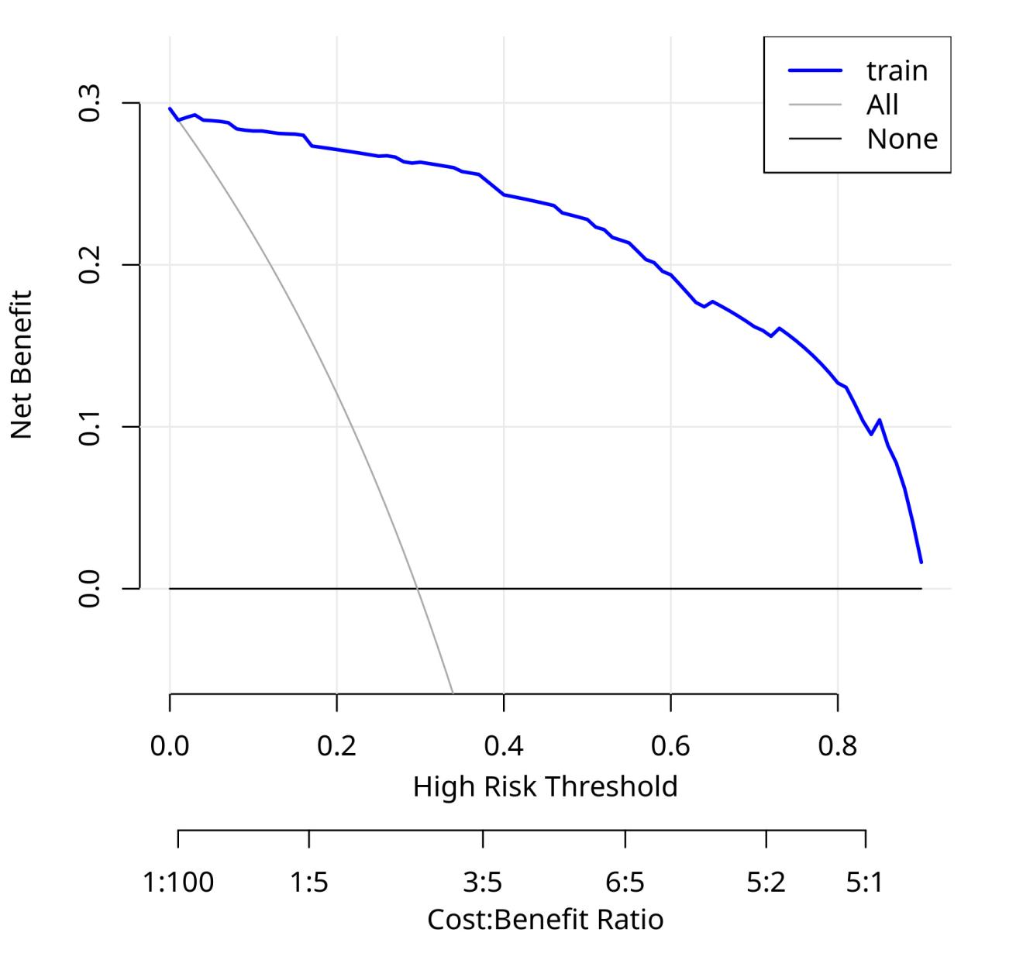

Figure S12 DCA of validation set of hospitalization in COPD
