Supplementary Figure 1. Volcano plot of gene expression analysis, generated using ggplot2 in R. Each point represents a gene, plotted according to its log2 fold change (x-axis) and -log10 adjusted p-value (y-axis). Genes with |log2(FC)| ≥ 1 and an adjusted p-value ≤ 0.05 are considered significantly differentially expressed: up-regulated genes are shown in blue, while down-regulated genes are shown in red. The top 10 most significant up-regulated and down-regulated genes (by adjusted p-value) are labeled with their respective gene names.

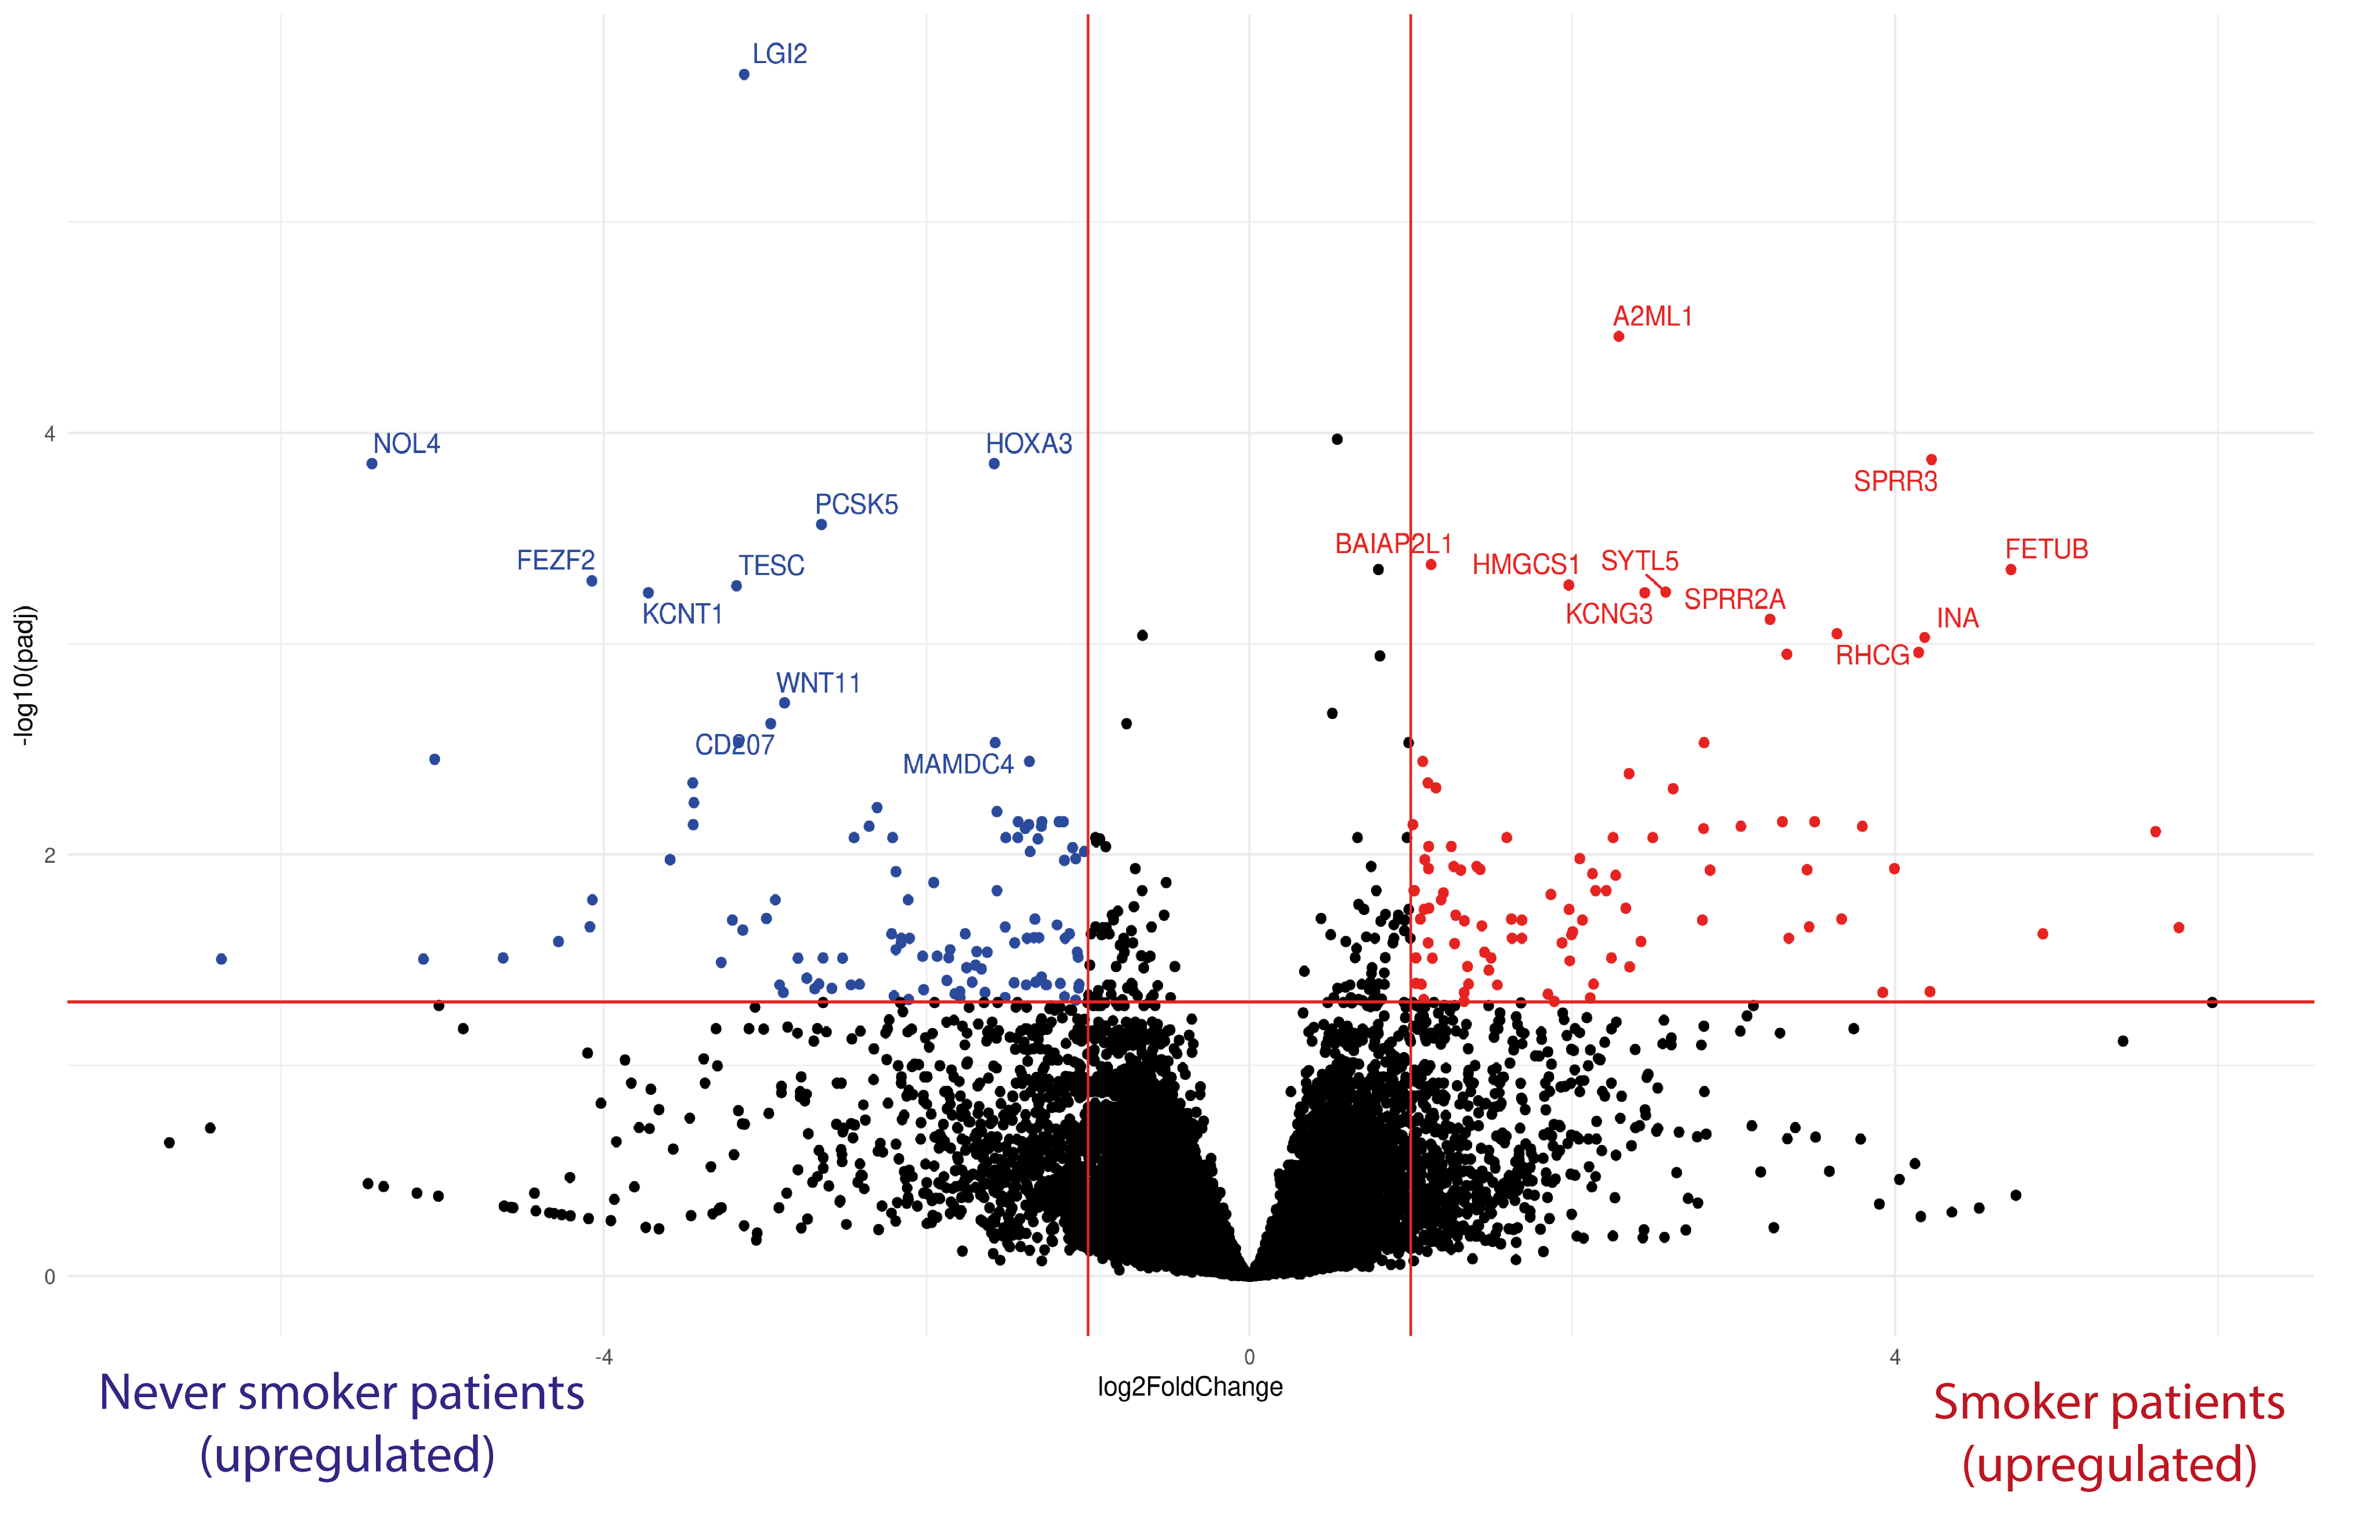

Supplementary Table 1. Common enriched pathways in never smoker and smoker patients. The table showed the differentially enriched pathways between the 2 groups of smoker and never-smoker patients.
db | enrichr.term | Non-smokers q.value | Smokers  q.value
GO_Molecular_Function_2018 | 1-phosphatidylinositol-3-kinase activity (GO:0016303) | 0.000171027 | 4.61423E-05
GO_Molecular_Function_2018 | phosphatidylinositol 3-kinase activity (GO:0035004) | 1.78749E-06 | 1.44329E-05
GO_Molecular_Function_2018 | phosphatidylinositol bisphosphate kinase activity (GO:0052813) | 3.48855E-05 | 1.36583E-05
GO_Molecular_Function_2018 | phosphatidylinositol kinase activity (GO:0052742) | 0.000239435 | 7.69968E-05
GO_Molecular_Function_2018 | phosphatidylinositol-4,5-bisphosphate 3-kinase activity (GO:0046934) | 3.48855E-05 | 1.36583E-05
GO_Biological_Process_2018 | regulation of cyclin-dependent protein serine/threonine kinase activity involved in G1/S transition of mitotic cell cycle (GO:0031657) | 5.16439E-05 | 0.0001874
GO_Biological_Process_2018 | replicative senescence (GO:0090399) | 3.20144E-05 | 0.000110879
GO_Biological_Process_2018 | negative regulation of cell cycle G1/S phase transition (GO:1902807) | / | 0.000490948
GO_Biological_Process_2018 | negative regulation of G1/S transition of mitotic cell cycle (GO:2000134) | / | 0.000581084
GO_Biological_Process_2018 | regulation of G1/S transition of mitotic cell cycle (GO:2000045) | / | 0.002373233
GO_Biological_Process_2018 | cell cycle G1/S phase transition (GO:0044843) | 2.75014E-05 | /
GO_Biological_Process_2018 | regulation of cell cycle arrest (GO:0071156) | 3.20144E-05 | /
GO_Biological_Process_2018 | signal transduction involved in mitotic G1 DNA damage checkpoint (GO:0072431) | 5.54016E-05 | /
GO_Biological_Process_2018 | negative regulation of cell cycle arrest (GO:0071157) | 7.02037E-05 | /
GO_Biological_Process_2018 | positive regulation of mitotic cell cycle phase transition (GO:1901992) | 0.00025483 | /

