Supplementary Tables
Table S1 Characteristics of patients with or without exercise habits during adolescence
 | Adolescent
 | Non-exerciser  (n = 40) | Exerciser  (n = 46) | P-value
Age (years, median [IQR])  Male (n, %)  BMI (kg/m², median [IQR])  Current smoker (n, %)  Pack-years (median [IQR])  mMRC score (median [IQR])  CAT score (median [IQR])  COPD (n, %)  Cardiovascular disease (n, %)  Osteoporosis (n, %)  Bronchodilator use (n, %)  Hand grip tests (kg, median [IQR])  6MWD (m, median [IQR])ª | 76.0 (72.0–80.8)  36 (90.0)  24.0 (21.6–25.4)  9 (22.5)  52.8 (33.8–63.0)  1.0 (0.0–1.8)  9.0 (3.0–12.8)  32 (80.0)  5 (12.5)  3 (7.5)  30 (75.0)  33.3 (27.0–35.8)  403 (371–431) | 76.0 (69.8–80.0)  45 (97.8)  24.4 (22.5–26.1)  7 (15.2)  49.5 (39.2–75.5)  1.0 (0.0–1.0)  7.0 (3.0–16.0)  40 (87.0)  9 (19.6)  0 (0.0)  30 (65.2)  34.5 (29.3–40.7)  397 (360–450) | 0.53  0.17  0.24  0.41  0.65  0.71  0.80  0.39  0.55  0.096  0.35  0.13  0.88
Notes: ªn = 29 (non-exerciser) and 31 (exerciser).
Abbreviations: IQR, interquartile range; BMI, body mass index; mMRC, modified Medical Research Council dyspnea scale; CAT, COPD Assessment Test; 6MWD, 6-minute walk test distance.

Table S2 Characteristics of patients with or without current exercise habits
 | Current
 | Non-exerciser  (n = 25) | Exerciser  (n = 61) | P-value
Age (years, median [IQR])  Male (n, %)  BMI (kg/m², median [IQR])  Current smoker (n, %)  Pack-years (median [IQR])  mMRC score (median [IQR])  CAT score (median [IQR])  COPD (n, %)  Cardiovascular disease (n, %)  Osteoporosis (n, %)  Bronchodilator use (n, %)  Hand grip tests (kg, median [IQR])  6MWD (m, median [IQR])ª | 76.0 (69.5–80.0)  21 (84.0)  24.1 (20.5–25.7)  9 (36.0)  54.0 (37.9–64.8)  1.0 (0.5–2.5)  9.0 (4.5–18.5)  22 (88.0)  7 (28.0)  1 (4.0)  20 (80.0)  31.6 (26.0–37.3)  372 (263–427) | 76.0 (71.0–80.0)  60 (98.4)*  24.2 (22.5–25.9)  7 (11.5)*  48.0 (38.5–72.0)  1.0 (0.0–1.0)*  8.0 (3.0–13.0)  50 (82.0)  7 (11.5)  2 (3.3)  40 (65.6)  33.8 (29.9–39.1)  410 (383–446) | 0.61  0.023  0.42  0.013  0.66  0.022  0.28  0.74  0.10  1.00  0.20  0.093  0.050
Notes: * is significant at the P < 0.05 level. ªn = 14 (non-exerciser) and 46 (exerciser).
Abbreviations: IQR, interquartile range; BMI, body mass index; mMRC, modified Medical Research Council dyspnea scale; CAT, COPD Assessment Test; 6MWD, 6-minute walk test distance.

Supplementary Figures
Figure S1 Questionnaire on exercise habits.
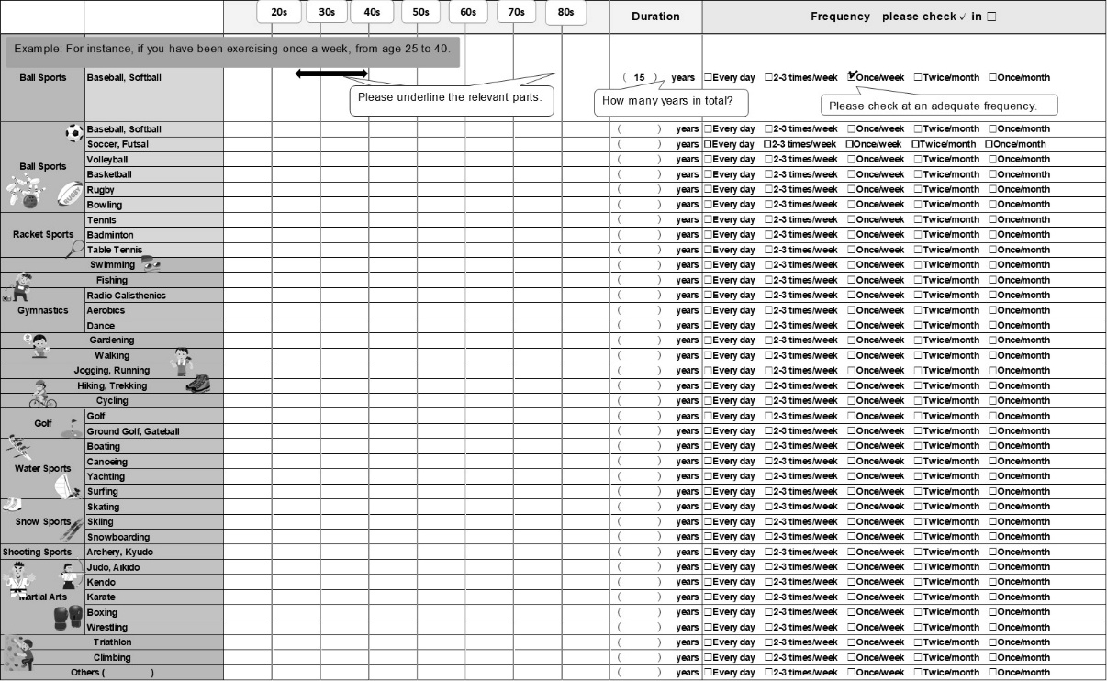

Figure S2 Exercise habit maintenance rates across age groups based on adolescent or current exercise habits.
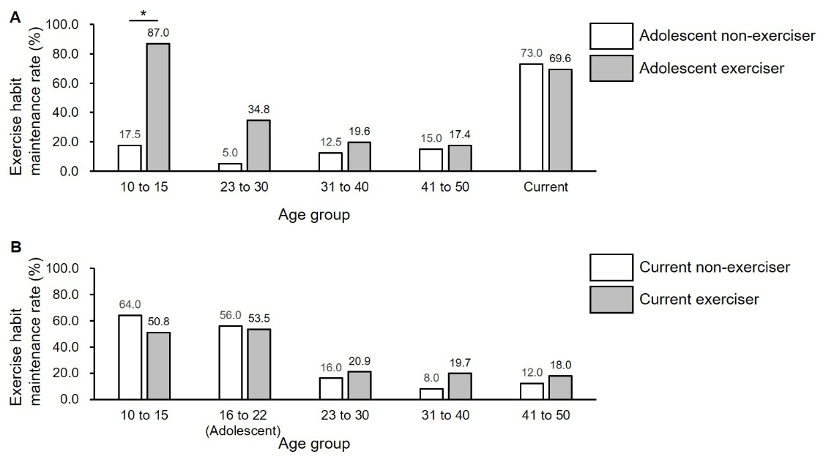
* is significant at the P < 0.05 level. (A) Exercise habit maintenance rates across age groups based on adolescent exercise habits. (B) Exercise habit maintenance rates across age groups based on current exercise habits.

