Bacteriological Identification and Characterization of Feces Microbiome in Prostate Cancer Patients
Undergoing Radiotherapy

Supplementary Materials

Supplementary Table 1. The results of the bacterial species correlation with the isolation time after examination of the residuals from the chi-square test.
Isolation time | Most overrepresented species | Positive Residual Value | Most underrepresented species | Negative Residual Value
K1 | Enterococcus hirae | 1.523 | Citrobacter braakii | -1.0
K2 | Citrobacter braakii | 1.827 | Bifidobacterium longum | -1.0
K3 | Enterobacter asburiae | 3.0 | Citrobacter braakii | -1.0

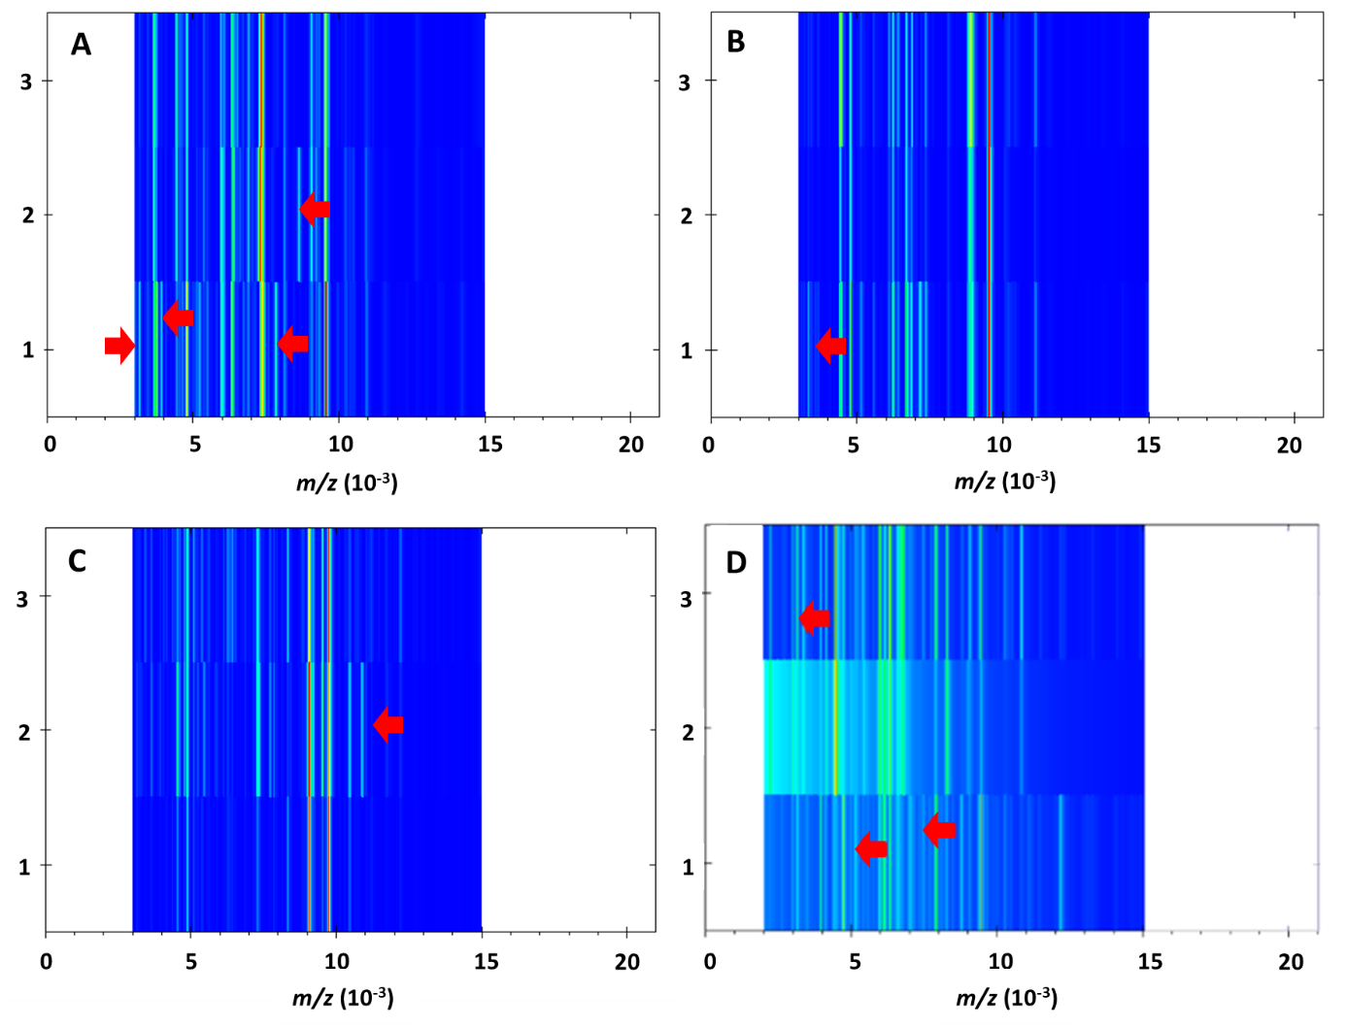
Supplementary Figure 1. GelView of four strains of (A) Enterococcus faecium, (B) Enterococcus faecalis, (C) Escherichia coli, (D) Streptococcus salivarius isolated from the same microbiological medium at time K1, K2, and K3. The red arrows indicate differentiating signals between the strains.

