Figure S1 Nomogram for predicting the probability of CAD in Validation cohort.
A. Model 1, The risk prediction model was constructed based on HAR.
B. Model 2: The risk prediction model was built based on age, hypertension, diabetes, smoking, and WBC.
C. Model 3: The risk prediction model was established based on HAR combined with age, hypertension, diabetes, smoking, and WBC.

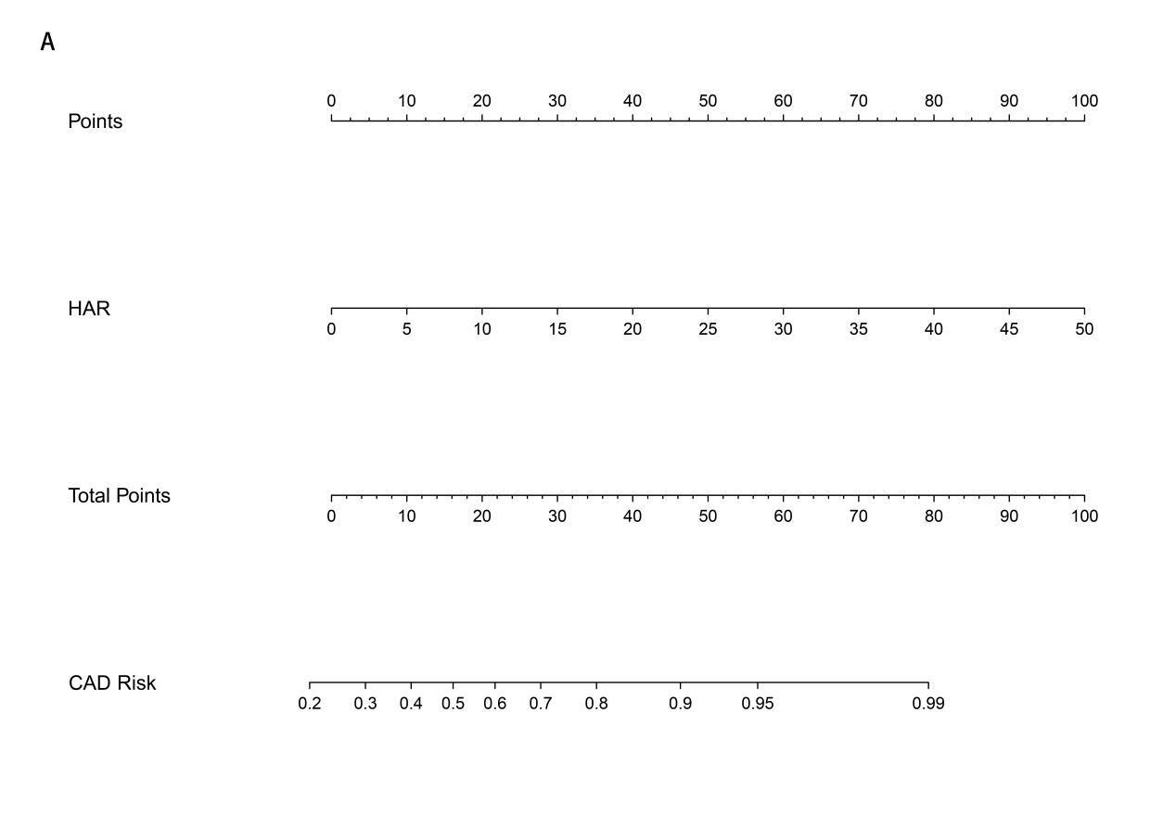

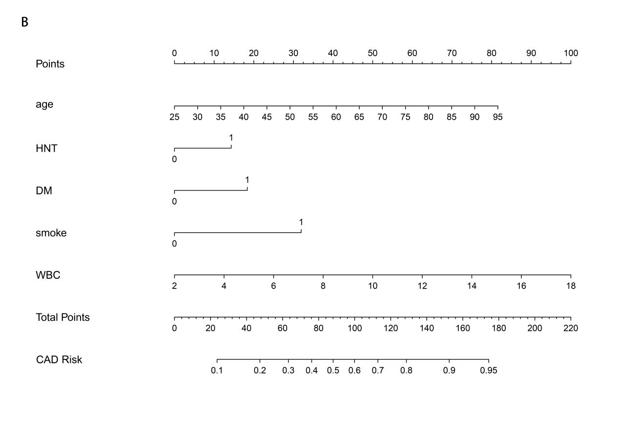

Figure S2 Calibration curve for predicting the probability nomogram of CAD in Validation cohort.
A. Model 1 Calibration Curve;
B. Model 2 Calibration Curve;
C. Model 3 Calibration Curve.
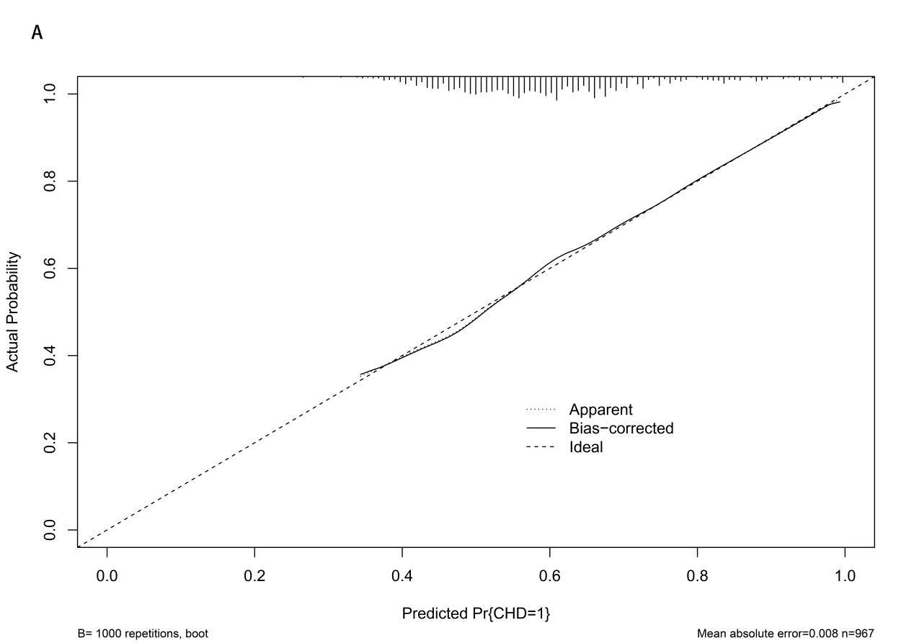

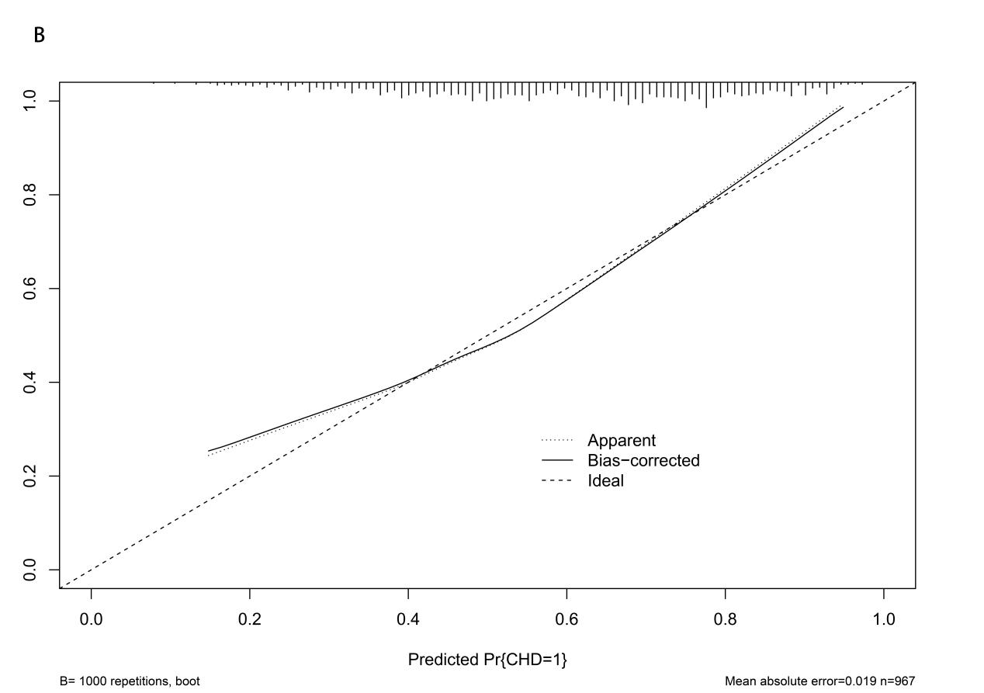

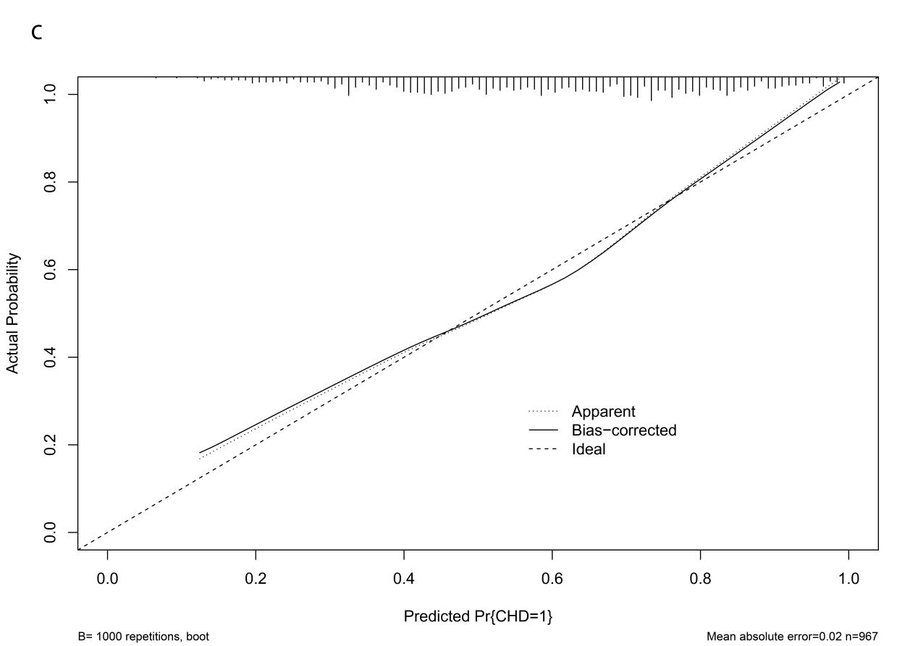

Figure S3 Nomogram for predicting the probability of Severe CAD in Validation cohort.
A. Model 1, The risk prediction model was constructed based on HAR.
B. Model 2: The risk prediction model was built based on age and WBC.
C. Model 3: The risk prediction model was established based on HAR combined with age and WBC.

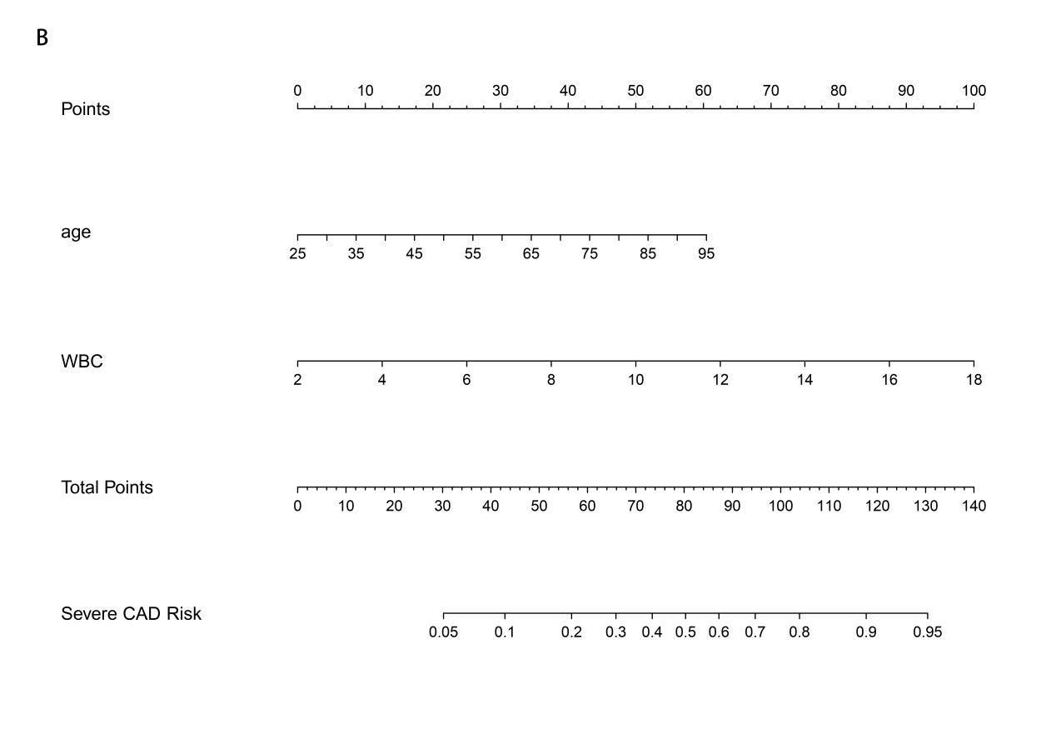
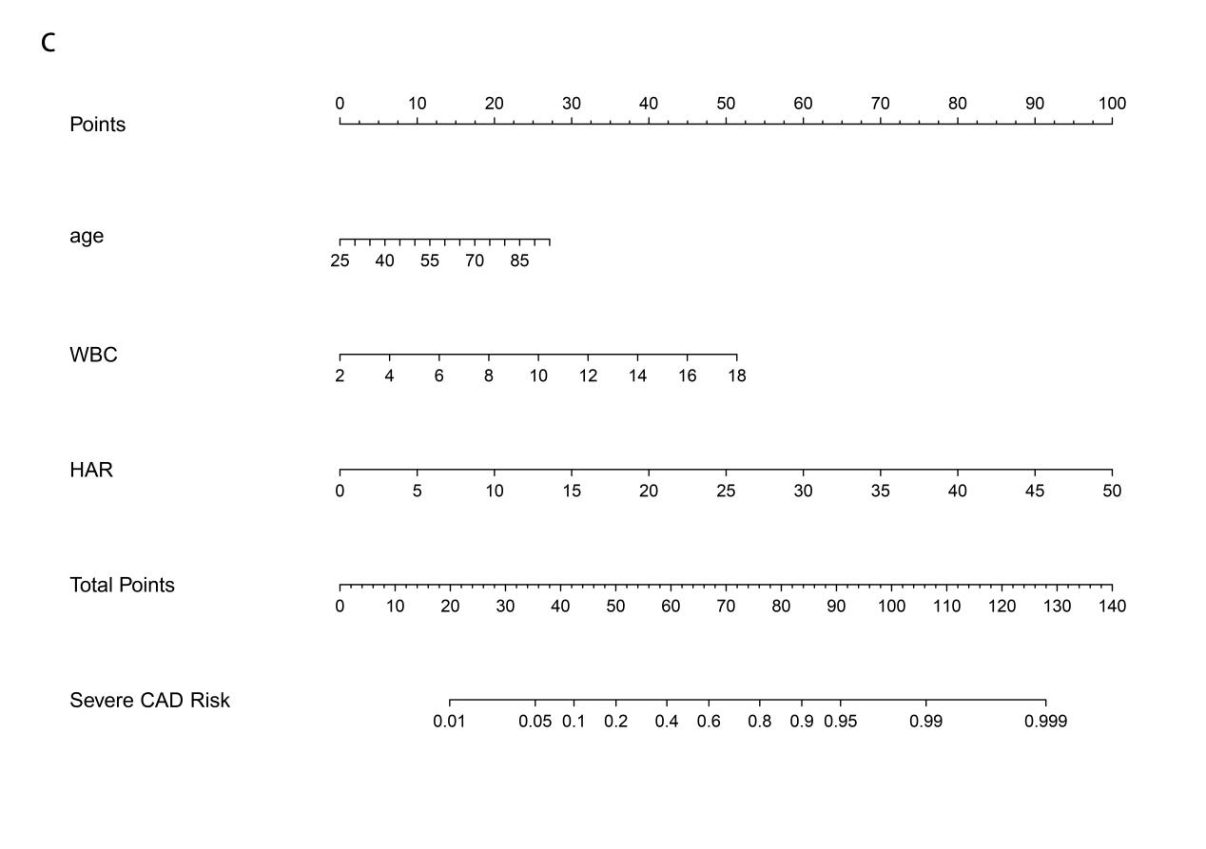

Figure S4 Calibration curve for predicting the probability nomogram of Severe CAD in Validation cohort.
A. Model 1 Calibration Curve;
B. Model 2 Calibration Curve;
C. Model 3 Calibration Curve.
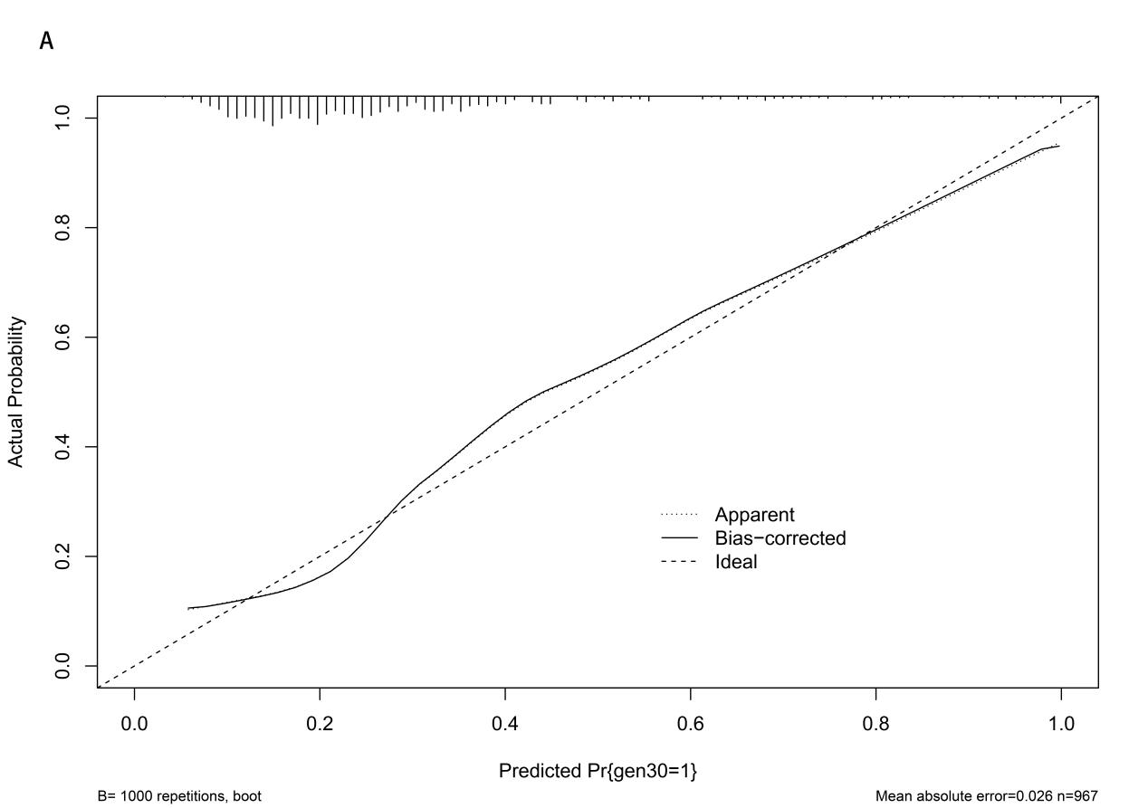

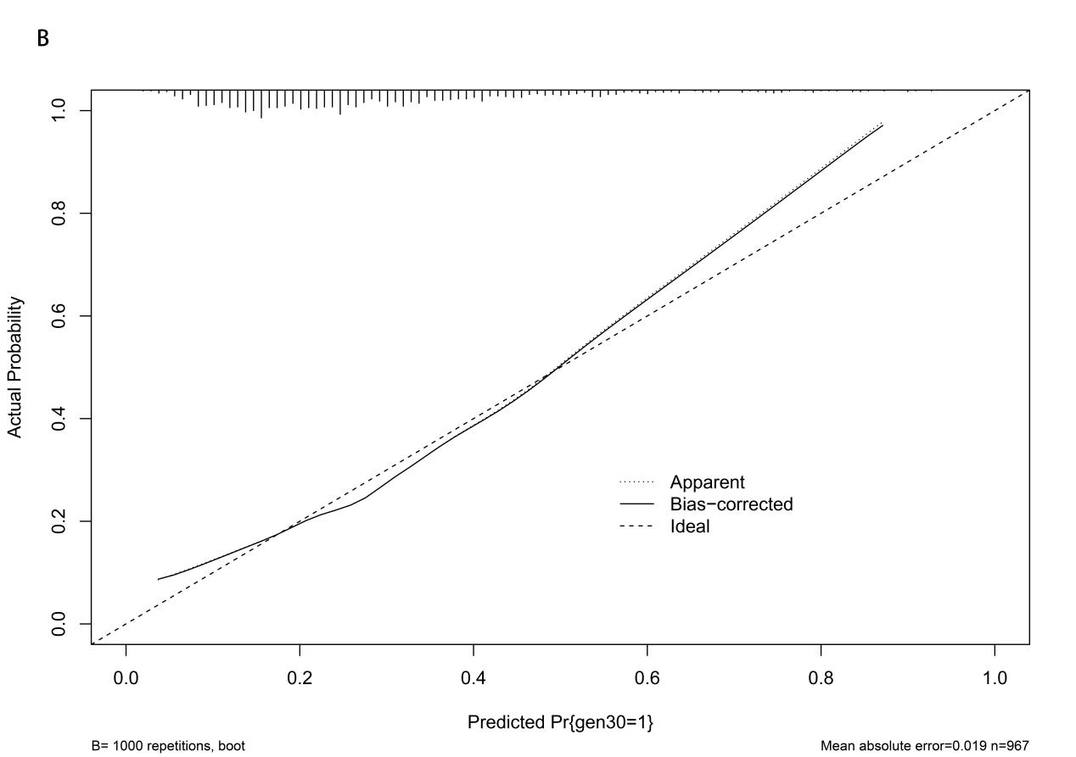

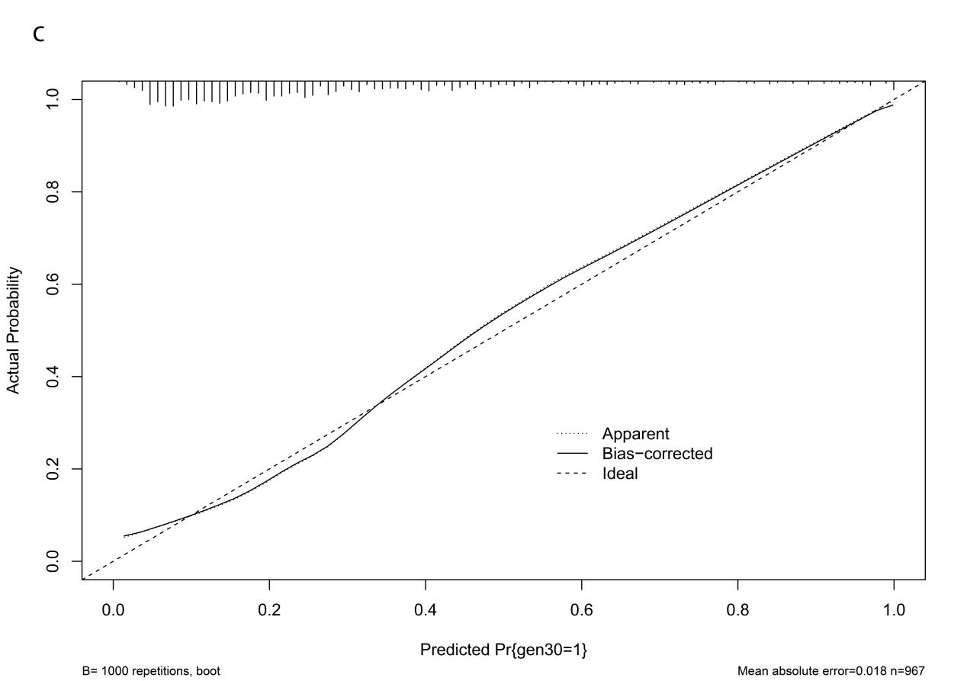

Figure S5 Correlation Analysis of HAR and Gensini Score in Validation cohort

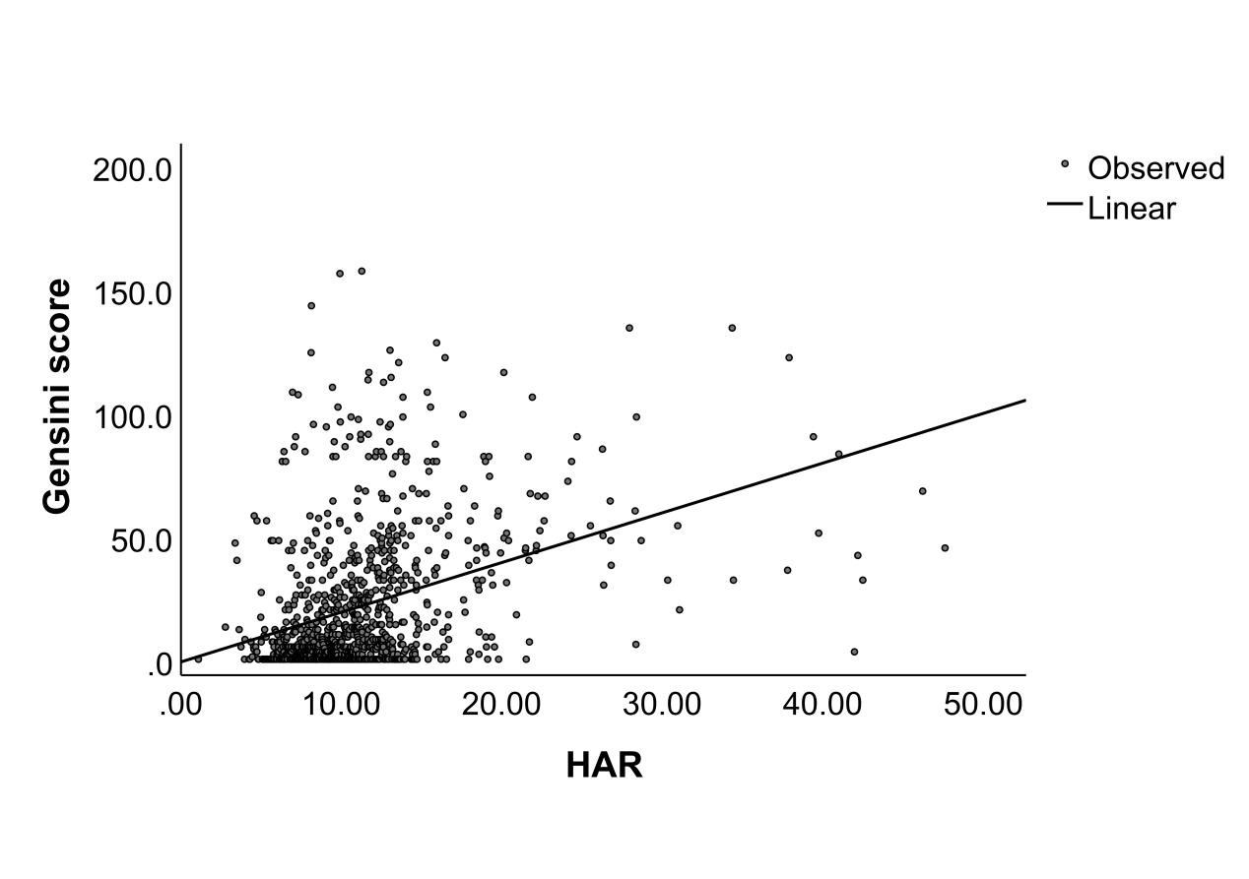

Figure S6 DCA curve analysis of the prediction model for severe coronary artery disease in Validation cohort.
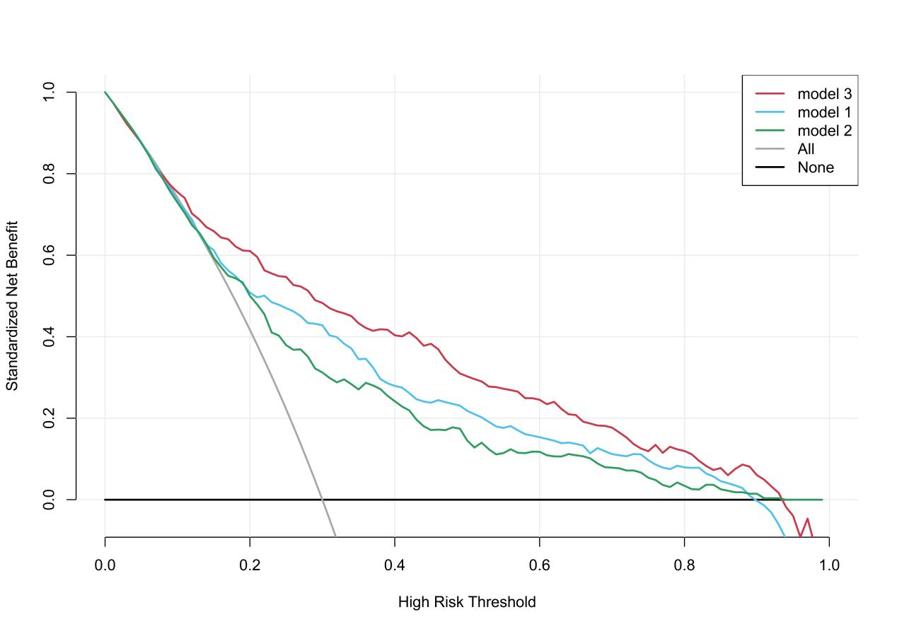

Figure S7 Decision Curve Analysis of HAR and other parameters in Validation cohort.
