Supplementary Figure 1. Kaplan-Meier survival curves showing: A）recurrence-free survival (RFS) in patients treated with narrow-margin mMMS who with or without hypopigmented patches, B) RFS in patients who with or without lymphovascular invasion.
A)
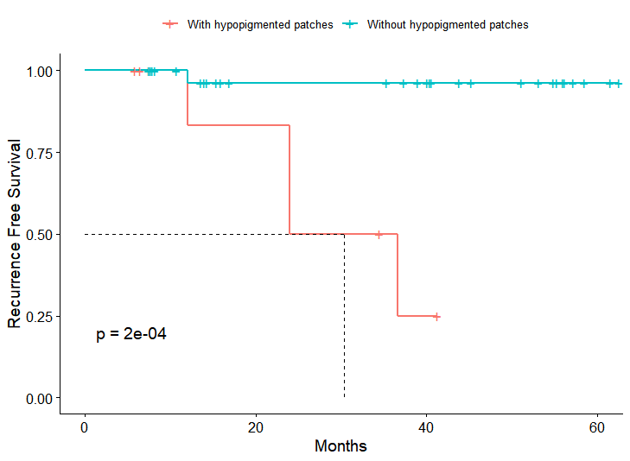
B）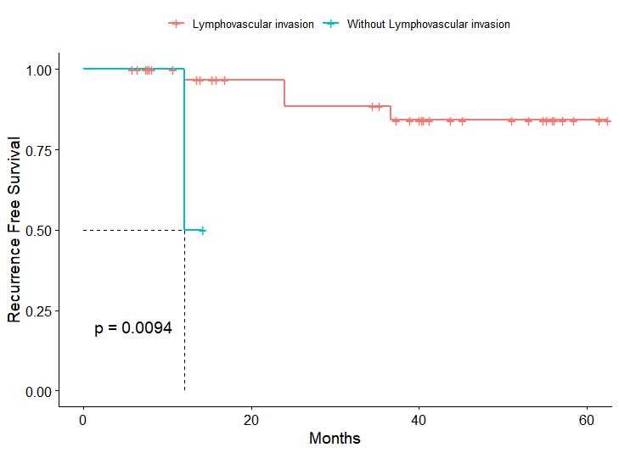
Supplementary Figure 2. Kaplan-Meier survival curves showing: A）RFS in patients who underwent surgery stratified according to the histological, B) and RFS in patients who is first EMPD or recurrent EMPD, C) and RFS in patients who is primary EMPD or secondary EMPD.
A）
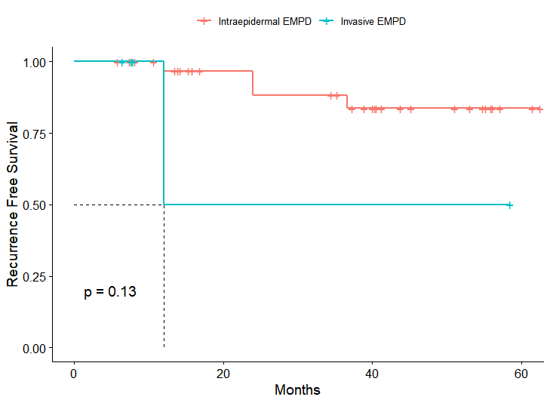
B）
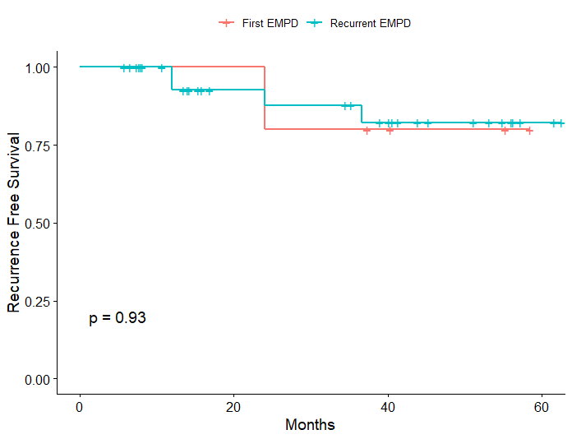

C）
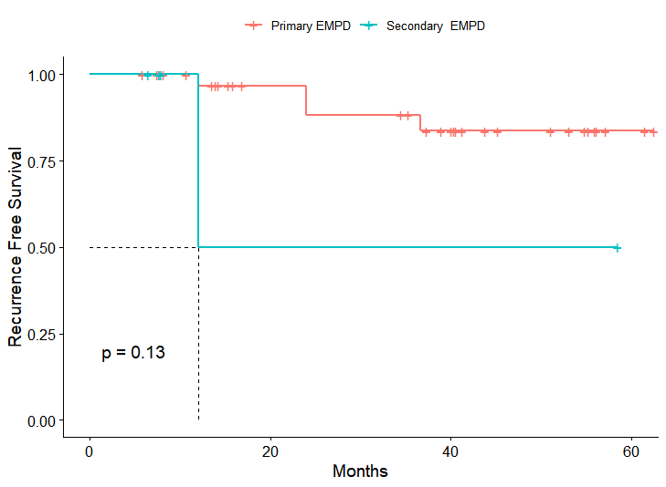

Supplementary Table 1. Patient demographics, tumor and treatment characteristics, and follow-up data
Case no. | Sex | Age | Site of EMPD | Size  (cm) | Primary tumors | Stages/margins  (cm) | Marginal negative | Reconstruction | Follow-up  (months) | Recurrence
1 | F | 44 | Axillary | 5×5 | Yes | 1/0.5 | Yes | Skin graft | 43.8 | No
2 | M | 77 | Axillary | 7×4 | Yes | 2/1 | Yes | Skin graft | NA | NA
3 | F | 58 | Vulva | 3×1.5 | Yes | 1/0.5 | Yes | Locoregional flap | 7.4 | No
4 | F | 91 | Vulva | 7×5 | Yes | 2/1 | Noª | Locoregional flap | NA | NA
5 | F | 75 | Vulva | 7×6 | No | 1/0.5 | No^{b} | Locoregional flap | 58.5 | No
a: This female patient had an uncleared labial tumor after surgery and refused to undergo a second operation.
b: This elderly woman had a palliative resection due to the difficulty of repair after complete surgical resection. she underwent a second operation 3 months later and the tumor were all clear.

