Supplementary data
- Standard Timeout Procedure
The standard time out procedure begins with confirmation of patients with two identifiers, asking them to state their name, date of birth, and which procedure is being performed while confirming congruence on the consent sheet. Patients are then asked whether they have any allergies to contrast. Next, the interventionalist states the procedure being performed and the laterality, marking the site on the patient’s skin with a waterproof marker. Next, each member of the team introduces him/herself and is encouraged to speak up if any questions are to arise at this point or any time during the procedure.

- Technique Fluoroscopic Guidance
Fluoroscopic guidance has been available and widely used for upper cervical spine injections and demonstrates the osseous structures well. For fluoroscopically guided interventions, a biplane fluoroscopic system, Artis Zee with Pure by Siemens (Washington, DC), is utilized. It is important to have the ability to rotate the fluoroscopy C-arm in order to visualize different angles of projection, but at the very least an AP and lateral projection must be able to be obtained. Patients’ pre-procedural preparations are similar, as is positioning. (Supplementary image 1) They lay prone and a posterior approach is used, with support under the patient’s neck allowing for slight flexion of the neck in order to open the joint. The patient’s mouth is opened in order to displace dentition and amalga. (Supplementary image 2) The image intensifier is then tilted cranio-caudal in order to obtain a projection orthogonal to the articular surface, wherein maximum linear lucency is visualized across the articulation. Subsequently, the technique is similar to that with CT. However, a slight bend to the tip of the needle may be used to assist with needle guidance. (Supplementary image 3) A 25-gauge needle is used to numb the skin followed by placement of a spinal needle. The initial target should be the articular pillars immediately above or below the joint at the junction of the medial 2/3rds and lateral 1/3rd of the joint. Once the initial trajectory is satisfactory and soft tissue purchase is achieved (approximately 2 cm of depth), a lateral projection should be checked to confirm depth. The clinician then returns to the AP projection to advance until reaching one of the bony landmarks as a backstop, with intermittent confirmation using the lateral. Advancing the needle when approximating the joint without the stylet in can help determine whether inadvertent vascular access has occurred. The joint immediately adjacent to our backstop point at the junction into the articulation is entered. Approximately 1 mL of fluoroscopic contrast is administered under live fluoroscopy through primed short external tubing. (Supplementary Figure 4) A lateral image is obtained to confirm contrast opacification of the joint recesses and articulation. Injectate is then administered. If dentition or amalga obscure the joint, having patients rotate their head while their mouth is open can help delineate the joint line.
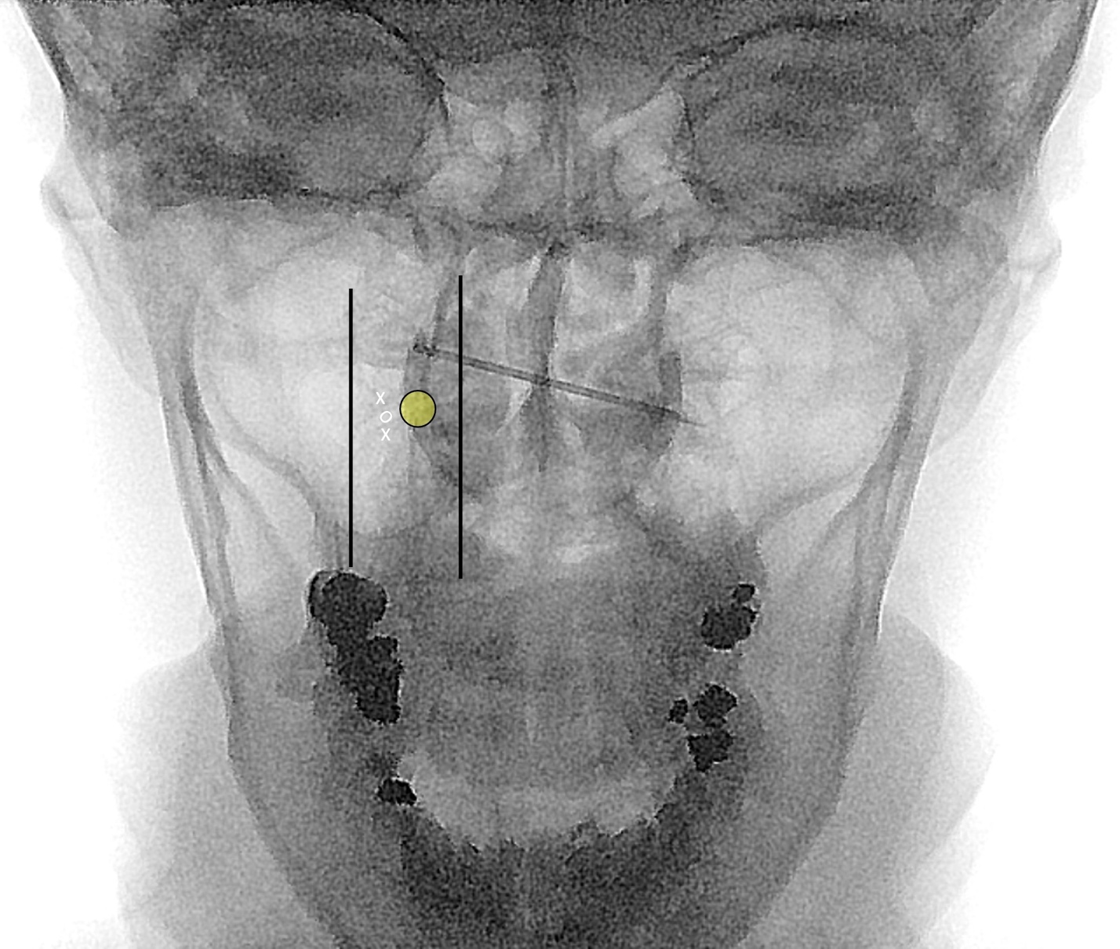
Supplementary Figure 1. Fluoroscopic image of this patient lying prone on the procedural table demonstrates the tip of an 18-gauge needle used to mark the target for access to lateral mass articulation injection. The contralateral (left) C1-C2 joint is marked with X’s at the sites where a 3.5” 22 gauge spinal needle is parked in order to determine the appropriate depth. This helps avoid inadvertent proximity to critical ventral structures. The line at the lateral margin of the joint marks where the clinician would expect the trajectory of the vertebral artery to be at the joint line. The line marking the medial aspect of the joint delineates where the spinal canal Is expected. The yellow circle marks the expected location of the dorsal root ganglion. Note that the ventral ramus of C2 is variable in location and can be anywhere along the lateral third of the joint. The “O” marks the site for subsequent access to the joint.

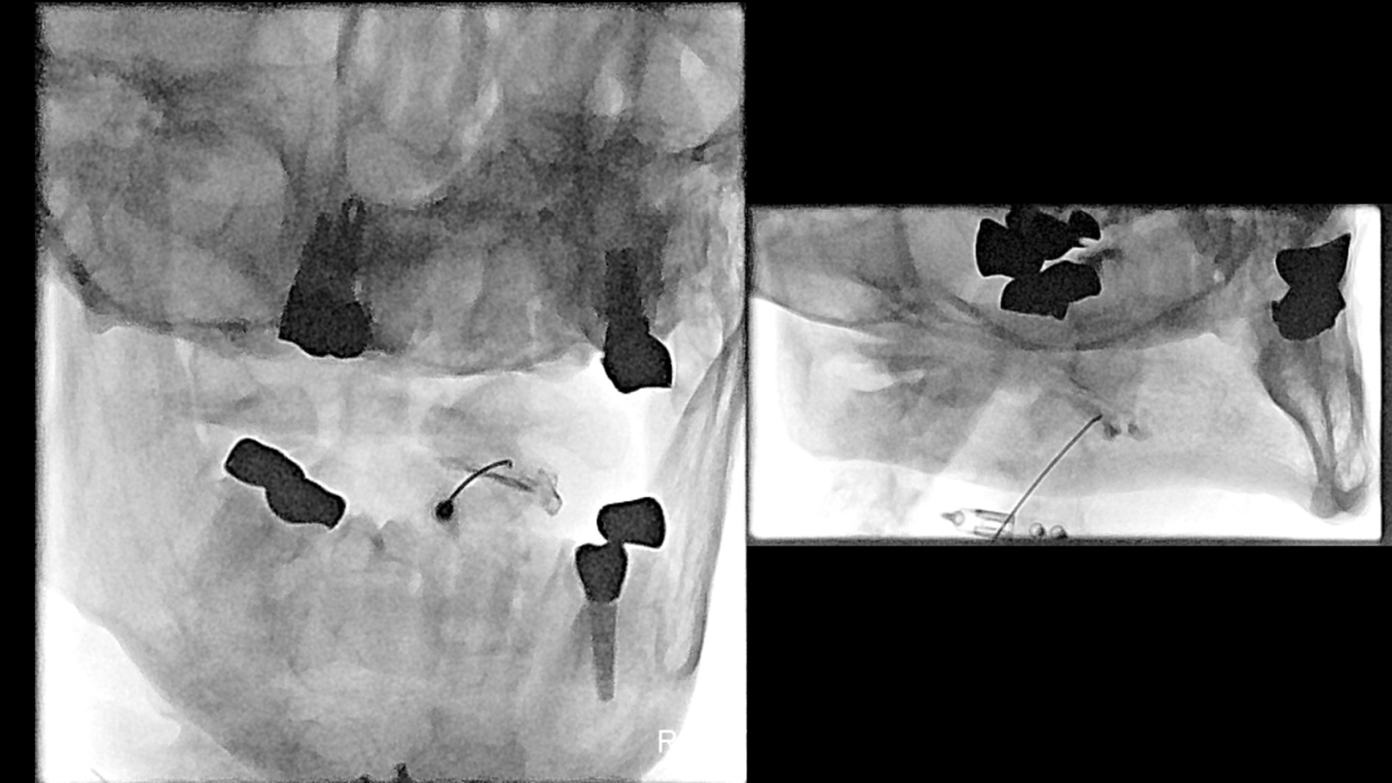
Supplementary Figure 2. AP view during fluoroscopic C1-C2 lateral mass injection demonstrates the benefit of an open mouth view. If the joint is obscured by dentition , it can be helpful to have the patient turn his/her head (in this case toward the joint of interest – to the right) in order to better delineate the spread of contrast or joint line.

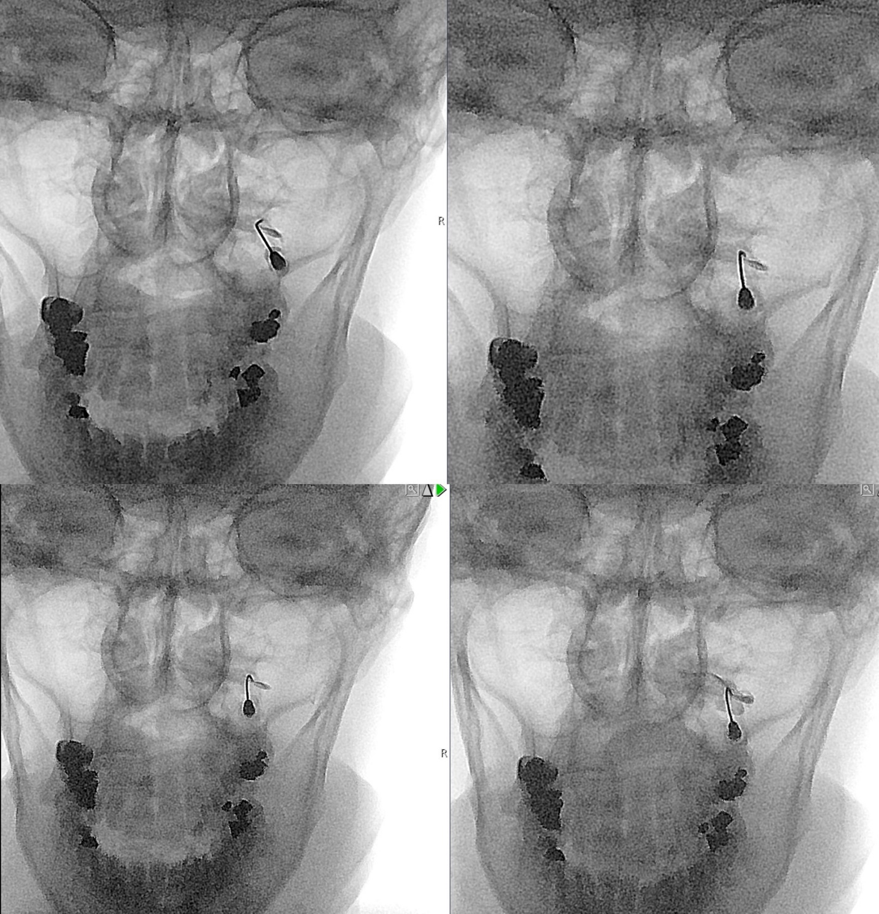
Supplementary Figure 3. During fluoroscopic injection, it is preferred to put a gentle bend at the end of the needle opposite the direction of the bevel (hole from which injectate exits). This allows for more precise needle redirection once soft tissue purchase is achieved. Initial image is obtained after parking the needle on the inferior articular process of the lateral mass of C1. The tip was bent in this case in order to help with redirecting the needle. Note that the needle tip was slightly rotated to redirect the tip from the site of parking for depth on the articular process to the site of access at the junction of the medial 2/3rds and lateral 1/3rd of the C1-C2 lateral mass articulation. Contrast should be injected with real time fluoroscopy in order to visualize any intravascular injection. Further administration of contrast confirms opacification of the joint articulation as well as the synovial recesses.

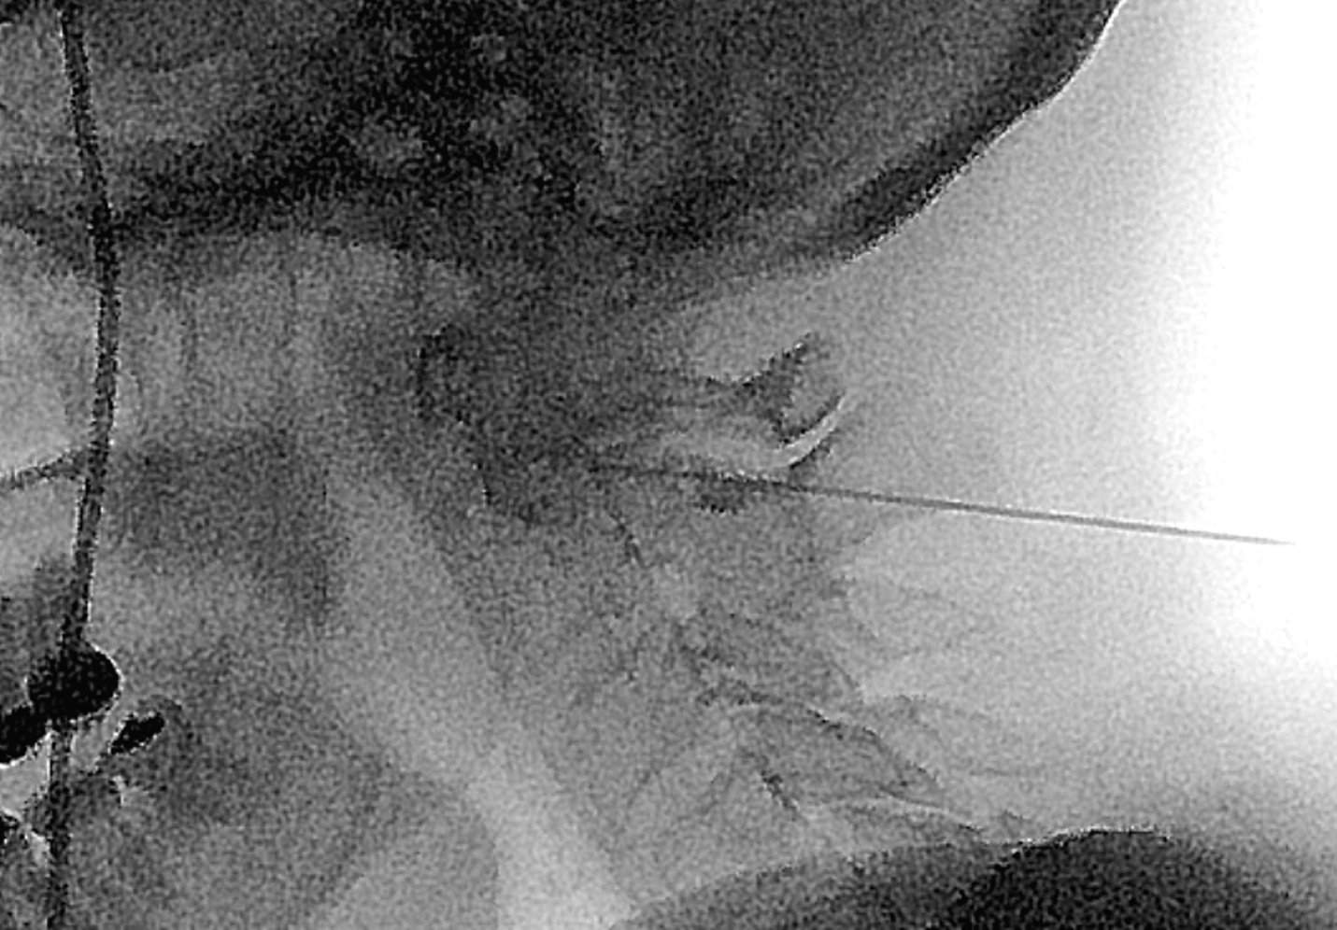
Supplementary Figure 4. A lateral fluoroscopic image at the time of injection confirms the appropriate depth of the needle, with the tip at the posterior margin of the C1-C2 lateral mass articulation.

