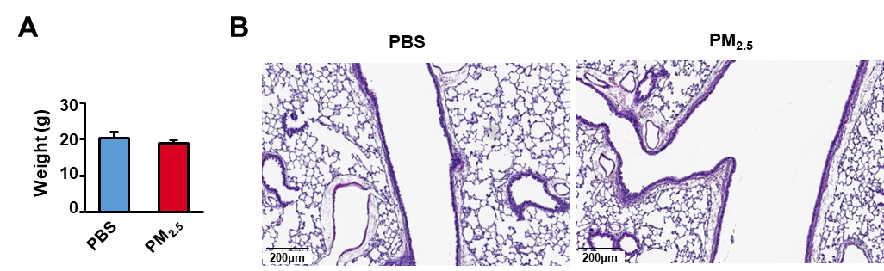
Figure S1. Body weight changes and lung recovery in juvenile mice after 35-day PM2.5 exposure.
- Body weight measurements at baseline (Day 0) and endpoint (Day 35) in PBS-treated (control) and PM2.5-exposed juvenile mice.
(B)Histopathological analysis of lung tissues from juvenile mice following PM2.5 exposure.
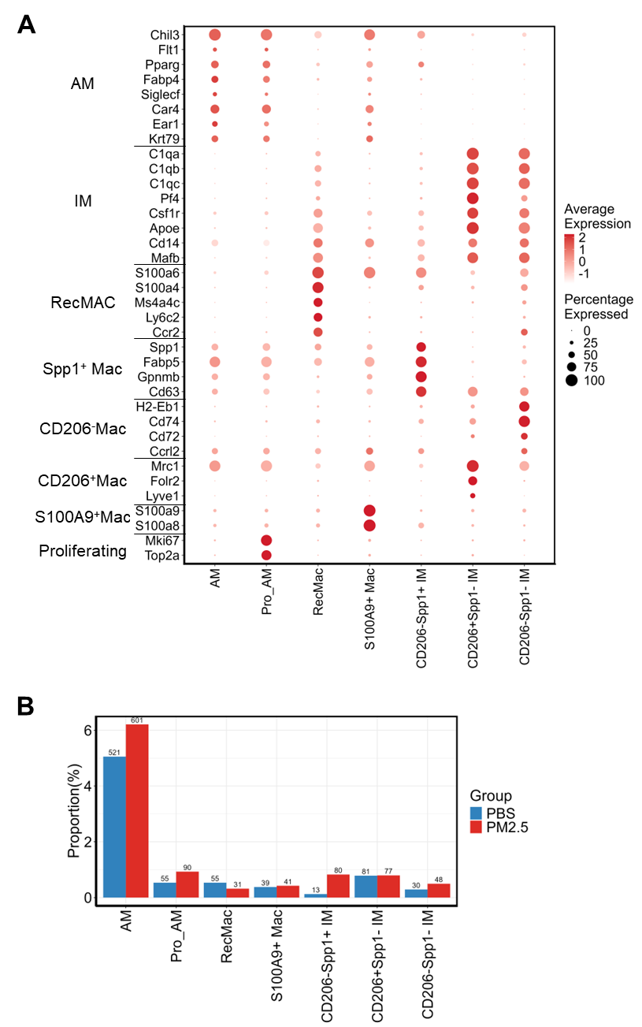
Figure S2. Macrophage subset marker gene expression and cell proportion analysis.
- Heatmap showing expression levels of marker genes for macrophage subsets after PM2.5 exposure.
- Cell proportion analysis of each macrophage subset following PM2.5 exposure.
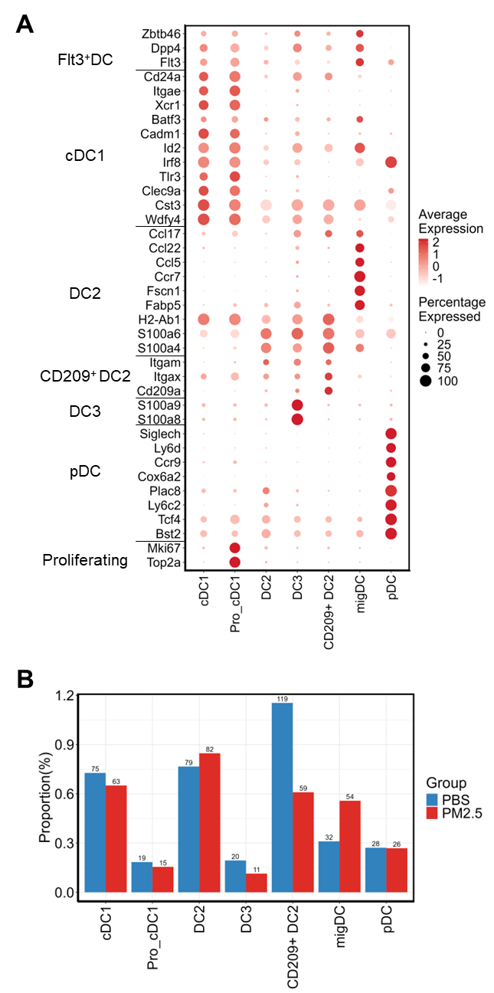
Figure S3. Marker gene expression and cell composition of dendritic cell subsets.
- Heatmap illustrating marker gene expression profiles of dendritic cell subsets after PM2.5 exposure.
(B) Proportional distribution of each dendritic cell subset following PM2.5 stimulation.

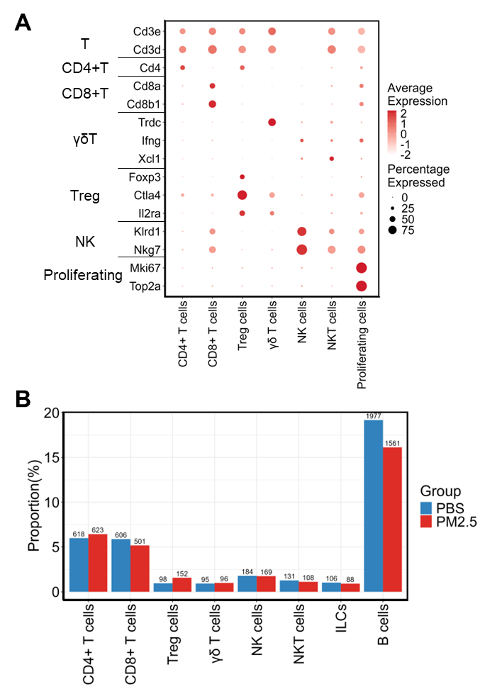
Figure S4. Marker gene expression and cell composition of lymphocyte subsets.
- Heatmap depicting marker gene expression patterns across lymphocyte subsets after PM2.5 exposure.
(B) Proportion of each lymphocyte subset following PM2.5 stimulation.

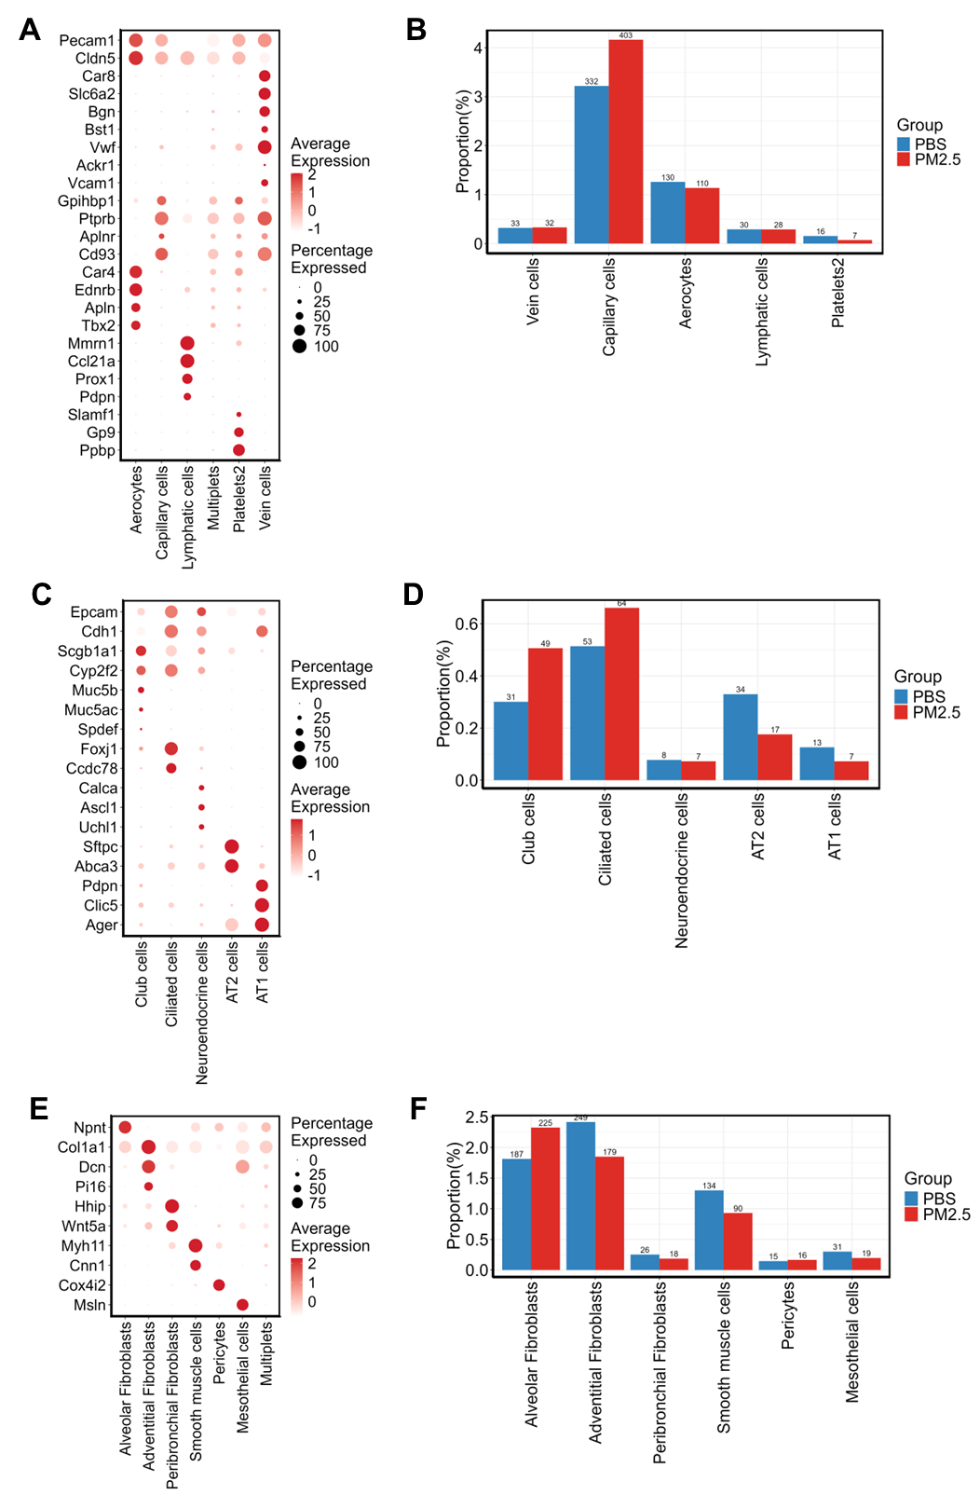
Figure S5. Marker gene expression and cell composition of parenchymal cell subsets.
- Heatmap showing marker gene expression of endothelial cell subsets post PM2.5 exposure.
(B) Proportional distribution of endothelial cell subsets.
(C) Heatmap displaying epithelial cell subset marker gene expression.
(D) Proportion of epithelial cell subsets following PM2.5 stimulation.
(E) Heatmap showing marker gene expression of stromal cell subsets.
(F) Cell proportion analysis of stromal cell subsets after PM2.5 exposure.

