Supplementary tables & figures
Supplementary Table 1: Sample grouping information
Sample ID | Group name | Group abbreviations | Staging of CKD
YYF | healthy control (no kidney impairment group) | A
ZY | healthy control (no kidney impairment group) | A
LWL | healthy control (no kidney impairment group) | A
LL | Chronic kidney disease (CKD) group | B | G5
WYA | Chronic kidney disease group | B | G5
YWH | Chronic kidney disease group | B | G5
CM | Diabetic nephropathy (DC) group | C | G4
CYQ | Diabetic nephropathy group | C | G5
HDM | Diabetic nephropathy group | C | G5

Supplementary Table 2: The bioinformatics tools and databases used in this study
Name of the database or tools | Functions and uses
CellRanger | The official software of 10x Genomics is used for alignment, UMI counting and gene expression quantification of single-cell sequencing data
Seurat | The core single-cell data analysis tool supports data quality control, standardization, dimensionality reduction, clustering and differential expression analysis
Scater | Single-cell data quality control, including outlier detection and visualization
scDblFinder | Detect doublet cells and filter low-quality cells by probability score
SingleR | Automatic annotation tool for cell types based on reference data sets
CellMarker | Artificially curated database of cell type markers to assist in manual correction of cell groups
Monocle | pseudotime analysis reveals cell differentiation trajectories and gene expression dynamics
clusterProfiler | GO/KEGG enrichment analysis to identify the biological functions and pathways of differential genes
Cytoscape | Visualize PPI networks with integrated plug-ins (e.g. MCODE, cytoHubba) for module analysis and hub gene screening
ggplot2 | Draw high quality visual charts such as box plots and heat maps
pheatmap | Heat map rendering, support for clustering and annotation
Venn | Drawing a Venn diagram, showing the intersection of gene sets
SPEED2 | Inferring gene upstream pathway activity and evaluating pathway changes in disease
GTEx Portal | Query the expression level of genes in different tissues (TPM value)
KEGG | Pathway enrichment analysis, provide metabolic pathways, signaling pathways and other annotations
GO | Genetic ontological analysis, including biological processes (BP), molecular functions (MF), and cell components (CC)
CellMarker | Cell type marker database for manual correction of single cell taxa
GTEx | Tissue-specific expression database to analyze gene expression patterns in different tissues
STRING | Construction and functional prediction of protein-protein interaction networks
UniProt | Protein sequence and functional annotation, supporting the resolution of receptor-ligand pairs (cell Phone EDB dependent)
CTD | Chemical-gene-disease association database for predicting drug targets and related diseases
GSEA MSigDB | Gene set enrichment analysis, providing hallmark pathway and custom gene set
GO:Gene Ontology; KEGG: Kyoto Encyclopedia of Genes and Genomes; GSEA: gene set enrichment analysis
Supplementary Table 3: Raw data statistics
Sample ID | Reads | Total_base(Mbases) | GC(%) | Q20(%) | Q30(%)
ZY | 322,317,688 | 97,339.94 | 36.52 | 84.16 | 76.51
CM | 327,505,686 | 98,906.72 | 36.53 | 84.16 | 76.59
LL | 342,927,235 | 112,026.10 | 40.05 | 85.23 | 77.99
YYF | 273,875,602 | 101,374.70 | 37.35 | 82.46 | 74.44
YWH | 348,124,333 | 105,133.60 | 37.03 | 82.75 | 74.86
WYA | 308,782,134 | 93,252.20 | 37.37 | 83.77 | 75.84
LWL | 327,999,453 | 99,055.84 | 36.87 | 82.85 | 75.14
HDM | 336,702,161 | 101,684.06 | 35.93 | 84.12 | 76.27
CYQ | 308,027,053 | 93,024.18 | 36.82 | 84.12 | 76.22
Reads: Total number of sequences in the raw data: Total_base (Mbases): the total number of bases in the raw data; GC (%): the proportion of G and C bases in the total bases of the raw data; Q20 (%): the percentage of bases in the raw data with a mass score greater than or equal to 20; Q30 (%): the percentage of bases in the raw data with a mass score greater than or equal to 30. Both Q20 and Q30 are quality metrics used to assess sequencing accuracy.

Supplementary Table 4: Statistical analysis of cell Ranger sequence
Sample ID | Number of Reads | Valid Barcodes | Sequencing Saturation | Q30 Bases in Barcode | Q30 Bases in RNA Read | Q30 Bases in Sample Index | Q30 Bases in UMI
CM | 327,505,686 | 98.40% | 86.50% | 96.70% | 95.10% | 96.50% | 94.30%
CYQ | 308,027,053 | 98.30% | 82.90% | 96.30% | 94.00% | 95.80% | 93.90%
HDM | 336,702,161 | 98.40% | 87.30% | 96.40% | 94.20% | 94.80% | 93.90%
LL | 342,927,235 | 96.40% | 90.70% | 96.20% | 93.80% | 96.60% | 93.30%
LWL | 327,999,453 | 98.50% | 82.50% | 96.40% | 94.50% | 95.70% | 93.30%
WYA | 308,782,134 | 98.60% | 85.70% | 96.80% | 94.20% | 95.80% | 93.80%
YWH | 348,124,333 | 98.60% | 86.20% | 96.70% | 94.20% | 95.60% | 93.50%
YYF | 335,677,648 | 98.70% | 81.80% | 96.30% | 93.90% | 96.40% | 93.40%
ZY | 322,317,688 | 98.40% | 89.10% | 96.50% | 94.90% | 97.10% | 94.10%
Number of Reads: total number of sequences; Valid Barcodes: the ratio of valid 10X Barcodes; Sequencing Saturation: level of sequencing saturation; Q30 Bases in Barcode: the percentage of bases with mass values greater than or equal to 30 in the Barcode sequence; Q30 Bases in RNA Read: the percentage of bases in RNA reads with mass values greater than or equal to 30; Q30 Bases in Sample Index: the percentage of bases with mass values greater than or equal to 30 in the sample index; Q30 Bases in UMI: the percentage of bases in the UMI sequence with mass values greater than or equal to 30.

Supplementary Table 5: Cell Ranger Analysis and comparison result statistics
Sample  ID | Reads Mapped to Genome | Reads Mapped Confidently to Genome | Reads Mapped Confidently to Intergenic Regions | Reads Mapped Confidently to Intronic Regions | Reads Mapped Confidently to Exonic Regions | Reads Mapped Antisense to Gene | Reads Mapped Confidently to Transcriptome | Fraction Reads in Cells
CM | 96.40% | 86.10% | 2.90% | 29.10% | 54.10% | 1.00% | 49.80% | 86.10%
CYQ | 97.20% | 89.50% | 2.20% | 23.60% | 63.70% | 1.10% | 59.20% | 87.60%
HDM | 97.10% | 92.70% | 2.30% | 23.90% | 66.50% | 1.20% | 61.60% | 72.50%
LL | 94.40% | 85.00% | 3.10% | 29.70% | 52.10% | 1.30% | 47.70% | 81.20%
LWL | 96.80% | 92.00% | 2.50% | 25.00% | 64.50% | 1.20% | 59.60% | 89.00%
WYA | 97.00% | 89.80% | 1.80% | 17.50% | 70.60% | 0.80% | 66.10% | 85.80%
YWH | 97.00% | 92.60% | 2.20% | 21.40% | 68.90% | 1.00% | 64.00% | 89.40%
YYF | 97.20% | 93.30% | 2.20% | 20.80% | 70.40% | 1.00% | 65.60% | 88.90%
ZY | 96.70% | 85.70% | 2.70% | 23.80% | 59.30% | 1.10% | 54.70% | 81.60%
Reads Mapped to Genomes: the percentage of total Reads aligned to the reference genome; Reads Mapped Confidently to Genome: the percentage of Reads confidently mapped to the genome; Reads Mapped Confidently to Intergenic Regions: the number of sequences aligned to intergenic regions as a percentage of the total number of sequences; Reads Mapped Confidently to Intronic Regions: the number of sequences aligned to intronic regions as a percentage of the total number of sequences; Reads Mapped Confidently to Exonic Regions: the number of sequences aligned to exonic regions; Reads Mapped Antisense to Gene: the number of sequences aligned to the antisense strand of genes; Reads Mapped Confidently to Transcriptome: the percentage of sequences aligned to known reference transcripts; Fraction Reads in Cells: the percentage of total sequences from high-quality cells compared to reference genes.

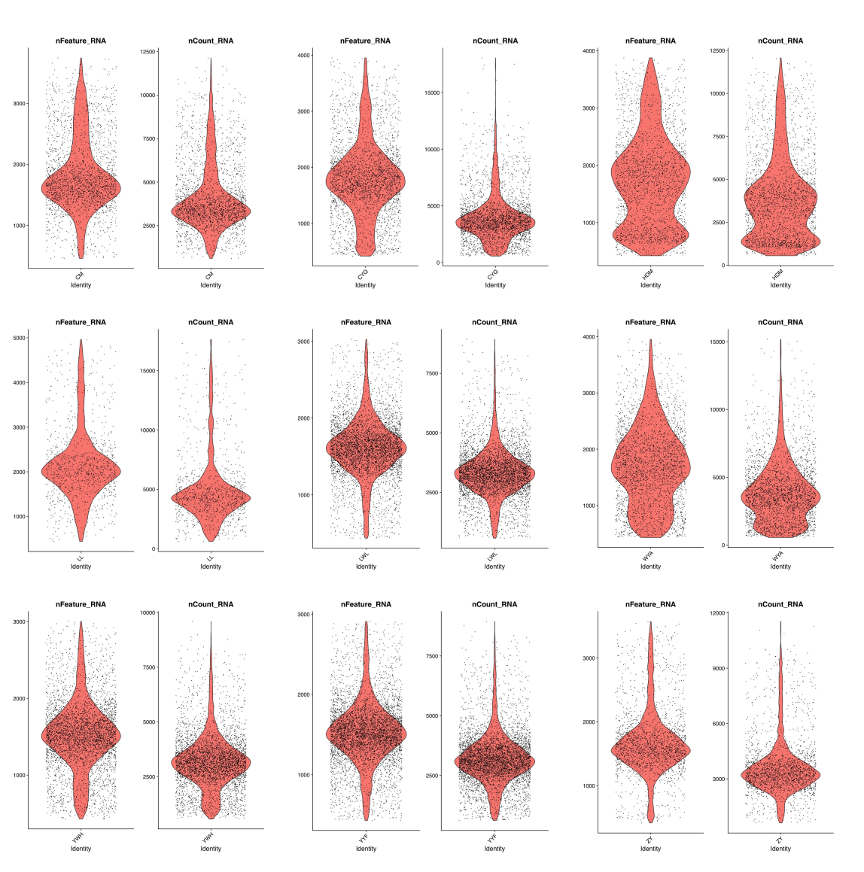

Supplementary Figure 1: Quality control of library size and gene counts

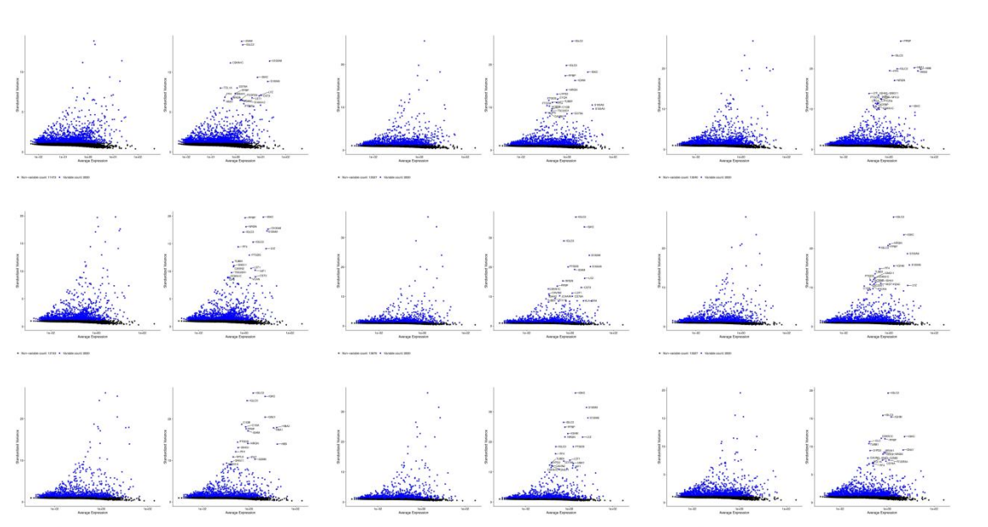

Supplementary Figure 2: Highly variable genes across all cell types

Highly variable genes were selected for PCA, with blue dots representing significantly differentially expressed genes.

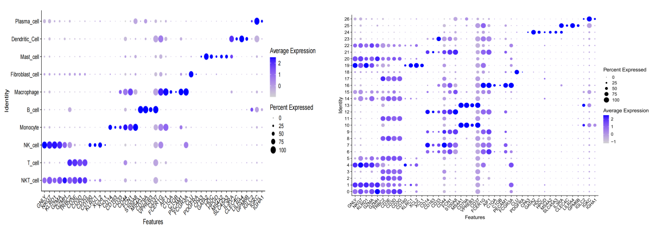
Supplementary Figure 3: Bubble map of each cell type
The ten cell types include NKT cells, T cells, NK cells, monocytes, B cells, macrophages, mast cells, dendritic cells, and plasma cells. Myeloid cells were directly divided into subtypes for heterogeneity analysis, resulting in refined cell types.
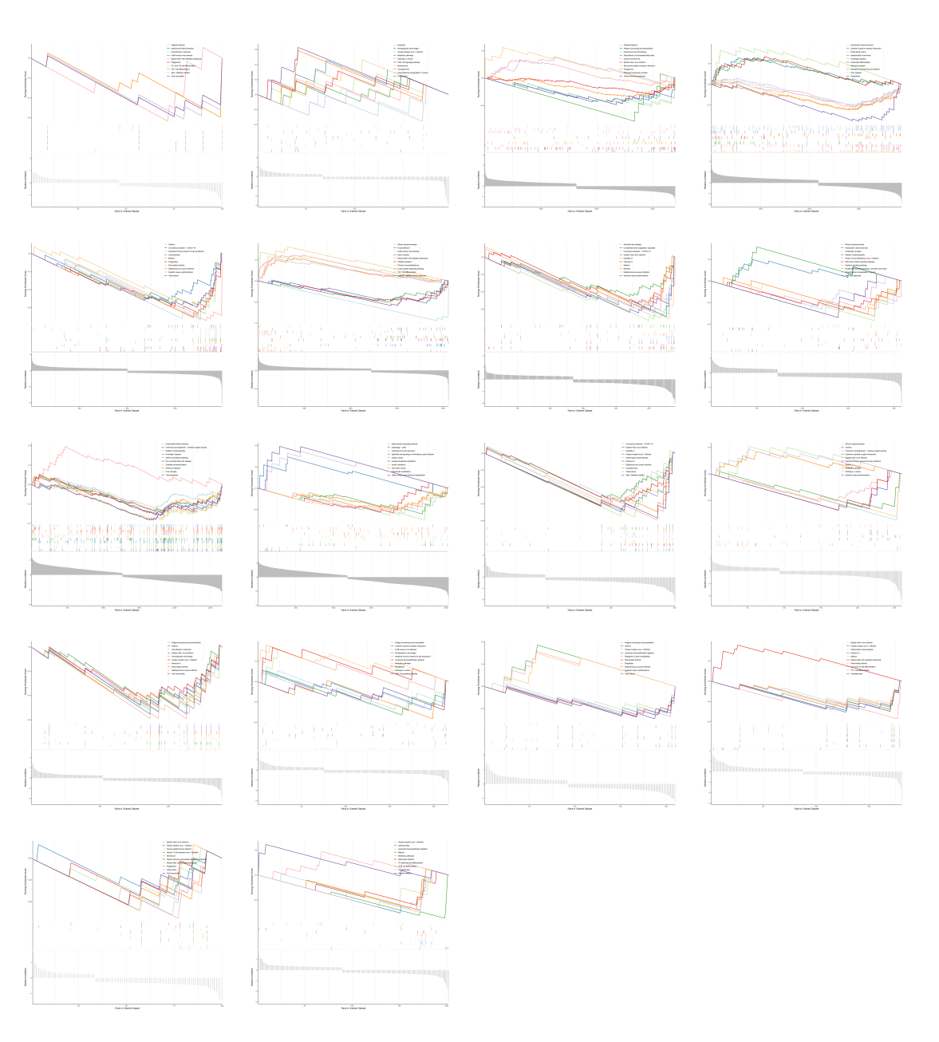
Supplementary Figure 4: Enriched pathways of nine cell types

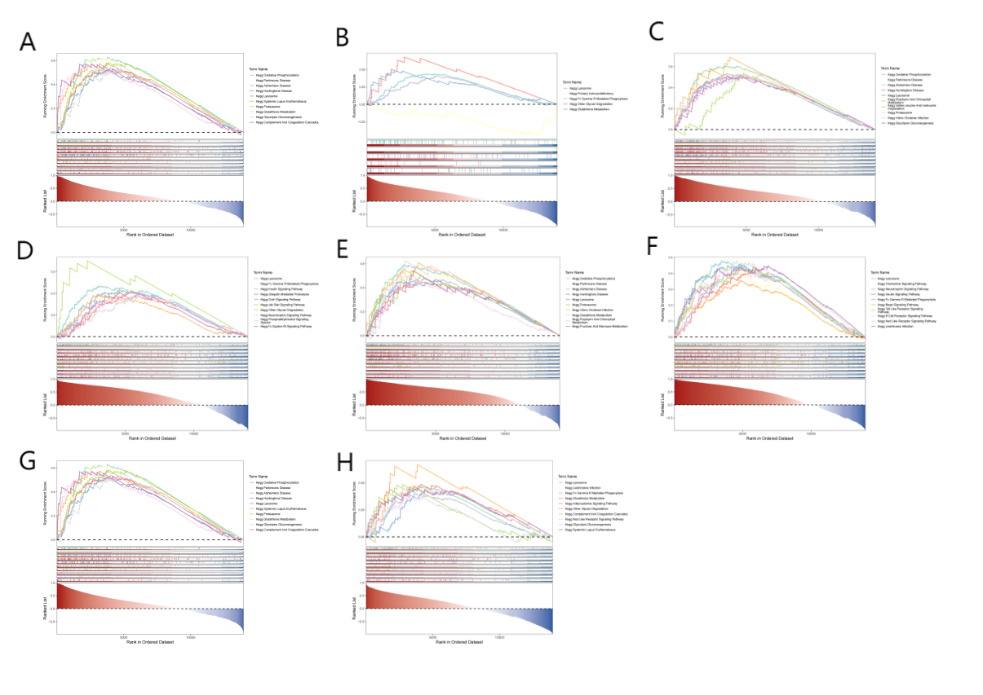

Supplementary Figure 5: GESA analysis. (A-H) GESA identified 10 enriched pathways for each of the biomarkers, MX1, STAT1, ISG15 and IRF7

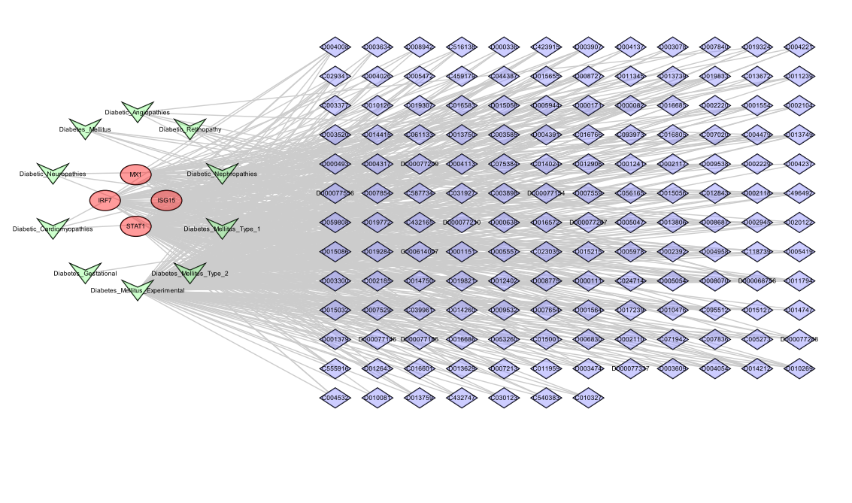
Supplementary Figure 6: Biomarker-drug-disease network
Using identified biomarkers and corresponding drugs, the CTD database (http://ctdbase.org/) was used to predict diseases associated with these drugs. From the results, 10 diseases related to diabetes and its complications were selected. The network visualization consists of165 nodes representing 4 genes (in red), 151 drugs (in blue), and 10 diseases(in green), interconnected by 635 edges.

