Supplementary Material

Supplementary Tables
Supplementary Table 1 Baseline characteristics of participants according to CVAI quartiles in the CHARLS cohort.
Variables | Total  (n=404) | Q1  (n=101) | Q2  (n=101) | Q3  (n=101) | Q4  (n=101) | Statistic | P value
Age | 47.72 ± 3.27 | 47.16 ± 1.97 | 47.19 ± 2.28 | 47.79 ± 3.03 | 48.75 ± 4.82 | 5.42 | <0.01
Residence place |  |  |  |  |  | 1.64 | 0.65
Rural | 253(62.62) | 61(60.40) | 68(67.33) | 64(63.37) | 60(59.41)
Urban | 151(37.38) | 40(39.60) | 33(32.67) | 37(36.63) | 41(40.59)
Residence region |  |  |  |  |  | 6.50 | 0.09
North | 183(45.30) | 37(36.63) | 45(44.55) | 46(45.54) | 55(54.46)
South | 221(54.70) | 64(63.37) | 56(55.45) | 55(54.46) | 46(45.54)
Marital status |  |  |  |  |  | 1.66 | 0.65
Married | 387(95.79) | 96(95.05) | 95(94.06) | 98(97.03) | 98(97.03)
Single | 17(4.21) | 5(4.95) | 6(5.94) | 3(2.97) | 3(2.97)
Education |  |  |  |  |  | 5.83 | 0.44
College and higher | 14(3.47) | 7(6.93) | 2(1.98) | 2(1.98) | 3(2.97)
High school | 159(39.36) | 41(40.59) | 37(36.63) | 41(40.59) | 40(39.60)
Elementary school and below | 231(57.18) | 53(52.48) | 62(61.39) | 58(57.43) | 58(57.43)
Household income |  |  |  |  |  | 3.77 | 0.29
<10000 yuan/year | 19(67.86) | 6(50.00) | 5(71.43) | 6(85.71) | 2(100.00)
10000-50000 yuan/year | 9(32.14) | 6(50.00) | 2(28.57) | 1(14.29)
Smoking status |  |  |  |  |  | 2.06 | 0.56
Non-smoker/Former smoker | 392(97.03) | 99(98.02) | 98(97.03) | 99(98.02) | 96(95.05)
Smoker | 12(2.97) | 2(1.98) | 3(2.97) | 2(1.98) | 5(4.95)
Drinking status |  |  |  |  |  | 4.58 | 0.60
Drink but less than once a month | 35(8.66) | 13(12.87) | 5(4.95) | 8(7.92) | 9(8.91)
Drink more than once a month | 34(8.42) | 8(7.92) | 10(9.90) | 9(8.91) | 7(6.93)
None | 335(82.92) | 80(79.21) | 86(85.15) | 84(83.17) | 85(84.16)
Menstrual status |  |  |  |  |  | 2.30 | 0.51
No | 142(35.15) | 40(39.60) | 38(37.62) | 33(32.67) | 31(30.69)
Yes | 262(64.85) | 61(60.40) | 63(62.38) | 68(67.33) | 70(69.31)
CVD |  |  |  |  |  | 3.99 | 0.26
No | 376(93.07) | 94(93.07) | 97(96.04) | 95(94.06) | 90(89.11)
Yes | 28(6.93) | 7(6.93) | 4(3.96) | 6(5.94) | 11(10.89)
DM |  |  |  |  |  | 9.51 | 0.02
No | 368(91.09) | 99(98.02) | 92(91.09) | 90(89.11) | 87(86.14)
Yes | 36(8.91) | 2(1.98) | 9(8.91) | 11(10.89) | 14(13.86)
Dyslipidemia |  |  |  |  |  | 47.40 | <0.0001
No | 261(64.60) | 88(87.13) | 74(73.27) | 51(50.50) | 48(47.52)
Yes | 143(35.40) | 13(12.87) | 27(26.73) | 50(49.50) | 53(52.48)
Hypertension |  |  |  |  |  | 31.46 | <0.0001
No | 297(73.51) | 91(90.10) | 79(78.22) | 70(69.31) | 57(56.44)
Yes | 107(26.49) | 10(9.90) | 22(21.78) | 31(30.69) | 44(43.56)
Obesity |  |  |  |  |  | 352.13 | <0.0001
Low weight/Normal | 185(45.79) | 97(96.04) | 62(61.39) | 26(25.74)
Obesity | 80(19.80) | 4(3.96) | 36(35.64) | 69(68.32) | 30(29.70)
Over weight | 139(34.41) |  | 3(2.97) | 6(5.94) | 71(70.30)
Lipid lowering drugs |  |  |  |  |  | 5.21 | 0.16
No | 388(96.04) | 100(99.01) | 98(97.03) | 96(95.05) | 94(93.07)
Yes | 16(3.96) | 1(0.99) | 3(2.97) | 5(4.95) | 7(6.93)
WBC (103/μL) | 6.40 ± 1.96 | 5.85 ± 1.91 | 6.45 ± 1.94 | 6.56 ± 1.99 | 6.73 ± 1.90 | 3.91 | <0.01
Hemoglobin (g/dL) | 13.30 ± 1.94 | 13.02 ± 1.64 | 13.13 ± 1.89 | 13.35 ± 1.96 | 13.71 ± 2.19 | 2.47 | 0.06
Hematocrit (%) | 38.76 ± 6.06 | 38.04 ± 5.14 | 39.35 ± 6.67 | 38.00 ± 6.05 | 39.66 ± 6.17 | 2.09 | 0.10
MCV (fl) | 87.46 ± 9.79 | 90.16 ± 10.59 | 86.49 ± 9.24 | 86.49 ± 10.38 | 86.75 ± 8.45 | 3.41 | 0.02
PLT (109/L) | 233.73 ± 74.21 | 215.05 ± 64.89 | 238.22 ± 71.51 | 242.34 ± 85.01 | 239.09 ± 71.66 | 2.88 | 0.04
CRP (mg/L) | 1.64 ± 4.77 | 0.90 ± 1.39 | 2.30 ± 8.99 | 1.31 ± 1.87 | 2.07 ± 2.02 | 1.90 | 0.13
Glucose (mg/dL) | 105.29 ± 25.72 | 99.41 ± 20.47 | 101.87 ± 21.97 | 108.47 ± 29.38 | 111.40 ± 28.38 | 4.91 | <0.01
HbA1c | 5.15 ± 0.65 | 5.00 ± 0.46 | 5.06 ± 0.70 | 5.22 ± 0.72 | 5.33 ± 0.64 | 5.67 | <0.001
Creatinine (mg/dL) | 0.66 ± 0.12 | 0.66 ± 0.10 | 0.66 ± 0.14 | 0.65 ± 0.12 | 0.66 ± 0.12 | 0.09 | 0.97
CystatinC (mg/L) | 0.82 ± 0.15 | 0.84 ± 0.14 | 0.83 ± 0.15 | 0.78 ± 0.15 | 0.82 ± 0.15 | 2.82 | 0.04
BUN (mg/dL) | 13.54 ± 3.79 | 14.04 ± 3.68 | 13.34 ± 4.50 | 13.49 ± 3.67 | 13.30 ± 3.19 | 0.84 | 0.47
Uric acid (mg/dL) | 3.72 ± 0.99 | 3.46 ± 0.83 | 3.68 ± 0.98 | 3.80 ± 1.05 | 3.96 ± 1.04 | 4.74 | <0.01
TC (mg/dL) | 185.86 ± 34.41 | 181.44 ± 29.11 | 181.43 ± 35.87 | 188.72 ± 32.53 | 191.84 ± 38.67 | 2.39 | 0.07
HDL (mg/dL) | 50.89 ± 12.77 | 61.13 ± 11.07 | 52.23 ± 11.13 | 46.32 ± 10.37 | 43.89 ± 11.16 | 49.68 | <0.0001
LDL (mg/dL) | 110.65 ± 30.50 | 109.48 ± 25.67 | 108.09 ± 29.40 | 111.83 ± 30.80 | 113.17 ± 35.52 | 0.56 | 0.64
TG (mg/dL) | 126.10 ± 84.43 | 72.70 ± 29.71 | 112.62 ± 59.31 | 151.43 ± 68.64 | 167.63 ± 119.02 | 31.24 | <0.0001
TC (mmol/L) | 4.81 ± 0.89 | 4.69 ± 0.75 | 4.69 ± 0.93 | 4.88 ± 0.84 | 4.96 ± 1.00 | 2.39 | 0.07
HDL (mmol/L) | 1.32 ± 0.33 | 1.58 ± 0.29 | 1.35 ± 0.29 | 1.20 ± 0.27 | 1.14 ± 0.29 | 49.68 | <0.0001
LDL (mmol/L) | 2.86 ± 0.79 | 2.83 ± 0.66 | 2.80 ± 0.76 | 2.89 ± 0.80 | 2.93 ± 0.92 | 0.56 | 0.64
TG (mmol/L) | 1.42 ± 0.95 | 0.82 ± 0.34 | 1.27 ± 0.67 | 1.71 ± 0.77 | 1.89 ± 1.34 | 31.24 | <0.0001
RC (mg/dL) | 24.32 ± 21.33 | 10.82 ± 8.13 | 21.10 ± 15.63 | 30.57 ± 17.66 | 34.78 ± 29.43 | 30.86 | <0.0001
RC (mmol/L) | 0.63 ± 0.55 | 0.28 ± 0.21 | 0.55 ± 0.40 | 0.79 ± 0.46 | 0.90 ± 0.76 | 30.86 | <0.0001
nonHDL (mg/dL) | 134.96 ± 34.42 | 120.31 ± 27.29 | 129.20 ± 33.53 | 142.41 ± 31.32 | 147.95 ± 38.06 | 14.79 | <0.0001
nonHDL (mmol/L) | 3.49 ± 0.89 | 3.11 ± 0.71 | 3.34 ± 0.87 | 3.68 ± 0.81 | 3.83 ± 0.98 | 14.79 | <0.0001
BMI (kg/m2) | 25.00 ± 3.98 | 21.29 ± 1.98 | 23.66 ± 1.96 | 25.31 ± 1.74 | 29.72 ± 3.83 | 200.25 | <0.0001
CVAI | 82.51 ± 33.26 | 42.16 ± 15.57 | 70.43 ± 6.06 | 92.66 ± 7.08 | 124.80 ± 20.64 | 653.48 | <0.0001
Waist circumference (cm) | 84.41 ± 11.99 | 73.05 ± 11.07 | 80.85 ± 8.82 | 87.17 ± 4.91 | 96.58 ± 7.39 | 143.69 | <0.0001
Continuous variables were reported as mean ± standard deviation. Categorical variables were presented as counts and percentages. CVD: cardiovascular disease; DM: diabetes mellitus; WBC: white blood cells; MCV: mean corpuscular volume; PLT: platelets; CRP: C-reactive protein; HbA1c: hemoglobin A1c; BUN: blood urea nitrogen; TC: total cholesterol; HDL: high-density lipoprotein; LDL: low-density lipoprotein; TG: triglycerides; RC: residual cholesterol; BMI: body mass index; CVAI: Chinese Visceral Adiposity Index

Supplementary Table 2 Odds ratios and 95 % confidence intervals of the menopausal status by quartiles of CVAI with exclusion of participants with CVD in the CHARLS cohort
 | Crude model |  | Model 1 |  | Model 2 |  | Model 3
CVAI | 95%CI | P | 95%CI | P | 95%CI | P | 95%CI | P
Q1 | ref |  | ref |  | ref |  | ref
Q2 | 1.09(0.62,1.92) | 0.77 | 1.56(0.82, 2.94) | 0.17 | 1.77(0.90, 3.48) | 0.10 | 1.76(0.89, 3.47) | 0.10
Q3 | 1.35(0.76,2.40) | 0.31 | 2.39(1.13, 5.05) | 0.02 | 2.99(1.29, 6.93) | 0.01 | 2.95(1.27, 6.85) | 0.01
Q4 | 1.48(0.83,2.65) | 0.19 | 4.08(1.43,11.65) | 0.01 | 5.59(1.71,18.27) | 0.004 | 5.38(1.64,17.62) | 0.01
P for trend (Median value) |  | 0.14 |  | 0.01 |  | 0.003 |  | 0.004
Crude model was adjusted for CVAIQ. Model 1 was adjusted for age, education, smoke, drink, marital status, BMI, DM, hypertension, and dyslipidemia based on Crude model. Model 2 was adjusted for LDL (mg/dL), TG (mg/dL), HDL (mg/dL), and TC (mg/dL) based on Model 1. Model 3 was adjusted for glucose (mg/dL), creatinine (mg/dL), and uric acid (mg/dL) based on Model 2. P for trend was calculated by taking the median of each quartile of CVAI.

Supplementary Table 3 Odds ratios and 95 % confidence intervals of menopausal status by quartiles of CVAI with exclusion of participants with hypertension in the CHARLS cohort
 | crude model |  | Model 1 |  | Model 2 |  | Model 3
CVAI | 95%CI | P | 95%CI | P | 95%CI | P | 95%CI | P
Q1 | ref |  | ref |  | ref |  | ref
Q2 | 1.09(0.62,1.92) | 0.77 | 1.58(0.84, 2.99) | 0.16 | 1.8(0.92, 3.53) | 0.09 | 1.8(0.91, 3.53) | 0.09
Q3 | 1.35(0.76,2.40) | 0.31 | 2.42(1.15, 5.09) | 0.02 | 3.02(1.31, 6.96) | 0.01 | 2.99(1.30, 6.91) | 0.01
Q4 | 1.48(0.83,2.65) | 0.19 | 4.1(1.45,11.63) | 0.01 | 5.57(1.71,18.12) | 0.004 | 5.4(1.66,17.59) | 0.01
P for trend (Median value) |  | 0.14 |  | 0.01 |  | 0.003 |  | 0.004
Crude model was adjusted for CVAIQ. Model 1 was adjusted for age, education, smoke, drink, marital status, BMI, DM, CVD, and dyslipidemia based on Crude model. Model 2 was adjusted for LDL (mg/dL), TG (mg/dL), HDL (mg/dL), and TC (mg/dL) based on Model 1. Model 3 was adjusted for glucose (mg/dL), creatinine (mg/dL), and uric acid (mg/dL) based on Model 2. P for trend was calculated by taking the median of each quartile of CVAI.

Supplementary Table 4 Baseline characteristics of participants according to menstrual status in the NHANES (2003-2020)
Variables | Pre-menopause | Post-menopause | P value
CVAI | 107.45(1.91) | 127.35(1.85) | < 0.0001
Age (years) | 46.01(0.13) | 53.23(0.15) | < 0.0001
Race |  |  | 0.01
Non-Hispanic white | 595(70.21) | 773(72.35)
Non-Hispanic black | 331(11.92) | 493(13.30)
Mexican American | 278(9.27) | 307(6.53)
Other | 203(8.61) | 217(7.82)
Education years |  |  | < 0.001
<9 years | 108(3.95) | 183(4.20)
9-12 years | 514(28.80) | 741(36.54)
>12years | 932(67.25) | 1096(59.26)
Partnership |  |  | 0.003
Without partner | 532(28.68) | 861(34.69)
With partner | 1025(71.32) | 1158(65.31)
Smoking |  |  | < 0.0001
Never | 1023(62.96) | 1148(52.03)
Former | 249(18.57) | 427(24.15)
Now | 284(18.47) | 444(23.82)
Alcohol intake |  |  | 0.01
Never | 234(11.26) | 351(13.88)
Former | 167(10.91) | 288(13.97)
Now | 1078(77.82) | 1244(72.15)
PIR | 3.28(0.06) | 3.19(0.06) | 0.31
BMI (kg/m²) | 29.56(0.25) | 29.95(0.24) | 0.22
WC (cm) | 96.50(0.56) | 99.21(0.53) | < 0.001
LDL (mmol/L) | 2.95(0.03) | 3.28(0.03) | < 0.0001
Total cholesterol (mmol/L) | 5.07(0.04) | 5.49(0.03) | < 0.0001
Fast triglyceride (mmol/L) | 1.29(0.05) | 1.47(0.03) | 0.01
HDL (mmol/L) | 1.55(0.01) | 1.54(0.01) | 0.74
Fast glucose (mmol/L) | 5.62(0.04) | 5.99(0.05) | < 0.0001
Creatinine (umol/L) | 66.20(0.54) | 67.51(0.48) | 0.05
Uric acid (umol/L) | 271.75(2.21) | 295.93(2.04) | < 0.0001
Blood urea nitrogen (mmol/L) | 4.03(0.05) | 4.70(0.05) | < 0.0001
Hyperlipidemia |  |  | < 0.0001
No | 518(33.34) | 328(14.49)
Yes | 1039(66.66) | 1692(85.51)
CVD |  |  | < 0.0001
No | 1485(96.21) | 1803(91.38)
Yes | 72(3.79) | 217(8.62)
DM |  |  | < 0.0001
No | 1321(88.93) | 1546(81.22)
Yes | 225(11.07) | 474(18.78)
Hypertension |  |  | < 0.0001
No | 1090(71.26) | 983(53.35)
Yes | 467(28.74) | 1037(46.65)
Continuous variables are presented as mean±standard deviation and categorical variables are presented as percentage. CVAI, Chinese visceral adiposity index; PIR, poverty income ratio; BMI, body mass index; WC, waist circumference; LDL, low-density lipoprotein; HDL, high-density lipoprotein; CVD, cardiovascular disease; DM, diabetes mellitus.

Supplementary Figures
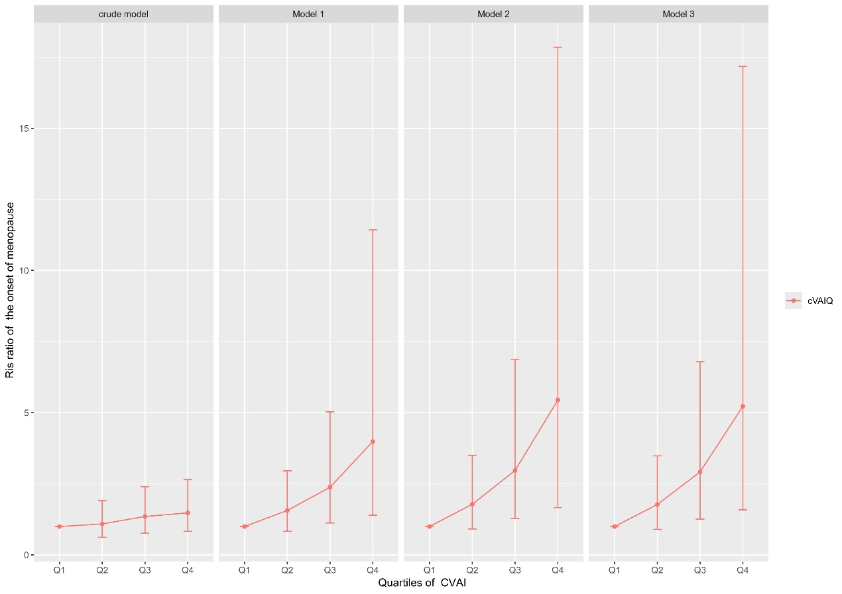
Supplementary Figure 1 Risk ratios and 95 % confidence intervals of the onset of menopause by quartiles of CVAI.

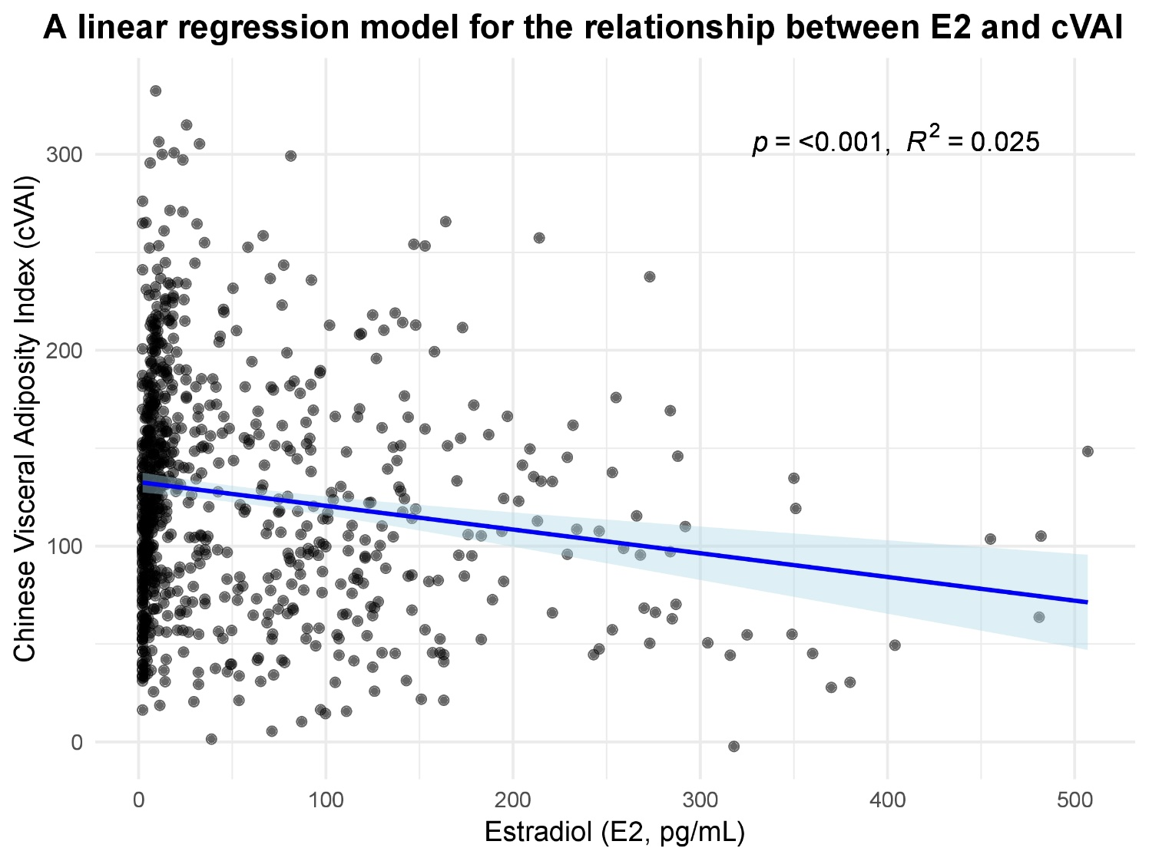
Supplementary Figure 2 Correlation between E2 and CVAI by linear regression.

