Figure S1. Cellular uptake of TcNVs and viability of melanoma cells.
(A) Representative fluorescence microscope images of cellular uptake of DiI-labeled LNVs (red) at 1, 5 and 10 μg/mL. Magnification: 200X. Scale bar=50 μm. (B) Quantification of the uptake of LNVs up to 12 h. ** indicate difference for p < 0.01 in comparison to the cells treated with cell culture media as control. (n = 3).

Figure S2. The effects of TcNVs on the cell vitality of THP-1 macrophages.
(A)-(B). The dose experiments of LNVs (A) and SNVs (B) affect the cell vitality of THP-1 macrophages. Different amounts of TcNVs (1 µg/5 µg /10 µg /20 µg/mL, represented by SNV/LNV-1/5/10/20) were added to the THP-1 macrophages for 48 h. The cell vitality was tested by Cell Counting Kit-8. Data were expressed as the mean ± SD.
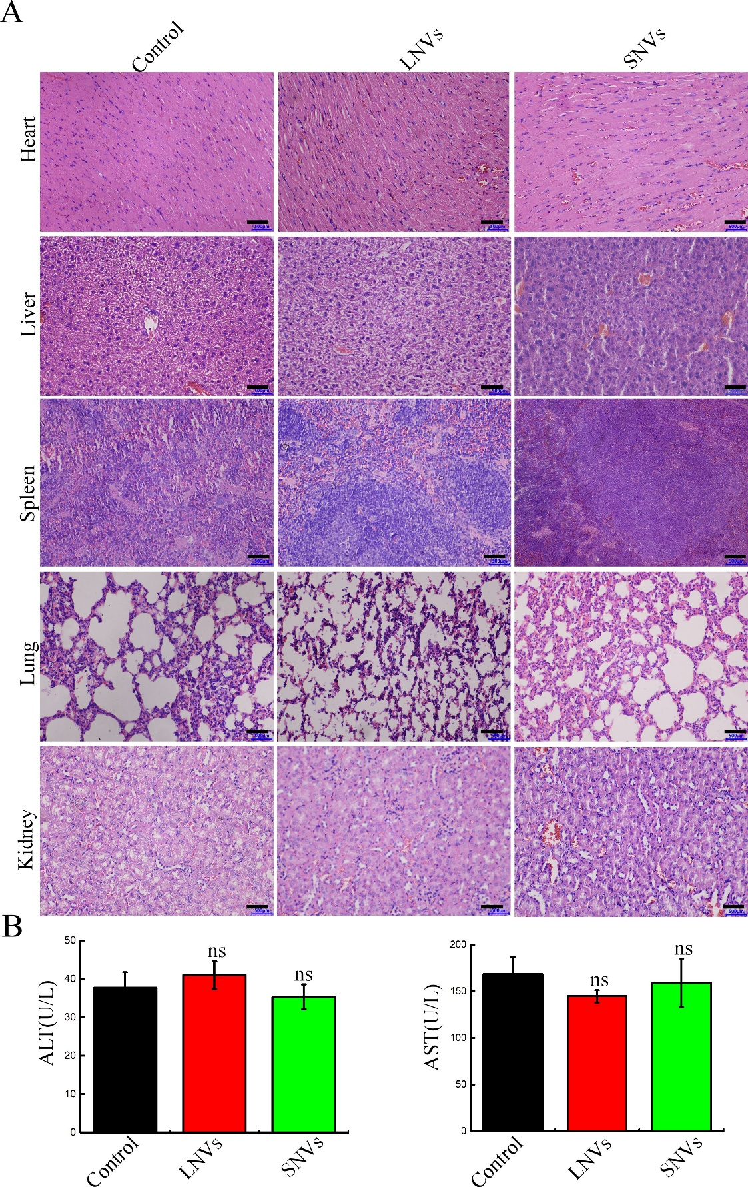

Figure S3. Biosafety of TcNVs in mice.
(A) H&E staining of major organs. Scale bar=500 µm. Magnification: 400X. (B) ALT and AST levels in the serum of mice. Error bar represents SD (n = 3; ^{ns}P >0.05, indicating no significantly different from control group).

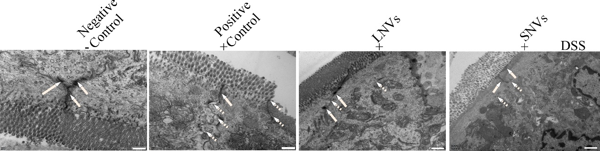
Figure S4. TcNVs treatment reversed gut barrier structural changes of colitis tissues.
The distribution of tight junction in the different experimental groups examined by transmission electron microscopy. The solid lines pointed to intact tight junction and dotted lines to damaged tight junction. Magnification: 30000X. Scale bar = 500 nm.

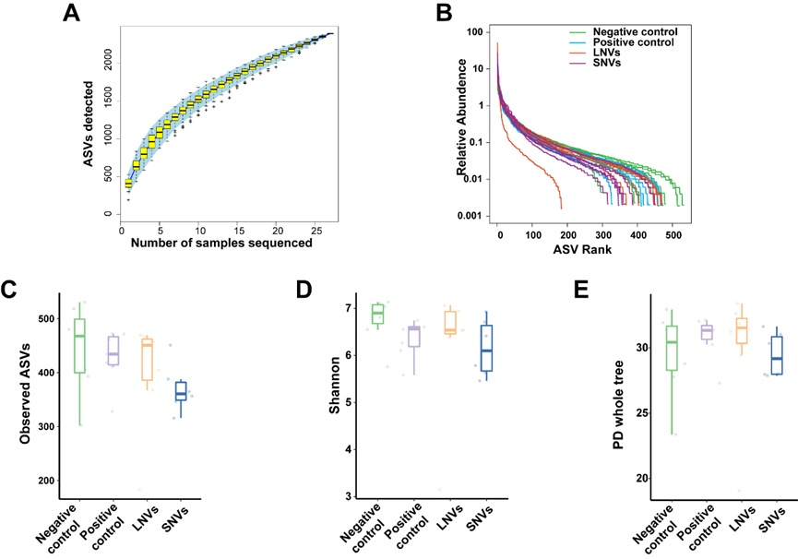
Figure S5. Change of bacterial alpha diversity of gut microbiota in DSS-induced UC mice model under TcNVs interventions.
(A) Species accumulation curves. With the increase of the number of samples, the microbial ASVs curve detected in the gut flora reached saturation, indicating that the gut flora we studied captured most of the gut microbial members. (B) ASVs rank analysis among four groups. (C)-(E) Comparison on bacterial alpha diversity by Observed ASVs (C), Shannon index (D), and PD whole tree (E) between groups (n = 6-7). Rank abundance and alpha diversity index analysis found that LNVs not SNVs was trend to improve microbial diversity of gut in DSS-induced UC mice, although there was no significant difference among these groups showing by Observed ASVs, Shannon index, and PD whole tree index. T-test (pairwise comparisons with pooled SD) was used for (C-D).

Figure S6. Significantly changed bacterial taxa in DSS-induced UC mice model under TcNVs interventions.
(A) Relative abundance of Escherichia coli among different TcNVs treatments. (B) Species Clostridiales bacterium. (C) uncultured bacterium (ASV10). Data were expressed as boxplot. A Kruskal Wallis statistical test was used. *p < 0.05, **p < 0.01.

Table S1. Primers used for RT-qPCR assays.
Primer name | Sequence from 5’ site to 3’ site
LP-IL-6 | AGCCACTCACCTCTTCAGAAC
RP-IL-6 | GCCTCTTTGCTGCTTTCACAC
LP-IL-8 | CTGATTTCTGCAGCTCTGTGT
RP-IL-8 | GGGTGGAAAGGTTTGGAGTATG
LP-IL-1β | GTGGCAATGAGGATGACTTGTTC
RP-IL-1β | TAGTGGTGGTCGGAGATTCGTA
LP-TNF-α | CTGCTGCACTTTGGAGTGAT
RP-TNF-α | AGATGATCTGACTGCCTGGG
LP-GAPDH | AAGGTCATCCATGACAACTTTGGC
LP-GAPDH | ACAGTCTTCTGGGTGGCAGTGAT

Table S2. Lipids found in TcNVs.
Class | all_sample | LNVs | SNVs
Cholesteryl ester | 1 | 0 | 1
Ceramide | 14 | 3 | 14
Phytoceramide | 16 | 6 | 16
Coenzyme Q | 2 | 2 | 2
Diacylglycerol | 31 | 20 | 31
Digalactosyldiacylglycerol | 16 | 4 | 16
Diacylglyceryl trimethylhomoserine | 12 | 3 | 11
Free fatty acid | 13 | 11 | 13
Hexosylceramide | 12 | 5 | 12
Lysodiacylglyceryl trimethylhomoserine | 4 | 4 | 3
Lysophosphatidic acid | 7 | 6 | 7
Lysophophatidylcholine | 20 | 11 | 20
Lysophosphatidylethanolamine | 9 | 8 | 9
Lysophosphatidylglycerol | 3 | 3 | 3
Lysophosphatidylinositol | 3 | 1 | 3
Monoacylglycerol | 3 | 3 | 3
Monogalactosyldiacylglycerol | 18 | 1 | 18
Phosphatidic acid | 12 | 6 | 12
Phosphatidylcholine | 23 | 12 | 23
Phosphatidylethanolamine | 31 | 17 | 31
Phosphatidylglycerol | 24 | 11 | 24
Phosphatidylinositol | 11 | 6 | 11
Phosphatidylmethanol | 4 | 2 | 4
Phosphatidylserine | 1 | 1 | 1
sphingosine | 5 | 3 | 5
Sulfoquinovosyl diacylglycerol | 8 | 2 | 8
Triacylglycerol | 218 | 142 | 218

Table S3: Proteomics analysis of TcNVs.
Accession Number | Protein description
A0A090ARE9 | Tubulin alpha chain
A0A1C9M356 | Photosystem II reaction center protein H
A0A2A2PGB2 | Efflux transporter periplasmic adaptor subunit
A0A2A2PN35 | Indole-3-glycerol phosphate synthase
A0A2A2PP79 | Murein transglycosylase
A0A2A2PQP1 | Outer membrane lipoprotein I
A0A2A2PQP6 | Imelysin
A0AA38BPN3 | Uncharacterized protein
A0AA38BQJ4 | fructose-bisphosphate aldolase
A0AA38BTU3 | Uncharacterized protein
A0AA38BWW7 | EGF-like domain-containing protein
A0AA38BYA7 | RING-type E3 ubiquitin transferase
A0AA38C0C7 | Peptidase A1 domain-containing protein
A0AA38C1H4 | Glucose-methanol-choline oxidoreductase
A0AA38C249 | Chlorophyllase
A0AA38C2I6 | Uncharacterized protein
A0AA38C4H0 | Peptidase M20 dimerisation
A0AA38C4W2 | Uncharacterized protein
A0AA38C7Q9 | Uncharacterized protein
A0AA38CA52 | Uncharacterized protein
A0AA38CB99 | Glycoside hydrolase family
A0AA38CD39 | Uncharacterized protein
A0AA38CD79 | Inhibitor I9 domain-containing protein
A0AA38CED5 | Glucan endo-1,3-beta-D-glucosidase
A0AA38CFC5 | Peroxidase
A0AA38CFJ5 | FHA domain
A0AA38CHK3 | Tobamovirus multiplication protein
A0AA38CHM3 | Glycerol-3-phosphate dehydrogenase
A0AA38CLL5 | Glycoside hydrolase family
A0AA38CMC2 | Gnk2-homologous domain
A0AA38CN74 | 14-3-3 domain
A0AA38CNH9 | Uncharacterized protein
A0AA38CRF1 | Uncharacterized protein
A0AA38CWX5 | Protein YIP
A0AA38EZ94 | Nucleoside phosphorylase domain
A0AA38F2Y4 | Bicarbonate transporter-like transmembrane domain
A0AA38F4W7 | Peptidase M28 domain
A0AA38F5T3 | oxygen evolving system of photosystem II
A0AA38F726 | Cytochrome b5 heme-binding domain
A0AA38F754 | Phosphoglycerate kinase
A0AA38F7S0 | Histone H2A/H2B/H3 domain
A0AA38F9M6 | Uncharacterized protein
A0AA38FAF7 | Ubiquitin-like domain
A0AA38FAK5 | MIF4G domain-containing protein
A0AA38FDS5 | MAR-binding filament-like protein 1-1
A0AA38FEL1 | Uncharacterized protein
A0AA38FF05 | Phytocyanin domain
A0AA38FGQ5 | Plasma membrane intrinsic protein
A0AA38FGU7 | Elongation factor Ts
A0AA38FJ85 | H⁽⁺⁾-exporting diphosphatase
A0AA38FJC0 | Uncharacterized protein
A0AA38FJE1 | Maternal effect embryo arrest 22
A0AA38FJI4 | Uncharacterized protein
A0AA38FMR6 | glycerophosphodiester phosphodiesterase
A0AA38FPI9 | Low-temperature-induced 65 kDa protein
A0AA38FQ79 | Peroxidase
A0AA38FS81 | Uncharacterized protein
A0AA38FSX3 | Acyl carrier protein
A0AA38FTC2 | Uncharacterized protein
A0AA38FTV4 | Chlorophyll synthase
A0AA38FUA8 | Acyl carrier protein
A0AA38FVY2 | Elongation factor 1-alpha
A0AA38G0X8 | CCHC-type domain
A0AA38G2E9 | Plant heme peroxidase family profile domain
A0AA38G4A7 | Uncharacterized protein
A0AA38G4K9 | Actin
A0AA38G4L5 | Non-specific lipid-transfer protein
A0AA38G752 | Saposin B-type domain
A0AA38G7M2 | Ubiquitin-like domain
A0AA38G835 | Homologous-pairing protein 2 homolog
A0AA38G851 | CBM20 domain
A0AA38GAD1 | Glucan endo-1,3-beta-D-glucosidase
A0AA38GAE1 | Lon proteolytic domain
A0AA38GAN4 | Bifunctional inhibitor/plant lipid transfer protein
A0AA38GB52 | Dehydrin 2
A0AA38GBC1 | Peptidase C14 caspase domain
A0AA38GBP3 | Dehydrin 9
A0AA38GCM3 | EF-hand domain-containing protein
A0AA38GE44 | ADP/ATP translocase
A0AA38GED4 | Uncharacterized protein
A0AA38GGB3 | FAS1 domain-containing protein
A0AA38GGP2 | Uncharacterized protein
A0AA38GLR0 | Centromere protein F
A0AA38GN40 | Uncharacterized protein
A0AA38GTU9 | Uncharacterized protein
A0AA38GUR7 | superoxide dismutase
A0AA38GWC4 | Uncharacterized protein
A0AA38GXE4 | FAS1 domain-containing protein
A0AA38GXQ8 | RRM domain-containing protein
A0AA38L734 | Plant heme peroxidase family profile domain
A0AA38L8X1 | Acyl carrier protein
A0AA38L9C7 | Ribulose bisphosphate carboxylase/oxygenase activase
A0AA38LGX4 | Dehydrin 2
A0AA38LHQ1 | Cadherin-like beta sandwich domain
A0AA38LK36 | Phytocyanin domain-containing protein
A0AA38LMM1 | Uncharacterized protein
A0AA38LPG2 | Uncharacterized protein
P85355 | Endochitinase 3

