Table S1: Search strategy of PubMed

# searches
1 ((((((((((((failed back surgery syndrome[MeSH Terms]) OR (Failed back surgery syndrome)) OR (FBSS)) ) OR (failed low back syndrome)) OR (Lumbar surgery syndrome)) OR (lumbar post surgery syndrome)) OR (failed low back surgery syndrome)) OR (Chronic radicular pain after lumbar spine surgery)) OR (psps-t2)) OR (PSPS-T2)) OR (Persistent Spinal Pain Syndrome Type 2)) OR (CPRS)) OR (lumbosacral radiculair syndrome)
2 (((((((((SCS[Title/Abstract]) OR (spinal cord stimulation[Mesh Terms])) OR (HF SCS[Title/Abstract])) OR (LF SCS[Title/Abstract])) OR (burst SCS[Title/Abstract])) OR (Subperception SCS[Title/Abstract])) OR (low frequency spinal cord stimulation)) OR ((high frequency spinal cord stimulation)) OR ((burst spinal cord stimulation)) OR ((culster spinal cord stimulation)
3 #1 AND #2
4 ((((meta analysis[MeSH Terms]) OR (meta analysis as topic[MeSH Terms])) OR (metaanalysis[Publication Type])) OR (review[Publication Type])) OR (meta-analysis[Title/Abstract])
5 #3 NOT #4
6 ((((((((((((randomized controlled trial[Publication Type]) OR (controlled clinical
trial[Publication Type])) OR (clinical trials as topic[MeSH Terms])) OR (random
allocation[MeSH Terms])) OR (randomized controlled trials as topic[MeSH Terms])) OR(clinical trial[Publication Type])) OR (clinical trial[Text Word])) OR (singl*[Text Word]))OR (doubl*[Text Word])) OR (trebl*[Text Word])) OR (tripl*[Text Word])) OR(randomly[Text Word])) OR (trial[Text Word])
7 #5 AND #6

Table S2: Search strategy of Web of Science: Science Citation Index Expanded

# Searches
1 ((((((((((((TS=(failed back surgery syndrome)) OR TS=(Failed back surgery syndrome)) OR TS=(FBSS)) OR TS=(failed low back syndrome)) OR TS=(Lumbar surgery syndrome)) OR TS=((lumbar post surgery syndrome)) OR TS=(failed low back surgery syndrome)) OR TS=(Chronic radicular pain after lumbar spine surgery)) OR TS=(psps-t2)) OR TS=(PSPS-T2)) OR TS=(Persistent Spinal Pain Syndrome Type 2)) OR TS=(CPRS)) OR TS=(lumbosacral radiculair syndrome))
2 ((((((((TS=(SCS)) OR TS=(spinal cord stimulation)) OR TS=(HF SCS)) OR TS=(LF SCS)) OR TS=(burst SCS)) OR TS=(Subperception SCS)) OR TS=(low frequency spinal cord stimulation)) OR TS=(high frequency spinal cord stimulation)) OR TS=(burst spinal cord stimulation)
3 #1 AND #2
4 (((TS=(meta analysis)) OR TS=(meta analysis as topic)) OR TS=(review)) OR TS=(meta-analysis)
5 #3 NOT #4
6 (((((((((TS=(randomized controlled trial)) OR TS=(controlled clinical trial)) OR TS=(singl*)) OR TS=(doubl*)) OR TS=(trebl*)) OR TS=(tripl*)) OR TS=(random*)) OR TS=(clinical tria*)) OR TS=(tria*))
7 #5 AND #6
Table S3: Search strategy of Cochrane Central Register of Controlled Trials

# Searches
1 MeSH descriptor: [Failed Back Surgery Syndrome] explode all trees
2 ("failed back surgery syndrome"):ti,ab,kw OR (failed low back syndrome):ti,ab,kw AND (FBSS):ti,ab,kw
3 lumbar surgery syndrome
4 (lumbar post surgery syndrome):ti,ab,kw OR (lumbosacral radiculair syndrome'):ti,ab,kw
5 chronic radicular pain after lumbar spine surgery
6 (persistent spinal pain syndrome type 2):ti,ab,kw OR (PSPS T2):ti,ab,kw AND (psps-t2):ti,ab,kw
7 #1 OR #2 OR #3 OR #4 OR #4 OR #6
8 ("spinal cord stimulation"):ti,ab,kw OR ("spinal cord stimulation therapy"):ti,ab,kw OR (SCS):ti,ab,kw
9 (lf scs):ti,ab,kw OR (low frequency spinal cord stimulation):ti,ab,kw
10 (hf scs):ti,ab,kw OR (high frequency spinal cord stimulation):ti,ab,kw
11 (subperception scs):ti,ab,kw OR (subperception spinal cord stimulation):ti,ab,kw
12 (burst spinal cord stimulation):ti,ab,kw OR (culster spinal cord stimulation):ti,ab,kw
13 #8 OR #9 OR #10 OR #11 OR #12
14 #7 AND #13
15 ("meta analysis"):ti,ab,kw OR ("meta analysis"):pt OR (review):pt
16 #14 NOT #15
17 ("randomized clinical trial"):pt OR ("controlled clinical trial"):pt OR ("clinical trial"):ti,ab,kw OR ("random allocation"):ti,ab,kw OR ("clinical trial"):ti,ab,kw
18 ("clinical trial") OR (singl*) OR (doubl*) OR (trebl*) OR ("randomly")
19 (trial*):ti,ab,kw OR (group*):ti,ab,kw
20 #17 OR #18 OR #19

Table S4: Search strategy of Embase
# Searches
1 'failed back surgery syndrome'/exp OR 'failed back surgery syndrome' OR fbss:ti,ab,kw OR 'failed low back syndrome':ti,ab,kw OR 'lumbar surgery syndrome':ti,ab,kw OR 'lumbar post surgery syndrome':ti,ab,kw OR 'chronic radicular pain after lumbar spine surgery':ti,ab,kw OR 'persistent spinal pain syndrome type 2':ti,ab,kw OR 'psps t2':ti,ab,kw OR cprs:ti,ab,kw OR 'lumbosacral radiculair syndrome':ti,ab,kw
2 scs OR 'spinal cord stimulation':ti,ab,kw OR 'hf scs':ti,ab,kw OR 'lf scs':ti,ab,kw OR 'burst scs':ti,ab,kw OR 'subperception scs':ti,ab,kw OR 'low frequency spinal cord stimulation':ti,ab,kw OR 'high frequency spinal cord stimulation':ti,ab,kw OR 'burst spinal cord stimulation':ti,ab,kw OR 'culster spinal cord stimulation':ti,ab,kw
3 #1 AND #2
4 review:it OR 'meta analysis':ti,ab,kw
5 #3 NOT #4
6 'controlled clinical trial'/exp OR 'randomized controlled trial':ti,ab,kw OR 'clinical study'/exp OR 'randomization'/exp OR 'single blind procedure'/exp OR 'double blind procedure'/exp OR 'placebo'/exp OR singl* OR doubl* OR trebl* OR tripl* OR randomly
7 #5 AND #6

Table S5: List of data extracted from the included randomized clinical trials

Data catagory | List of variables
Study | Primary author, year of publication, total number of patients in each group
Patients | Sex, age, FBSS rate, global pain score, back pain score , leg pain score, ODI and EQ-5D score at baseline
Interventions | Parameters of spinal cord electrical stimulation
Efficacy outcome | Mean of change in global pain score, back pain score , leg pain score, ODI and EQ-5D score with respective standard deviation from baseline , responder rate

Figure S1: Overall risk of bias presented as percentage of each risk of bias item across all included studies.

Green = Low risk, Red = High risk, Yellow = Some concerns.
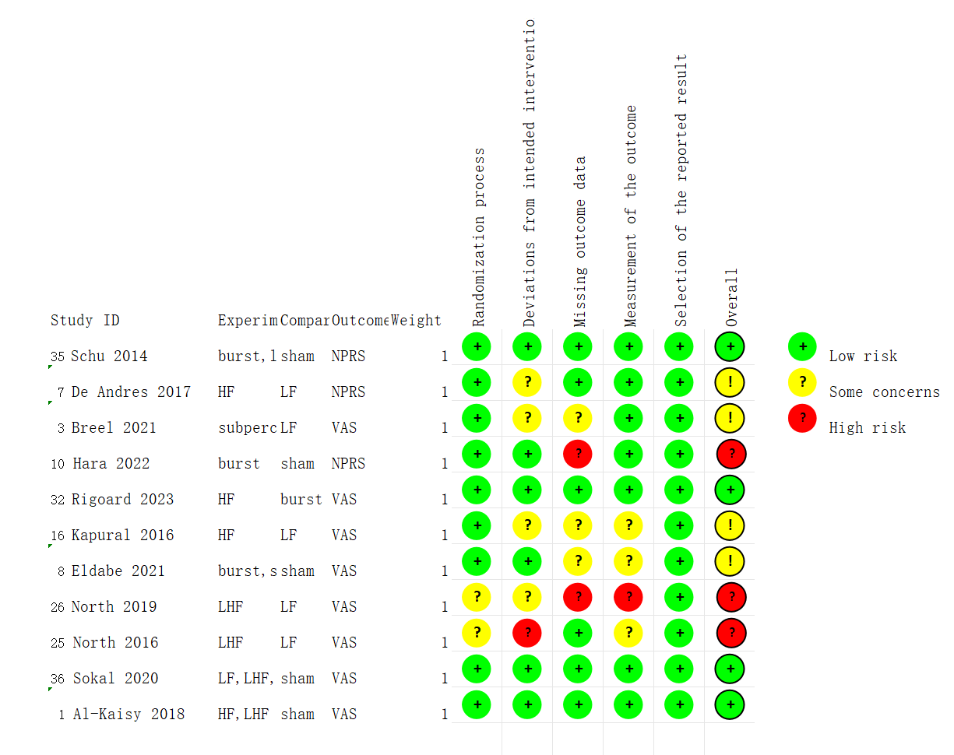

Table S6: Study level risk of bias assessment using Cochrane risk of bias tool 2.0 for assessing risk of bias of randomized clinical trials.

Table S7: Global consistency

Clinical outcome | Chi square | P value
Global pain | 2.12 | 0.5469
Back pain | 1.41 | 0.7032
Leg pain | 0.03 | 0.8633
Responder rate | 0.00 | 0.9648
ODI | 3.61 | 0.1646
EQ-5D | 1.90 | 0.1687

Table S8: Side-splitting of global pain. Inconsistency test between direct and indirect treatment comparisons in mixed treatment comparison.(A=HF, B=LF, C=burst, D=sham, E=perception)

Side | Direct |  | Indirect |  | Difference
 | Coef. | Std. Err. | Coef. | Std. Err. | Coef. | Std. Err. | P>z
A B * | 0.079707 | 0.591929 | 0.056214 | 12.91313 | 0.023492 | 12.92669 | 0.999
B C | -0.71939 | 0.556842 | 0.52536 | 0.475266 | -1.24475 | 0.731909 | 0.089
B D | -0.75578 | 0.652996 | -0.18703 | 0.562407 | -0.56875 | 0.861626 | 0.509
B E * | 0.072575 | 0.310302 | -0.72491 | 1.216603 | 0.797489 | 1.254845 | 0.525
C D | . | . | . | . | . | . | .
C E * | -0.1065 | 0.334253 | 1.648793 | 1.148412 | -1.75529 | 1.195291 | 0.142
D E * | 0.317159 | 0.333015 | 2.072453 | 1.148739 | -1.75529 | 1.195291 | 0.142

Table S9a: Side-splitting of back pain. Inconsistency test between direct and indirect treatment comparisons in mixed treatment comparison.
Side | Direct |  | Indirect |  | Difference |  |  | tau
 | Coef. | Std. Err. | Coef. | Std. Err. | Coef. | Std. Err. | P>z
A B | -0.6521 | 0.157252 | -0.59887 | 0.294208 | -0.05323 | 0.333596 | 0.873 | 1.12E-09
A D | -0.62125 | 0.293619 | -0.89229 | 0.340978 | 0.271047 | 0.450545 | 0.547 | 6.59E-09
A E | -0.49393 | 0.291743 | -0.41777 | 0.194527 | -0.07616 | 0.350359 | 0.828 | 1.17E-08
B C | -0.18166 | 0.316708 | 0.31425 | 0.285146 | -0.49591 | 0.426053 | 0.244 | 1.07E-10
B E | 0.207775 | 0.118444 | 0.131724 | 0.32973 | 0.076051 | 0.350357 | 0.828 | 3.36E-09
C D | -0.2378 | 0.149621 | 0.126184 | 0.3788 | -0.36398 | 0.407278 | 0.371 | 6.66E-10
C E | 0.162968 | 0.316617 | 0.063852 | 0.277124 | 0.099116 | 0.420629 | 0.814 | 1.62E-09
D E | 0.132675 | 0.288895 | 0.462501 | 0.292539 | -0.32983 | 0.410669 | 0.422 | 1.88E-10

Table S9b

Side | Direct |  | Indirect |  | Difference
 | Coef. | Std. Err. | Coef. | Std. Err. | Coef. | Std. Err. | P>z
A B | -0.6521 | 0.157252 | -0.59887 | 0.294208 | -0.05323 | 0.333596 | 0.873
A D | -0.62125 | 0.293619 | -0.89229 | 0.340978 | 0.271047 | 0.450545 | 0.547
A E | -0.49393 | 0.291743 | -0.41777 | 0.194527 | -0.07616 | 0.350359 | 0.828
B C | -0.18166 | 0.316708 | 0.31425 | 0.285146 | -0.49591 | 0.426053 | 0.244
B E | 0.207775 | 0.118444 | 0.131724 | 0.32973 | 0.076051 | 0.350357 | 0.828
C D | -0.2378 | 0.149621 | 0.126184 | 0.3788 | -0.36398 | 0.407278 | 0.371
C E | 0.162968 | 0.316617 | 0.063852 | 0.277124 | 0.099116 | 0.420629 | 0.814
D E | 0.132675 | 0.288895 | 0.462501 | 0.292539 | -0.32983 | 0.410669 | 0.422

Table S10: Side-splitting of leg pain. Inconsistency test between direct and indirect treatment comparisons in mixed treatment comparison.

Side | Direct |  | Indirect |  | Difference
 | Coef. | Std. Err. | Coef. | Std. Err. | Coef. | Std. Err. | P>z
A B * | -0.34372 | 0.154305 | 0.047864 | 18.25817 | -0.39159 | 18.25883 | 0.983
B C * | -0.12082 | 0.31644 | -0.23796 | 0.605771 | 0.117142 | 0.68265 | 0.864
B E * | 0.132032 | 0.118182 | 0.915228 | 36.55415 | -0.7832 | 36.55434 | 0.983
C D * | -0.11896 | 0.149216 | 0.977892 | 63.36307 | -1.09685 | 63.36324 | 0.986
C E * | 0.303393 | 0.317566 | 0.185788 | 0.604036 | 0.117605 | 0.682681 | 0.863

Table S11: Side-splitting of responder rate, Inconsistency test between direct and indirect treatment comparisons in mixed treatment comparison.

Side | Direct |  | Indirect |  | Difference
 | Coef. | Std. Err. | Coef. | Std. Err. | Coef. | Std. Err. | P>z
A B | -1.20683 | 1.293173 | -1.11125 | 1.707786 | -0.09558 | 2.142155 | 0.964
A C * | -0.40547 | 1.399636 | -0.59482 | 4.051848 | 0.189358 | 4.284832 | 0.965
A D * | 0.200671 | 1.397379 | 0.105992 | 1.62397 | 0.094679 | 2.142416 | 0.965
B D | 1.312408 | 0.983542 | 1.407524 | 1.904477 | -0.09512 | 2.143453 | 0.965
C D * | 0.606136 | 1.400357 | 0.416778 | 4.051101 | 0.189358 | 4.284833 | 0.965

Table S12: Side-splitting of ODI. Inconsistency test between direct and indirect
treatment comparisons in mixed treatment comparison.

Side | Direct |  | Indirect |  | Difference
 | Coef. | Std. Err. | Coef. | Std. Err. | Coef. | Std. Err. | P>z
A B * | -0.21102 | 0.359945 | 0.107895 | 18.25973 | -0.31892 | 18.26328 | 0.986
B C * | -0.05536 | 0.509858 | 0.350094 | 1.292228 | -0.40545 | 1.389159 | 0.77
B E * | -0.05033 | 0.509918 | -0.45345 | 1.292659 | 0.403122 | 1.389578 | 0.772
C D * | -0.35903 | 0.340472 | 0.046679 | 1.34993 | -0.40571 | 1.392335 | 0.771
C E * | -0.19427 | 0.224409 | 0.935741 | 0.632728 | -1.13001 | 0.674353 | 0.094
D E | 0.356174 | 0.493582 | 0.01823 | 0.642072 | 0.337945 | 0.809546 | 0.676

Table S13a: Side-splitting of EQ-5D. Inconsistency test between direct and indirect
treatment comparisons in mixed treatment comparison.

Side | Direct |  | Indirect |  | Difference |  |  | tau
 | Coef. | Std. Err. | Coef. | Std. Err. | Coef. | Std. Err. | P>z
A B * | 0.292074 | 0.440796 | -0.18341 | 44.73775 | 0.475486 | 44.73992 | 0.992 | 0.305825
A C * | 0.1669 | 0.440205 | -0.07085 | 22.36383 | 0.237746 | 22.36817 | 0.992 | 0.305825
B C * | -0.12517 | 0.44008 | -0.60067 | 44.72808 | 0.475493 | 44.73023 | 0.992 | 0.305825
C D * | 0.105835 | 0.316458 | -0.36966 | 44.73666 | 0.475492 | 44.7378 | 0.992 | 0.305825
C E * | 0.339729 | 0.355519 | -0.91685 | 0.83715 | 1.256578 | 0.912052 | 0.168 | 0.005201
D E * | -0.1175 | 0.354593 | 1.139128 | 0.841611 | -1.25663 | 0.914478 | 0.169 | 0.023904

Table S13b

Side | Direct |  | Indirect |  | Difference
 | Coef. | Std. Err. | Coef. | Std. Err. | Coef. | Std. Err. | P>z
A B * | 0.292074 | 0.440796 | -0.18341 | 44.73775 | 0.475486 | 44.73992 | 0.992
A C * | 0.1669 | 0.440205 | -0.07085 | 22.36383 | 0.237746 | 22.36817 | 0.992
B C * | -0.12517 | 0.44008 | -0.60067 | 44.72808 | 0.475493 | 44.73023 | 0.992
C D * | 0.105835 | 0.316458 | -0.36966 | 44.73666 | 0.475492 | 44.7378 | 0.992
C E * | 0.339729 | 0.355519 | -0.91685 | 0.83715 | 1.256578 | 0.912052 | 0.168
D E * | -0.1175 | 0.354593 | 1.139128 | 0.841611 | -1.25663 | 0.914478 | 0.169

Table S14: Heterogeneity score by each comparison for main model of global pain.
Treatment 1 | Treatment 2 | τ² pairwise | τ² network
LF | HF | 0.00 | 0.02
burst | HF | NA | 0.02
sham | HF | NA | 0.03
subperception | HF | NA | 0.03
burst | sham | 0.1 | NA
burst | subperception | 0 | 0.02
sham | subperception | 0 | 0.02

Table S15: Heterogeneity score by each comparison for main model of back pain.
Treatment 1 | Treatment 2 | τ² pairwise | τ² network
LF | HF | 0 | 0.08
LF | sham | 0 | 0.08
LF | subperception | 0 | 0.08
HF | burst | NA | 0.1
HF | subperception | 0 | 0.07
burst | sham | 0 | 0.1
burst | subperception | 0 | 0.09
sham | subperception | 0 | 0.1

Table S16: Heterogeneity score by each comparison for main model of leg pain.
Treatment 1 | Treatment 2 | τ² pairwise | τ² network
LF | HF | 0 | 0.09
HF | burst | 0 | 0.06
HF | subperception | 0 | 0.09
burst | sham | 0 | 0.1
burst | subperception | 0 | 0.01

Supplementary Material 1

CINeMA Assessment
We use the CINeMA framework to evidence certainty, assessing it for each network estimate based on the following criteria:
A: Within study bias: We classified the overall risk of bias for each study as low risk of bias, the risk of bias as moderate when none of the four assessed risk of bias items were rated as high risk, and the risk of bias as high when one or both items were rated as high risk. See Tables S7-S16 for the bias assessment.

Figure S2: Risk of bias contribution by intervention group in global pain

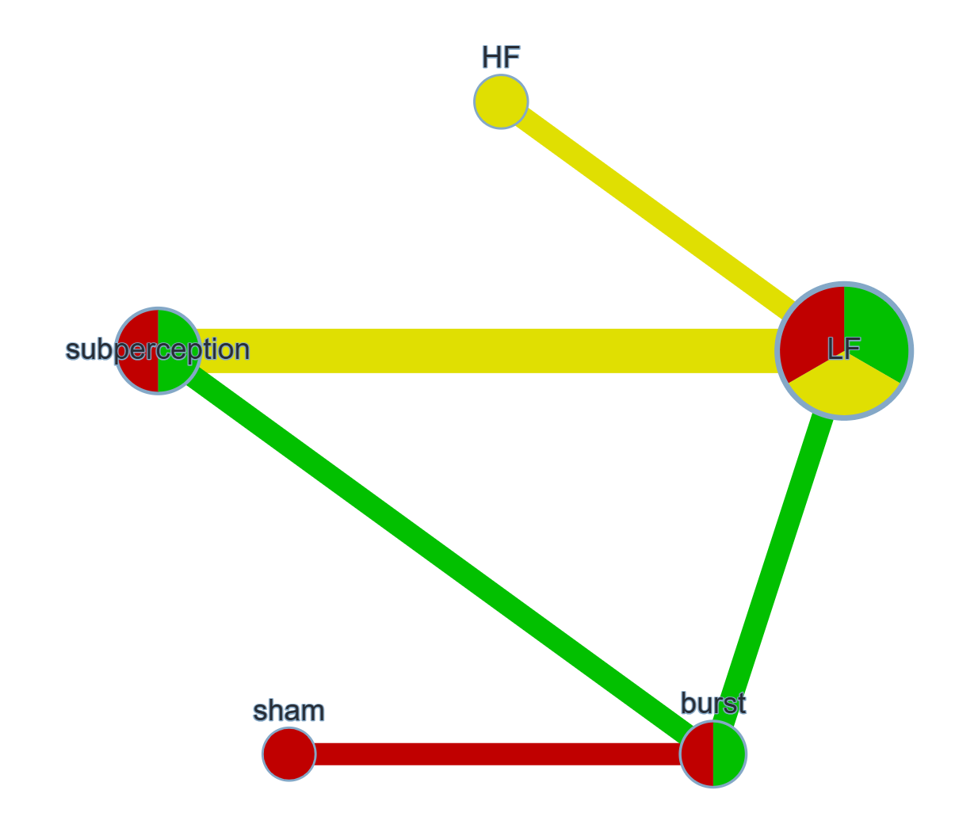

Figure S3: Overall risk of bias by treatment comparison in global pain
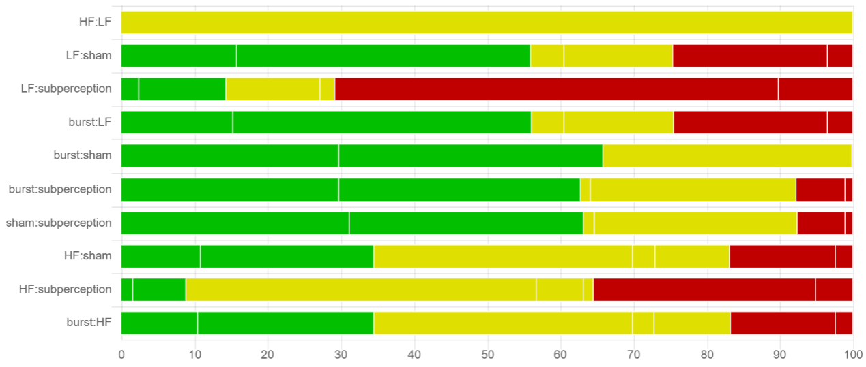

Figure S4: Risk of bias contribution by intervention group in back pain
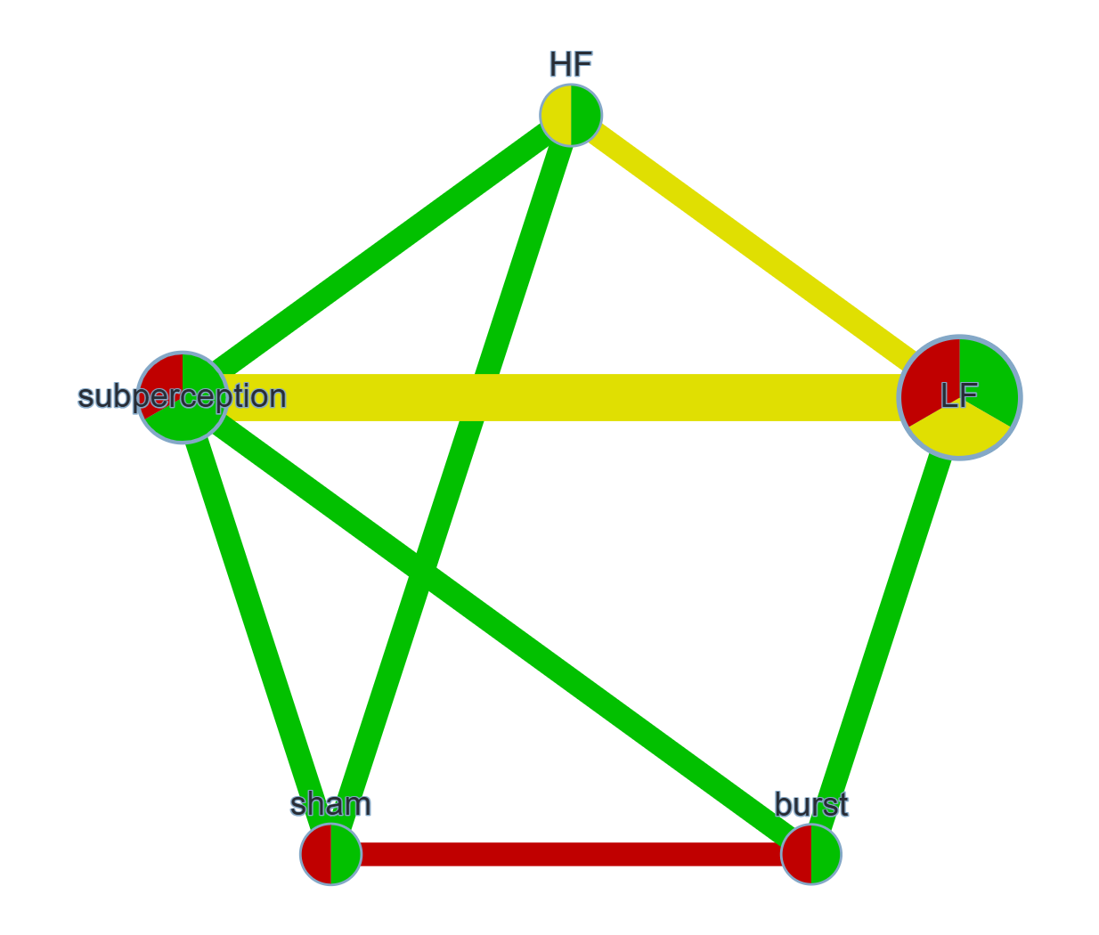

Figure S5: Overall risk of bias by treatment comparison in back pain
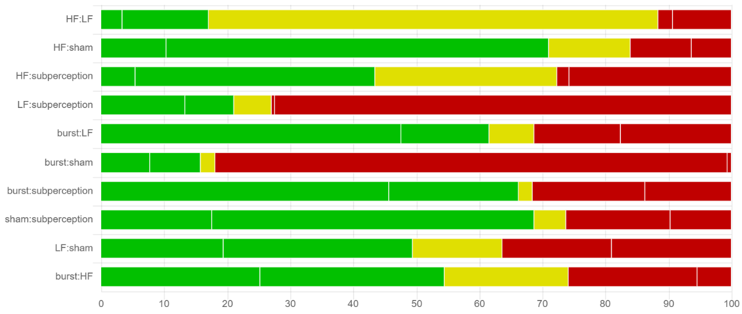

Figure S6: Risk of bias contribution by intervention group in leg pain
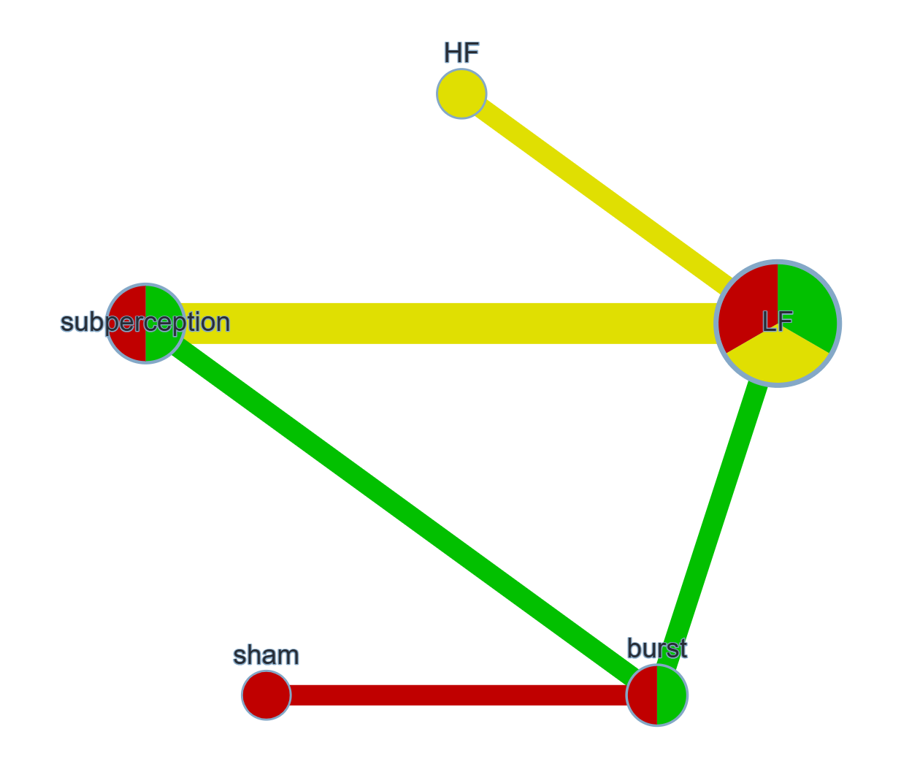

Figure S7: Overall risk of bias by treatment comparison in leg pain
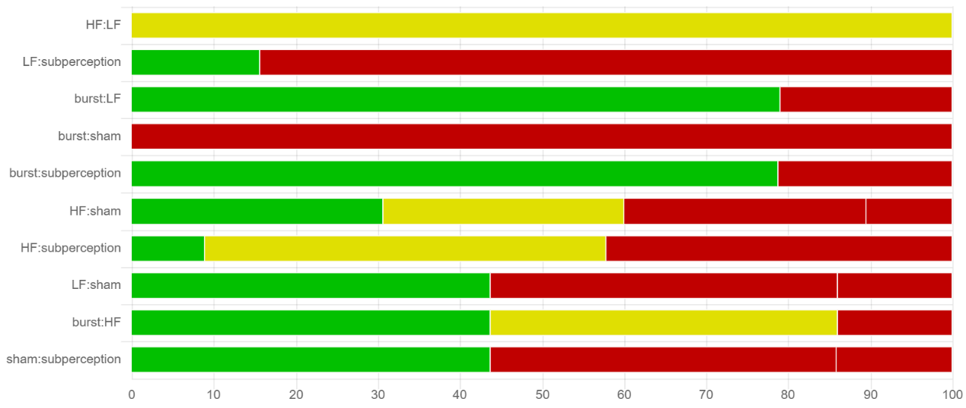

Figure S8: Transitivity (Indirectness) Assessment

Imprecision: We use the CINeMA website to grade the accuracy of each comparison.

Heterogeneity: We assessed the degree of worry by comparing clinical reasoning based on 95% confidence intervals (CIs) while applying the same clinical reasoning framework as for inaccuracy. In particular, we judged the consistency of our findings based on the confidence and prediction intervals associated with clinically important effect sizes. And we used the same thresholds of clinical significance as described above and followed the recommendations automatically provided by CINeMA (https://cinema.ispm.unibe.ch/).

Inconsistency: For inconsistency, we looked at the results for node splitting (Supplementary Material 1) and we saw major problems when p<0.10, but otherwise no problems.

Table S17: CINeMA Results of global pain

Comparison | Within-study bias | Reporting bias | Indirectness | Imprecision | Heterogeneity | Incoherence | Confidence rating
HF:LF | Some concerns | Low risk | No concerns | Major concerns | No concerns | No concerns | Low
burst:LF | No concerns | Low risk | No concerns | Major concerns | No concerns | Major concerns | Low
LF:sham | No concerns | Low risk | No concerns | No concerns | No concerns | No concerns | High
LF:subperception | Major concerns | Low risk | No concerns | No concerns | No concerns | No concerns | Moderate
burst:sham | No concerns | Low risk | No concerns | No concerns | No concerns | No concerns | High
burst:subperception | No concerns | Low risk | No concerns | Major concerns | No concerns | Major concerns | Low
sham:subperception | No concerns | Low risk | No concerns | No concerns | Major concerns | Some concerns | Moderate
burst:HF | Some concerns | Low risk | No concerns | Major concerns | No concerns | No concerns | Low
HF:sham | Some concerns | Low risk | No concerns | Major concerns | No concerns | No concerns | Low
HF:subperception | Some concerns | Low risk | No concerns | Major concerns | No concerns | No concerns | Low

Table S18: CINeMA Results of back pain
Comparison | Within-study bias | Reporting bias | Indirectness | Imprecision | Heterogeneity | Incoherence | Confidence rating
HF:LF | Some concerns | Low risk | No concerns | No concerns | No concerns | No concerns | Moderate
HF:sham | No concerns | Low risk | No concerns | No concerns | Major concerns | No concerns | Low
HF:subperception | Some concerns | Low risk | No concerns | No concerns | Major concerns | No concerns | Low
burst:LF | No concerns | Low risk | No concerns | Major concerns | No concerns | No concerns | Low
LF:subperception | Major concerns | Low risk | No concerns | No concerns | No concerns | No concerns | Low
burst:sham | Major concerns | Low risk | No concerns | No concerns | No concerns | No concerns | Low
burst:subperception | No concerns | Low risk | No concerns | Major concerns | No concerns | No concerns | Low
sham:subperception | No concerns | Low risk | No concerns | Some concerns | No concerns | No concerns | Moderate
burst:HF | No concerns | Low risk | No concerns | No concerns | Major concerns | No concerns | Low
LF:sham | Some concerns | Low risk | No concerns | Major concerns | No concerns | No concerns | Low

Table S19: CINeMA Results of leg pain
Comparison | Within-study bias | Reporting bias | Indirectness | Imprecision | Heterogeneity | Incoherence | Confidence rating
HF:LF | Some concerns | Low risk | No concerns | No concerns | Major concerns | No concerns | Low
burst:LF | No concerns | Low risk | No concerns | Some concerns | No concerns | No concerns | Moderate
LF:subperception | Major concerns | Low risk | No concerns | No concerns | Major concerns | No concerns | Low
burst:sham | Major concerns | Low risk | No concerns | Some concerns | No concerns | No concerns | Low
burst:subperception | No concerns | Low risk | No concerns | Major concerns | No concerns | No concerns | Low
burst:HF | Some concerns | Low risk | No concerns | Major concerns | No concerns | No concerns | Low
HF:sham | Some concerns | Low risk | No concerns | No concerns | Major concerns | No concerns | Low
HF:subperception | Some concerns | Low risk | No concerns | Major concerns | No concerns | No concerns | Low
LF:sham | Some concerns | Low risk | No concerns | No concerns | Major concerns | No concerns | Low
sham:subperception | Some concerns | Low risk | No concerns | Some concerns | No concerns | No concerns | Moderate

Notes: Tables S20-S25 - Summary Estimates for SCS on the treatment of FBSS from Network Meta-analysis. Each cell in the table compares the row-defined SCS modality against the column-defined SCS modality. Effect estimates are reported as mean differences (MD) with 95% confidence intervals (CI). For example:
HF-SCS vs. LF-SCS for global pain: MD -0.08 (95% CI -1.24 to 1.08)
Interpretation:
• MD < 0 favors the row modality
• MD > 0 favors the column modality

Table S20: Global pain
HF
-0.08 (-1.24,1.08) | LF
-0.08 (-1.48,1.33) | 0.00 (-0.80,0.81) | burst
0.35 (-1.06,1.76) | 0.43 (-0.37,1.23) | 0.42 (-0.28,1.13) | sham
-0.11 (-1.39,1.18) | -0.03 (-0.59,0.54) | -0.03 (-0.71,0.65) | -0.45 (-1.13,0.22) | subperception

Table S21: Back pain
HF
0.64 (0.37,0.91) | LF
0.55 (0.10,1.00) | -0.09 (-0.51,0.32) | burst
0.74 (0.30,1.17) | 0.10 (-0.32,0.51) | 0.19 (-0.08,0.46) | sham
0.44 (0.12,0.76) | -0.20 (-0.42,0.02) | -0.11 (-0.52,0.30) | -0.30 (-0.70,0.11) | subperception

Table S22: Leg pain
HF
0.34 (0.04,0.65) | LF
0.49 (-0.14,1.12) | 0.15 (-0.40,0.70) | burst
0.61 (-0.08,1.30) | 0.26 (-0.36,0.89) | 0.12 (-0.17,0.41) | sham
0.21 (-0.17,0.59) | -0.13 (-0.36,0.10) | -0.28 (-0.83,0.27) | -0.40 (-1.02,0.23) | subperception

Table S23: Responder rate
subperception
1.24 (0.03,2.45) | HF
0.56 (-1.28,2.39) | -0.68 (-2.67,1.31) | burst
0.10 (-1.34,1.54) | -1.14 (-2.48,0.21) | -0.46 (-2.29,1.38) | LF

Table S24: ODI
HF
0.21 (-0.30,0.72) | LF
0.23 (-0.54,1.00) | 0.02 (-0.55,0.60) | burst
0.43 (-0.37,1.23) | 0.22 (-0.40,0.83) | 0.20 (-0.07,0.46) | sham
0.30 (-0.47,1.06) | 0.08 (-0.49,0.66) | 0.06 (-0.35,0.48) | -0.13 (-0.58,0.31) | subperception

Table S25: EQ-5D
subperception
0.02 (-0.87,0.91) | LF
0.15 (-0.49,0.78) | 0.13 (-0.50,0.75) | burst
0.07 (-0.56,0.71) | 0.05 (-0.70,0.81) | -0.07 (-0.51,0.36) | sham
0.31 (-0.58,1.20) | 0.29 (-0.33,0.91) | 0.17 (-0.45,0.79) | 0.24 (-0.52,1.00) | HF

Figure S9: Cumulative ranking curve plots of SCSs for global pain in range network. Higher surface under the curve reflects higher probability of pain relief with SCS.

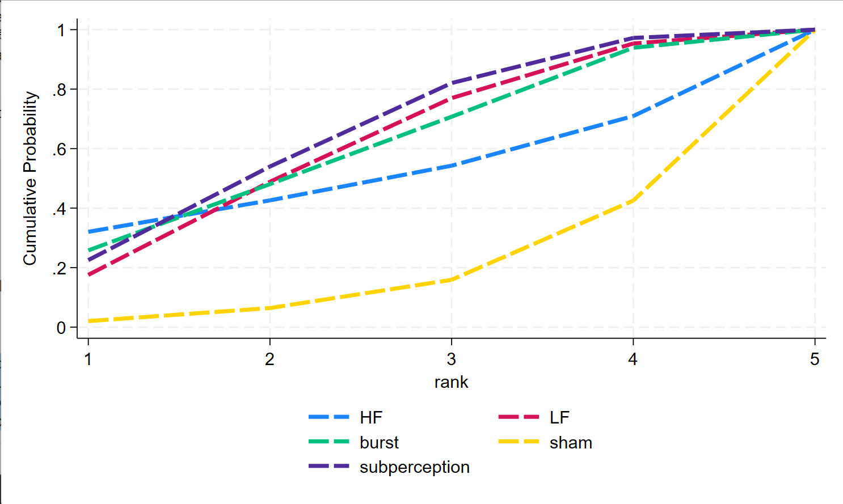

Table S26: SUCRA of the effects of various SCSs on global pain.

Treatment | SUCRA | PreBest | MeanRank
HF | 50.0 | 32.0 | 3.0
LF | 59.7 | 17.6 | 2.6
Burst | 59.6 | 25.5 | 2.6
Sham | 16.7 | 2.0 | 4.3
Subperception | 64.0 | 22.5 | 2.4
Abbreviations: SUCRA, surface under the cumulative ranking curve.

Figure S10: Cumulative ranking curve plots of SCSs for back pain in range network.
Higher surface under the curve reflects higher probability of pain relief with SCS.

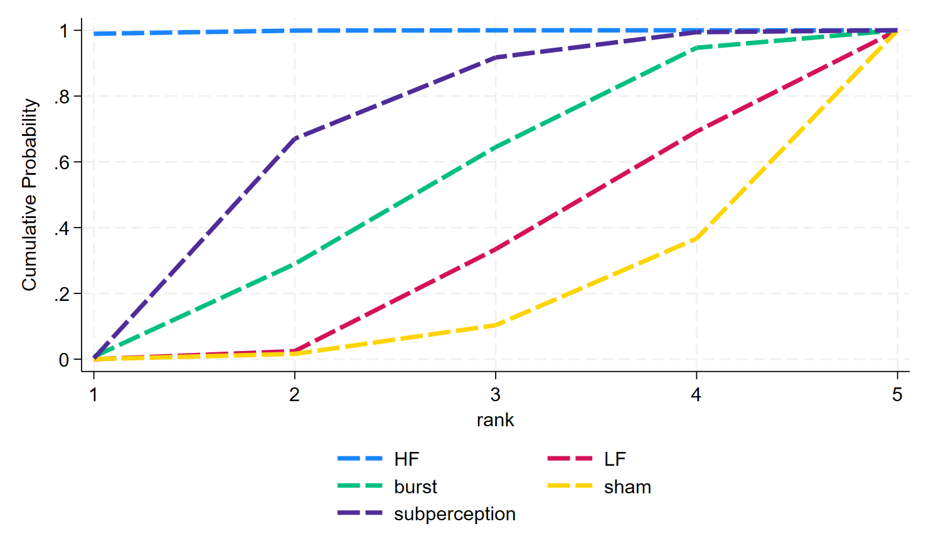

Table S27: SUCRA of the effects of various SCSs on back pain.

Treatment | SUCRA | PreBest | MeanRank
HF | 99.7 | 98.9 | 1.0
LF | 27.6 | 0.0 | 3.9
Burst | 47.2 | 0.8 | 3.1
Sham | 12.2 | 0.0 | 4.5
Subperception | 64.4 | 0.3 | 2.4
Abbreviations: SUCRA, surface under the cumulative ranking curve.

Figure S11: Cumulative ranking curve plots of SCSs for leg pain in range network. Higher surface under the curve reflects higher probability of pain relief with SCS.

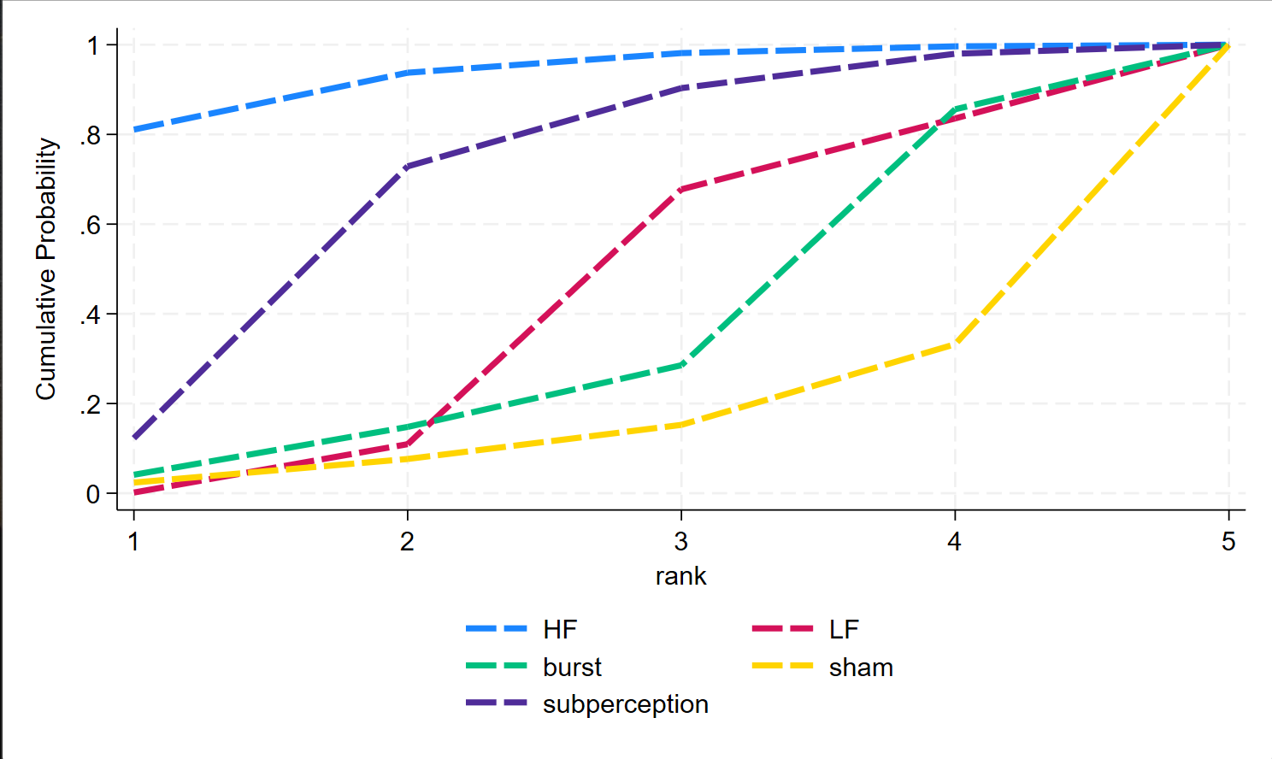

Table S28: SUCRA of the effects of various SCSs on leg pain.

Treatment | SUCRA | PreBest | MeanRank
HF | 93.2 | 81.1 | 1.3
LF | 40.6 | 0.2 | 3.4
Burst | 33.3 | 4.1 | 3.7
Sham | 14.6 | 2.4 | 4.4
Subperception | 68.4 | 12.3 | 2.3
Abbreviations: SUCRA, surface under the cumulative ranking curve.

Figure S12: Cumulative ranking curve plots of SCSs for responder rate in range network. Higher surface under the curve reflects higher probability of pain relief with SCS.

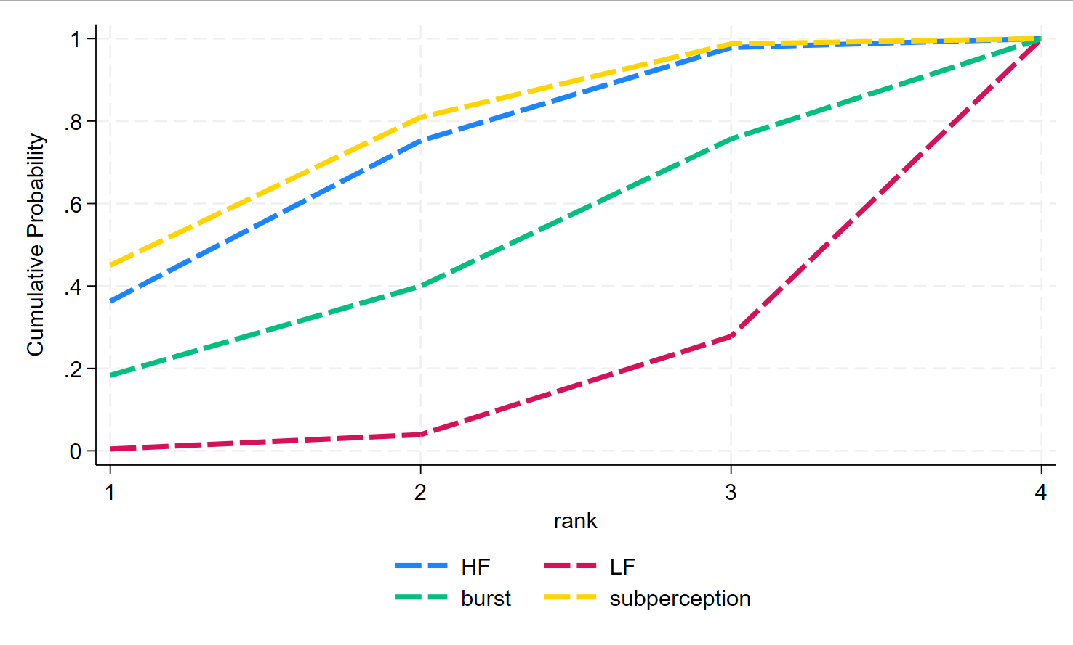

Table S29: SUCRA of the effects of various SCSs on leg pain.

Treatment | SUCRA | PreBest | MeanRank
HF | 69.9 | 36.7 | 1.9
LF | 10.9 | 0.2 | 3.7
Burst | 44.2 | 18.2 | 2.7
Subperception | 75.3 | 44.8 | 1.7
Abbreviations: SUCRA, surface under the cumulative ranking curve.

Figure S13: Cumulative ranking curve plots of SCSs for ODI in range network. Higher surface under the curve reflects higher probability of functional improvement with SCS.

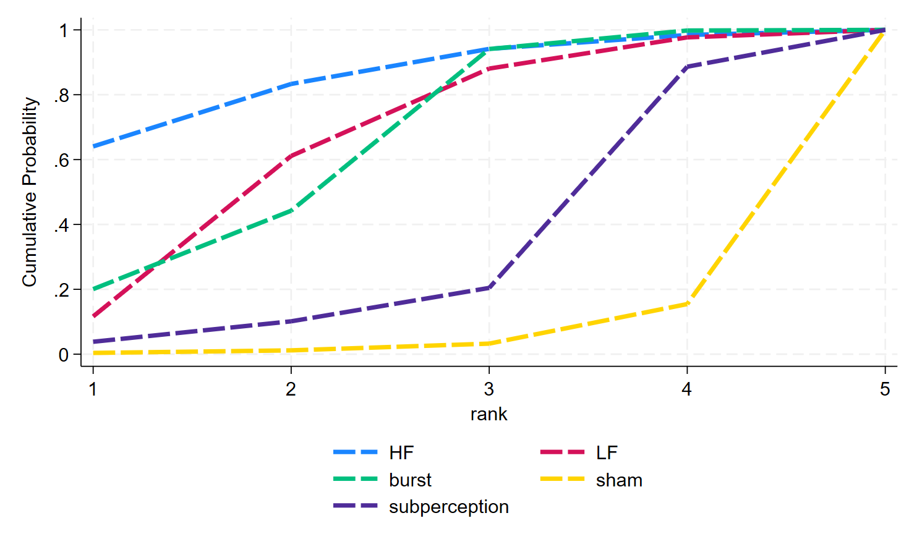

Table S30: SUCRA of the effects of various SCSs on ODI.

Treatment | SUCRA | PreBest | MeanRank
HF | 85.0 | 64.1 | 1.6
LF | 64.6 | 11.6 | 2.4
burst | 64.6 | 20.1 | 2.4
sham | 5.1 | 0.4 | 4.8
subperception | 30.8 | 3.8 | 3.8
Abbreviations: SUCRA, surface under the cumulative ranking curve.

Figure S14: Cumulative ranking curve plots of SCSs for EQ-5D in range network. Higher surface under the curve reflects higher probability of improvement of life quality with SCS.

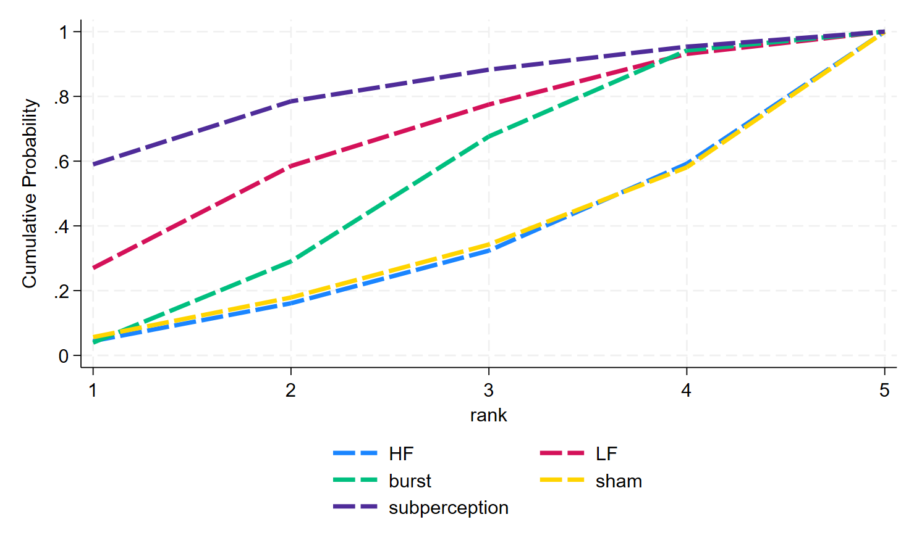

Table S31: SUCRA of the effects of various SCSs on EQ-5D.

Treatment | SUCRA | PreBest | MeanRank
HF | 28.0 | 4.4 | 3.9
LF | 64.0 | 27.0 | 2.4
burst | 48.7 | 3.9 | 3.1
sham | 29.0 | 5.6 | 3.8
subperception | 80.3 | 59.0 | 1.8
Abbreviations: SUCRA, surface under the cumulative ranking curve.

Table S32: Sensitivity analyses of outcomes

Outcomes | Main estimate | Sensitivity analyses
Global pain | 0.16(-0.09,0.40) | 0.16(-0.09,0.40)
Back pain | 0.08 (-0.17, 0.34) | 0.00 (-0.23, 0.23)
Leg pain | 0.17 (0.02, 0.31) | 0.11 (-0.06, 0.28)
Responder rate | . | .
ODI | 0.19 (0.01, 0.37) | 0.19 (0.01, 0.37)
EQ-5D | 0.18 (-0.06, 0.42) | 0.18 (-0.06, 0.42)

Figure S15: Effects of different follow-up durations for FBSS patients global pain and back pain

Notes: Network meta-analysis maps of the studies examining the efficacy of different follow-up durations for FBSS patients global pain (A) and back pain (B).The size of the nodes relates to the number of participants in that intervention type, and the thickness of lines between the interventions relates to the number of studies for that comparison. Short-term follow-up duration: <1 month, Long-term follow-up duration: >1 month. (A1) Network map of global pain with short-term follow-up duration. (A2) Forest plot of global pain with short-term follow-up duration. (A3) Global pain with short-term follow-up duration. (A4) Network map of global pain with long-term follow-up duration. (A5) Forest plot of global pain with long-term follow-up duration. (A6) Global pain with long-term follow-up duration. (B1) Network map of back pain with short-term follow-up duration. (B2) Forest plot of back pain with short-term follow-up duration. (B3) Global pain with long-term follow-up duration. (B4) Network map of back pain with long-term follow-up duration. (B5) Forest plot of back pain with long-term follow-up duration. (B6) Global pain with long-term follow-up duration.

(A1)

(A2)
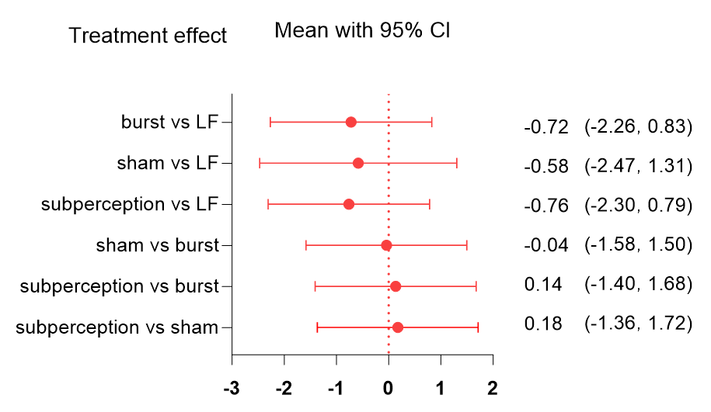

(A3)
LF | 0.72 (-0.83,2.26) | 0.58 (-1.31,2,47) | 0.76 (-0.79, 2.30)
-0.72 (-2.26，0.83) | burst | 0.04 (-1.50，1.58) | -0.14 (-1.68,1.40)
-0.58 (-2.47,1.31) | -0.04 (-1.58，1.50) | sham | -0.18 (-1.72,1.36)
-0.76 (-2.30,0.79) | 0.14 (-1.40,1.68) | 0.18 (-1.36,1.72) | subperception

(A4)

(A5)
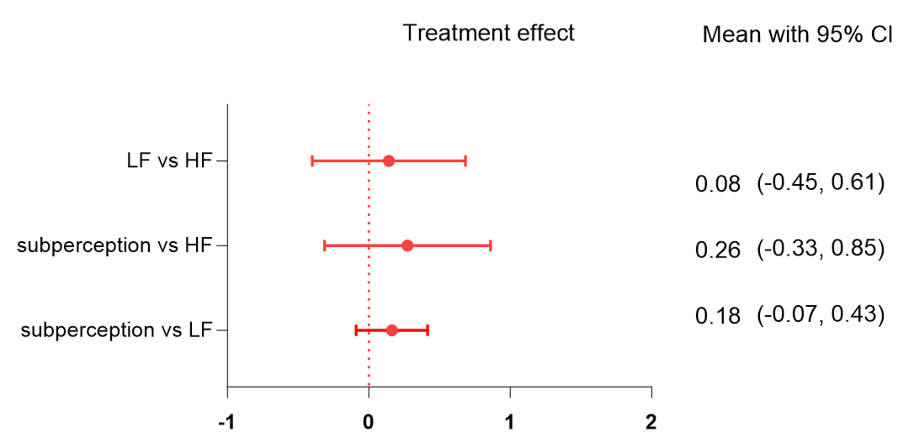

(A6)
HF | -0.08 (-0.61,0.45) | -0.26 (-0.85,0.33)
0.08 (-0.45,0.61) | LF | -0.18 (-0.43,0.08)
0.26 (-0.33,0.85) | 0.18 (-0.07,0.43) | subperception_

(B1)

(B2)
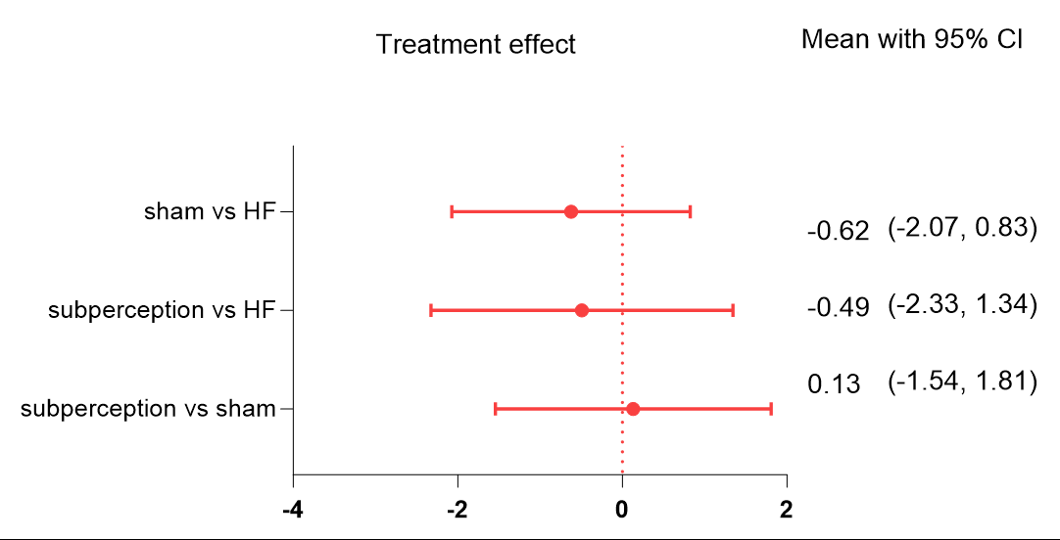

(B3)
HF | 0.62 (-0.83,2.07) | 0.49 (-1.34,2.33)
-0.62 (-2.07,0.83) | sham | 0.13 (-1.81)
-0.49 (-2.33,1.34) | 0.13 (-1.54,1.81) | subperception

(B4)

(B5)
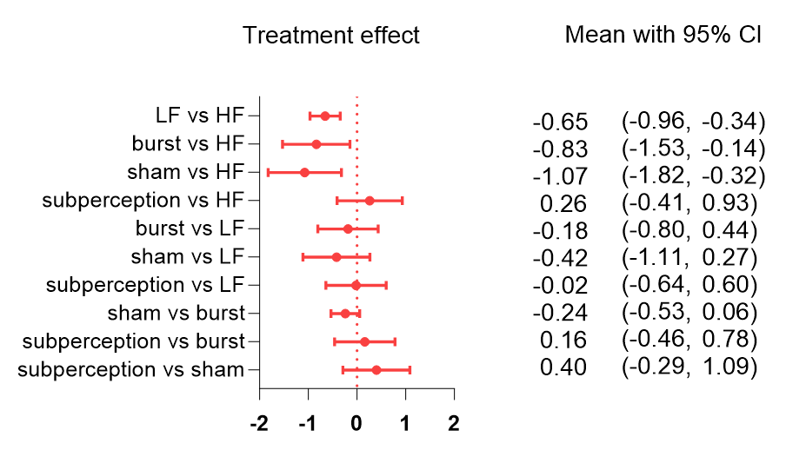

(B6)
HF | 0.65 (0.34,0.96) | 0.83 (0.14,1.53) | 1.07 (0.32,1.82) | -0.26(-0.93,0.41)
-0.65(-0.96,0.34) | LF | 0.18 (-0.44,0.80) | 0.42 (-0.27,1.11) | 0.02 (-0.60,0.64)
-0.83(-1.53,0.14) | -0.18(-0.80,0.44) | burst | 0.24 (-0.06,0.53) | -0.16(-0.78,0.46)
-1.07(-1.82,-0.32) | -0.42 (-1.11,0.27) | -0.24 (-0.53,0.06) | sham | -0.40 (-1.09,0.29)
0.26(0.41,0.93) | -0.02(0.64,0.60) | 0.16 (-0.46,0.78) | 0.40 (-0.29,1.09) | subperception

