Cationic Liposome-Mediated Bcl-2 Gene Transfection in Bone Marrow Mesenchymal Stem Cells: A Novel Regenerative Approach for Spinal Cord Injury
Haitao Yuan^{1#}, Xiaojun Feng^{1#}, Kamran Hidayat Ullah², Bo Chu¹, Tianqi Wang¹, Xin Zhou¹, Jun Gu^{1*}
¹ Department of Orthopedics, Xishan People's Hospital Of Wuxi City, Wuxi city, 204105, Jiangsu province, China
² Department of Pharmacy, CECOS University of IT and Emerging Sciences, Peshawar, Pakistan.

Supplementary Figure S1. Q-Q plot for data involved in ELISA results for Bcl-2 protein.

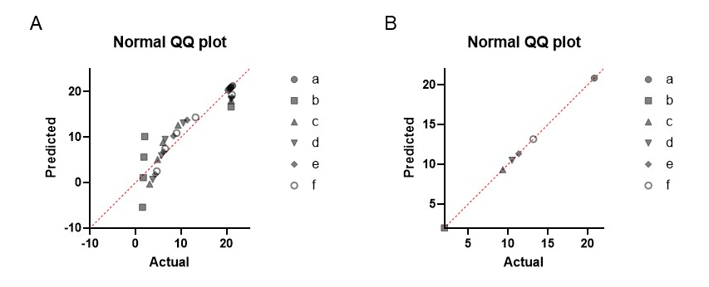

Supplementary Figure S2. Q-Q plot for data involved in (A) BBB scores and (B) inclined plane test scores.

